ROS Documentation Task – 2
- Swaminathan S K
Sources:
https://emanual.robotis.com/docs/en/platform/turtlebot3/quick-start/
https://emanual.robotis.com/docs/en/platform/turtlebot3/simulation/#gazebo-simulation

- Installing the dependencies and packages for turtlebot3 -
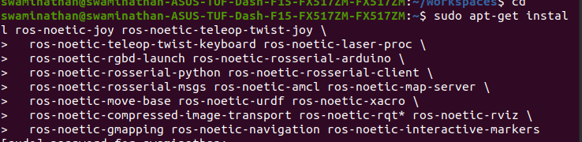
- ifconfig could only be done after installing net-tools.

- cd to the task_ws2 workspace. and catkin_make package of turtlebot3_simulations.
- running the gazebo_simulator -
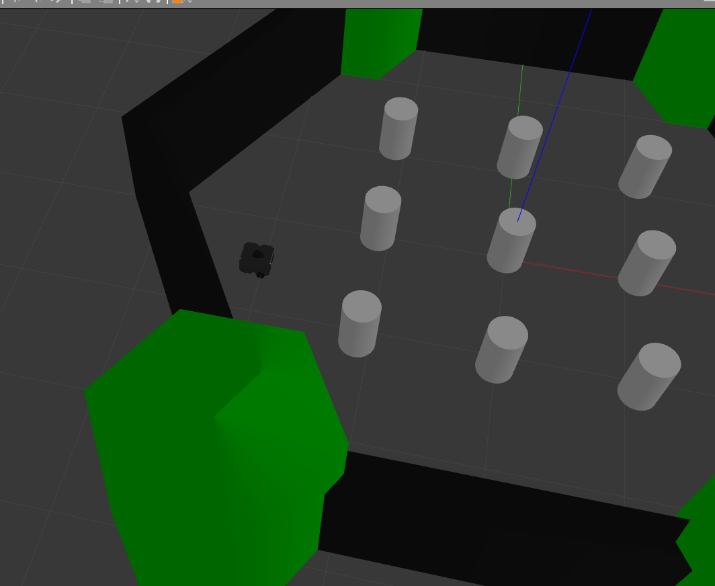
Controlling the turtlebot3 gazebo with arrow keys:
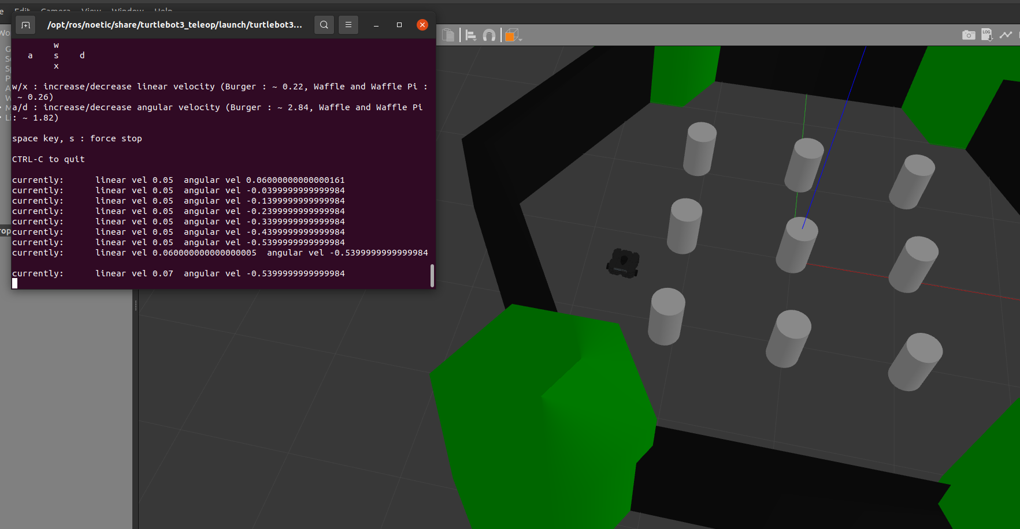
Code used:
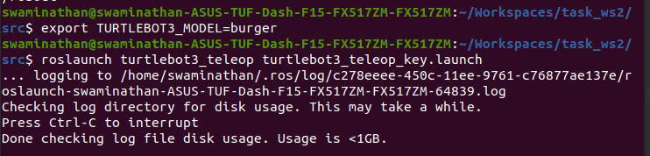
The cmd_vel topic messages were recorded in a bag file, converted to .yaml file and then edited with python.

Errors and Fixes:
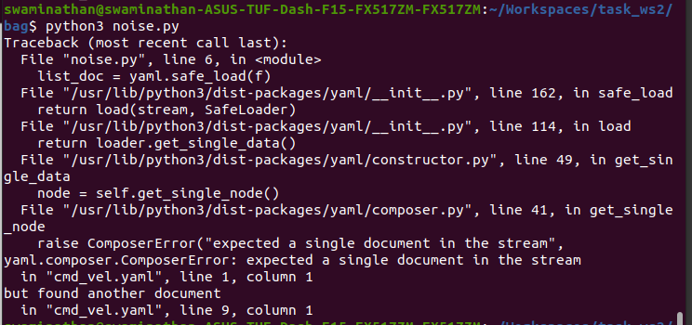

https://stackoverflow.com/questions/14359557/reading-yaml-file-with-python-results-in-yaml-composer-composererror-expected-a

the --- in a line creates a separate yaml file each time.
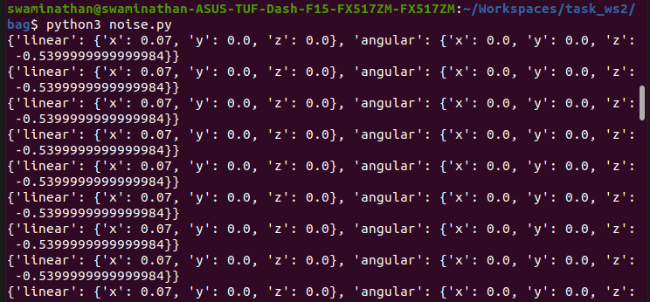
The code for the noise:
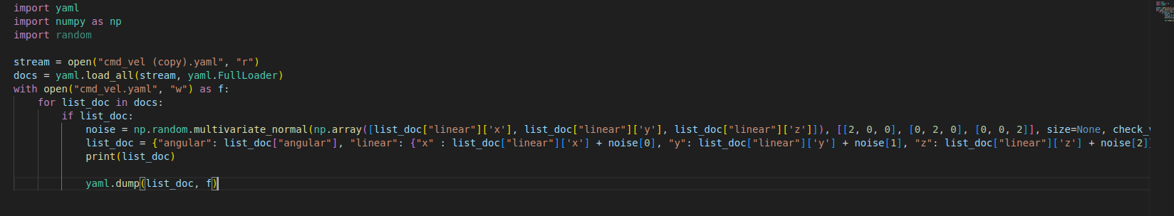
The final publisher.py code:
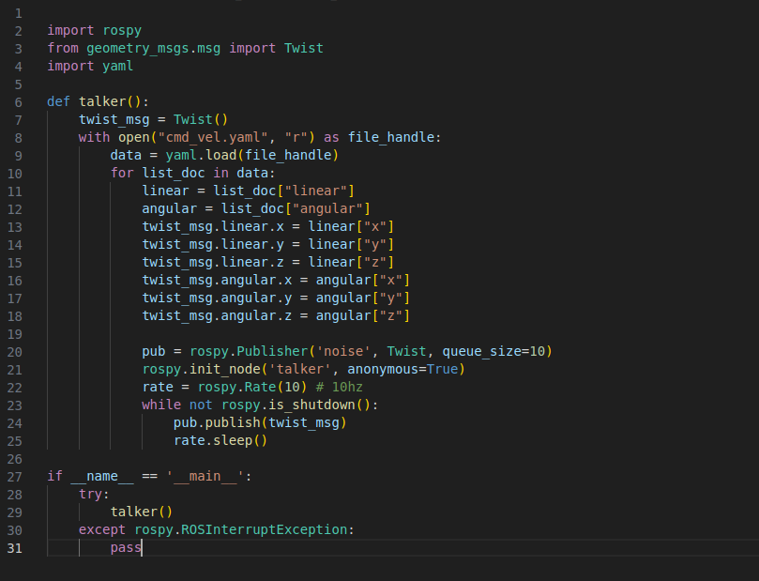
- Error occurs. (Not fixed yet)

