ROS Exercise 3
- Swaminathan S K 22CS30057 (AGV Software Team)

The smb_common_v2 was symlinked with the src folder.
The $ catkin build command was used to build the newer version. Now, to change the launch file -
The singlepillar.world file was download and placed in the smb_gazeebo/worlds/ folder.
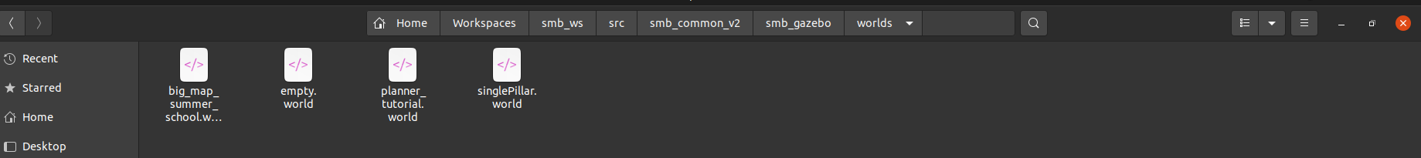
This is the modified .launch file:
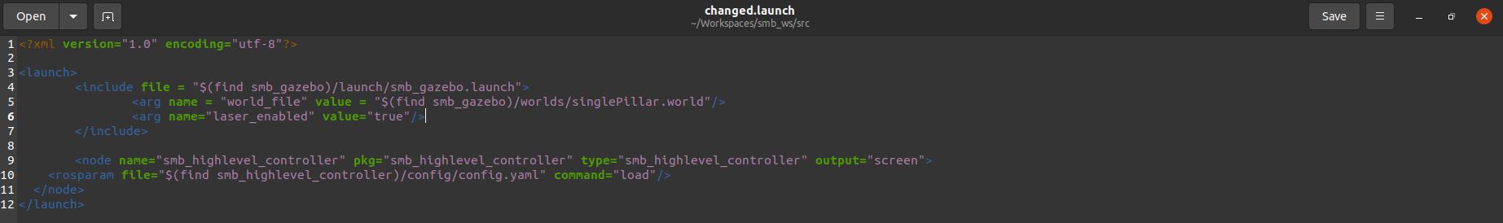
After lauching this file, we get:
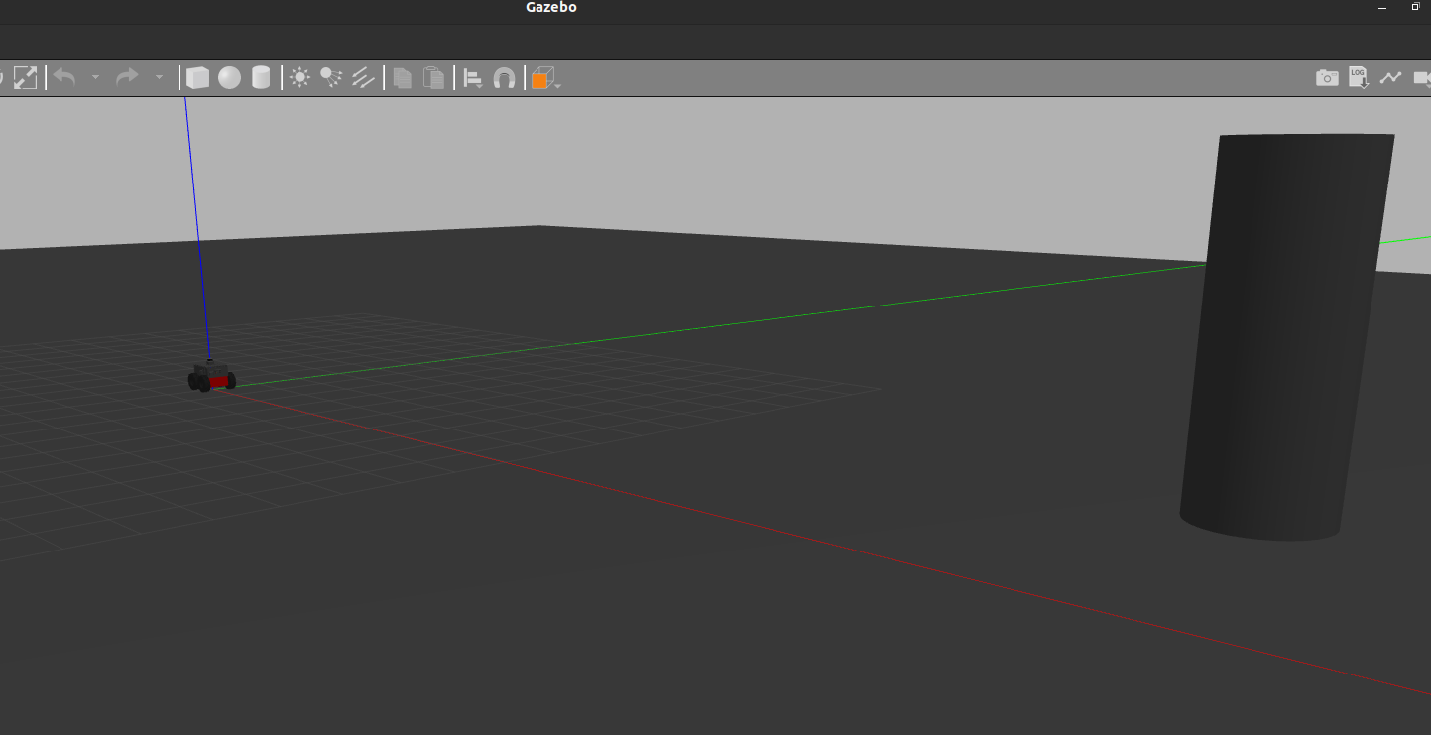
Getting the laser scan data and finding the distance of pillar relative to it:
Source(s): http://docs.ros.org/en/melodic/api/sensor_msgs/html/msg/LaserScan.html

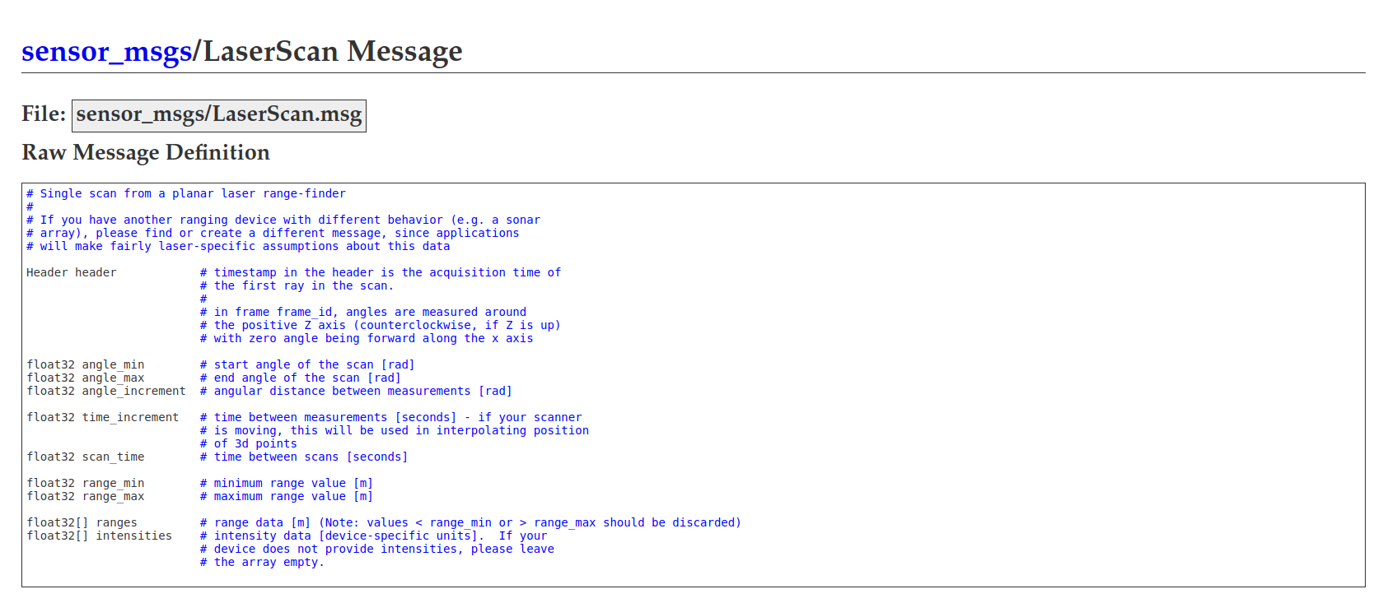
It is found that float32[] ranges returns the distances relative to the lase r scanner for each m(th) step. This is published to the topic /scan.
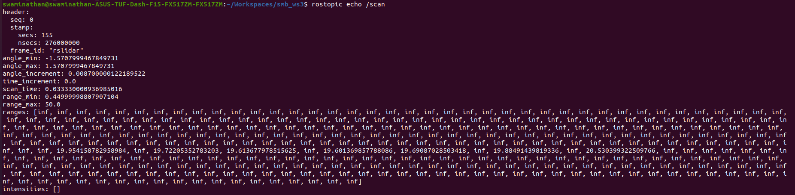
(*)If inf, not in range
Thus we observe that the pillar is approximately at a distance from 19.6 to 20.5.
To find the

