ROS Task Documentation – Exercises
- Swaminathan S K (AGV Software Team)

Exercise 2:
http://wiki.ros.org/ROS/Tutorials/WritingPublisherSubscriber%28c%2B%2B%29
https://www.youtube.com/watch?v=v9RgXcosuww

- Created a new workspace called smb_ex_2
- downloaded the zip folder for smb_high_level_controller
- changed the SmbHighlevelController.cpp to include a subscriber.
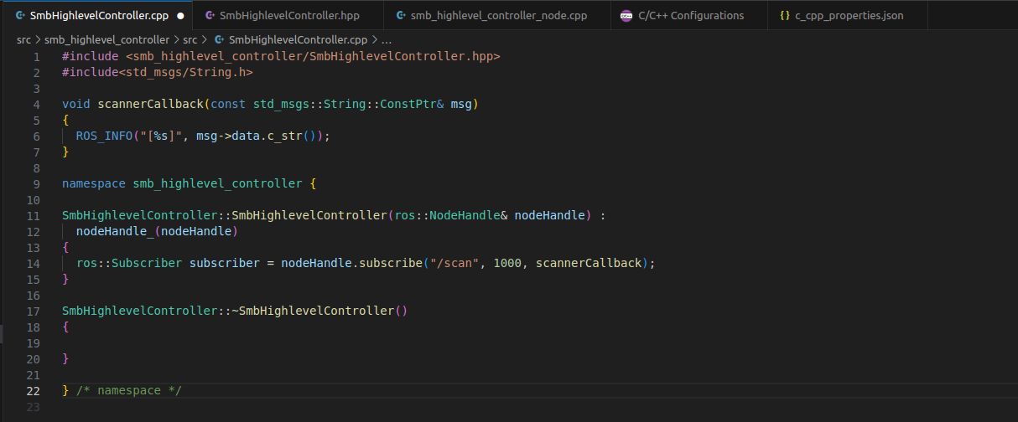
Errors and Fixes:
There was an error with the subscribe function whenever the callback function didnt take any arguments. Keeping the argument of callback function as msg fixed this issue.

As per the given exercise, sensor_msgs/LaserScan.h was supposed to be imported, since the message that the subscriber receives is of that form. To go through the values that the message offers, this link was referred.

http://docs.ros.org/en/api/sensor_msgs/html/msg/LaserScan.html

Thus the modified object oriented code is given below:

