In-Class Activity #13B — Reflection & Evidence
CSC 4360 Mobile App Development · Firebase Authentication in Flutter
Name: Swamireddy Ailuri
Test date: November 10, 2026
Platform/device: Android emulator (Medium Phone, sdk gphone16k x86_64), debug build
Repository: https://github.com/SwamireddyA/auth-lab-13b
Test account: test13b@example.com (fictional; passwords not shown)

1. Test Results
# | Test action | Expected | Observed | Result
1 | Register test13b@example.com (password ≥ 6 chars, confirmed) | Profile shows the email; account listed in Firebase Console → Users | Profile showed "Signed in as test13b@example.com" | Pass
2 | Sign in with an invalid email format | Inline validation error; no Firebase request | Red inline "Enter a valid email, like name@example.com." | Pass
3 | Tap Create account and watch the form | Spinner; fields and button disabled | Fields greyed out, spinner shown in button | Pass
4 | Change password from Profile | Dialog closes; success message | Dialog closed with no error (snackbar not captured) | Pass
5 | Sign out | Sign-in screen; profile unreachable | Sign-in screen shown | Pass
6 | Sign in with OLD password | Fails with safe, generic message | Banner "Email or password is incorrect." (no raw exception) | Pass
7 | Sign in with NEW password | Profile shown | Profile with test13b@example.com | Pass
8 | Register with a 5-character password | Inline "at least 6 characters" | [fill in] | [ ]
9 | Close app fully while signed in, reopen | Profile shown without signing in | [fill in] | [ ]
10 | Press Back on sign-in screen after sign-out | Does not return to Profile | [fill in] | [ ]
11 | requires-recent-login recovery | Reauth dialog, then update succeeds | Not triggered — see test plan below | Not tested

2. Screenshot Evidence
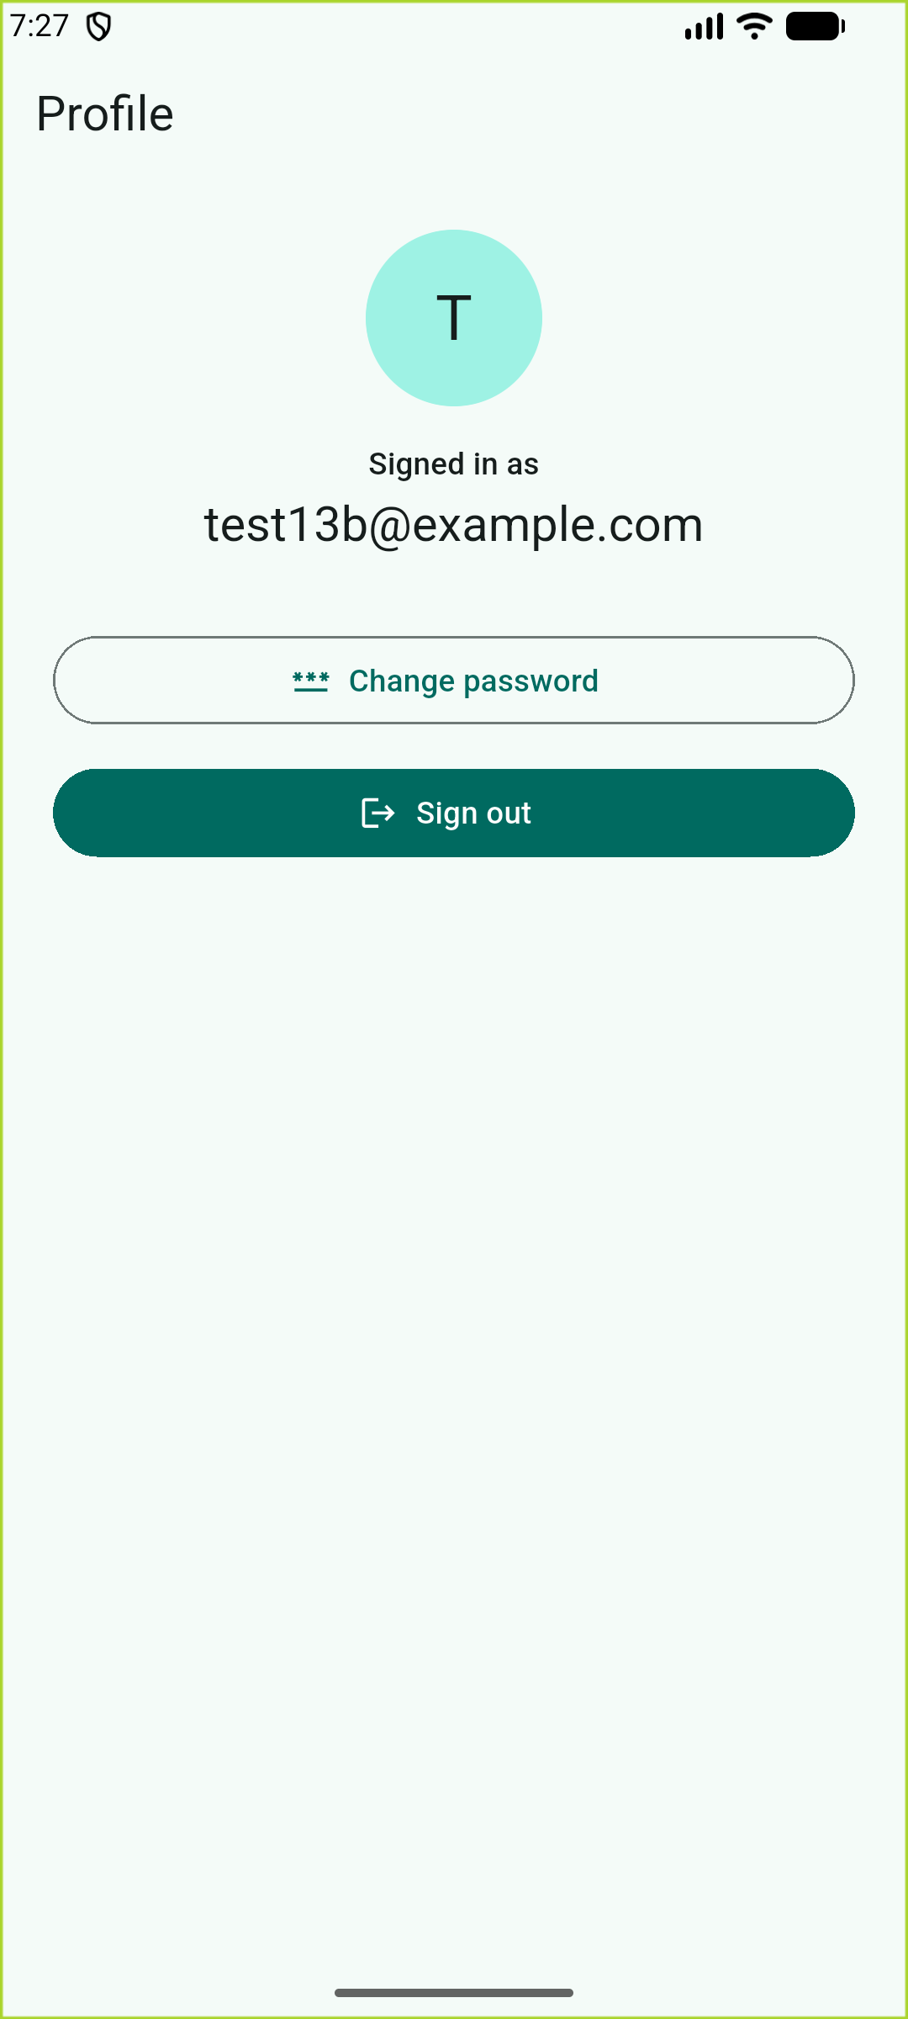
Screenshot 1. Successful registration — Profile shows test13b@example.com. Confirmed new account: Firebase Console → Authentication → Users [verify and note here]. Result: Pass.
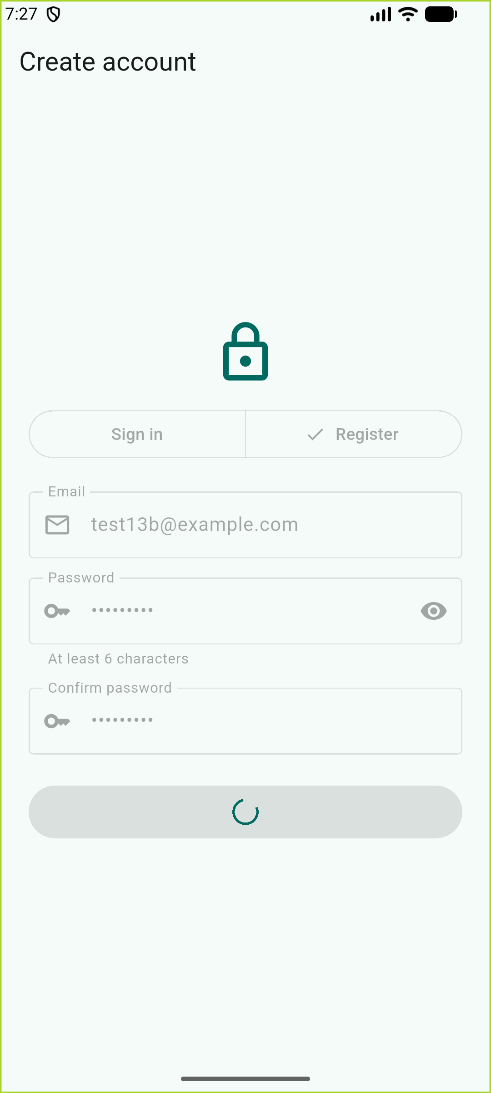
Screenshot 2. Loading state while creating the account — fields and button disabled, spinner visible, preventing duplicate submissions. Result: Pass.
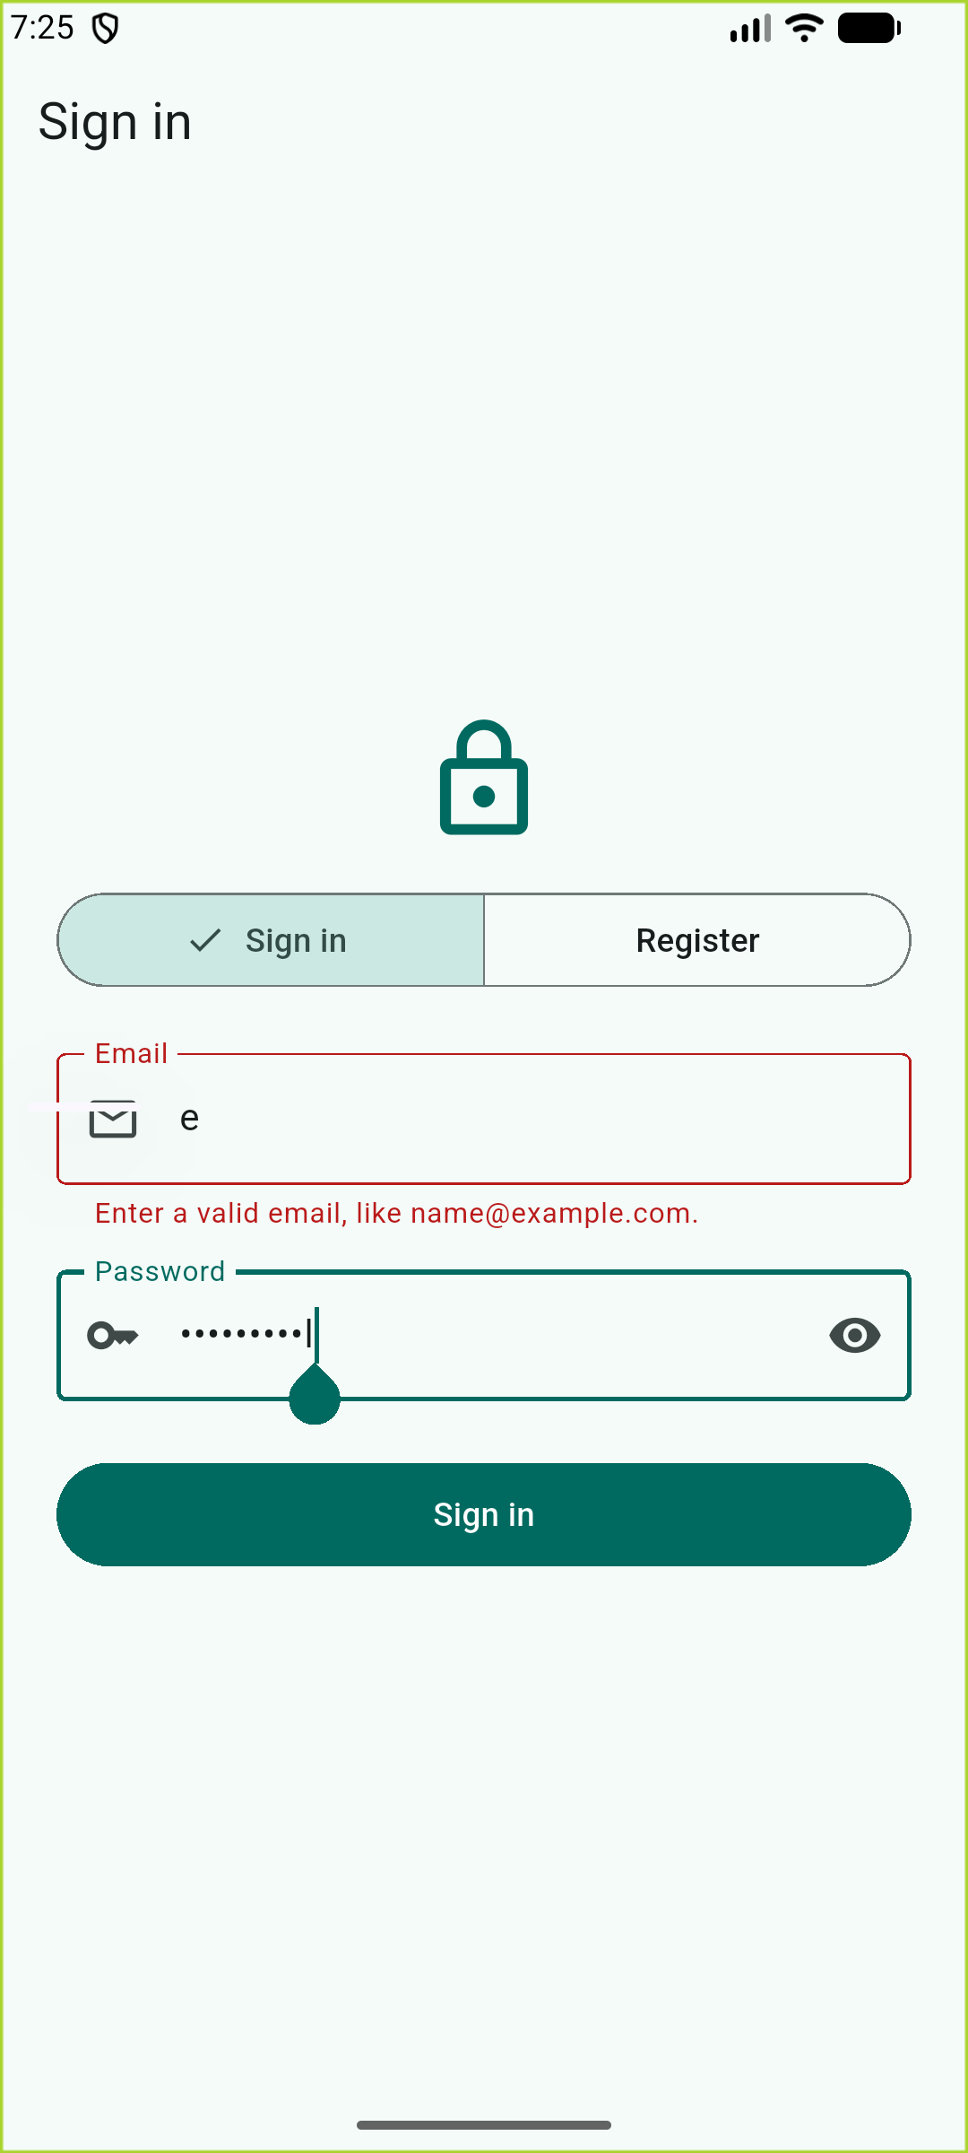
Screenshot 3. Invalid input — an invalid email is caught by client-side validation with a specific inline message before any request is sent. Result: Pass.
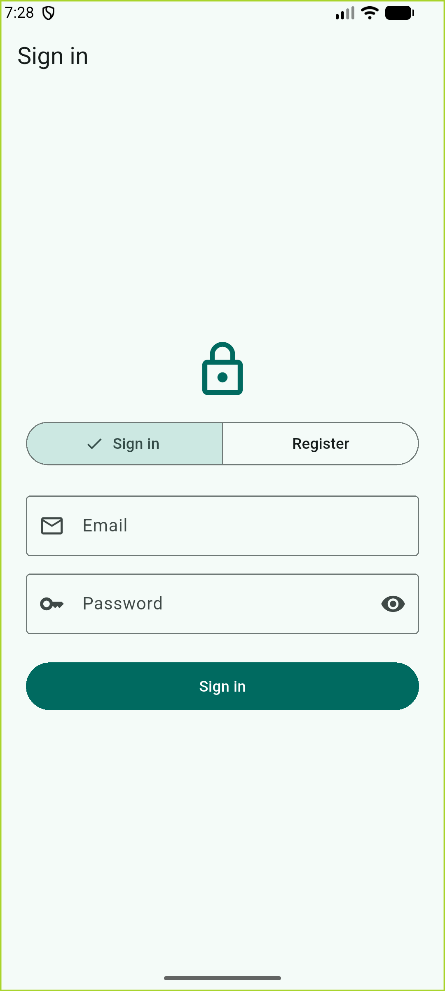
Screenshot 4. Signed-out screen after tapping Sign out. AuthGate builds ProfileScreen only when authStateChanges() emits a non-null user, so the profile is not reachable while signed out. Result: Pass.
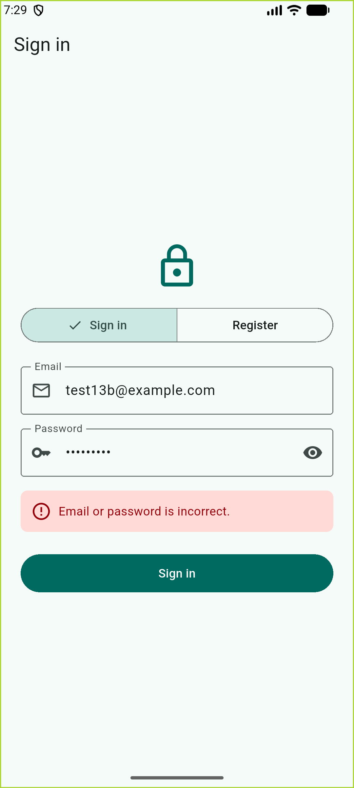
Screenshot 5. After the password update, signing in with the OLD password fails with a generic message that does not reveal whether the account exists. Result: Pass.
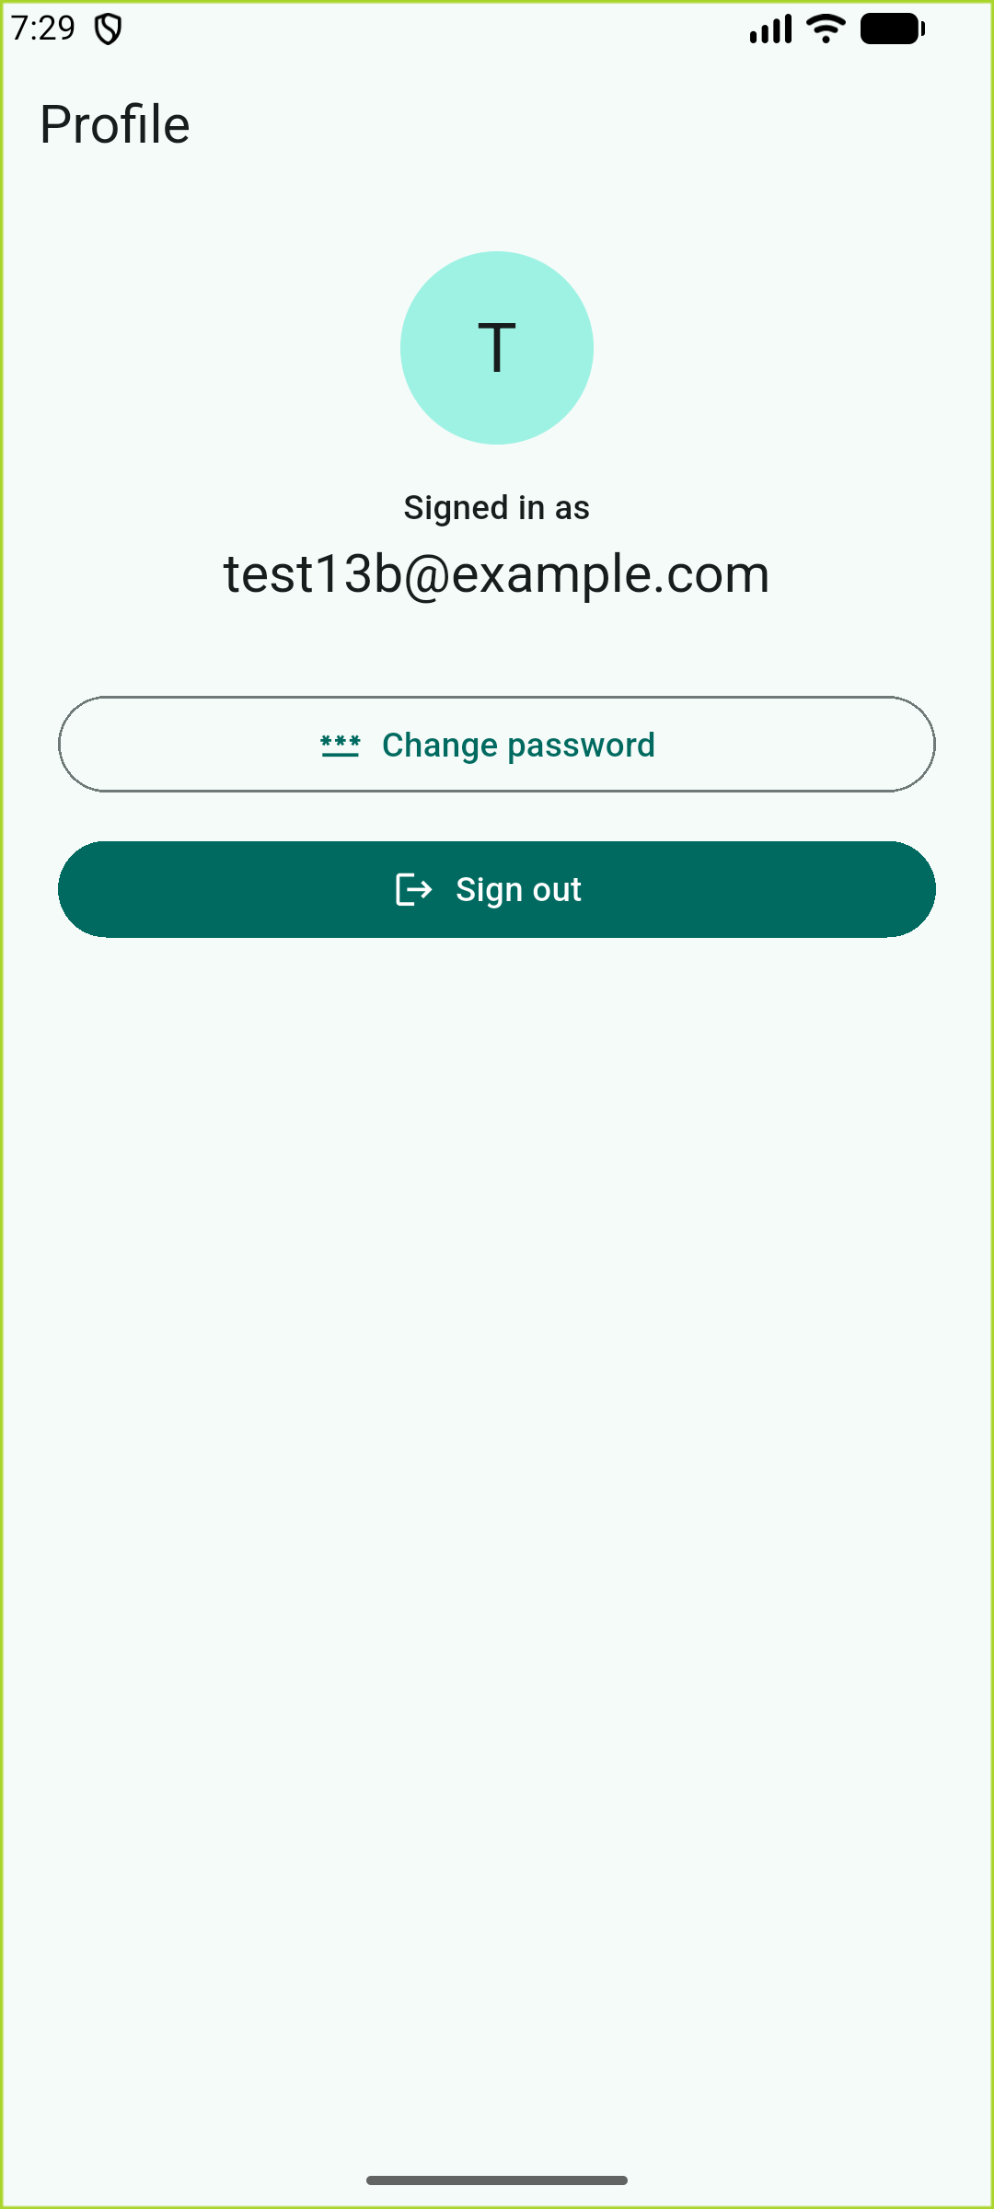
Screenshot 6. Signing in with the NEW password succeeds and returns to the Profile. Result: Pass.
TO DO (write in your own words): Add screenshots for tests 8 (short password) and 9 (session restored after reopening). Optionally re-capture the "Password updated successfully." snackbar.

3. Recent-Login Recovery — Test Plan (not triggered)
Status: requires-recent-login did not occur during testing because the password was changed shortly after signing in. This section is a test plan and code explanation, not a claimed pass.
Handler: AuthService.updatePassword() catches FirebaseAuthException and maps the code requires-recent-login to AuthFailure(requiresRecentLogin: true). The change-password dialog then reveals a "Current password" field. On submit, reauthenticateAndUpdate() builds EmailAuthProvider.credential(email, currentPassword), calls reauthenticateWithCredential(), and retries updatePassword().
Plan to trigger: Sign in, leave the session idle long enough for Firebase to consider the login stale, then change the password. Expected: "Confirm it's you" dialog → enter current password → success message.

4. AI Comparison (Undergraduate track unless instructor assigned Graduate)

My prediction (written before asking AI)
TO DO (write in your own words): 3–5 lines describing the register → profile → sign-out flow, plus two tests you expected to pass.

AI tool and date
TO DO (write in your own words): e.g. "Gemini (free), Nov 10, 2026" — plus a short summary of its suggestions in your words.

Compare, verify, decide
TO DO (write in your own words): One AI idea you kept, one claim you checked against https://firebase.google.com/docs/auth/flutter/manage-users, and what you changed or rejected.

AI-use disclosure
TO DO (write in your own words): State that Claude (Anthropic) generated the app code scaffolding and helped run the tests, and any other AI you used.

5. Reflection

Prompt 1 — Expectation vs. obtained
TO DO (write in your own words): What you expected vs. what happened.

Prompt 1 follow-up — Root cause and lesson
TO DO (write in your own words): One root cause and one design lesson.

Prompt 2 — Debug evidence
TO DO (write in your own words): A real issue (e.g. code pasted into the wrong project, PATH for flutterfire) and the evidence the fix worked.

Prompt 2 follow-up — Alternative fix
TO DO (write in your own words): An alternative you considered and why you rejected it.

Prompt 3 — Improvement plan
TO DO (write in your own words): One improvement and why.

Prompt 4 — Security vs. UX
TO DO (write in your own words): e.g. the generic "Email or password is incorrect." message: safer (no account enumeration) but less specific.

Prompt 5 — Auth, authorization, prior learning
TO DO (write in your own words): Connect AuthGate (StreamBuilder on authStateChanges) to In-Class 12, and explain how Firestore rules on users/{uid} enforce access.

Prompt 6 — Scale (10,000 users)
TO DO (write in your own words): What you would change first and why.

Sources
Firebase Flutter setup: https://firebase.google.com/docs/flutter/setup
Firebase Authentication for Flutter: https://firebase.google.com/docs/auth/flutter/start
Manage users in Flutter: https://firebase.google.com/docs/auth/flutter/manage-users
Flutter form validation: https://docs.flutter.dev/cookbook/forms/validation

