Supplemental Material
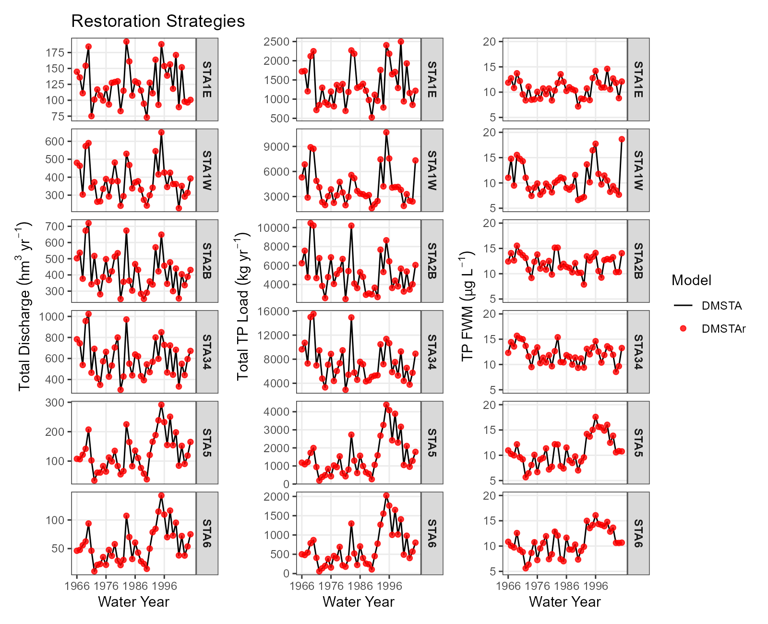
Figure S1. Time series plots of annually aggregated total outflow discharge, total outflow total phosphorus (TP) load and TP flow-weighted mean concentration using the DMSTA legacy and DMSTAr estimated value for stormwater treatment areas modelled in Restoration Strategies.

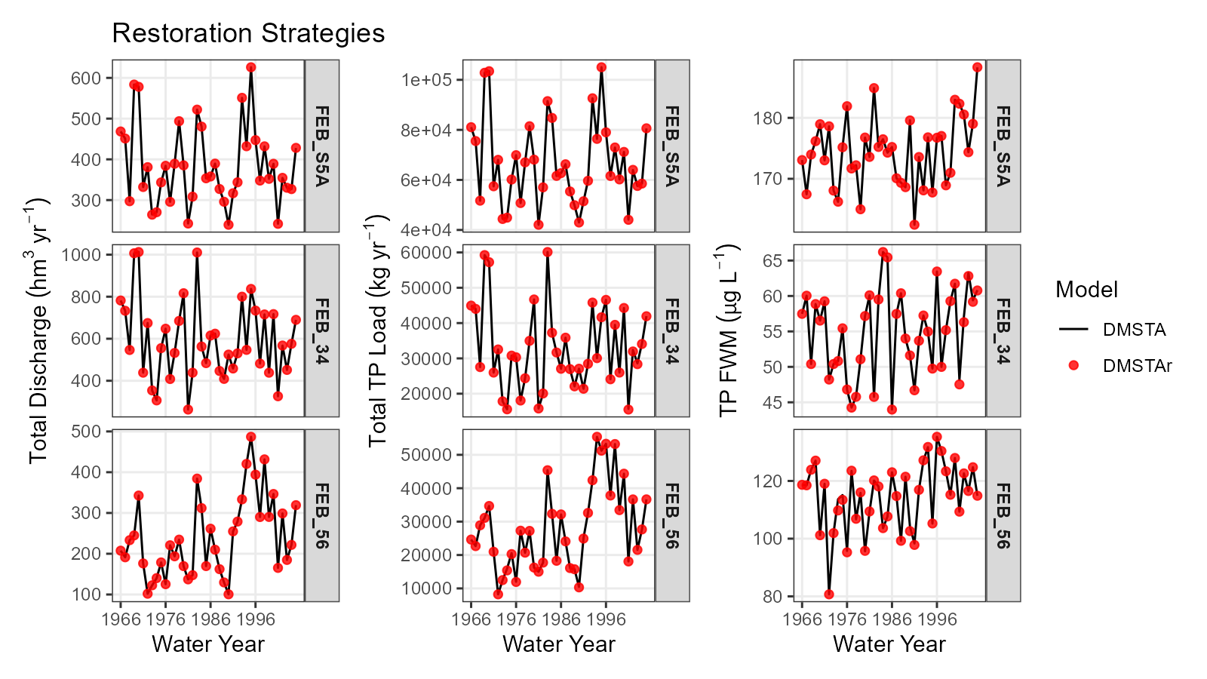
Figure S2. Time series plots of annually aggregated total outflow discharge, total outflow total phosphorus (TP) load and TP flow-weighted mean concentration using the DMSTA legacy and DMSTAr estimated value for flow-equalization basins modelled in Restoration Strategies.

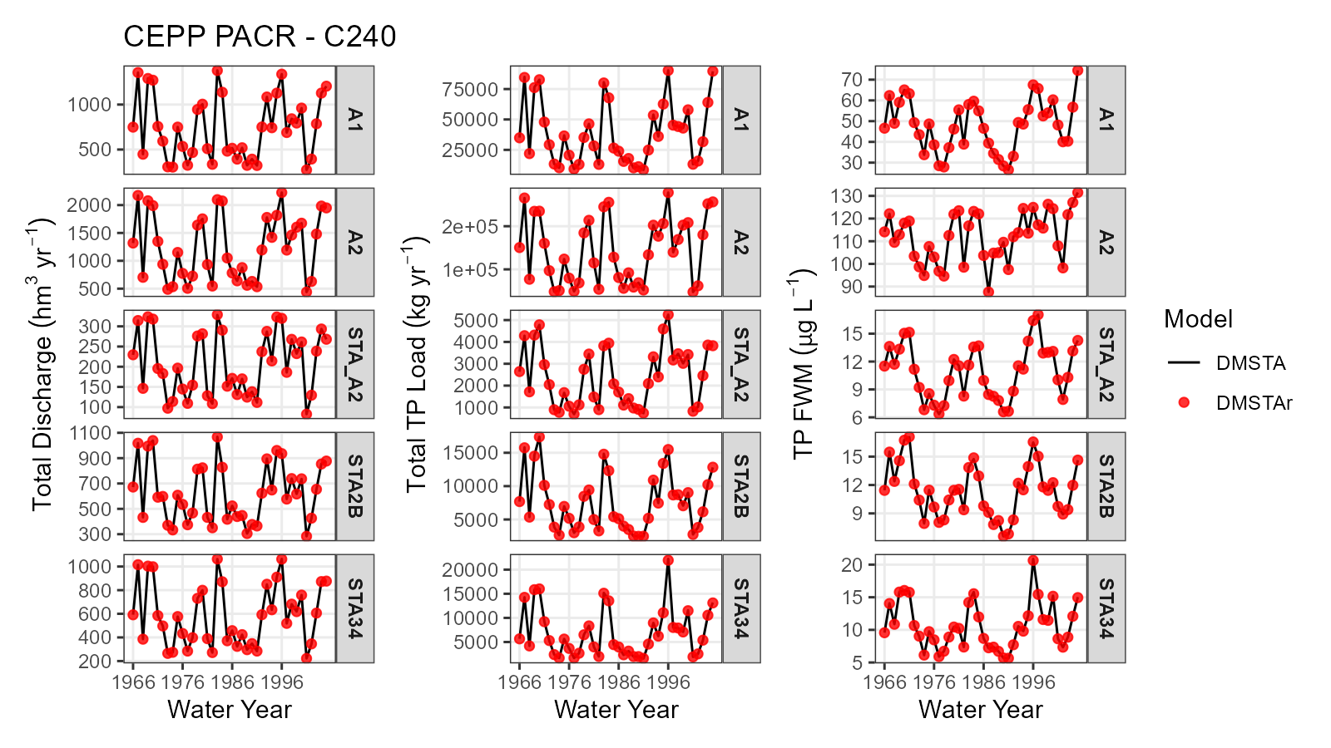
Figure S3. Time series plots of annually aggregated total outflow discharge, total outflow total phosphorus (TP) load and TP flow-weighted mean concentration using the DMSTA legacy and DMSTAr estimated value for flow equalization basin (A1), deep reservoir (A2) and stormwater treatment areas (STA2B, STA3/4 and STA A2) modelled in Central Everglades Planning Project.

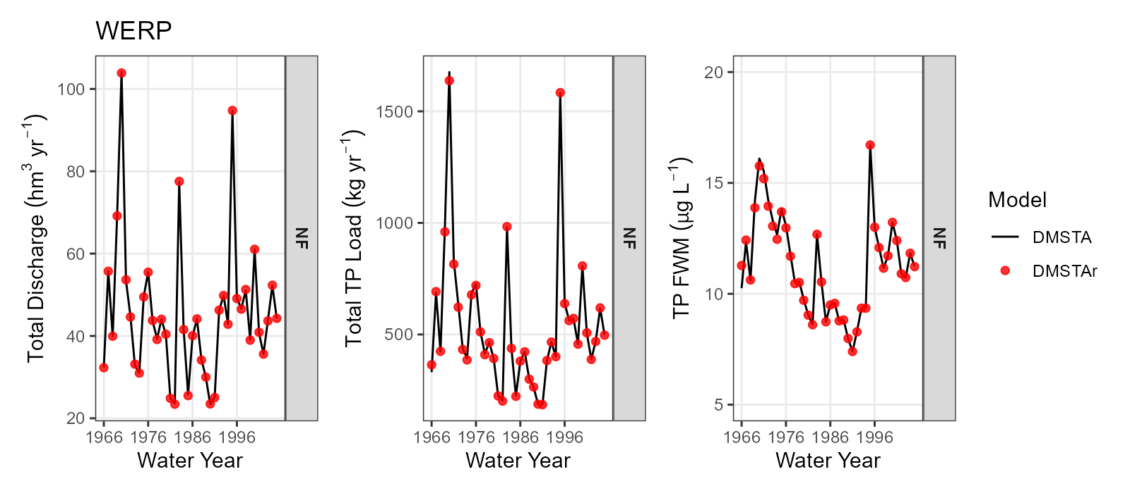
Figure S4. Time series plots of annually aggregated total outflow discharge, total outflow total phosphorus (TP) load and TP flow-weighted mean concentration using the DMSTA legacy and DMSTAr estimated value for the North Feeder (NF) stormwater treatment area modelled in Western Everglades Restoration Project.

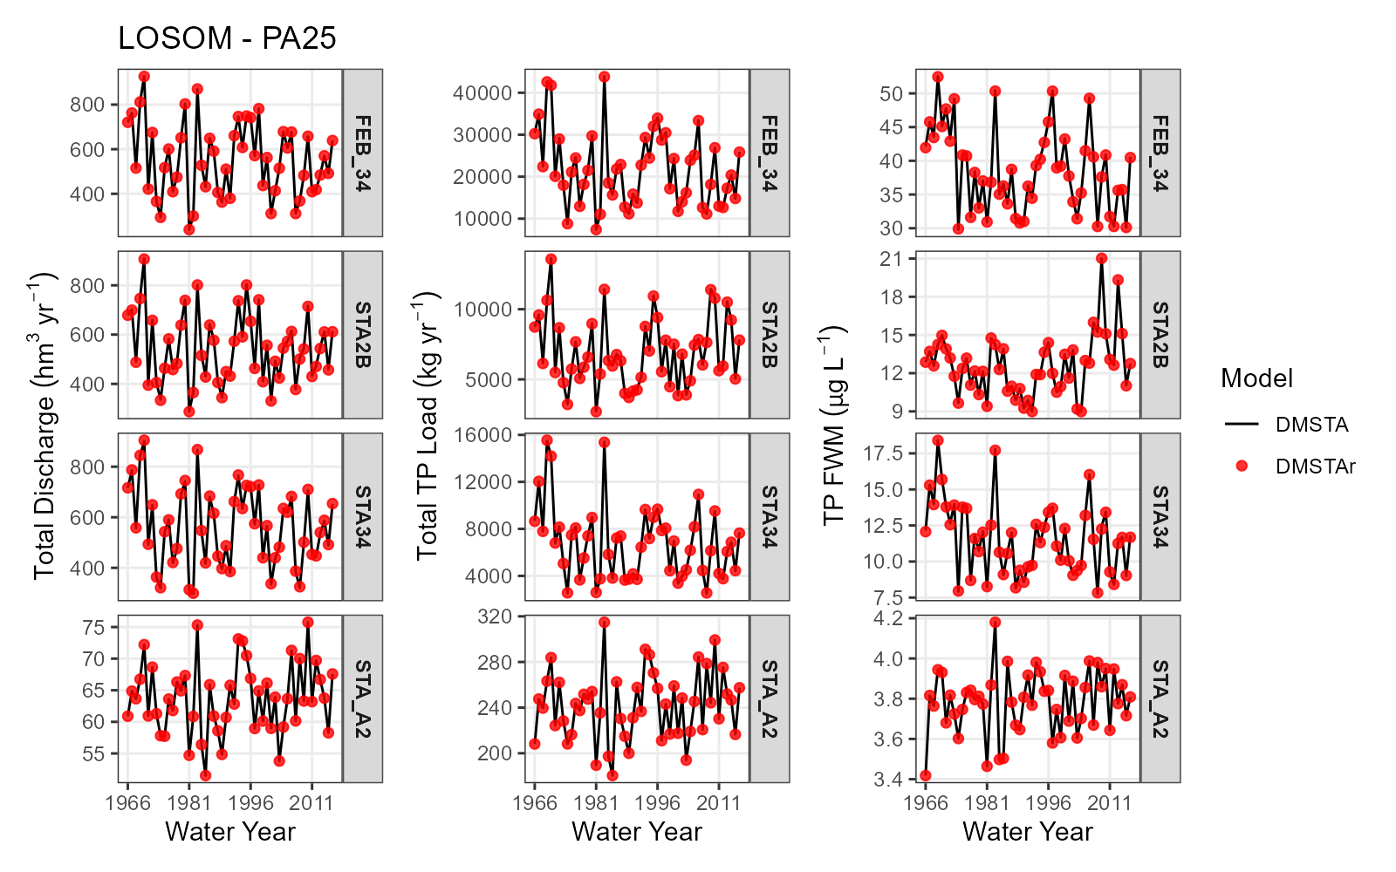
Figure S5. Time series plots of annually aggregated total outflow discharge, total outflow total phosphorus (TP) load and TP flow-weighted mean concentration using the DMSTA legacy and DMSTAr estimated value for stormwater treatment areas modelled in Lake Okeechobee System Operating Manual.

Table S1. Original Data sources for DMSTA output used in this study available on the Statewide Model Management System (https://www.sfwmd.gov/science-data/mms).
Project | DMSTA Version | Link
Restoration Strategies | 2C | https://smmsviewer.apps.sfwmd.gov/modelreport/1687
Central Everglades Planning Project | 2C2B | https://smmsviewer.apps.sfwmd.gov/modelreport/3426
Western Everglades Restoration Planning | Unknown (Possible 2C) | https://smmsviewer.apps.sfwmd.gov/modelreport/3458
Lake Okeechobee System Operating Manual | 2C2B_20102b | https://smmsviewer.apps.sfwmd.gov/modelreport/3580

Table S2. Error indices evaluated in this study, where $y_{test,i}$ and $y_{ref,i}$ are test and reference outputs on day i, n is the number of days in a simulation and ${\overline{y}}_{ref}$ is the mean of the reference output.
Name | Equation
Root-mean-square error (RMSE) | $$RMSE=\sqrt{\frac{1}{n}{\sum_{i=1}^{n}{\left(y_{test,i}-y_{ref,i}\right)}}^{2}}$$
Normalized root-mean-square error (NRMSE) | $$NRMSE=100×\frac{\sqrt{\frac{1}{n}{\sum_{i=1}^{n}{\left(y_{test,i}-y_{ref,i}\right)}}^{2}}}{ {\overline{y}}_{ref}}$$
Mean absolute error (MAE) | $$MAE=\frac{1}{n}\sum_{i=1}^{n}{\left| y_{test,i}- y_{ref,i}\right| }$$
Maximum Absolute Error (Max Error) | $$Max Error=\max_{i}\left| y_{test,i}- y_{ref,i}\right|$$

Table S3. Agreement summary for annual values between DMSTAr and the legacy DMSTA implementation for Restoration Strategies. Signed differences are reported as DMSTAr − DMSTA. Percent differences are symmetric percent differences calculated relative to the mean of the two model outputs.
Project | STA | Output Metric | n | Mean diff. | Median abs. diff. | RMSE | Mean % diff. | % diff.  within ±1%
RS | FEB_34 | Total Discharge | 40 | 0.0137 | 0.0000 | 0.06 | 0.003 | 100.0
RS | FEB_34 | Total Load | 40 | -24.50 | 0.00 | 83.67 | -0.093 | 95.0
RS | FEB_34 | Flow Weighted Mean | 40 | -0.0529 | 0.0000 | 0.18 | -0.096 | 95.0
RS | FEB_56 | Total Discharge | 40 | 0.0082 | 0.0000 | 0.03 | 0.006 | 100.0
RS | FEB_56 | Total Load | 40 | -21.90 | 3.28 | 101.42 | -0.155 | 92.5
RS | FEB_56 | Flow Weighted Mean | 40 | -0.1737 | 0.0102 | 0.72 | -0.161 | 92.5
RS | FEB_S5A | Total Discharge | 40 | 0.0058 | 0.1072 | 0.17 | -0.000 | 100.0
RS | FEB_S5A | Total Load | 40 | 1.23 | 22.12 | 33.09 | -0.000 | 100.0
RS | FEB_S5A | Flow Weighted Mean | 40 | -0.0000 | 0.0057 | 0.01 | 0.000 | 100.0
RS | STA1E | Total Discharge | 40 | 0.0000 | 0.0000 | 0.00 | 0.000 | 100.0
RS | STA1E | Total Load | 40 | 0.00 | 0.00 | 0.00 | 0.000 | 100.0
RS | STA1E | Flow Weighted Mean | 40 | 0.0000 | 0.0000 | 0.00 | 0.000 | 100.0
RS | STA1W | Total Discharge | 40 | 0.0059 | 0.1017 | 0.12 | 0.001 | 100.0
RS | STA1W | Total Load | 40 | 2.00 | 2.29 | 7.57 | 0.019 | 100.0
RS | STA1W | Flow Weighted Mean | 40 | 0.0039 | 0.0056 | 0.02 | 0.018 | 100.0
RS | STA2B | Total Discharge | 40 | 0.0088 | 0.0000 | 0.03 | 0.003 | 100.0
RS | STA2B | Total Load | 40 | 0.11 | 0.04 | 0.62 | 0.002 | 100.0
RS | STA2B | Flow Weighted Mean | 40 | -0.0001 | 0.0001 | 0.00 | -0.001 | 100.0
RS | STA34 | Total Discharge | 40 | 0.0149 | 0.0000 | 0.09 | 0.003 | 100.0
RS | STA34 | Total Load | 40 | -0.66 | 0.00 | 2.68 | -0.012 | 100.0
RS | STA34 | Flow Weighted Mean | 40 | -0.0015 | 0.0000 | 0.00 | -0.014 | 100.0
RS | STA5 | Total Discharge | 40 | 0.0167 | 0.0000 | 0.05 | 0.032 | 100.0
RS | STA5 | Total Load | 40 | -0.11 | 0.15 | 0.53 | 0.006 | 100.0
RS | STA5 | Flow Weighted Mean | 40 | -0.0023 | 0.0007 | 0.01 | -0.026 | 100.0
RS | STA6 | Total Discharge | 40 | 0.0482 | 0.0542 | 0.06 | 0.139 | 100.0
RS | STA6 | Total Load | 40 | -0.94 | 1.48 | 3.49 | -0.241 | 80.0
RS | STA6 | Flow Weighted Mean | 40 | -0.0389 | 0.0280 | 0.09 | -0.380 | 82.5

Table S4. Agreement summary for annual values between DMSTAr and the legacy DMSTA implementation. Signed differences are reported as DMSTAr − DMSTA. Percent differences are symmetric percent differences calculated relative to the mean of the two model outputs.
Project | STA | Output Metric | n | Mean diff. | Median abs. diff. | RMSE | Mean % diff. | % diff.  within ±1%
CEPP | A1 | Total Discharge | 40 | -0.2708 | 0.5672 | 0.89 | -0.028 | 100.0
CEPP | A1 | Total Load | 40 | -111.72 | 71.70 | 217.39 | -0.238 | 92.5
CEPP | A1 | Flow Weighted Mean | 40 | -0.1004 | 0.1022 | 0.22 | -0.210 | 95.0
CEPP | A2 | Total Discharge | 40 | 0.0063 | 0.4143 | 0.76 | 0.001 | 100.0
CEPP | A2 | Total Load | 40 | -23.95 | 73.58 | 108.62 | -0.030 | 100.0
CEPP | A2 | Flow Weighted Mean | 40 | -0.0313 | 0.0206 | 0.05 | -0.031 | 100.0
CEPP | STA_A2 | Total Discharge | 40 | 0.1573 | 0.0707 | 0.28 | 0.073 | 100.0
CEPP | STA_A2 | Total Load | 40 | 3.84 | 2.50 | 5.86 | 0.189 | 100.0
CEPP | STA_A2 | Flow Weighted Mean | 40 | 0.0110 | 0.0088 | 0.02 | 0.116 | 100.0
CEPP | STA2B | Total Discharge | 40 | -0.1705 | 0.5634 | 0.89 | -0.034 | 100.0
CEPP | STA2B | Total Load | 40 | -6.37 | 12.68 | 41.90 | -0.054 | 97.5
CEPP | STA2B | Flow Weighted Mean | 40 | -0.0036 | 0.0189 | 0.04 | -0.020 | 100.0
CEPP | STA34 | Total Discharge | 40 | 0.0271 | 0.5660 | 0.87 | 0.028 | 100.0
CEPP | STA34 | Total Load | 40 | -25.60 | 13.91 | 67.52 | -0.148 | 92.5
CEPP | STA34 | Flow Weighted Mean | 40 | -0.0280 | 0.0193 | 0.07 | -0.176 | 95.0
WERP | NF | Total Discharge | 40 | -0.0002 | 0.0994 | 0.13 | -0.011 | 100.0
WERP | NF | Total Load | 40 | -2.23 | 1.40 | 9.69 | -0.172 | 80.0
WERP | NF | Flow Weighted Mean | 40 | -0.0289 | 0.0082 | 0.20 | -0.162 | 82.5
LOSOM | FEB_34 | Total Discharge | 51 | 0.0018 | 0.2184 | 0.56 | 0.002 | 100.0
LOSOM | FEB_34 | Total Load | 51 | -46.67 | 44.93 | 74.74 | -0.209 | 98.0
LOSOM | FEB_34 | Flow Weighted Mean | 51 | -0.0848 | 0.0714 | 0.14 | -0.211 | 98.0
LOSOM | STA_A2 | Total Discharge | 51 | -0.0000 | 0.0000 | 0.00 | -0.000 | 100.0
LOSOM | STA_A2 | Total Load | 51 | 0.00 | 0.00 | 0.00 | 0.000 | 100.0
LOSOM | STA_A2 | Flow Weighted Mean | 51 | 0.0000 | 0.0000 | 0.00 | 0.000 | 100.0
LOSOM | STA2B | Total Discharge | 51 | -2.1240 | 2.1268 | 2.36 | -0.417 | 100.0
LOSOM | STA2B | Total Load | 51 | -26.68 | 24.15 | 30.91 | -0.426 | 98.0
LOSOM | STA2B | Flow Weighted Mean | 51 | 0.0004 | 0.0080 | 0.02 | -0.010 | 100.0
LOSOM | STA34 | Total Discharge | 51 | 2.1362 | 2.0796 | 2.39 | 0.425 | 96.1
LOSOM | STA34 | Total Load | 51 | -1.79 | 25.88 | 35.44 | 0.093 | 86.3
LOSOM | STA34 | Flow Weighted Mean | 51 | -0.0432 | 0.0396 | 0.08 | -0.332 | 86.3

