Flow Measurement  
Monitoring Termination Justification

Lake Okeechobee  
Water Control Structures

Justification for Removal of C41H78   
Flow Data from the Lake Okeechobee Operating Permit Requirements

**Permit Number: 0174552**

Prepared for the

Florida Department of Environmental Protection

C:\Documents and Settings\ctking\My Documents\My Pictures\District Standards\sfwmd_seal.emf

Prepared by Tom James

September 30, 2016

Revised by Manuel F. Zamorano

August 13, 2020

Compliance Assessment and Reporting Section

Water Quality Bureau

South Florida Water Management District

# Background

To meet the requirements of the Lake Okeechobee Operating Permit (0174552-001-GL), issued under the authority of the Lake Okeechobee Protection Act, Chapter 373.4595, Florida Statutes (F.S.), and Title 62, Florida Administrative Code (F.A.C.), the South Florida Water Management District (SFWMD) is required to monitor flow and nutrient discharge from L61E, HP-7, and Inflow 1, 2, and 3 (hereinafter L61E basins). Due to the small flow contribution from the L61E basins, and the constraints (accessibility and infrastructure) to estimate flows from these small structures, SFWMD requested that an indirect method be used to determine flows and loads at these sites.

An indirect method was approved by the Florida Department of Environmental Protection minor modification of the Lake Okeechobee Operating Permit (0174552-006-EM). This method involved the installation of a Doppler index-velocity (IV) meter and autosampler at a point (C41H78) in the C-41 canal downstream of all lateral inflows, and just south of Highway 78 (**Figure 1**). Two Doppler IV meters, one operating at a higher acoustic frequency and one at a lower frequency, were deployed to assess their capabilities. A stilling well was also installed at this location to monitor water stages. A set of stream-gauging measurements by Acoustic Doppler Current Profiler was subsequently performed to develop a rating to attain an estimate of the mean velocity of the flow based on the index-velocity monitored in real‑time. A rating to estimate the flow area, given the water stage, was developed using a survey of the cross-sectional area of C-41 at the site made on September 17, 2007. Real-time flow was then estimated based on IV and stage data monitored in real-time as the product of the mean flow velocity and cross-sectional area derived from the IV rating and stage-area ratings. Daily mean flow estimates were then computed and archived in the SFWMD DBHydro database.

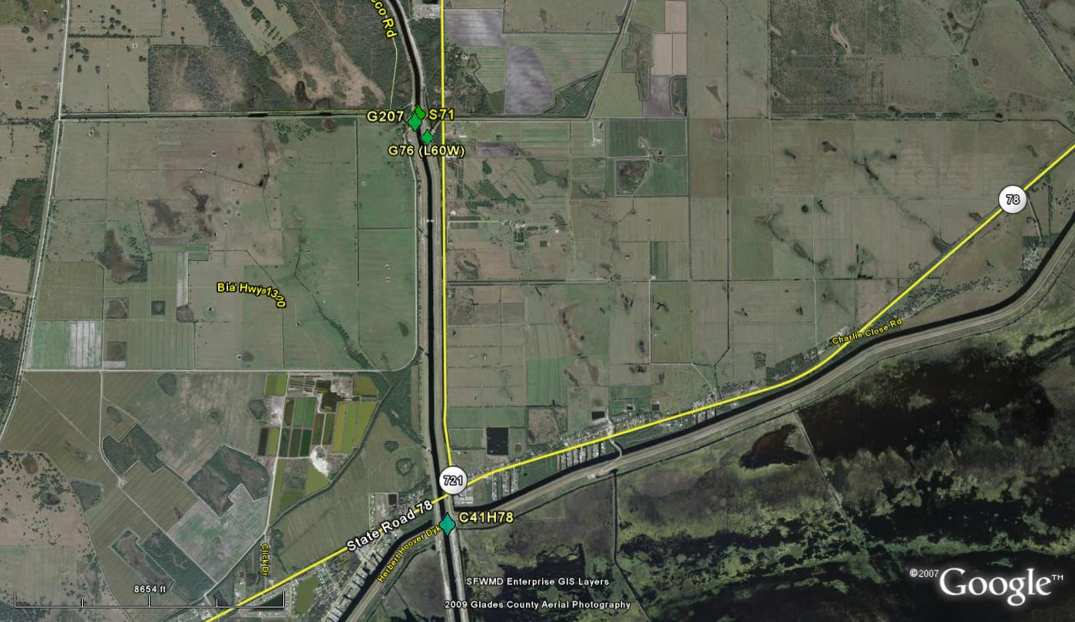

Figure 1. Lower C-41 Canal and contributing basins and flow measurement sites.

# Method

The initial method for calculating total phosphorus (TP) loads at the C41H78 site before WY2017 used both the autosampler water quality (WQ) and flow measurement data. Currently, WQ grab samples collected at C41H78 (as required by the most recent update of the permit, 0174552-011) are used for TP load calculation instead of autosampler WQ. Only positive daily flow measurements were included to represent inflows to Lake Okeechobee. Flow and TP load estimates are summed by month to reduce noise. S71 and L60W flows and TP loads are summed and G207 (which removes water from the canal through a pump) is subtracted from this sum to represent the upper basin inflow. This upper basin flow is subtracted from C41H78 flow measurements to estimate total flow and TP load from the L-61E basins (**Figure 2**). These values are summed by water year (WY) and included in the annual SFER in Volume I Chapter 8 (Zhang et al. 2020) and in Volume III Appendix 4-1 (Annual Permit Report for Lake Okeechobee Water Control Structures Operation; [Jones 2019](#_ENREF_4)).

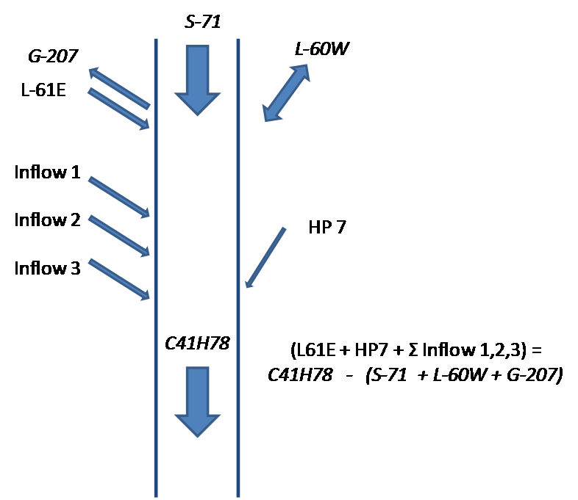

$$(L61E+HP7+∑Inflow 1,2,3)=C41H78-(S71+L60W-G207)$$

Figure 2. Schematic of the C-41 canal inflows and outflows. The smaller ungauged flows and loads (L‑61E, HP-7, Inflow 1, 2, and 3) are estimated as the difference of the downstream C41H78 minus the upstream flows: S-71, L-60W, and G‑207.\*  
(\* G‑207 flow is either negative (out of the canal) or zero.)

# Results

The method described above was used to calculate flows for water years 2009 to 2016 using measurements (from gauge sites S71, G76, G207, and C41H78) stored in the SFWMD DBHydro database (**Table 1**). On average, estimates of L-61E basin flows and TP loads during this period accounted for 16 percent of the total discharge and 8 percent of the TP load from the C41 canal (**Figure 3**). The reported total flows and loads to Lake Okeechobee from WY2009 to WY2019 averaged 2.39 million acre-feet and 537 metric tons of phosphorus (Zhang et al. 2020). The estimated flows and loads from the L61E basins represented 1.25% and 0.8% of this total flow and load to the lake, respectively.

Several problems arose with the L61E basins estimates, primarily attributed to flow measurements at C41H78 ([James 2011](#_ENREF_1), [James and Sharfstein 2012](#_ENREF_2), [2015](#_ENREF_3), [2016](#_ENREF_4)). While the flow measurements at C41H78 were reasonable and reflected the higher flows at S-71 (**Figure 4**), several months had C41H78 flows that were much smaller than the S-71 flows. In addition, when S-71 discharge was below 2,000 acre-feet month‑1 the average flow and load estimates from C41H78 were five times greater than at S-71 (**Figure 5**). This is unlikely during these drier periods because of the much smaller area of the L61E basin (14,407 acres) in comparison to the S-71 basin (112,880 acres).

Table 1. Station name and DBKEY used to estimate the flows at L61E, HP-7 and Inflow 1, 2, and 3.

|  |  |  |
| --- | --- | --- |
| **Station Name** | **DBKEY** | **Data Type\*** |
| S71 | 15633 | PREF |
| L60W (G76) | 87645 | TELE |
| G207 | 87641 | TELE |
| C41H78 | VM765 | CR10 |

\* Data types are PREF - Preferred, TELE - Telemetry (Radio Network), CR10 - Campbell Scientific Inc. Measurement and Control Module.

Figure 3. Water Year measurements at S71, L60W, and estimates for small basins (L61E, HP-7, Inflow 1, 2, and 3. A) Flow; B) Phosphorus load (values are percent of total for the given year).

Figure 4. Monthly flow estimates for S71 and C41H78 from WY2009 to WY2019

Figure 5. Comparison of S71 and C41H78 average measurements for months when flow   
volume from S-71 was 2,000 acre-feet per month or less.\* A) Flow volume; B) TP load.  
(\* From WY2009 to WY2016, S-71 discharge volume was less than or equal to   
2,000 acre‑feet for 36 of the 98 months.)

As described by James and Sharfstein (2015), one possible explanation for higher flow estimates at C41H78 during drier periods could be that it is caused by backflow into the canal from the lake due to wind that creates eddies in the canal, which are not measured by the Doppler meters. Stream surveys during periods of no discharge from S71 support this potential explanation (**Figure 6**). Furthermore, this effect resulted in inaccuracies in the autosampler WQ collection. Therefore, the autosampler WQ method was replaced by the grab method.

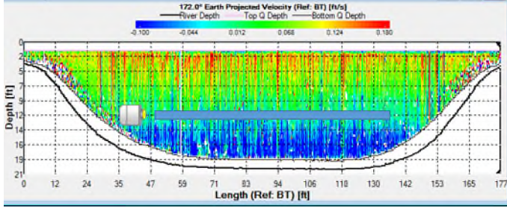

Figure 6. Density plot of the streamwise velocity of one of the transects from an ADCP measurement at C41H78 made to develop the IV rating. Note that the flow was bidirectional (top and bottom portions of the cross-section flowing in opposite direction) and that, at the area where the Doppler IV meter samples (blue-grey window), the ADCP shows a net positive flow. Estimating the flow discharge based on IV data using the rating developed for unidirectional flow (towards the lake) when the mean flow is bidirectional will yield biased flow estimates.

Using these C41H78 flow measurements to calculate the L61E basin discharges by the equation in **Figure 2**, the accuracy can be assessed by comparing rainfall (from the Okeechobee rainfall basin NEXRAD data, SFWMD [2016](#_ENREF_6)) to runoff (based on the area of the L61E basin [14,407 acres],  [Zhang et al. 2016](#_ENREF_5)). These comparisons can be further evaluated through a comparison of rainfall and runoff in the smaller adjoining basin L60W (3,453 acres,  [Zhang et al. 2016](#_ENREF_5)). The rainfall runoff relationship for L61E basins is negative while the relationship for the L60W basin is positive (**Figure 7**). This lack of a relationship as compared to the positive relationship for L60W demonstrates that the L61E flow calculation is poor. Also, the values for the L61E basins range from 12 to 34 inches of runoff as compared to 7 to 15 inches from the L60W basin.

Additional problems with the load and flow estimates for the L61E basins were observed in the monthly data calculations for WY2009 to WY2016 which showed 9 months of flow without TP load and another nine months of TP load without flow. (**Table 2**).

Figure 7. Water year rainfall (from NEXRAD for the Okeechobee Rainfall Basin, [SFWMD 2016](#_ENREF_6)) compared to runoff for A) L61E basins, and B) L60W basin.

Table 2. Monthly estimated L-61 basin flows and loads from WY2009 to WY2016  
that indicate either flow and no load or load and no flow.

|  |  |  |  |  |  |  |  |  |  |  |
| --- | --- | --- | --- | --- | --- | --- | --- | --- | --- | --- |
| **Date** | **Flow (acre-feet month-1)** | | | | | **TP Load (kg month-1)** | | | | |
| **S-71** | **L-60W** | **G-207** | **C41H78** | **L-61 Sub-Watersheds** | **S-71** | **L-60W** | **G-207** | **C41H78** | **L-61 Sub-Watersheds** |
| May-2009 | 8,759 | 269 | 2,076 | 10,752 | 3,801 | 2,913 | 62 | 182 | 2,762 | 0 |
| Aug-2010 | 14,931 | 236 | 0 | 17,120 | 1,952 | 5,104 | 36 | 0 | 4,658 | 0 |
| Aug-2011 | 11,020 | 104 | 0 | 11,520 | 396 | 2,652 | 25 | 0 | 2,444 | 0 |
| Jun-2012 | 16,791 | 329 | 12 | 17,567 | 460 | 5,413 | 33 | 2 | 138 | 0 |
| Nov-2012 | 1,050 | 9 | 12 | 67 | 0 | 105 | 1 | 2 | 1,126 | 1,022 |
| Apr-2013 | 1,850 | 447 | 17 | 5,879 | 3,599 | 170 | 59 | 3 | 179 | 0 |
| Jun-2013 | 36,271 | 392 | 13 | 38,851 | 2,202 | 17,341 | 37 | 2 | 0 | 0 |
| Jul-2013 | 72,117 | 1,336 | 0 | 78,016 | 4,563 | 27,287 | 219 | 0 | 0 | 0 |
| Aug-2013 | 30,541 | 458 | 14 | 32,323 | 1,338 | 9,437 | 106 | 2 | 298 | 0 |
| Nov-2014 | 5,544 | 18 | 14 | 4,217 | 0 | 834 | 3 | 2 | 933 | 97 |
| Feb-2015 | 3,319 | 74 | 13 | 3,056 | 0 | 546 | 13 | 2 | 646 | 90 |
| Apr-2015 | 4,574 | 210 | 13 | 735 | 0 | 885 | 26 | 2 | 1,114 | 205 |
| Jun-2015 | 4,494 | 290 | 15 | 644 | 0 | 876 | 38 | 2 | 1,439 | 527 |
| Jul-2015 | 3,852 | 466 | 0 | 183 | 0 | 1,107 | 58 | 0 | 2,557 | 1,393 |
| Oct-2015 | 3,912 | 28 | 13 | 6,222 | 2,296 | 1,044 | 4 | 2 | 585 | 0 |
| Dec-2015 | 19,646 | 160 | 7 | 300 | 0 | 7,235 | 27 | 1 | 8,328 | 1,067 |
| Feb-2016 | 18,077 | 601 | 17 | 744 | 0 | 4,180 | 111 | 3 | 5,159 | 872 |
| Mar-2016 | 7,971 | 75 | 11 | 2,312 | 0 | 1,610 | 13 | 2 | 2,428 | 807 |

# Conclusion and Recommendation

These results demonstrate that flow estimates for the L61E basins are highly uncertain. This can be attributed to the large cross-sectional area of the C-41 canal at the C41H78 site and the smaller window of velocity that is measured by the Doppler meters. In addition, it has been challenging to estimate the flow from the L61E basins from the much larger flows from the C41 canal at C41H78 and S71.

Because the flow and associated TP load estimates for the L61E basins are uncertain but are considerably small in comparison to the total flows and TP loads to Lake Okeechobee, SFWMD recommends the following changes:

1. Discontinue measurements of flow at C41H78; this change was implemented in January 2019.
2. Continue sampling of TP and TN at C41H78 using grab samples collected “biweekly” instead of “biweekly with flow otherwise monthly” as indicated in the most recent Lake Okeechobee Operating Permit (0174552‑011). This will also maximize the number of samples collected at C41H78 to provide a more accurate load estimate.
3. Determine loads at C41H78 using the monthly average of the biweekly/otherwise monthly grab water quality samples and the total monthly flow volume from S71 and L60W (minus G207).
4. If the monthly load at C41H78 is greater than the combined monthly load at S71+L60W-G207, then the difference between these two values is considered the monthly load from the L61E basins.

The current method of estimating loads using flows measured at C41H78 was prone to overestimation under low flow conditions due to sensor errors. The proposed method relies on structure flow gauges which are inherently more accurate than the doppler sensors. While the risks of over- and underestimation due to extreme high/low flows remains, these risks are reduced under the proposed method by using more consistent and reliable flow measurements. Load estimates using the proposed method are approximately half of those calculated with the previous method (**Figure 8**),

Figure 8. Current and proposed estimates of TP loads from the L61E basins

# References

James R.T. 2011. Appendix 4-1: Annual Permit Report for Lake Okeechobee Water Control Structures Operation. In: *2011 South Florida Environmental Report – Volume III*, South Florida Water Management District, West Palm Beach, FL.

James R.T., and B. Sharfstein. 2012. Appendix 4-1: Annual Permit Report for Lake Okeechobee Water Control Structures Operation. In: *2012 South Florida Environmental Report – Volume III*, South Florida Water Management District, West Palm Beach, FL.

James R.T., and B. Sharfstein. 2015. Appendix 4-1: Annual Permit Report for Lake Okeechobee Water Control Structures Operation. In: *2015 South Florida Environmental Report – Volume III*, South Florida Water Management District, West Palm Beach, FL.

James R.T., and B. Sharfstein. 2016. Appendix 4-1: Annual Permit Report for Lake Okeechobee Water Control Structures Operation. In: *2016 South Florida Environmental Report – Volume III*, South Florida Water Management District, West Palm Beach, FL.

Jones P. 2019. Appendix 4-1: Annual Permit Report for Lake Okeechobee Water Control Structures Operation. In: *2019 South Florida Environmental Report – Volume III*, South Florida Water Management District, West Palm Beach, FL.

SFWMD. 2016. NEXRAD-ET. <https://apps.sfwmd.gov/nexrad2/>. Accessed September 24, 2016.

Zhang, J., B. Sharfstein, and L. Bertolotti. 2016. Chapter 8: Lake Okeechobee Watershed Protection Program Annual Update. In: *2016 South Florida Environmental Report – Volume I*, South Florida Water Management District, West Palm Beach, FL.

Zhang, J., Z. Welch, and P. Jones. 2020. Chapter 8B: Lake Okeechobee Watershed Annual Report. In: *2020 South Florida Environmental Report – Volume I*, South Florida Water Management District, West Palm Beach, FL.