CS 255 System Design Document
DriverPass Project
Patrick Byrne

UML Diagrams

UML Use Case Diagram
The use case diagram below captures the major DriverPass use cases inside the system boundary along with the actors that interact with them. Three internal user types sit on the left (Customer, Secretary, Driver) and four sit on the right (IT Officer, Owner, DMV, Payment Processor). The Owner generalizes from the IT Officer because the Owner has every IT Officer permission plus additional reporting access. The DMV and Payment Processor are external systems, not people. The diagram covers all the major functionality requested in the interview, including account management, reservations, practice tests, package management, audit reporting, and the DMV content integration. An <<include>> relationship connects Make Reservation to Process Payment, reflecting that a reservation always triggers payment processing.
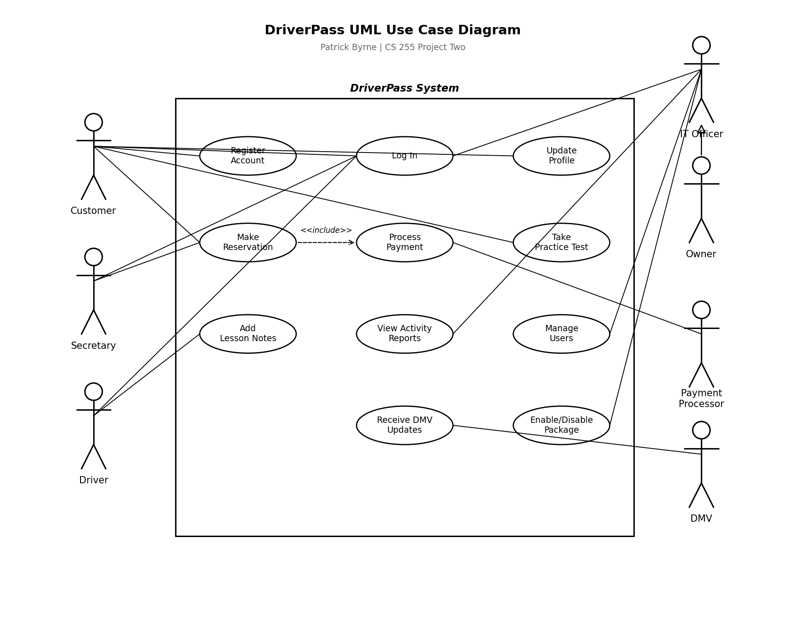
Figure 1. UML Use Case Diagram for the DriverPass System.

UML Activity Diagrams
Two use cases from the use case diagram were selected for detailed activity-level modeling: Make Reservation and Take Practice Test. Both are core to the DriverPass customer experience and both involve enough decision logic to make the activity diagram a useful design tool.
Activity Diagram 1: Make Reservation
This diagram walks through the full reservation flow from login to confirmation. The customer logs in, the system validates their credentials, and then they select a package and view available drivers, cars, and times. They pick a specific date, time, pickup, and drop-off. If the slot is no longer available, the flow loops back so they can select a different time. Once confirmed, the system processes payment through the payment processor. A successful payment triggers the reservation save and confirmation email; a failed payment routes to an error end state.
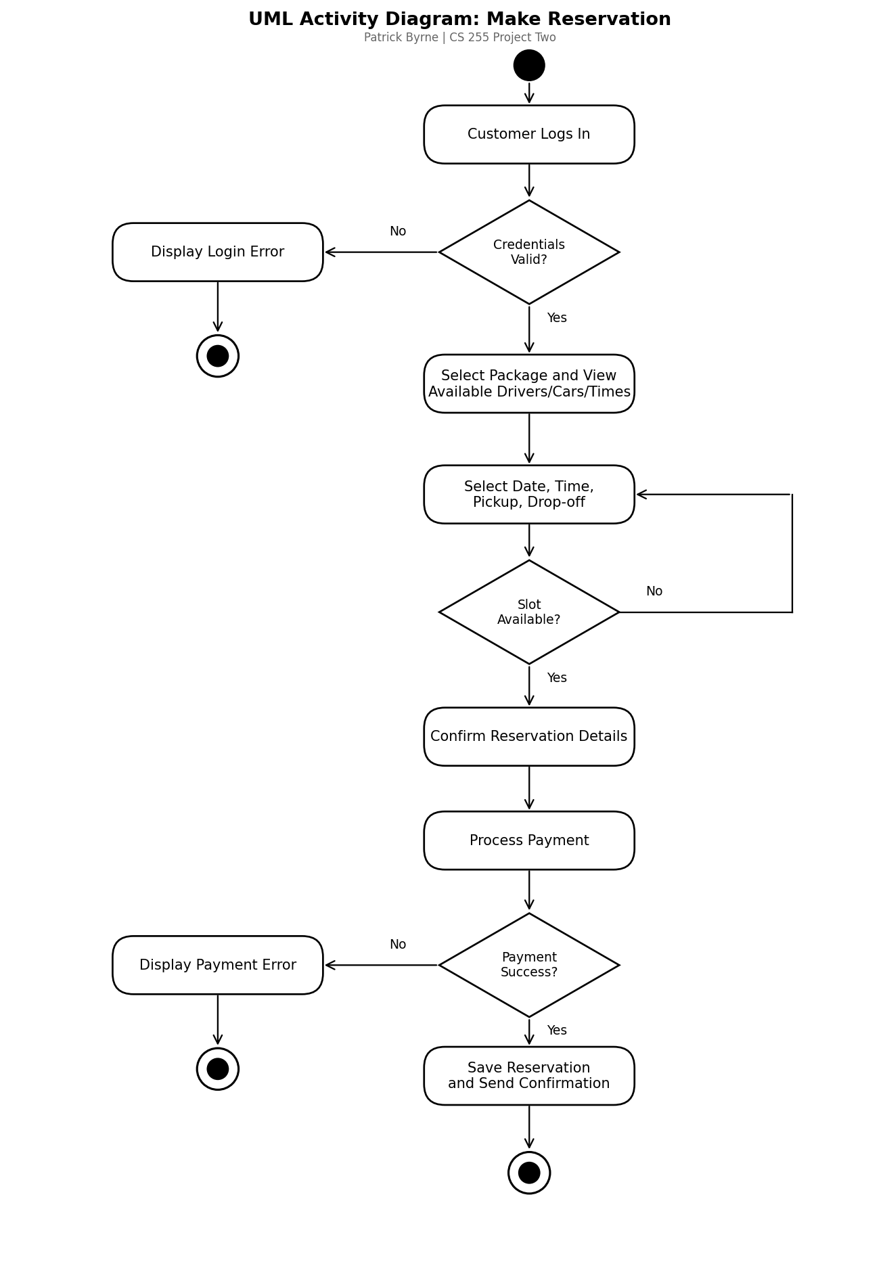
Figure 2. UML Activity Diagram for the Make Reservation use case.
Activity Diagram 2: Take Practice Test
This diagram covers the online practice test flow. After login, the customer picks a practice test, the system loads questions and starts a timer, and the customer answers questions one at a time. The decision at Test Complete or Time Up? catches both the natural completion path and the timer-expiry path; either way, the test gets submitted, scored, and saved with a pass or fail status, and the score is displayed to the customer.
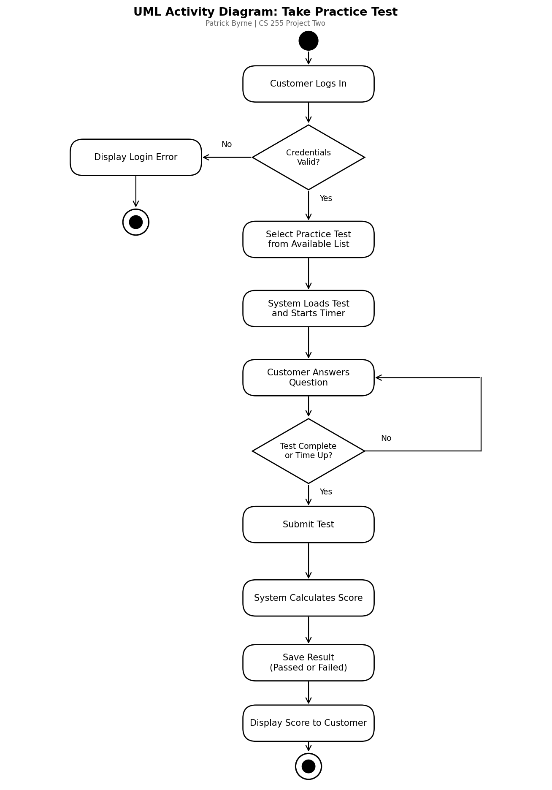
Figure 3. UML Activity Diagram for the Take Practice Test use case.

UML Sequence Diagram
The sequence diagram below shows the Make Reservation use case from the message-passing point of view. Four participants are involved: the Customer (the actor placing the reservation), the Web Portal (the customer-facing front end), the Database (where reservations, users, and availability live), and the Payment Processor (the external service that handles credit card transactions). Numbered messages run top to bottom, showing the exact order of interactions from login through final confirmation. Synchronous calls are drawn as solid arrows and return messages as dashed arrows, following standard UML convention.
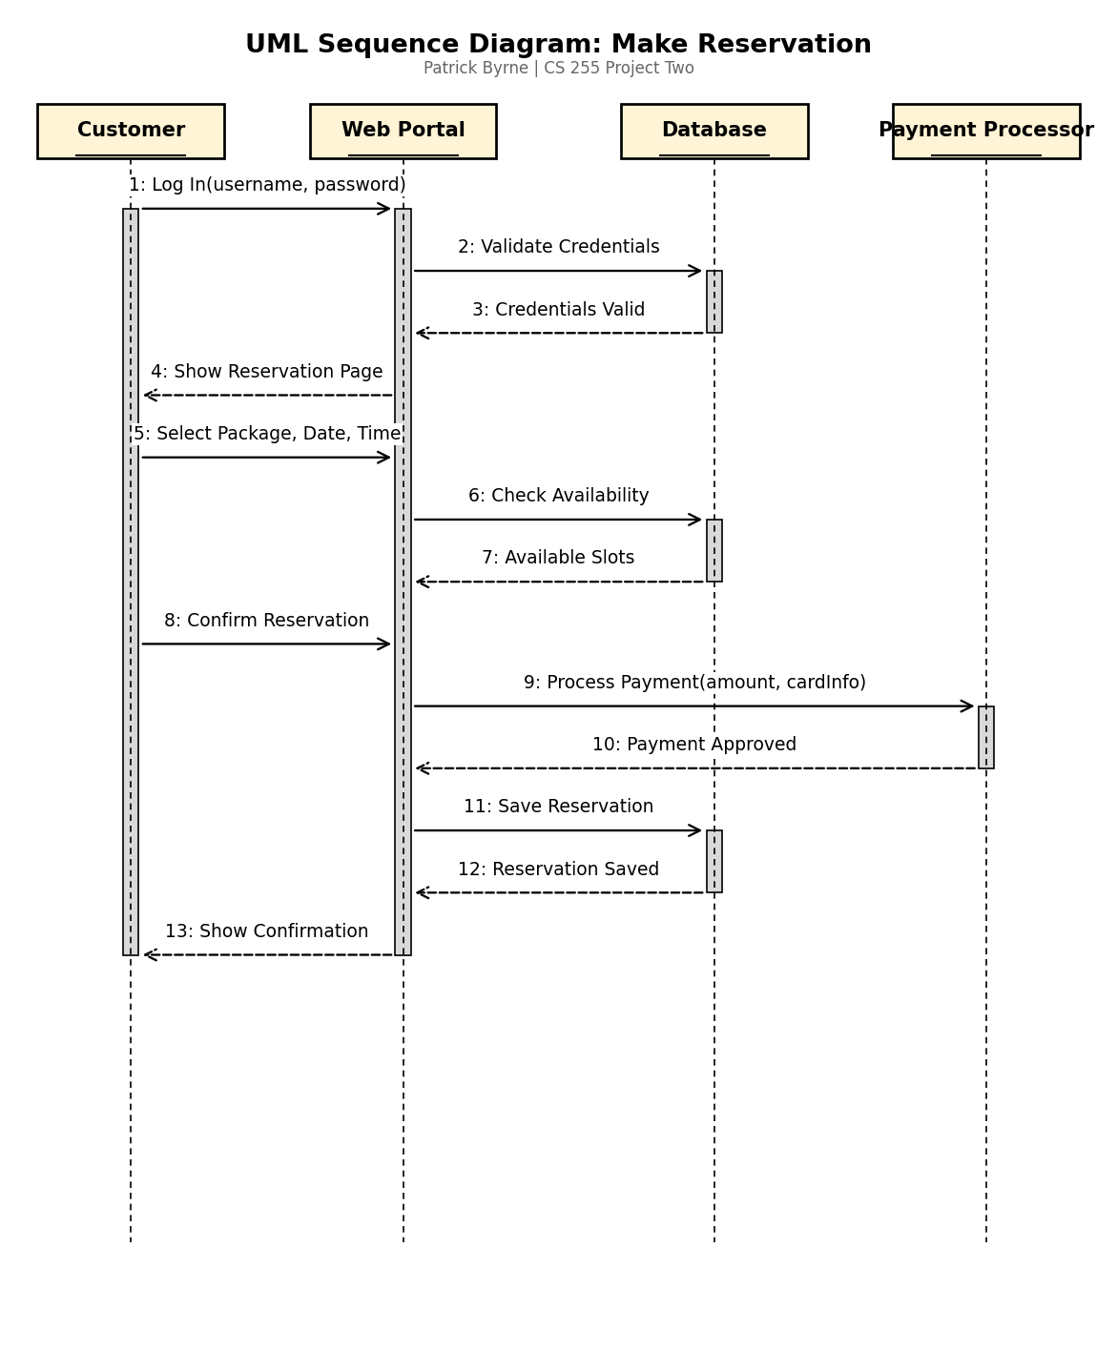
Figure 4. UML Sequence Diagram for the Make Reservation use case.

UML Class Diagram
The class diagram below captures the major classes needed for the DriverPass system, their attributes, and the relationships between them. A User parent class holds the attributes and behaviors shared across every account in the system (userId, username, password, email, phone, plus login, logout, and resetPassword methods). Three subclasses inherit from User: Customer (for end users of the platform), Driver (for the trainers), and Staff (a single class covering Secretary, IT Officer, and Owner roles, distinguished by a role attribute and permission set). The remaining classes capture the core business entities: Reservation, DrivingPackage, PracticeTest, and TestResult. Multiplicities are shown on each association: a Customer makes 0..* Reservations, a Driver is assigned to 0..* Reservations, each Reservation uses exactly 1 DrivingPackage, each Customer has 0..* TestResults, and each PracticeTest produces 0..* TestResults.
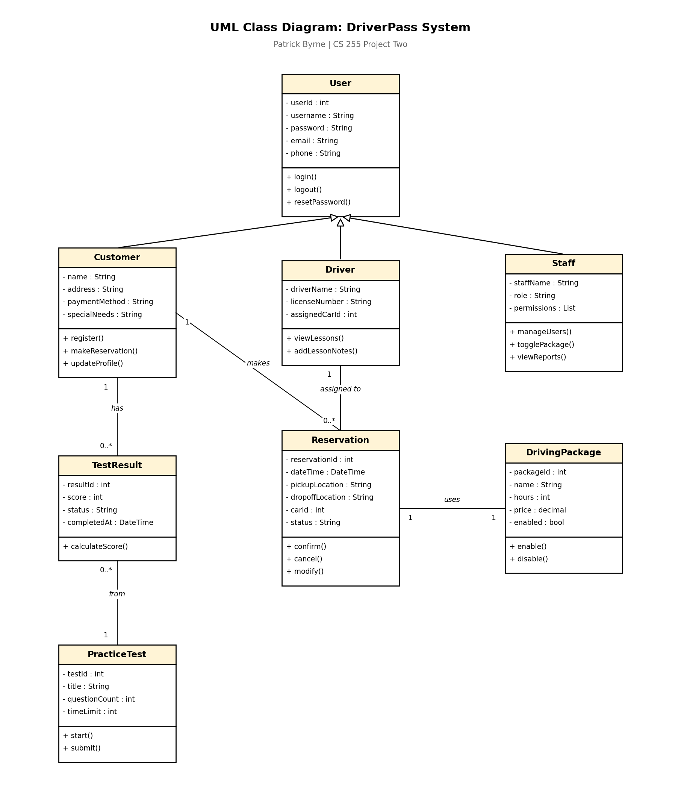
Figure 5. UML Class Diagram for the DriverPass System.

Technical Requirements
Based on the diagrams above and the nonfunctional requirements captured in the Project One business requirements document, the DriverPass system needs the following hardware, software, tools, and infrastructure to operate as designed.
Hardware
Client devices: any modern desktop, laptop, tablet, or smartphone with a working internet connection. Customers, drivers, and staff all reach the system through a web browser, so no DriverPass-issued hardware is required at the customer level. Server hardware is not owned by DriverPass directly. Per Ian's request in the interview, all backend compute and storage is provisioned through a major cloud provider so DriverPass does not have to manage physical machines, backups, or on-site security.
Software
On the backend, a server-side web framework such as Node.js with Express, Python with Django or Flask, or Java with Spring Boot. The choice depends on team familiarity, but the framework must support RESTful APIs, role-based authorization middleware, and TLS-encrypted endpoints out of the box. On the frontend, HTML5, CSS3, and JavaScript with a modern responsive framework like React, Vue, or Angular so the same code base works on desktop, tablet, and mobile browsers. A relational database such as PostgreSQL or MySQL holds all persistent data including user accounts, reservations, drivers, cars, packages, photos, test results, lesson notes, and the audit log. The server-side operating system is Linux, either Ubuntu LTS or Red Hat Enterprise Linux, both of which are standard images on every major cloud provider. Browser support targets current versions of Chrome, Firefox, Safari, and Edge.
Tools
A cloud platform (AWS, Azure, or Google Cloud) provides the compute, storage, and managed database services. A PCI-compliant third-party payment processor like Stripe or Square handles credit card transactions, which means raw card numbers never touch the DriverPass database and the security burden of payment data is moved off DriverPass's plate. A custom API client integrates with the DMV's published feed to pull rule changes, policy updates, and practice questions on the schedule the DMV publishes them. Monitoring and logging tools such as CloudWatch, Datadog, or New Relic track system health, error rates, and audit log queries. Version control is Git, hosted in GitHub or GitLab, so the development team can collaborate and roll back when needed.
Infrastructure
The hosting environment is fully cloud-based with auto-scaling configured so the system can absorb peak booking periods without manual intervention. All client-server traffic runs over HTTPS with TLS encryption to protect credentials, personal information, and payment data in transit. A content delivery network such as CloudFront or Cloudflare caches static assets close to customers across the country to keep page loads fast. Database backups run daily with point-in-time recovery, and cross-region replication provides a disaster recovery option in case an entire region goes down. Authentication is role-based across the five user types (Customer, Secretary, Driver, IT Officer, Owner), with session timeouts, automatic password reset via verified email, and account lockout after a configured number of failed login attempts to block brute-force attacks. The IT Officer can revoke access for any user immediately through the admin interface, which covers the offboarding requirement Ian called out in the interview.

