Business Requirements Document
DriverPass Project
Patrick Byrne

System Components and Design

Purpose
What is the purpose of this project? Who is the client and what do they want their system to be able to do?
- The client is DriverPass, a new driver training company started by Liam, the owner. They want a system that handles online practice tests, online classes, and scheduling for on-the-road driving lessons.
- Our consulting company has been hired to build that system so DriverPass can run all three of those services from one platform instead of bolting separate tools together.
- The system needs to support multiple types of users including the owner, IT officer, secretary, drivers, and customers, each with their own level of access.
- The end goal is to help DriverPass customers pass their DMV driving tests by giving them better study tools, practice tests, and real on-the-road experience with a trainer.

System Background
What does DriverPass want the system to do? What is the problem they want to fix? What are the different components needed for this system?
- Liam started DriverPass because he sees a clear gap in the market. Too many people fail their DMV driving tests, and there is no real one-stop shop that combines study material, practice exams, and actual driving lessons.
- The solution DriverPass wants to offer is a web and cloud-based system that brings online learning, practice tests, and bookable in-car lessons into a single platform customers can access from any computer or mobile device.
- The system will support three packages. Package 1 is six hours in a car with a trainer. Package 2 is eight hours plus an in-person DMV rules lesson. Package 3 is twelve hours plus the in-person lesson plus access to the online class with practice tests.
- Reservations can be made online through the customer's account, by phone with the secretary, or in person at the office. Each lesson is two hours long and gets matched to a specific driver and car.
- The system has to connect to the DMV so rule changes, policy updates, and new sample questions flow into the platform automatically with notifications when content changes.
- Major components needed include a customer-facing web portal, an internal admin and secretary view, a reservation engine that ties customer to driver, car, time, and pickup location, a credit card intake flow, an audit log that tracks who created or modified records, and a DMV integration for content updates.
- Hosting will be cloud-based so DriverPass does not have to manage backups or security in-house and can keep their focus on running the business.
- The interface mockup Liam provided includes specific customer-facing elements: online test progress, a student information form, a special needs section, driver notes with lesson times and comments, photos of both the driver and the student, and a way to contact DriverPass staff or the student.

Objectives and Goals
What should this system be able to do when it is completed? What measurable tasks need to be included in the system design to achieve this?
- The system shall allow customers to register an account and store their personal info including first name, last name, address, phone number, state, and credit card details.
- The system shall allow customers, the secretary, and Liam to create, modify, and cancel reservations for two-hour driving lessons.
- The system shall let customers select between three driving packages and shall block registration for any package the owner has chosen to disable.
- The system shall allow the IT officer to enable or disable any package without requiring a code change.
- The system shall match each reservation to a specific driver, car, date, time, pickup location, and drop-off location.
- The system shall enforce role-based access for the owner, IT officer, secretary, drivers, and customers, with different permissions for each role.
- The system shall log every change to a record, including creation, modification, and cancellation, along with the user responsible, and shall produce a printable activity report on demand.
- The system shall provide online practice tests and shall display each test with the test name, time taken, score, and status (not taken, in progress, failed, or passed).
- The system shall display driver notes and lesson times to the customer, including start hour, end hour, and any comments left by the driver.
- The system shall allow customers and admins to reset forgotten passwords automatically.
- The system shall connect to the DMV's content feed to receive updated rules, policies, and sample questions, and shall send a notification when an update has been pushed.
- The system shall be accessible from any computer or mobile device through a standard web browser, with the back end hosted in the cloud.
- The system shall allow users to download reports and selected data for offline review in tools like Excel, while keeping write access disabled offline to prevent data redundancy.
- The system shall capture and display each customer's special needs or accommodation requirements as part of their profile and reservation details.
- The system shall store and display photos of the assigned driver and the student on the reservation page so each party can identify the other before the lesson.
- The system shall include a contact page that allows customers to reach DriverPass staff with questions or issues.
- The system shall provide a way for DriverPass staff to contact the student through the platform.

Requirements

Nonfunctional Requirements
In this section, you will detail the different nonfunctional requirements for the DriverPass system. You will need to think about the different things that the system needs to function properly.

Performance Requirements
What environments (web-based, application, etc.) does this system need to run in? How fast should the system run? How often should the system be updated?
- The system must be web-based and accessible from any computer or mobile device through a standard browser.
- Page load and response times must be fast enough to support live booking, account lookup, and practice tests without noticeable delay.
- The system must be available continuously since customers can book lessons or take practice tests outside of business hours.
- DMV content updates must flow into the system as soon as the DMV pushes them, with a notification triggered to relevant users when new content has arrived.
- Backend hosting must support automatic backups, scaling, and security patching without requiring DriverPass to manage infrastructure.
- Routine software updates to the platform should be scheduled outside peak booking hours to minimize customer impact.

Platform Constraints
What platforms (Windows, Unix, etc.) should the system run on? Does the back end require any tools, such as a database, to support this application?
- The system is cloud-hosted. Ian specifically requested this so DriverPass does not have to handle backups, security, or hardware in-house.
- The front end must run in a standard web browser on both desktop and mobile, with no separate native app required for launch.
- A database is required on the back end to store user accounts, reservations, packages, drivers, cars, photos, test results, lesson notes, and audit log entries.
- An integration with the DMV is required to pull rule changes, policy updates, and sample questions into the platform.
- A PCI-compliant credit card payment processor must be integrated to handle customer transactions securely.
- The system must prevent edits while a user is offline so that duplicate or conflicting data does not get written across servers. Offline access is limited to read-only views and downloaded reports.

Accuracy and Precision
How will you distinguish between different users? Is the input case-sensitive? When should the system inform the admin of a problem?
- The system must distinguish between five user roles: owner (Liam), IT officer (Ian), secretary, driver, and customer.
- Each role must have a unique permission set. The IT officer must have full access to all accounts, including the ability to reset passwords and block access for departed employees.
- Each reservation must be linked to a specific customer, driver, car, date, time, pickup location, and drop-off location with no ambiguity.
- Input validation must be applied to all customer-supplied data including credit card number, expiration date, security code, address, phone number, and email.
- Passwords must be treated as case-sensitive and matched exactly against the stored value.
- The system must alert the IT officer or owner when there are repeated failed login attempts, suspected unauthorized access, or other admin-level events.
- Practice test results must be recorded with test name, time taken, score, and accurate status (not taken, in progress, failed, or passed).

Adaptability
Can you make changes to the user (add/remove/modify) without changing code? How will the system adapt to platform updates? What type of access does the IT admin need?
- The IT officer must be able to add, modify, or remove user accounts directly through the admin interface without code changes.
- The IT officer must be able to enable or disable any driving package without requiring a developer.
- Adding entirely new packages or new feature modules may require a developer or systems analyst. This is acceptable for the current scope and may be revisited in a future release.
- The cloud hosting platform must continue to operate normally as the provider pushes operating system and security updates to the back end.
- The DMV integration must absorb DMV content changes automatically as they are pushed, without requiring DriverPass staff to manually update anything.
- The system architecture should allow new user roles or permission tweaks to be added without rewriting the core authorization layer.

Security
What is required for the user to log in? How can you secure the connection or the data exchange between the client and the server? What should happen to the account if there is a “brute force” hacking attempt? What happens if the user forgets their password?
- Users must log in with a unique username and password. Passwords must meet a minimum strength requirement covering length and character variety.
- All communication between client and server must be encrypted using TLS (HTTPS) so credentials, payment data, and personal information cannot be intercepted in transit.
- The system must lock or temporarily disable an account after a defined number of failed login attempts to mitigate brute-force attacks, and must notify the IT officer when a lockout occurs.
- The system must offer an automatic password reset flow, with verification via the email on file, so users can recover access without contacting support.
- Credit card data must be handled in accordance with PCI requirements. The system should not store raw card numbers in its own database when a compliant payment processor can be used.
- All record creations, modifications, and cancellations must be logged with the responsible user, timestamp, and the affected record. The audit log must be available as a printable activity report.
- The IT officer must be able to immediately revoke access for any user, particularly when an employee leaves the company.
- Session timeouts must be enforced so an idle session does not remain authenticated indefinitely on an unattended browser.

Functional Requirements
Using the information from the scenario, think about the different functions the system needs to provide. Each of your bullets should start with “The system shall . . .” For example, one functional requirement might be, “The system shall validate user credentials when logging in.”
- The system shall validate user credentials at login and apply role-based permissions for the rest of the session.
- The system shall allow new customers to register an account with their first name, last name, address, city, state, zip code, phone number, email, and credit card details.
- The system shall allow customers to make, modify, and cancel reservations online from their account.
- The system shall allow the secretary to make, modify, and cancel reservations on behalf of customers who call or visit the office.
- The system shall match each reservation to a specific driver, car, date, time, pickup location, and drop-off location.
- The system shall present three driving packages (Package 1, Package 2, and Package 3) with their respective features and prices.
- The system shall allow Liam to disable any package so new customers cannot register for it, while preserving any existing customer enrollments.
- The system shall log every record creation, modification, and cancellation with the responsible user and a timestamp, and shall produce a printable activity report on demand.
- The system shall provide online practice tests and display each test with name, time taken, score, and status (not taken, in progress, failed, or passed).
- The system shall display a driver notes section showing Lesson Time, Start Hour, End Hour, and Driver Comments for each lesson.
- The system shall receive content updates from the DMV and notify users when new rules, policies, or practice questions have been pushed.
- The system shall allow users to reset forgotten passwords automatically through a verified email flow.
- The system shall provide a contact page so customers can reach DriverPass staff with questions or issues.
- The system shall allow DriverPass staff to contact customers through the platform.
- The system shall allow customers and admins to download reports and selected data for offline review while keeping write access disabled offline.
- The system shall store photos of the assigned driver and the student so each party can identify the other before the lesson.
- The system shall capture and display each customer's special needs or accommodation requirements as part of their profile and reservation details.
- The system shall process credit card transactions through an integrated payment processor at the time of registration or package purchase.

User Interface
What are the needs of the interface? Who are the different users for this interface? What will each user need to be able to do through the interface? How will the user interact with the interface (mobile, browser, etc.)?
- The interface must run in a standard web browser on both desktop and mobile, with no separate native app required at launch.
- Five distinct user views are needed: customer, secretary, IT officer, driver, and owner. Each view exposes only the actions appropriate to that role.
- The customer view must follow the wireframe Liam provided, including a header with the DriverPass logo, an online test progress panel, a student information form, a special needs section, a driver notes panel, photos of both the assigned driver and the student, and a contact page.
- The customer information form must accept first name, last name, address, city, state, zip code, phone number, email, and other relevant contact details.
- The driver notes panel must display, at minimum, Lesson Time, Start Hour, End Hour, and Driver Comments for each lesson.
- The online test progress panel must show test name, time taken, score, and status (not taken, in progress, failed, or passed).
- The secretary view must support making, modifying, and cancelling reservations on behalf of customers, along with looking up customer accounts.
- The IT officer view must support account management, package enable/disable controls, password resets for other users, and access to the printable activity report.
- The owner view must include all of the above plus access to financial and operational reports.
- The driver view must show upcoming lessons assigned to that driver, including customer information, pickup and drop-off locations, the car assigned, and any special needs flagged on the reservation.
- All forms must validate input and display clear error messages for missing or malformed data.
- The interface must be responsive so it works on common screen sizes including phones, tablets, laptops, and desktops.

Assumptions
What things were not specifically addressed in your design above? What assumptions are you making in your design about the users or the technology they have?
- Customers, drivers, and staff have a working internet connection and a device with a modern web browser.
- The DMV publishes a content feed or API that DriverPass can integrate with for rule, policy, and practice question updates.
- A list of approved drivers and cars is maintained inside the system so reservations can be matched against real available resources.
- DriverPass contracts with a cloud hosting provider that handles infrastructure backups, security patching, and uptime guarantees.
- DriverPass uses a PCI-compliant payment processor so the system itself does not store raw credit card numbers.
- Customers provide valid contact information and a working credit card at the time of registration.
- Customers are able to read and follow the UI in English. Multilingual support is not in scope for the initial release.
- Staff users (secretary, IT officer, drivers, owner) receive their accounts through internal provisioning rather than self-registration.

Limitations
Any system you build will naturally have limitations. What limitations do you see in your system design? What limitations do you have as far as resources, time, budget, or technology?
- The system cannot be used to edit or modify data while offline. This is intentional to prevent data redundancy across servers, but it does mean staff cannot make changes from a location without internet access.
- New driving packages or new feature modules cannot be created by end users. Adding new modules requires a developer or systems analyst, which means a release cycle rather than a same-day change.
- Future features such as advanced analytics dashboards, dedicated mobile apps, or additional third-party integrations are out of scope for the initial release and may be revisited later.
- DriverPass's content depth is bound to whatever the DMV makes available through their feed. If the DMV does not publish a particular rule update, DriverPass cannot expose it either.
- System availability is dependent on the cloud hosting provider. An outage on the provider's side will result in a DriverPass outage.
- The current project does not include a separate public marketing site. Marketing pages and SEO are considered out of scope for this release.
- Project timeline and budget are bounded by the schedule laid out in the Gantt chart. Significant scope additions during the build will impact the May delivery date.

Gantt Chart
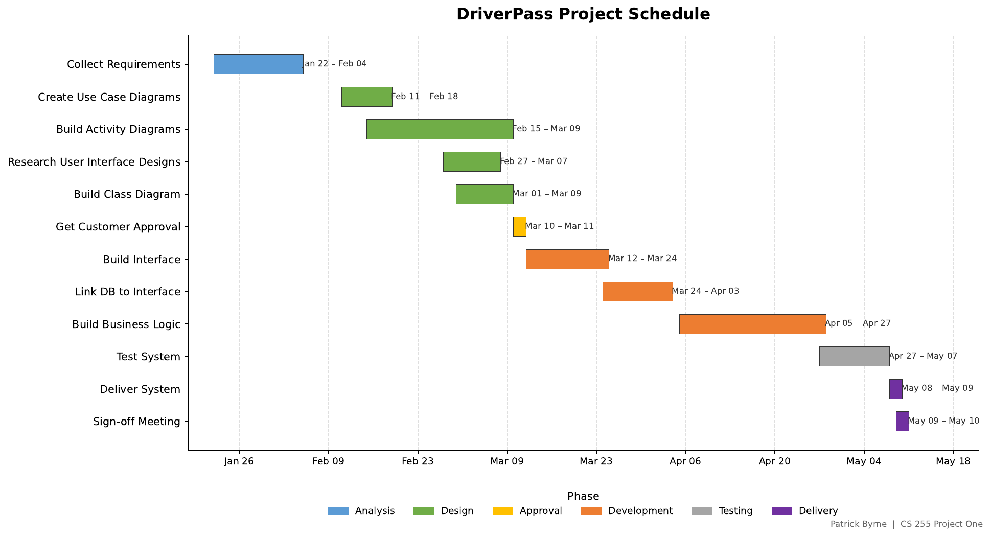
Figure 1. DriverPass Project Schedule (built in Python with matplotlib).

