Recorded at Request of and   
After Recording Return to:

Eric Linger  
Shadows at Swan Lake Homeowners Association  
23705 NE 61st Street  
Redmond, WA 98053

DECLARATION AND COVENANTS, CONDITIONS, RESTRICTIONS, EASEMENTS AND RESERVATIONS FOR SHADOWS AT SWAN LAKE

Table of Contents

Declaration And Covenants, Conditions, Restrictions, Easements And Reservations For Shadows At Swan Lake 5

Recitals 5

Article 1. Definitions 6

Section 1.1 Words Defined. 6

1.1.1 “Association” 6

1.1.2 “Board” 6

1.1.3 “Construction” and “Constructed” 6

1.1.4 “Declarant” 6

1.1.5 “Declaration” 7

1.1.6 “First Mortgage” and “First Mortgagee” 7

1.1.7 “Lot” 7

1.1.8 “Mortgage” 7

1.1.9 “Mortgagee” 7

1.1.10 “Owner” 7

1.1.11 “Participating Builder” 7

1.1.12 “Person” 7

1.1.13 “Plat” 7

1.1.14 “Property” 8

1.1.15 “Restrictive Areas” 8

1.1.16. “Structure” 8

1.1.17 “Transition Date” 8

Section 1.2 Form of Words. 8

Section 1.3 Exhibits. 8

Article 2. Easements. 8

Section 2.1 Easements for Utilities. 8

Section 2.2 Storm Detention. 9

Section 2.3 Monuments and Landscaping. 9

Section 2.4 Restrictive Areas. 9

Section 2.5 Limited Access. 9

Section 2.6 Private Storm Drainage Easements. 9

Section 2.7 Common Driveway. 9

Section 2.8 Public Roadway Easement. 10

Section 2.9 Temporary Turnaround Easement. 10

Section 2.10 King County Easements - Cuts and Fills. 10

Section 2.11 Conditions for Grant of Easements. 10

Article 3. Construction On Lots And Use Of Lots. 10

Section 3.1 Uniformity of Use and Appearance. 10

Section 3.2 Submission and Approval of Plans 11

3.2.1 Construction. 11

3.2.2 Submission. 11

3.2.3 Approval. 11

Section 3.3 Size and Height. 11

3.3.1 Floor Area. 11

3.3.2 Lot Size. 12

3.3.3 Local Codes. 12

Section 3.4 Appearance. 12

3.4.1 Roofing. 12

3.4.2 Siding. 13

3.4.3 Entry Porches Walks, and Decks. 13

3.4.4 Driveways. 13

3.4.5 Window Coverings. 13

Section 3.5 Use Restrictions. 13

3.5.1 Residential Use. 13

3.5.2 Maintenance of Buildings and Lots. 13

3.5.3 Maintenance of Landscaping. 13

3.5.4 Completion of Construction. 14

3.5.5 Parking. 14

3.5.6 Signs. 14

3.5.7 Animals. 14

3.5.8 Temporary Structures. 14

3.5.9 Clothes Lines. 15

3.5.10 Woodpiles. 15

3.5.11 Radio and Television Aerials and Satellite Dishes. 15

3.5.12 Trash Containers and Debris. 15

3.5.13 Offensive Activity. 15

3.5.14 Use of Homes. 16

3.5.15 Underground Utilities. 16

3.5.16 Water Supply/Sewage Disposal. 16

3.5.17 Damage. 16

3.5.18 Fences. 16

Article 4. Shadows At Swan Lake Homeowners Association. 16

Section 4.1 Form of Association. 16

Section 4.2 Board of Directors. 17

Section 4.3 Qualification for Membership. 17

Section 4.4 Transfer of Membership. 17

Section 4.5 Number of Votes. 18

Section 4.6 Voting. 18

Section 4.7 Pledged Votes. 18

Section 4.8 Annual and Special Meetings. 18

Section 4.9 Books and Recordings. 19

Section 4.10 Transition Date. 19

Article 5. Notices For All Purposes. 19

Article 6. Authority Of The Board. 20

Section 6.1 Adoption of Rules and Regulations. 20

Section 6.2 Enforcement of Declaration, Etc. 20

Article 7. Budget And Assessment For Common Expenses. 20

Section 7.1 Fiscal Year; Preparation of Budget. 20

Section 7.2 Certificate of Unpaid Assessments. 21

Section 7.3 Annual Assessments. 21

Section 7.4 Special Assessments; Capital Improvements. 21

Article 8. Lien And Collection Of Assessments. 22

Section 8.1 Assessments Are a Lien; Priority. 22

Section 8.2 Lien May Be Foreclosed. 22

Section 8.3 Assessments are Personal Obligations. 22

Section 8.4 Late Charges and Interest on Delinquent Assessments. 22

Section 8.5 Remedies Cumulative. 23

Section 8.6 No Avoidance of Assessments. 23

Article 9. Failure Of Board To Insist On Strict Performance No Waiver. 23

Article 10. Limitation Of Liability. 23

Article 11. Indemnification. 24

Article 12. Insurance. 24

Article 13. Amendments Of Declaration. 24

Article 14. Annexation And Subdivision. 25

Article 15. Duration. 25

Article 16. Severability. 25

Article 17. Effective Date. 25

Exhibit A. Legal Description of the Property. 25

Exhibit B. Description of Landscape Easement. 26

Exhibit C. Fence Detail. 31

# Declaration And Covenants, Conditions, Restrictions, Easements And Reservations For Shadows At Swan Lake

The Declaration and Covenants, Conditions, Restrictions, Easements and Reservations (CC&Rs) for Shadows at Swan Lake (the “Declaration”) were originally made by Countrywood Homes, Inc., a Washington corporation on (“Declarant”) March 15, 1995. These CC&Rs replace the original CC&Rs and subsequent amendments filed with King County and are filed with King County by the current declarant, Shadows at Swan Crest.

# Recitals

Declarant is the owner of certain real property (the “Property”) in King County, Washington, legally described on Exhibit A hereto.

The Property is subdivided as shown in the Plat for Shadows at Swan Lake recorded in volume 166 of Plats, pages 23 through 75 records of King County, Washington (the ““Plat”).

Declarant wishes to subject the Property to this Declaration.

Now, therefore, Declarant declares that the Property subject to all restrictions and easements of the Plat, shall be held, transferred, sold, conveyed, leased, used and occupied subject to the covenants, conditions, restrictions, easements, assessments, and liens hereinafter set forth which are for the purpose of protecting the value and desirability of and which shall touch and concern and run with title to the Property and which shall be binding on all parties having any right, title, or interest in the Property or any portion thereof, and their respective heirs, successors and assigns, and shall inure to the benefit of each owner thereof.

# Article 1. Definitions

## Section 1.1 Words Defined.

In this Declaration and any amendments hereto, the following terms shall have the following meanings and all definitions shall be applicable to the singular and plural forms of such terms:

### 1.1.1 “Association”

shall mean Shadows at Swan Lake Homeowners Association described in Article 4 of this Declaration, its successors and assigns.

### 1.1.2 “Board”

shall mean the Board of Directors of the Association, and “Directors” shall mean members of the Board of Directors.

### 1.1.3 “Construction” and “Constructed”

shall mean any construction, reconstruction, erection or alteration of an Improvement, except wholly interior alterations to a then existing Structure.

### 1.1.4 “Declarant”

shall mean Shadows at Swan Lake or such successor that Declarant may assign and put in writing and record with King County.

### 1.1.5 “Declaration”

shall mean this Declaration of Covenants, Conditions, Restrictions, and Reservations for Shadows at Swan Lake, as it may from time to time be amended.

### 1.1.6 “First Mortgage” and “First Mortgagee”

shall mean, respectively, (a) a recorded mortgage on a Lot that has legal priority over all other Mortgages thereon, and (b) the holder of a First Mortgage.

### 1.1.7 “Lot”

shall mean any legally platted plot of land shown upon any recorded subdivision map of the Property.

### 1.1.8 “Mortgage”

shall mean a recorded mortgage or deed of trust that creates a lien against a Lot and shall also mean a real estate contract for the sale of a Lot.

### 1.1.9 “Mortgagee”

shall mean the beneficial owner, or the designee of the beneficial owner, of an encumbrance on a Lot created by a mortgage or deed of trust and shall also mean the vendor, or the designee of a vendor, of a real estate contract for the sale of a Lot.

### 1.1.10 “Owner”

shall mean the record owner, whether one or more Persons, of fee simple title to a Lot within the Property, including a contract purchaser entitled to beneficial possession.

### 1.1.11 “Participating Builder”

shall mean a Person who acquires from Declarant one or more Lots for the purpose of improving the same for resale to future Owners.

### 1.1.12 “Person”

shall mean an individual, corporation, partnership, association, trustee, or other legal entity.

### 1.1.13 “Plat”

shall mean the recorded plat of Shadows at Swan Lake and any amendments, corrections or addenda thereto subsequently recorded.

### 1.1.14 “Property”

shall mean the land described on Exhibit A and such additions thereto as may hereafter be subjected to the terms of the Declaration, and all improvements and structures now or hereafter placed on the land.

### 1.1.15 “Restrictive Areas”

shall mean those areas which are designated as such on the face of the Plat.

### 1.1.16. “Structure”

shall mean any building, fence, wall, driveway, walkway, patio, garage, storage shed, carport, mailboxes, swimming pool, rockery, dog run or the like.

### 1.1.17 “Transition Date”

shall be as defined in Section 4.10.

## Section 1.2 Form of Words.

The singular form of words shall include the plural and the plural shall include the singular. Masculine, feminine, and neuter pronouns shall be used interchangeably.

## Section 1.3 Exhibits.

The following are exhibits to this Declaration:

Exhibit A - Legal Description of the Property. Exhibit B - Description of Landscape Easement. Exhibit C - Fence Detail.

# Article 2. Easements.

## Section 2.1 Easements for Utilities.

Declarant hereby creates and reserves a 10 foot easement along all front property lines for the benefit of Puget Sound Power and Light Company, G.T.E. Telephone, Viacom T.V., Washington Natural Gas Company and such other similar private utility and drainage users as may be authorized by the Board, all for installation, repair, replacement and operation of the underground utility services provided by such entities. No structures shall be constructed on any area reserved for this easement. The Board, with the consent of at least 51% of the voting power of the Association, shall be entitled to designate those additional private utilities that shall be entitled to utilize the easement area reserved in this Section 2.1.

## Section 2.2 Storm Detention.

Tract A is hereby dedicated to King County for storm detention purposes and King County shall be solely responsible for maintenance of any storm detention and drainage facilities located thereon.

## Section 2.3 Monuments and Landscaping.

Lots 1 and 11 shall be subject to an easement for installation, repair, replacement and operation of entry monumentation and landscaping, which is legally described in Exhibit B. The Association shall be responsible for maintenance, operation and repair of the entry monumentation and landscaping and may assess the Lot Owners for payment of expenses relating thereto.

## Section 2.4 Restrictive Areas.

No clearing of vegetation is permitted within the Restrictive Areas except for installation and maintenance of drain fields and cleaning and removal of existing debris piles. The owners of the Restrictive Areas shall be the Owners of the underlying fee of the respective abutting Lots, as indicated by the dotted lines, as shown on the face of the Plat. Each Owner shall be responsible for maintenance of the Restrictive Area associated with their respective Lot.

## Section 2.5 Limited Access.

There shall be no direct vehicular ingress or egress directly onto 238th Avenue N.E. from Lots 1 and 11.

## Section 2.6 Private Storm Drainage Easements.

Lot 4 is subject to a private storm drainage easement fifteen feet in width as shown on the face of the Plat, for the benefit of Lot 5.

## Section 2.7 Common Driveway.

Lot 5 is subject to an easement fifteen feet in width on which a driveway will be located to provide common ingress and egress to Lots 4 and 5. The Owners of Lots 4 and 5 will share equally in the costs of repair, maintenance, construction and replacement of the common driveway located in the easement area. Any dispute between the Owners of Lots 4 and 5 concerning the Common Driveway or the terms of this Section shall be submitted to the Board for resolution and the decision of the Board shall be binding.

## Section 2.8 Public Roadway Easement.

Lot 11 is subject to a public roadway easement for future street widening, as set forth on the face of the Plat.

## Section 2.9 Temporary Turnaround Easement.

Lots 6, 7 and 8 are subject to a temporary turnaround easement as set forth on the face of the Plat, which shall terminate at such time N.E. 61st Street is extended in a westerly direction to a publicly maintained road system and is accepted for maintenance by a public entity.

## Section 2.10 King County Easements - Cuts and Fills.

Lots 1 and 11 are subject to easements in favor of King County for the purpose of permitting slopes for cuts and fills along 238th Avenue S.E. which easements were recorded under King County Auditor’s File Nos. 2916722, 4812911 and 4812932.

## Section 2.11 Conditions for Grant of Easements.

The easements granted in Section 2.1 are subject to the agreement of grantees to compensate grantor (or grantor’s successors and assigns) for any damage to the affected property caused by the exercise of grantee’s easement rights; to use reasonable care in carrying out any construction or repair in the easement areas and to restore such areas, to the extent reasonably practicable, to the condition they were immediately prior to such work; and to indemnify and hold harmless grantor (and grantor’s successors and assigns) from any and all claims for injuries and/or damages suffered by any person caused by grantee’s exercise of the rights herein granted.

# Article 3. Construction On Lots And Use Of Lots.

## Section 3.1 Uniformity of Use and Appearance.

One of the purposes of this Declaration is to assure within the Property a uniformity of use and quality of workmanship, materials, design, maintenance and location of Structures with respect to topography and finish grade elevation. It is in the best interests of each Owner that such uniformity of use be maintained as hereinafter provided. Notwithstanding anything herein set forth, the Construction of any Structure shall comply with the more restrictive of either (i) the terms and conditions of this Declaration or (ii) the laws, codes, ordinances and regulations of any governmental entity having jurisdiction.

## Section 3.2 Submission and Approval of Plans

### 3.2.1 Construction.

No Structure shall be Constructed or caused to be Constructed on any Lot unless the Plans for the Structure have been approved in writing by the Board. The Board’s approval of any Plans shall not constitute any warranty or representation whatsoever by the Board or any of its members that such Plans were examined or approved for engineering or structural integrity or sufficiency or compliance with applicable governmental laws, codes, ordinances and regulations, and each Owner hereby releases any and all claims or possible claims against the Board or any of them, and their heirs, successors and assigns, or of any nature whatsoever, based upon engineering or structural integrity or sufficiency or compliance with applicable governmental laws, codes, ordinances and regulations.

### 3.2.2 Submission.

At least 45 days before commencing Construction of any Structure on any Lot, the Owner shall submit to the Board two complete sets of detailed building, construction, surface water run-off control and specifications and a site plan showing the location of all proposed Structures (the plans, specifications and site plans are individually and collectively referred to herein as the “Plans”).

### 3.2.3 Approval.

The Board may withhold its approval by reason of its reasonable dissatisfaction with the location of the Structure on the Lot, color scheme, finish, architecture, height, impact on view from another Lot or Lots, appropriateness of the proposed Structure or materials used therein. The Board’s approval or disapproval of Plans shall be made within 45 days of submission of a complete set of plans, shall be in writing, and approval shall be evidenced by written endorsement on such Plans, one copy of which shall be delivered to the owner of the Lot upon which the Structure is to be Constructed. Except for violation of those restrictions specifically set forth in Sections 3.3 through 3.5, if no suit challenging any construction has been commenced within six months after its completion, Board approval will not be required and the related Covenants shall be deemed to have been fully complied with.

## Section 3.3 Size and Height.

### 3.3.1 Floor Area.

The floor area of the main house Structure, exclusive of open porches and garages shall be not less than: (i) 1,500 square feet for a dwelling containing a single level; and (ii) 1,800 square feet for a dwelling containing two levels.

### 3.3.2 Lot Size.

No Lot or portion of a Lot in this Plat shall be divided and sold or resold, or ownership changed or transferred whereby the ownership of any portion of this Plat shall be less than the area required for the use district in which the Lot is located.

### 3.3.3 Local Codes.

All buildings or Structures shall be constructed in accordance with the King County and other applicable Codes. In the event of a conflict between any applicable codes and these CC&Rs, the codes shall govern.

## Section 3.4 Appearance.

Unless otherwise approved by the Board, the following design/construction requirements shall apply.

### 3.4.1 Roofing.

Existing cedar shake roofs may be replaced with architecture style composite shingles. The list below contains acceptable examples. All roofs are to be unpainted cedar shingles, shakes, tile, or architecture style composition shingles with a minimum weight 400 lbs. per square. Certain synthetic roof systems are allowed, subject to Board approval prior to installation. Metal roofs are not allowed. Composite shingle roof replacement options are restricted to the colors and products in the list below. All prospective non-cedar roof replacement projects require board approval prior to installation.

Acceptable Examples of Replacement Roofs

| Manufacturer/Product | Weight per Square | Colors |
| --- | --- | --- |
| CertainTeed / Presidential TL | 480 lbs. | Aged Bark, Autumn Blend, Charcoal Black, Country Gray, Platinum, Shadow Gray |
| GAF-Elk / Grand Canyon | 400+ lbs. | Black Oak, Mission Brown, Sedona Sunset, Stone Wood, Storm Cloud Gray |
| Owens Corning / Woodmoore | 465 lbs. | Carbon, Chestnut, Granite, Mesquite, Sycamore, Timber |
| Pabco / Paramount Advantage | 495 lbs. | Antique Black, Cedarwood, Driftwood, Oakwood, Pewter Gray, Weathered Wood |

### 3.4.2 Siding.

All siding material shall be masonry, stucco, or a premium quality beveled wood or Hardiplank lap siding. All material other than masonry or stucco shall be horizontal with an exposure between 4 inches and 6 inches, painted or stained with earth tone colors.

### 3.4.3 Entry Porches Walks, and Decks.

All front entryways and walks shall be exposed aggregate or stamped concrete. All decks and porch surfaces shall be constructed of cedar or high-quality natural board or composite boards (i.e., Ironwood/ Trex). Material selection shall be approved by the Board prior to construction start.

### 3.4.4 Driveways.

All driveways shall be constructed of exposed aggregate concrete paving.

### 3.4.5 Window Coverings.

Curtains, drapes, blinds or valances shall be installed on all windows facing or visible from public roadways within ninety (90) days of occupancy. No newspapers, bed sheets or other makeshift window coverings shall be visible.

## Section 3.5 Use Restrictions.

### 3.5.1 Residential Use.

The Lots shall be used only for single family residential purposes, and only one single family residence (and such accessory structures as are approved pursuant to this Article 3) shall be constructed on each Lot.

### 3.5.2 Maintenance of Buildings and Lots.

Each Owner shall, at the Owner’s sole expense, keep the interior and exterior of the Structure on the Owner’s Lot, as well as the Lot, in a clean and sanitary condition, free of rodents end pests, and in good order, condition and repair and shall do all redecorating, painting, landscaping, and maintenance at any time necessary to maintain the appearance and condition of the Structure and the Lot.

### 3.5.3 Maintenance of Landscaping.

Owners shall at all times keep the lot landscaped and well maintained, including but not limited to weed and dead plant removal, mowing, fertilizing, trimming of bushes and trees, and watering (subject to government limitations on watering). These restrictions apply to all parts of the Owner’s property that are visible from the street or to other Owners within 100 feet of any of the property lines. If an Owner fails to maintain the lot and fails to cure the defect within thirty (30) days after notification from the Board, the Board may then, by resolution adopted by sixty-six (66%) of the total Board membership, engage a commercial landscaping company to do necessary maintenance and may separately assess such maintenance as a charge against the offending Lot Owner.

### 3.5.4 Completion of Construction.

Any Structure erected or placed on any Lot shall be completed as to external appearance within eight months from the date Construction is started, however, with good cause shown, the Board may extend this term. All front landscaping must be completed within one month from the date of issuance of the certificate of occupancy, all side and rear landscaping must be completed within six (6) months of issuance of certificate of occupancy, however, with good cause shown, the Board may extend this term. All Lots shall be maintained in a neat and orderly condition during Construction.

### 3.5.5 Parking.

No commercial-type trucks, Recreational Vehicles, campers, trailers, motorhomes, boats, or motorcycles, ATV, personal water or snow-craft shall be parked or permitted to remain on any Lot, unless the same is stored or placed in a garage, in a rear yard area screened from adjoining lots, or in a screened carport. No such vehicles shall be parked overnight on any street adjoining any Lot, provided that such vehicles belonging to guests may occasionally be so parked. No motor vehicles, inoperative for reasons of mechanical failure, shall be parked and or stored on any Lot or in the street right- of-way for more than 72 hours.

### 3.5.6 Signs.

No sign of any kind shall be displayed to the public view on or from any Lot without the prior written consent of the Board, except for “For Rent”, “For Sale”, or house security warning signs in a form not prohibited by any rules and regulations of the Board.

### 3.5.7 Animals.

No horses, livestock, poultry, reptiles, pigs or other non-domestic animals shall be kept on any lot. All animal enclosures must be kept in a clean, neat and odor-free condition at all times. Notwithstanding anything set forth herein all Owners shall comply with all applicable governmental laws, codes, ordinances, and relations pertaining to animals.

### 3.5.8 Temporary Structures.

No Structure of a temporary character, trailer, tent, shack, garage, barn, or other outbuilding shall be installed, placed or used an any Lot as a residence, either temporarily or permanently.

### 3.5.9 Clothes Lines.

No washing, rugs, clothing, apparel or any other article shall be hung from the exterior of any Structure or on a Lot so as to be visible from the streets and roadways adjoining the Lots.

### 3.5.10 Woodpiles.

No woodpiles shall be located within the front yard, or in any other location visible from the street.

### 3.5.11 Radio and Television Aerials and Satellite Dishes.

No satellite dishes or other such antennas shall be located on any Lot in a location that is visible from the adjoining homes, streets, and roadways. No rotary beams, separate towers or other similar devices shall be constructed on any Lot. All aerials, antennas, and satellite dish installations must receive prior written approval from the Board.

### 3.5.12 Trash Containers and Debris.

All trash shall be placed in sanitary containers either buried or screened so as not to be visible from adjoining structures or streets or roadways. Trash containers (trash/recycle/yard waste, etc.) shall not be stored on the driveway. After the trash is picked up on collection day, the trash containers shall be removed from the street within 24 hours of the trash being picked up. If for any reason the trash collection is delayed the trash containers must be removed from the street within 24 hours and stored until the next scheduled pick up. No Lot or any portion thereof shall be used as a dumping ground for trash or rubbish of any kind. Yard raking, dirt and debris resulting from landscaping work or Construction shall not be dumped onto adjoining lots or streets or roadways. Compost piles may be kept upon the Lots provided they are kept in a clean, neat, odorless, and sanitary condition.

### 3.5.13 Offensive Activity.

No trade, craft, business, profession, commercial or manufacturing enterprise or business or commercial activity of any kind, including day schools, nurseries, or church schools (except in-home day care for not more than two children, provided that there shall be no external signage of such activity), shall be conducted or permitted on any Lot, nor shall goods, equipment, vehicles or materials used in connection therewith, be kept, parked, stored, dismantled or repaired outside of any Lot or any street within the Property. No noxious activity, including but not limited to the creation of excess levels of noise, shall be carried on in any Lot, nor shall anything be done therein which may be or become an annoyance or nuisance to other Owners or tenants.

### 3.5.14 Use of Homes.

Homes are to be used as full-time residences and not vacation or short-term rentals. Rentals such as Airbnb are not allowed.

### 3.5.15 Underground Utilities.

No outdoor overhead wire or service drop for the distribution of electric energy or for telecommunications purposes nor any pole, tower or other structure supporting said outdoor overhead wires shall be erected, placed or maintained within the Property. All Owners shall use underground service wires to connect any Structure to electric or telephone utility facilities.

### 3.5.16 Water Supply/Sewage Disposal.

No individual water supply system or individual sewage system shall be permitted on any Lot.

### 3.5.17 Damage.

Any damage to streets, Plat improvements, entry structure, fences, landscaping, mailboxes, lights and lighting standards by Lot Owners, their children, contractors, agents, visitors, friends, relatives or service personnel shall be repaired and restored to like new condition by such Owner within twelve (12) days from the occurrence of such damage.

### 3.5.18 Fences.

All fences shall conform to the fence detail shown on Exhibit C unless otherwise authorized by the Board. No portion of a fence shall be closer to the street than the front most portion of the Structure (house). However, nothing shall prevent erection of a necessary retaining wall, the top of which does not extend more than two feet above the finished grade at the back of said retaining wall. Border fences (wire or plastic) in the tree lines need to be reviewed and approved by the Board.

# Article 4. Shadows At Swan Lake Homeowners Association.

## Section 4.1 Form of Association.

The Owners of Lots within the Property shall constitute the members of Shadows at Swan Lake Homeowners Association, a Washington nonprofit corporation to be formed by Declarant. The rights and duties of the members and of the Association shall continue to be governed by the provisions of this Declaration, and the Association’s Articles of Incorporation and Bylaws.

## Section 4.2 Board of Directors.

The affairs of the Association shall be governed by a Board of Directors (the “Board”). The initial Board shall be as described in the Articles of Incorporation of Shadows at Swan Lake Homeowners Association and shall serve a three year period. The Board shall consist of such numbers of members as provided for in the Articles of Incorporation and Bylaws of the Association. The Board of Directors shall be elected by a majority of the homeowners and can appoint any homeowner, including themselves as the Pres, VP, Sec, Treasurer. See the Articles of Incorporation for The Board operating procedures.

Subject to any specific requirements hereof, the Board shall have authority to establish operating rules and procedures. In the event of death or resignation of any member or members of the Board, the remaining member or members, if any, shall have full authority to appoint a successor member or members. Members of the Board shall not be entitled to any compensation for services performed as Directors pursuant to this Declaration. Upon the Transition Date and without further action by any person or persons, (i) the term of the initial Directors or their successors shall end, and (ii) the initial Directors and their then successors shall be released from any and all liability whatsoever for claims arising out of or in connection with this Declaration, excepting only claims arising prior to the Transition Date.

## Section 4.3 Qualification for Membership.

Each owner of all or a portion of the fee interest in a Lot (including Declarant) shall be a member of the Association. The persons constituting an Owner shall be entitled to one vote for each Lot owned; provided, that if a Lot has been sold on contract, the contract purchaser shall exercise the rights of an Owner for purposes of the Association and this Declaration except as hereinafter limited, and shall be the voting representative unless otherwise specified. Ownership of a Lot shall be the sole qualification for membership in the Association.

## Section 4.4 Transfer of Membership.

The Association membership of each person constituting an Owner shall be appurtenant to the Lot giving rise to such membership, and, except as specifically permitted herein, shall not be assigned, transferred, pledged, hypothecated, conveyed, or alienated in any way except upon the transfer of title to the Lot and then only to the transferee of title to the Lot. Any attempt to make a prohibited transfer shall be void. Any transfer of title to a Lot shall operate automatically to transfer the membership in the Association to the persons constituting the new Owner.

## Section 4.5 Number of Votes.

The total voting power of the Association at any given time shall equal the number of Lots included within the Property at that time. Each Owner of a Lot or Lots shall be entitled to one vote for each Lot owned.

## Section 4.6 Voting.

If a Lot is owned by more than one person and only one of them is present or represented at a meeting, the one who is present or represented will represent the Owner. The vote for a Lot must be cast as a single vote, and fractional votes shall not be allowed. If joint owners are unable to agree among themselves how their vote shall be cast, they shall lose their right to vote on the matter in question. An Owner may, by written notice to the Board, designate a voting representative for the Lot. The designated voting representative need not be an Owner. The designation may be revoked at any time by written notice to the Board from a Person having an ownership interest in a Lot, or by actual notice to the Board of the death or judicially declared incompetence of any Person with an ownership interest in the Lot, except in cases in which the Person designated is a Mortgagee of the Lot. This power of designation and revocation may be exercised by the guardian of an Owner, the attorney-in-fact for the Owner under a durable power of attorney, and the administrator or executor of an Owner’s estate. If no designation has been made, or if a designation has been revoked and no new designation has been made, the voting representative of each Lot shall be the group composed of all of its Owners.

## Section 4.7 Pledged Votes.

An Owner may, but shall not be obligated to, pledge his vote on all issues or on certain specific issues to a Mortgagee; provided, however, that if an Owner is in default under a Mortgage on his Lot for 90 consecutive days or more, the Owner’s Mortgagee shall automatically be authorized to declare at any time thereafter that the Owner has pledged his vote to the Mortgagee on all issues arising after such declaration and during the continuance of the default. If the Board has been notified of any such pledge to a Mortgagee, only the vote of the Mortgagee will be recognized on the issues that are subject to the pledge.

## Section 4.8 Annual and Special Meetings.

There shall be a meeting of the members of the Association and thereafter there shall be an annual meeting of the members of the Association each year at such reasonable place and time as may be designated by written notice from the Board delivered to the Owners no less than 30 days before the meeting. At the first such meeting, and at each annual meeting thereafter; the Owners shall elect by majority vote individuals to serve as Directors until a successor is elected at the next annual meeting. Each Lot shall be entitled to one vote for each Director and the voting for Directors shall be non-cumulative. The financial statement for the preceding fiscal year (if any) and the budget the Board has adopted for the pending fiscal year shall be presented at the annual meeting for the information of the members. Special meetings of the members of the Association may be called at any time upon not less than 14 days prior written notice to all Owners, for the purpose of considering matters which require the approval of all or some of the Owners, or for any other reasonable purpose. Any First Mortgagee of a Lot may attend or designate a representative to attend the meeting of the Association.

## Section 4.9 Books and Recordings.

The Board shall cause to be kept complete, detailed, and accurate books and records of the receipts and expenditures (if any) of the Association, in a form that complies with generally accepted accounting principles. The books and records, authorizations for payment of expenditures, and all contracts, documents, papers, and other records of the Association shall be available for examination by the Lot Owners, Mortgagees, and the agents or attorneys of either of them, during normal business hours and at any other reasonable time or times.

## Section 4.10 Transition Date.

The “Transition Date” shall be the date control at the Board passes from the initial Board to the Association. The Transition occurred in September 1996.

# Article 5. Notices For All Purposes.

All notices given to homeowners under the provisions of this Declaration or rules or regulations of the Association shall be in writing and may be delivered either personally or by mail or by e-mail. If delivery is made by mail, the notice shall be deemed to have been delivered on the third day of regular mail delivery after a copy has been deposited in the United States mail, first class, postage prepaid, addressed to the Person entitled to such notice at the most recent address known to the Board. Notices to the Board may be given by electronic email at swan-crest-board@googlegroups.com or mailed to the following address:

Board of Directors c/o Kyle Rader  
Shadows at Swan Lake Homeowners Association  
23714 NE 61st ST  
Redmond, WA 98053

The entire board can be contacted through one email address: swan-crest-board@googlegroups.com.

The Board’s physical and email address may be changed from time to time by the execution and recording of an instrument in the real property Records of King County, Washington which (1) refers to this Declaration and this Article V and (ii) sets forth the Board’s new address.

# Article 6. Authority Of The Board.

## Section 6.1 Adoption of Rules and Regulations.

The Board is empowered to adopt, amend, and revoke on behalf of the Association detailed administrative rules and regulations necessary or convenient from time to time to insure compliance with the general guidelines of this Declaration to promote the comfortable use and enjoyment of the Property and to govern the operation and procedures of the Association. The rules and resolutions may, without limitation, authorize voting by proxy or mail, or both, on Association matters. The rules and regulations of the Association shall be binding upon all Owners and occupants and all other Persons claiming any interest in the Property.

## Section 6.2 Enforcement of Declaration, Etc.

The Board shall have the power to enforce the provisions of this Declaration, and the rules and regulations of the Association for the benefit of the Association, and to separately assess the Owner against whom this Declaration is being enforced. The failure of any Owner to comply with the provisions of this Declaration, or the rules and regulations of the Association will give rise to a cause of action-in the Association (acting through the Board) and any aggrieved Lot Owner for recovery of damages, or injunctive relief, or both. If a legal action is brought to interpret or enforce compliance with the provisions of this Declaration, or the rules or regulations of the Association, the prevailing party shall be entitled to judgment against the other party for its reasonable expenses, court costs, and attorneys’ fees in the amount awarded by the Court.

# Article 7. Budget And Assessment For Common Expenses.

## Section 7.1 Fiscal Year; Preparation of Budget.

The Board may adopt such fiscal year for the Association as it deems to be convenient. Unless another year is adopted, the fiscal year will be the calendar year. As soon as the Board in its discretion deems advisable and prior to the expiration of each fiscal year thereafter, the Board shall establish a budget for the costs of maintaining the Common Area during the ensuing fiscal year. The Board shall then assess each Lot within the Property with its pro rata share, based upon the number of Lots then within the Property, of such estimated costs. The Board, at its election, may require the Lot Owners to pay the amount assessed in equal monthly or quarterly installments or in a lump sum annual installment. The Board shall notify each Lot Owner in writing at least ten days in advance of each assessment period of the amount of the assessment for said period, which notice shall be accompanied by a copy of the budget upon which the assessment is based. The assessments levied by the Board shall be used exclusively to promote the recreation, health, safety and welfare of the Lot Owners and for the improvement and maintenance of the Common Areas.

## Section 7.2 Certificate of Unpaid Assessments.

Any failure by the Board or the Association to make the budget and assessments hereunder before the expiration of any fiscal year for the ensuing fiscal year shall not he deemed a waiver or modification in any respect of the provisions of this Declaration, or a release of the owners from the obligation to pay assessments during that or any subsequent year, and the assessment amount and payment method established for the preceding fiscal year (if any) shall continue until a new assessment is established. Upon the request of any Owner or Mortgagee or prospective Owner or prospective Mortgagee of a Lot, the Board will furnish a statement of the amount, if any, of unpaid assessments charged to the Lot. The statement shall be conclusive upon the Board and the Association as to the amount of such indebtedness on the date of the statement in favor of all purchasers and Mortgagees of the Lot who rely on the statement in good faith. All assessments and other receipts received by the Association shall belong to the Association.

## Section 7.3 Annual Assessments.

Commencing on the first January 1 following the Transition Date, and continuing each year thereafter, the annual assessment shall be limited to an increase as follows: * Annual Assessments between $0- $699: The maximum annual increase is 33% * Annual Assessments > $700: The maximum annual increase is 15%

Increases above defined rates require the approval of a majority of the members voting at a meeting duly called for such purpose.

## Section 7.4 Special Assessments; Capital Improvements.

In addition to the annual assessments authorized above, the Association may levy, in any Assessment year, 4 special assessment applicable to that year only for the purpose of defraying, in whole or in part, the cost of any construction, reconstruction, repair or replacement of the Improvements upon the Common Area or any other area owned. or required to be maintained by the Association, provided that such assessment shall be approved by a majority of the members voting at a meeting duly called for such purpose.

# Article 8. Lien And Collection Of Assessments.

## Section 8.1 Assessments Are a Lien; Priority.

All unpaid sums assessed by the Association specially assessed to any Lot under the authority of this Declaration shall constitute a lien on the Lot end all its appurtenances from the date the assessment becomes due and until fully paid. The lien for such unpaid assessments shall be subordinate to tax liens on the Lot in favor of any assessing unit and/or special district, and to all sums unpaid on all First Mortgages of record, but, to the extent permitted by applicable law, shall have priority over all other liens against the Lot. A First Mortgagee that obtains possession through a Mortgage foreclosure or deed of trust sale, or by taking a deed in lieu of foreclosure or sale, or a purchaser at a foreclosure sale, shall take the Lot free of any claims for the share of assessments by the Association chargeable to the Lot which became due before such possession, but will be liable for assessments that accrue after the taking of possession. Notwithstanding any of the foregoing, however, the Owner and the real estate contract purchaser shall continue to be personally liable for past due assessments as provided in Section 7.3. For purposes of this Section, “Mortgage” does not include a real estate contract and “Mortgagee” does not include the vendor or the assignee or designee of a vendor of a real estate contract.

## Section 8.2 Lien May Be Foreclosed.

The lien for delinquent assessments may be foreclosed by suit by the Board, acting on behalf of the Association, in like manner as the foreclosure of a mortgage of real property. The Board, acting on behalf of the Association, shall have the power to bid in the Lot at the foreclosure sale, and to acquire and hold, lease, mortgage, and convey the same.

## Section 8.3 Assessments are Personal Obligations.

In addition to constituting a lien on the Lot, all sums assessed by the Association chargeable to any Lot together with interest, late charges, costs and attorneys’ fees in the event of delinquency, shall be the joint and several personal obligations of the Owner and any contract purchaser of the Lot when the assessment is made and their grantees. Suit to recover personal judgment for any delinquent assessments shall be maintainable without foreclosing or waiving the liens securing them.

## Section 8.4 Late Charges and Interest on Delinquent Assessments.

The Board may from time to time establish late charge and a rate of interest to be charged on assessments delinquent for a period of more than 10 days after the date when due. In the absence of another established, nonusurious rate, delinquent assessments shall bear interest at the rate of 12% per annum. If an installment on an assessment against a Lot is not paid when due, the Board may elect to declare the entire assessments against the Lot for the remainder of the fiscal year to be immediately due and payable.

## Section 8.5 Remedies Cumulative.

The remedies provided herein are cumulative and the Board may pursue them, and any other remedies which may be available under law although not expressed herein, either concurrently or in any order.

## Section 8.6 No Avoidance of Assessments.

No Owner may avoid or escape liability for assessments provided for herein by abandoning his or her Lot.

# Article 9. Failure Of Board To Insist On Strict Performance No Waiver.

The failure of the Board in any instance to insist upon the strict compliance with this Declaration or rules and regulations of the Association, or to exercise any right contained in such documents, or to serve any notice or to institute any action, shall not be construed as a waiver or a relinquishment for the future of any term, covenant, condition, or restriction. The receipt by the Board of payment of any assessment from an Owner, with knowledge of any breach by the Owner, shall not be a waiver of the breach. No waiver by the Board of any requirement shall be effective unless expressed in writing and signed for the Board.

# Article 10. Limitation Of Liability.

So long as a Director, or Association member; acting on behalf of the Board or the Association, has acted in good faith, without willful or intentional misconduct, upon the basis of such actual information as is then possessed by such Person, then no such Person shall be personally liable to any Owner, or to any other Person, including the Association, for any damage, lose, or prejudice suffered or claimed on account of any act, omission, error, or negligence of such Person; provided that this Article shall not apply to the extent the liability of such person for such act, omission, error, or negligence is covered by any insurance actually obtained by the Board.

# Article 11. Indemnification.

Each Director shall be indemnified by the Association against all expenses and liabilities, including attorneys’ fees, reasonably incurred by or imposed in connection with any proceeding to which such person may be party or in which such person may become involved, by reason of holding or having held such position, or any settlement thereof, whether or not such person holds such position at the time such expenses or liabilities are incurred, except to the extent such expenses and liabilities are covered by insurance actually obtained by the Board and except in such cases wherein such Director is adjudged guilty of willful misfeasance in the performance of his or her duties; provided, that in the event of a settlement, the indemnification shall apply only when the Board approves such settlement and reimbursement as being for the best interests of the Association.

# Article 12. Insurance.

At such times as the Board deems appropriate, the Board shall cause the Association to purchase and maintain as a common expense a policy or policies which the Board deems necessary or desirable to provide casualty insurance; comprehensive liability insurance; with such deductible provisions as the Board deems advisable; insurance, if available, for the protection of the Association’s Directors, and representatives from personal liability in the management of the Association’s affairs; and such other insurance as the Board deems advisable. The Board shall review the adequacy of the Association’s insurance coverage at least annually.

# Article 13. Amendments Of Declaration.

After the Transition Date, any Lot Owner may propose amendments to this Declaration to the Board. A majority of the members of the Board may cause a proposed amendment to be submitted to the members of the Association for their consideration. If an amendment is proposed by Owners of 20% or more of the Lots, then, irrespective of whether the Board concurs in the proposed amendment, it Shall be submitted to the members of the Association for their consideration at their next regular or special meeting for which timely notice may be given. Notice of a meeting at which an amendment is to be considered shall include the text of the proposed amendment, Amendments may be adopted at a meeting of the Association or by written consent of the requisite number of Persons entitled to vote, after notice has been given to all Persons entitled to receive notice of a meeting of the Association. The unanimous consent of all Owners shall be required for adoption of an amendment changing the voting power or portion of assessments appurtenant to each Lot. All other amendments shall be adopted if approved by at least 67% of all Lot Owners. Once an amendment has been adopted by the Association, the amendment will become effective when a certificate of the amendment, executed by a member of the Board, has been recorded in the real property Records of King County, Washington.

# Article 14. Annexation And Subdivision.

Residential property other than common areas may be annexed or added to the Property only with the consent of 67% of the Lot Owners. No Lot shall be subdivided or combined without the approval of all Lot Owners.

# Article 15. Duration.

The covenants, conditions, and restrictions of this Declaration shall run with and bind the Property and shall inure to the benefit of and be· enforceable by the Owners, their respective legal representatives, heirs, successors, and assigns, for, a period of 15 years from the date this Declaration is recorded, after which the covenants, conditions and restrictions shall be automatically extended for successive periods of 10 years each unless an instrument signed by a majority of the then Owners has been recorded agreeing to terminate the covenants, conditions and restrictions.

# Article 16. Severability.

The provisions of this Declaration shall independent and severable, and the unenforceability of any one provision shall not affect the enforceability of any other provision if the remainder affects the common plan.

# Article 17. Effective Date.

This Declaration shall be effective upon recording.

# Exhibit A. Legal Description of the Property.

Missing.

# Exhibit B. Description of Landscape Easement.

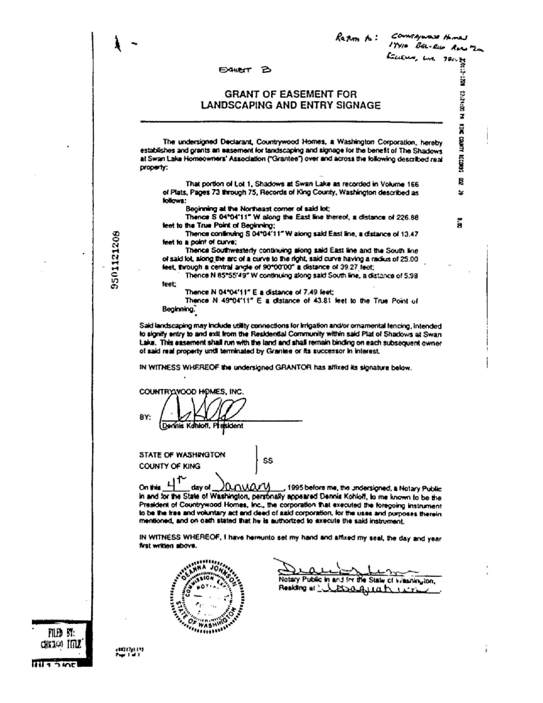 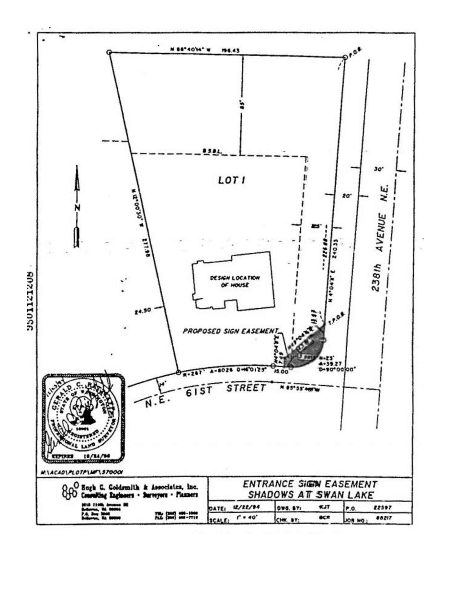 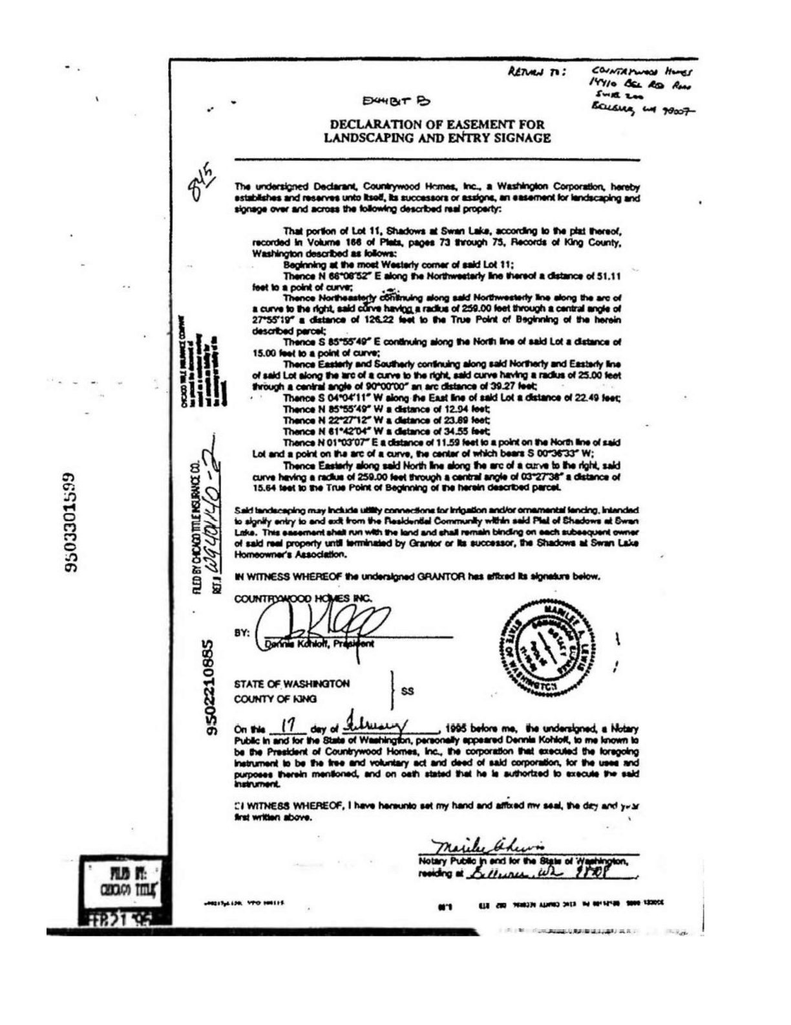 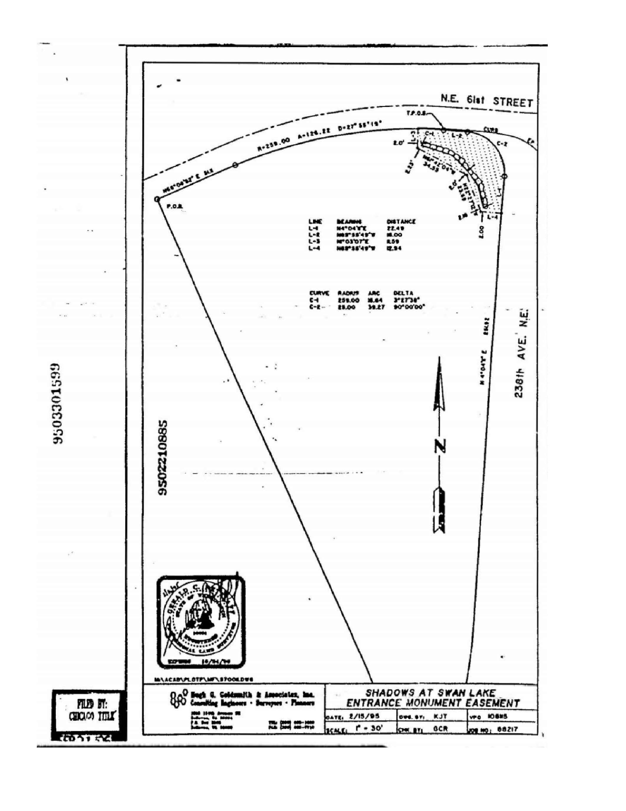

# Exhibit C. Fence Detail.

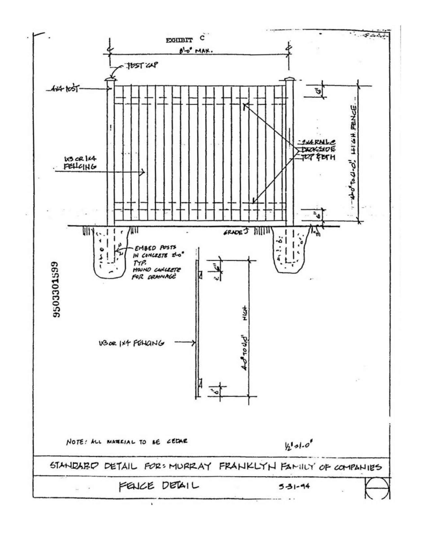

Exhibit C-1