**Abstract-:**

We use mechatronics and control systems to create mechanism which appear to be living things as opposed to be like animated robotic. Most frequently these figures are operated by compressed air, pressurized oil with the help of hydraulics or electricity in some situations. These bodies are crafted to match the precise measurements and ratios of real-world organisms. Mobility actuators are repeatedly use to simulate real world movements like those of limbs in addition the model is coated or wrapped with flexible artificial skins and body shells which consists of both soft and hard plastic. So, in this project we created a hand which would serve as a shadow hand using Arduino Uno, since developing the whole robotic body would be more expensive. In this paper our major highlight is the use of wireless application and implement the use in various fields of work which could reduce the employee’s work and could benefit it in major and tough situations, such fields can be defense, medical surgeries, and the chemical industries.

**1.INTRODUCTION**

**1.1 Literature Survey**

Animatronic hand is that which is wirelessly operated and is well equipped with cutting-edge wireless technology. This hand can be used in the place where the human hand can be harmed, so these models play an important role in replacing it with the actual hand so that it can reach in the complicated places where a human hand are necessary to fulfill the essential work or is difficult to work. Here to do the identical activity to reduce the danger this animatronic hand can be installed on a moving platform to accomplish the necessary duty. For example, it we take a situation where if a doctor must perform a surgery in a very small and complicated position so he or she can use this hand using a camera installed on it to perform the smooth operation of the patient. Also, this hand can help the people with Parkinson’s

disease or those who are paralyzed where this hand can be used to get things which a person cannot grab with his or her hand. Our aim for this project is to come up with an affordable product with the help of various wireless modules like Xbee as well Arduino Uno board. But in this project, we have implemented it on an Arduino Uno Board with a Wi-Fi module so we no need to buy ESP8266 separately where Arduino Uno WIFI is a microcontroller which is also similar to Arduino UNO Rev3 but the major difference is it has ESP8266 Wi-Fi module integrated in it.So basically there two main parts of the project that is a hand with servo motors attached to it which help the fingers to make movements, and the jumping cables connected to the Arduino uno Wi-fi module for integration. Secondly the code will be implemented in the Arduino IDE where the camera will be switched on and, if the person makes any movements with his or her hand in front of the camera then with respect to the instructions the hand will make movements. In future we would also like to improve it and expand it on the larger scale and make it moveable with respect to places as per the requirements of the clients.

**1.2 Problem Statements**

Conventional animatronic frequently includes wired connections which usually restricts their adaptability in terms of mobility. These can reduce the sense of the motion in these applications where the flexibility of the movements is essential. To address these challenges a proposal of wireless system development is must. Without any physical tethering the hand can be controlled with the help of wi-fi module which will enhance the flexibility and mobility of the hand to allow the quick and natural movements. The research will focus of improving the wireless communication interface and ensuring the low latency which is the major and important thing for reliability in real time control. Additionally, improvements will be made for power efficiency and performance analysis.

**2.METHODOLOGY**

**2.1 Hardware Used and Design**

**A. Servo motors**

It is an electromechanical mechanism which produces torque and velocity based on the current and voltage supplied to it. It plays a role of closed loop system by providing the torque and velocity as instructed by the servo motor controller. It consists of a controlling circuit, assembly gear, a potentiometer and as DC or AC motor.

**B. Arduino Uno with Wi-fi module**

It is same as Rev3 but it has an integrated Wi-Fi module. It is a microcontroller with ATmega328P and ESP8266 module. It consists of 14 digital pins,6 analog inputs,16 MHz ceramic resonator a power jack and USB connection. The useful feature of the UNO Wi-Fi is the support for over the air programming either for transfer of Arduino sketches or Wi-Fi firmware.

**C. Model hand and connecting wires**

In this project we have used a model hand with three servo motors for the finger movements and metallic strips with plastic coils on it to perform the actions. We have also used the connecting wires to connect to breadboard and Arduino uno board for the integration.

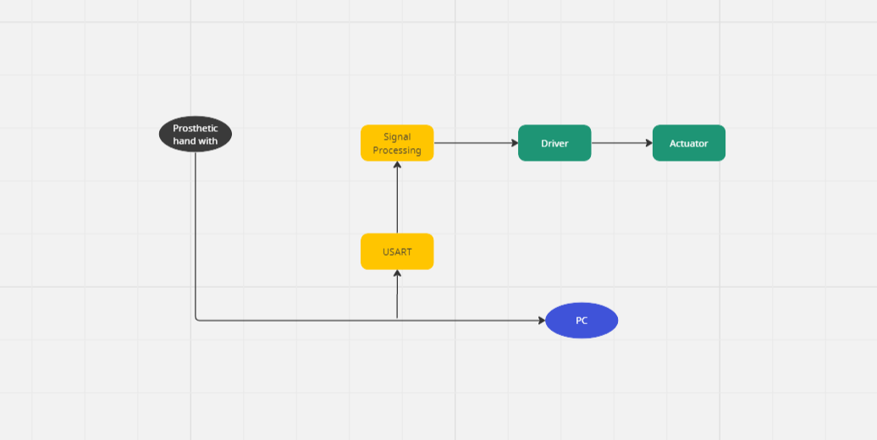

**D. Design and Block diagram**

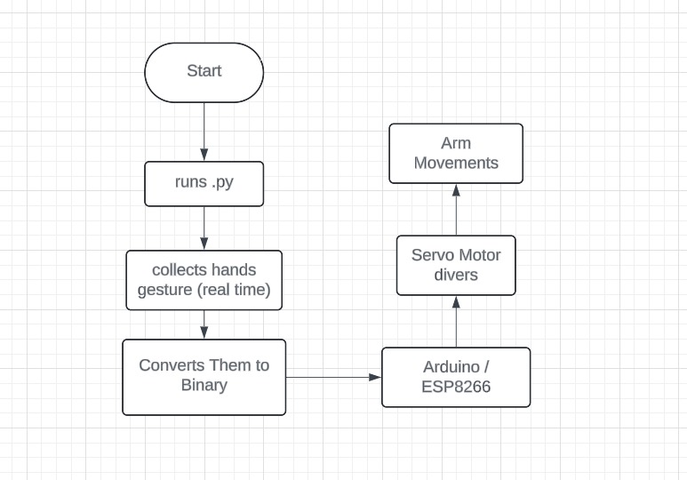

**1**.**UART Communication:**

A popular serial communication technique for exchanging data between devices is UART (Universal Asynchronous Receiver-Transmitter) communication. UART acts as a communication interface within the context of the prosthetic limb chauffeur, connecting the prosthetic hand actuators to the control unit (such as a computer or microcontroller). It makes it possible to send control signals effectively and dependably, including orders for movement and sensor data.

**2.PC Interface:**

The client's connection for manipulating the prosthetic hand is the PC interface. Users can enter instructions and modify prosthetic hand settings using its graphical or command-line interface. Sending control signals and receiving information from feedback, the PC interface normally connects with the prosthetic limb driver via UART or other communication protocols. Users may alter the prosthetic hand's functionality by modifying its grip power, finger activity, and sensor sensitivity.

**3.Prosthetic Hand Driver:**

The prosthetic hand driver acts as a bridge between the prosthetic hand's actuators and control unit. It converts instructions from the PC port or different control sources into signals that move the actuators in the required directions. Additionally, the prosthetic hand driver gathers feedback data from force and position sensors integrated in the hand, giving the control unit information regarding the hand's present condition.

**4. Actuator:**

This is the part of the prosthetic hand that produces mechanical movement. It converts electrical impulses from the mechanical hand driver into movement, including wrist rotation or finger opening and shutting. Prosthetic hands can employ a variety of actuator types, such as hydraulic, pneumatic, and electric motors, each of which has special benefits in regards to size, efficiency of power, and force production.

**2.2 Software Used : Python and Arduino**

**A. Computer Vision Code**

**Python code for Computer vision code:** import cvzone.SerialModule from cvzone.HandTrackingModule import HandDetector import cv2 cap = cv2.VideoCapture(0) detector = HandDetector(detec onCon=1, maxHands=2) ser = cvzone.SerialModule.SerialObject("/dev/cu.usbserial-110") while True: # Get image frame success, img = cap.read() # Find the hand and its landmarks hands, img = detector.findHands(img) # with draw # hands = detector.findHands(img, draw=False) # without draw if hands: # Hand 1 hand1 = hands[0] lmList1 = hand1["lmList"] # List of 21 Landmark points bbox1 = hand1["bbox"] # Bounding box info x,y,w,h centerPoint1 = hand1['center'] # center of the hand cx,cy handType1 = hand1["type"] # Handtype Le or Right fingers1 = detector.fingersUp(hand1) print(fingers1) ser.sendData(fingers1) # if len(hands) == 2: # # Hand 2 # hand2 = hands[1] # lmList2 = hand2["lmList"] # List of 21 Landmark points # bbox2 = hand2["bbox"] # Bounding box info x,y,w,h # centerPoint2 = hand2['center'] # center of the hand cx,cy # handType2 = hand2["type"] # Hand Type "Le " or "Right" # # fingers2 = detector.fingersUp(hand2) # Find Distance between two Landmarks. Could be same hand or different hands # length, info, img = detector.findDistance(lmList1[8], lmList2[8], img) # with draw # # length, info = detector.findDistance(lmList1[8], lmList2[8]) # with draw # Display cv2.imshow("Image", img) cv2.waitKey(1) cap.release() cv2.destroyAllWindows()

**B. Arduino Code**

#include <Servo.h> const int NumServos = 5; const int BaudRate = 9600; const char StartBit = '$'; Servo servos[NumServos]; // Thumb, Index, Middle, Ring, Pinky int servoPins[] = {8, 9, 10, 11, 12}; // Thumb, Index, Middle, Ring, Pinky const int servoPin = 9; void setup() { for (int i = 0; i < NumServos; ++i) { servos[i].a ach(servoPins[i]); servos[i].write(0); delay(1000); } Serial.begin(BaudRate); } char getChar() { if (!Serial.available()) return '?'; char cur = Serial.read(); Serial.print("Char: " + cur); return cur; } String readSerialData() { String res = ""; bool readStartBit = false; while (Serial.available() && getChar() != StartBit) ; while (res.length() != NumServos) { char cur = getChar(); if (cur == '0' || cur == '1') res += cur; } return res; } void loop() { String cur = readSerialData(); Serial.println("Current: " + cur); for (int i = 0; i < NumServos; ++i) { int value = int(cur[i]-'0')*180; if (i % 2 == 1 || i==0) { value = 180 - value; // Invert the value } servos[i].write(value); } }

**3. Expected Result**

The animatronic hand will be controlled wirelessly using finger gestures recognized by a camera. Here's the expected functionality:

* User Input: The user will make specific hand gestures in front of a camera.
* Computer Vision Processing: The computer vision (CV) software will analyze the camera feed and detect the finger gestures.
* Data Transmission: The CV software will convert the recognized gestures into a data signal.
* Wireless Communication: This data signal will be transmitted wirelessly to the Arduino board using Wi-Fi.
* Signal Processing: The Arduino will receive and interpret the data signal.
* Movement Control: Based on the interpreted data, the Arduino will send control signals to the servo motors attached to the animatronic hand.
* Hand Movement: The servo motors will adjust their positions, causing the animatronic hand to mimic the user's finger gestures.

**4. Conclusion**

This project aims to develop a low-cost, wirelessly controlled animatronic hand using an Arduino Uno Wi-Fi board and servo motors. The hand will be operated by a user's hand gestures detected by a camera and processed through computer vision software. This animatronic hand has the potential for various applications, including:

**5.APPLICATIONS**

The wireless animatronic hand, controlled by user gestures and computer vision, has the potential to revolutionize various fields. Here are some of its major applications:

1. **Hazardous Environments:**Nuclear Industry: The hand can handle radioactive materials in nuclear power plants or clean up spills without risking human exposure.Bomb Disposal: It can be used for bomb disposal, allowing bomb squads to disarm explosives from a safe distance.Firefighting: The hand can enter burning buildings to locate survivors or shut off valves without endangering firefighters.
2. **Remote Manipulation:**Space Exploration: Astronauts can operate the hand from a distance to perform delicate tasks in space or maintain satellites.Underwater Exploration: The hand can be attached to submersibles for deep-sea exploration and sample collection.Search and Rescue: It can be used in collapsed buildings or disaster zones to locate victims and clear debris remotely.
3. **Medical Applications:**Minimally Invasive Surgery: Surgeons can use the hand with a camera for laparoscopic surgeries, improving precision and reducing patient recovery time.Telemedicine: Doctors in remote areas can perform surgery on patients using the hand while being physically distant.Rehabilitation: The hand can be used in physical therapy to assist patients with limited mobility in regaining hand function.
4. **Industrial Applications:**Assembly Lines: The hand can perform delicate tasks in assembly lines, such as handling small components or applying adhesives with high precision.Quality Control: It can be used for automated quality control checks in manufacturing, inspecting products for defects.Dangerous Machinery: The hand can operate machinery in hazardous environments, such as around high-pressure equipment or hot surfaces.
5. **Assistive Technology:**Prosthetics: The hand can be adapted as a prosthetic limb for individuals with hand amputations, providing them with greater control and functionality.Daily Living Assistance: It can assist people with disabilities in performing daily tasks like dressing, eating, or operating electronic devices.These are just a few of the major applications for this versatile technology. As the technology advances, we can expect even more innovative uses for the wireless animatronic hand in the future.
6. **Working Model:**

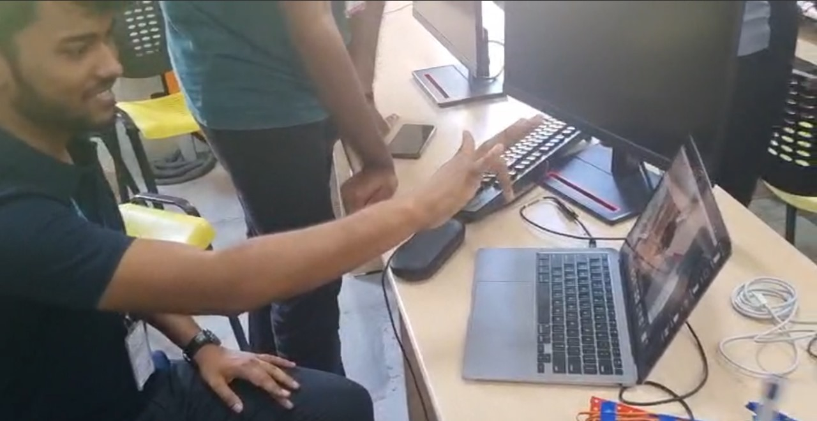

1. **Capturing Hand Gestures from the Camera**

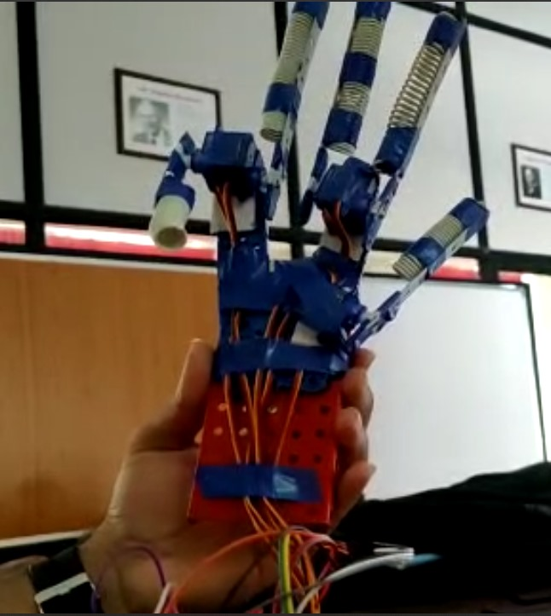

1. **Working model of WOAH**

**7. REFERENCES**

[1] Yuanhao Wu, Ken Chen and Chenglong Fu, Natural Gesture Modelling and Recognition Approach Based on Joint Movements and Arm Orientations, IEEE SENSORS JOURNAL, VOL. 16, November 1, 2016.

[2] Abdullah Shaikh, Gandhar Khaladkar, Rhutuja Jage and Tripti Pathak Javed Taili, Robotic arm movement wirelessly synchronized with human arm movements using real-time image processing. 2013 Texas Instruments India Educators conference. 10 International Journal of Pure and Applied Mathematics Special Issue 1344

[3] Gaurav Chauhan and Prasad Chaudhari, Gesturebased wireless control using Image Processing. 5th Nirmala University International Conference on Engineering, 2015.

[4] Pankaj S Lengare and Milind E Rane, Human Hand Tracking using MATLAB to control Arduino based Robotic Arm. International conference on pervasive computing, 2015.

[5] Panth Shah, Tithi Vyas. Interfacing of MATLAB with Arduino for object detection Algorithm Implementation using Serial Communication. International Journal of Engineering Research and Technology (IJERT), Vol. 3, Issue 10, October 2014.

[6] C.Theis.I.Iossifidis and A.Steinhage, Image Processing methods for interactive Robot control. Proceedings 10th IEEE International Workshop on Robot and Human Interactive Communication, 2001.

[7] Operating two servos motors with Arduino. <http://www.robotoid.com/appnotes/arduinooperatingtwo-servos.html>

[8] Bhumeshwari Basule, Shubhangi Borkar. Robotic Four Finger ARM controlling using Image Processing. Volume 7, Issue

[9] C.S. Lovchik and M.A. Diftler, "The Robonaut Hand: a Dexterous Robot Hand for Space", in Proc. IEEE Int. Conf. on Robotics and Automation '99, ICRA 99, Michi-gan, May 1999.

[10] H. Kawasaki, H. Shimomura, Y. Shimizu, "Educational-industrial complex development of an anthropomorphic robot hand 'Gifu hand"', Advanced Robotics, Vol. 15, No. 3, pp. 357-363, 2001.

[11] J. Butterfass, M. Grebenstein, H. Liu, G. Hirzinger, "DLR-Hand II: Next Generation of a Dextrous Robot Hand", in Proc. IEEE Int. Conf. on Robotics and Automation '01, ICRA 01, Seoul, Korea, May 21-26, 2001.

[12] C.Melchiorri and G.Vassura , "Mechanical and control features of the UB Hand Version II", in Proc. IEEE/RSJ Int. Conf. on Intelligent Robots and Systems '92, IROS 92, Raleigh, NC, 1992.

[13] I.A. Kapandji, The Physiology of the Joints: Upper Limb, vol. 1, 5th ed. New York: Elsevier, 1986.

[14] R. M. Murray and S. S. Sastry, A Mathematical Introduction to Robotic Manipulation. Boca Raton, FL: CRCPress, 1993.

[15]. A. Bicchi, "Hand for dexterous manipulation and robust grasping: A difficult road toward simplicity," IEEE Trans. Robot. Autom. vol. 16, no. 6, pp. 652-662, Dec. 2000.

[16]. S. Hirose and Y. Umetani, "The development of soft gripper for the versatile robot hand," Mech. Mach. Theory, vol. 13, pp. 351-359, 1978.

[17] R. Cabas and C. Balauger, "Design anddevelopment of a light weight em-bodied robotic hand activated with only one actuators," in Proc. IEEE/RSJ Int. Conf. Intell. Robots Syst., pp. 741-746, 2005

[18] I.W. Park, J.Y. Kim, J. Lee, and J.H. Oh,"Mechanical design of humanoid robot platform KHR-3 (KAIST humanoid robot-3: HUBO)," in Proc. 5th IEEE-RAS Int. Conf. Humanoid Robots, pp. 321-3262005, 2005.