Software Design & Development CA1

**Name:** Ben Swan

**Student Number:** N00193159

**Year:** Year 2

**Course:** DL836 Creative Computing

**Module:** Software Design & Development

**Case Study:** Game Studio

I have the Create, Read, Update and Delete functionalities all implemented and working without major issues.

After several tests on each function, I only found one error, which I would consider to be more of an inconvenience; In the Update function, I noticed that the last parameter (“difficulty”) did not seem to update along with the parameters before it, despite myself inputting that parameter correctly. I see nothing incorrect with the code, so I’m not sure how that is happening.

The part of CRUD that I found most difficult was the Create. The code was a bit of a rollercoaster when trying to understand what each line’s role was. However, after receiving help from both the lecturer and classmates, I was able to get an idea of how the code was structured. Incidentally, it also helped me fix some errors I had with the other functions within CRUD, so I’m happy with what I have to submit.

# Diagrams

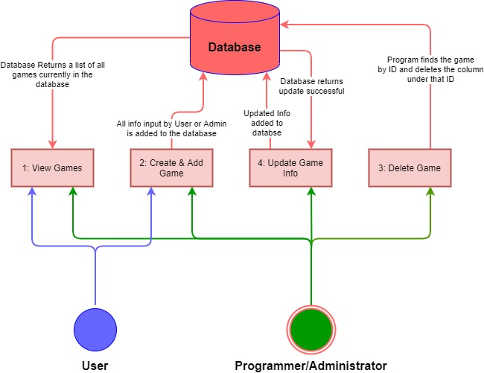*Use Case Diagram*

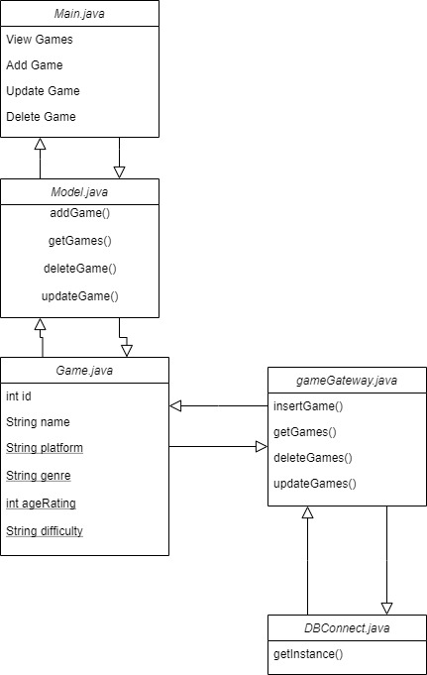*Class diagram*

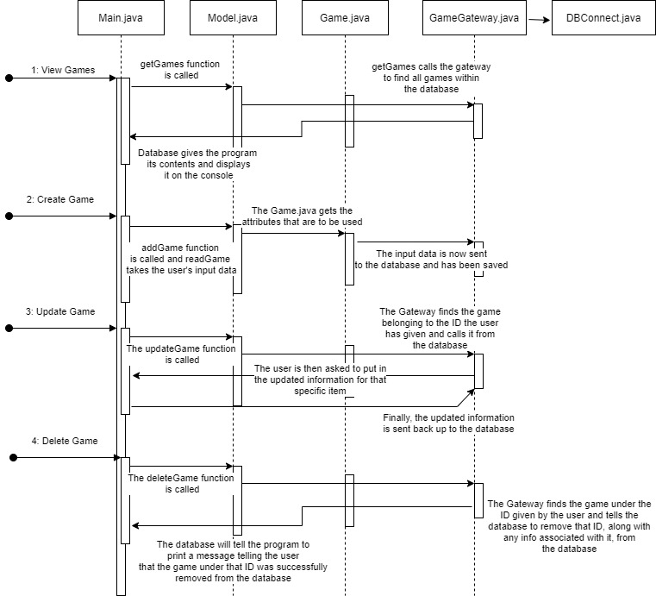*Sequence Diagram*