INTRODUCTION

An Adverse Drug Reaction (ADR) can be defined as a significantly harmful or unpleasant reaction usually attributed to the use of medicines and may warrant treatment, prevention, alteration of dosage, or withdrawal of the usage of that drug. They are a major threat to the healthcare system since they contribute to mortality, morbidity, extended hospital stays, and increased healthcare costs. Many of the side effects are not observed during clinical trials but are mostly identified only after the drug has reached the market.
Several studies also show that reports of Adverse Drug Reactions tend to be skewed based on sex, geographic region of origin, and country of origin. For instance, according to, women are at more risk of adverse drug reactions due to differences in pharmacokinetic and pharmacodynamic effects of drugs in addition to their higher dosage concerning body weight. Further, factors such as access to healthcare based on country of residence and their healthcare quality play a role as well. According to, the median proportion of preventable ADRs in developed and developing countries is 71.6% and 59.6% respectively, and the median proportions of ADRs relating in mortality were 1.7% and 1.8% in developed and developing countries respectively. The majority of these ADRs were preventable in both situations signifying the importance of early prediction of such ADRs and improving medical use in developing countries.
Accurate identification of ADRs is difficult considering it depends on the expertise of the attending physician and the quality of information available. Sometimes even experienced physicians have difficulty in determining causality. In addition to this, the usage of multiple medicines, underlying conditions of the patient, and assumptions such as the active principle of the medication cause adverse drug effects make the task of accurately identifying them extremely challenging. Further, they are sufficiently rare since they are

tested amongst a small sample size during clinical trials, they tend to elude detection during the drug development process.
A primary cause of Adverse Drug Reactions is Drug-Drug Interactions. Drug- drug interactions occur when drugs compete for the same target. They also involve drug metabolizing enzymes and influx-efflux drug transporters which determine the adsorption, distribution, metabolism, and excretion of drugs. They are one of the most common causes of medication error particularly among elderly people due to poly-therapy. Drug-drug interactions can render a clinically prescribed drug ineffective and may cause adverse drug reactions which can be fatal.
With the growing popularity of deep learning models due to their ability to recognize underlying patterns in various types of data and the advent of Graph Neural Networks that can represent the physical and chemical properties of a drug, models based on such concepts can be used to effectively correlate drug- drug interactions to their side effects. Further techniques such as self-supervised learning and ensemble learning have proven to increase the overall model performance since self-supervised learning can capture and learn the distribution of data on an upstream task with very few labelled samples. The knowledge base obtained can be transferred to a downstream task while ensemble techniques combine multiple deep learning models to improve the overall performance.
In consideration of such improvement and the growing concern about Adverse Drug Reactions, we propose a deep learning technique that leverages the spatial characteristics of graph neural networks and models the dynamics of a chemical interaction to predict the side effects caused by Adverse Drug Reactions (ADRs). We leverage the underlying feature learning capabilities of self- supervised learning and the complexity of Dual Path Graph Neural Networks to effectively predict side effects caused by drug-drug interactions. Our study and

experiments lay the groundwork to begin further research into the field of Adverse Drug Reactions from a deep learning and mathematical perspective.

PURPOSE
The purpose of this project is to develop a robust and scalable framework for predicting adverse drug reactions (ADRs) caused by drug-drug interactions (DDIs) using graph neural networks (GNNs) and self-supervised learning (SSL). By leveraging these advanced machine learning techniques, the project aims to improve drug safety, enhance the accuracy of ADR predictions, and enable early identification of harmful drug combinations. This approach facilitates safer drug development, supports drug repurposing, and advances precision medicine by tailoring predictions to individual patient profiles, ultimately contributing to more effective and personalized healthcare solutions.
    - Enhance Drug Safety
    - Improve Prediction Accuracy
    - Facilitate Drug Repurposing
    - Support Precision Medicine
    - Advance Computational Methods In Pharmacology

SCOPE
The scope of this project encompasses the prediction and analysis of adverse drug reactions (ADRs) caused by drug-drug interactions (DDIs) using advanced machine learning techniques, specifically graph neural networks (GNNs) and self-supervised learning (SSL). The project integrates diverse biomedical data, such as chemical structures, pharmacological properties, and biological interaction networks, to model complex relationships between drugs and their interactions. By leveraging SSL, the project aims to address the challenge of limited labelled data, enhancing prediction accuracy and scalability. It supports drug development by identifying safer combinations and potential therapeutic

uses for existing drugs, contributing to drug repurposing efforts. Furthermore, the project provides a framework adaptable to new drugs and datasets, facilitating broader applicability. Ultimately, this approach supports precision medicine by offering tailored predictions of ADRs for individual patients.

OVERVIEW
The project focuses on leveraging Graph Neural Networks (GNNs) and Self- Supervised Learning (SSL) to predict adverse drug reactions (ADRs) caused by drug-drug interactions (DDIs). DDIs are a significant source of harmful side effects, often arising from the combined effects of two or more drugs. By modeling drugs and their interactions as a graph, where nodes represent drugs and edges represent known or potential interactions, GNNs can capture the intricate relationships between drugs. SSL techniques are employed to pre-train the model on large amounts of unlabeled drug data, addressing the challenge of limited labeled datasets. The framework aims to predict the likelihood of ADRs for specific drug combinations, providing a scalable and accurate method for early detection of harmful interactions. The system will integrate data from reliable sources, perform predictions, and offer visual insights to support decision-making in drug safety, clinical practice, and pharmaceutical research. This innovative approach holds the potential to significantly enhance drug safety, reduce patient risks, and uncover new insights into drug interactions.

SYSTEM ANALYSIS

EXISTING SYSTEM
The presence of Artificial Intelligence (AI) is apparent throughout all realms of science. Nevertheless, AI in chemistry has come up to be one of the most researched areas. Reference successfully modeled QSAR which predicts the carcinogenic potency of aromatic amines and an FDA/OTR MultiCASE model predicting the carcinogenicity of pharmaceuticals. Similarly, it’s worth noting that employed 2D similarity fingerprints for its efficiency and simplicity of computation for drug-drug interactions to prevent adverse effects. The advent of Machine Learning (ML) and Neural Networks (NN) has raised interest in drug discovery. Reference uses genomic features from the cell lines and chemical information from drugs and shows that it is possible to build in-silico-based multi-drug models to impute missing IC50 values with non-parametric machine learning algorithms. Reference calculates drug-drug pair similarities using four features namely: drug phenotypic, therapeutic, chemical, and genomic properties with applied predictive models namely Naive Bayes, Decision Tree, k-nearest neighbour, logistic regression, and support vector machine (SVM). Reference discusses a two stage hybrid approach model that identifies the positive instances using a feature based binary classifier, and then a Long Short Term Memory (LSTM) based classifier to classify positive instances while uses Discriminative Vector Machines for accurate prediction of protein-protein interactions.The Graph Neural Network(GNN) Model approach is known to perform well in chemical graphs inclusive of but not limited to analysing molecular structures, protein-protein interaction networks, and drug discovery. Graph Attention Network (GAT) has been applied in various tasks and applications such as and Reference uses the Graph Convolution operation which allows the nodes to aggregate information.

DISADVANTAGES
    - The complexity of data: Most of the existing machine learning models must be able to accurately interpret large and complex datasets for Detecting Side Effects of Adverse Drug Reactions.
    - Data availability: Most machine learning models require large amounts of data to create accurate predictions. If data is unavailable in sufficient quantities, then model accuracy may suffer.
    - Incorrect labeling: The existing machine learning models are only as accurate as the data trained using the input dataset. If the data has been incorrectly labeled, the model cannot make accurate predictions.

PROBLEM STATEMENT
Adverse Drug Reactions (ADRs) caused by drug-drug interactions (DDIs) represent a significant challenge in the field of pharmacology, leading to increased patient morbidity, hospitalizations, and even fatalities. Traditional methods of identifying and predicting ADRs rely heavily on clinical data, which is often scarce, incomplete, and time-consuming to gather. Additionally, as the number of drugs available increases, the complexity of potential interactions grows exponentially, making it difficult to predict all possible ADRs using conventional methods. This project aims to develop an advanced machine learning-based framework for detecting ADRs arising from DDIs using Graph Neural Networks (GNNs) and Self-Supervised Learning (SSL). The goal is to model drug-drug interactions as a graph, where drugs are represented as nodes, and interactions between them are represented as edges. By leveraging GNNs, the model will learn the complex relationships and dependencies between drugs, identifying potential ADRs that could occur due to these interactions. Using SSL, the model will further enhance its ability to generalize to unseen drug pairs without relying on a large labelled dataset, thus overcoming the limitations of traditional supervised learning techniques.

PROPOSED SYSTEM
The study aims to reduce the number of clinical hospitalizations due to Adverse Drug Effects. Our proposed framework predicts the side effects of drug-drug interactions based on the molecular structure of the drug and their interaction dynamics. This enables a holistic and early determination of side effects caused by such adverse reactions and ensures that variables such as quality of the physician, subjectivity of the reports, and quality of healthcare are eliminated. We present an approach to side effect prediction due to drug-drug interaction using Graph Neural Networks by representing the drugs involved in the reaction as molecules. To realize the dynamics of a chemical reaction and effectively leverage the spatial and physical features of both the reactants, we develop a Dual Input Graph Neural Network Hybrid Model with a 2-stage training phase. The Dual Input framework is designed to model the dynamics of a chemical reaction by sharing features between both reactants. The dataset used is Two Sides poly-pharmacy side effects dataset from Therapeutic Data Commons (TDC). Since the TwoSides poly-pharmacy side effects dataset is the only available dataset for side effects prediction and owing to a lack of previous benchmarks on the same, we provide an experimental validation of our proposed framework on the DrugBank Dataset. Though the final task for the DrugBank dataset is the prediction of the drug-drug interaction type; by comparing our results with related works, we achieve state-of-the-art results for our proposed framework on the drug-drug interaction type prediction task as well.

ADVANTAGES
    - A framework to model drug-drug interactions using Graph Neural Networks by modelling the properties of drug molecules and leveraging the pattern recognition abilities of self-supervised learning.
    - The complex representations and operations offered by Graph Neural Networks to model their atomic and bond-level properties.
    - Graph Convolution Network, Graph Attention Network, and SAGE and their outstanding results on graph-level tasks have increased the popularity of Graph Neural Networks thus making it a reliable option in various fields.

SYSTEM REQUIREMENT SPECIFICATIONS

HARDWARE REQUIREMENTS:
    - Processor: Pentium –IV
    - RAM: 4 GB (min)
    - Hard Disk: 20 GB
    - Key Board: Standard Windows Keyboard
    - Mouse: Two or Three Button Mouse
    - Monitor: SVGA

SOFTWARE REQUIREMENTS:
    - Operating system: Windows 7 Ultimate
    - Coding Language: Python
    - Front-End: Python
    - Back-End: Django-ORM
    - Designing: Html, CSS, javascript
    - Data Base: MySQL (WAMP Server)

FUNCTIONAL REQUIREMENTS:
    - Data Collection and Preprocessing: Collect drug-related data, including chemical properties, biological targets, and known interactions, from reliable databases.
    - Graph Construction: Represent drugs and their interactions as a graph with drugs as nodes and interactions as edges.Encode drug-specific features at the node level and interaction data at the edge level.

    - Model Development: Implement a Graph Neural Network (GNN) architecture for processing drug graphs. Integrate Self-Supervised Learning (SSL) techniques to pre-train on unlabeled data.
    - Prediction and Querying: Predict the likelihood of side effects for specific drug combinations. Allow users to query specific drug pairs for risk assessment.
    - Visualization and Reporting: Provide a visual representation of the drug interaction graph. Highlight high-risk drug combinations and generate detailed reports.
    - Performance Evaluation: Evaluate model performance using metrics like accuracy, precision, recall, and AUC.Use validation techniques like cross- validation to ensure robustness.
    - User Access and Management: Provide secure user authentication and role-based access to system functionalities.

NON FUNCTIONAL REQUIREMENTS
    - Performance: The system must handle large-scale graphs with millions of nodes and edges efficiently.
    - Scalability: The system must scale to accommodate growing datasets as new drugs and interactions are discovered.
    - Accuracy: Achieve at least 85% prediction accuracy for adverse drug reactions on benchmark datasets.Minimize false positives and false negatives.
    - Reliability: Ensure consistent and reproducible results across multiple runs. Implement recovery mechanisms to handle system failures gracefully.
    - Usability: Provide an intuitive user interface for querying, visualization, and accessing reports.Include comprehensive documentation and user guides.

SYSTEM DESIGN

The system aims to predict the side effects of drugs due to interactions with other drugs using a machine learning approach. Specifically, Graph Neural Networks (GNNs) will model the relationships between drugs, while Self- Supervised Learning (SSL) will enhance the training process by leveraging unlabelled data and improving model performance.

SYSTEM DESIGN SPECIFICATIONS

4.1.1 Data Collection and Preprocessing:
    - Data Sources: Public drug interaction datasets (e.g., DrugBank, SIDER, PubMed), Clinical data, patient medical records (anonymized) if available.
    - Drug-Drug Interaction (DDI) Data: Create a graph representing drugs as nodes and interactions as edges. The edge weights can reflect the strength of interactions or types of side effects.
    - Side Effect Data: Mapping side effects to specific drug combinations based on clinical reports or existing datasets.

4.1.2 Graph Representation:
    - Nodes: Drugs (each drug is represented as a node in the graph).
    - Edges: Drug-drug interactions (edges between nodes indicate interactions, possibly with labels indicating interaction type or intensity).
    - Node Features: Features representing each drug, such as chemical properties, molecular structure, or classification (e.g., pharmacological class).
    - Edge Features: The type and strength of drug interactions.

4.1.3 Graph Neural Network (GNN) Model:
    - Graph Convolutional Networks (GCN): Layers that aggregate neighborhood information for each drug node (drug's interactions).
    - Graph Attention Networks (GAT): A more advanced version where attention mechanisms are used to focus on more significant interactions.
    - Goal: Predict the likelihood of a particular side effect for a drug combination, or categorize the side effects.

4.1.4 Self-Supervised Learning:
    - Contrastive Learning: The system can use unlabeled drug-drug interactions to train the model by creating positive and negative pairs (drug pairs that are more likely or less likely to cause side effects).
    - Data Augmentation: Randomly corrupt drug interactions to create augmented versions of the graph and use those as additional learning signals.
    - Pretext Tasks: Tasks like predicting missing drug-drug interactions or side effects using graph structures can help the model to learn better representations of drug relationships without explicit labels.
    - Goal: Improve generalization and robustness by making use of large amounts of unlabelled data.

4.1.5 Side Effect Prediction:
    - Prediction Layer: After passing through the GNN layers, the model outputs the probability or category of side effects for given drug pairs.
    - Post-Processing: Apply thresholds, filtering, or ranking to present the most likely or severe side effects to clinicians.

4.1.6 User Interface (UI):
    - Drug Search: A search bar where users (e.g., healthcare professionals) can input one or more drug names.
    - Side Effect Prediction: Once drugs are selected, the system shows potential side effects of drug combinations, highlighting possible interactions and their severity.
    - Visualization of Graphs: Interactive visualization of the drug interaction graph to help users better understand drug-drug interactions.

SYSTEM ARCHITECTURE:

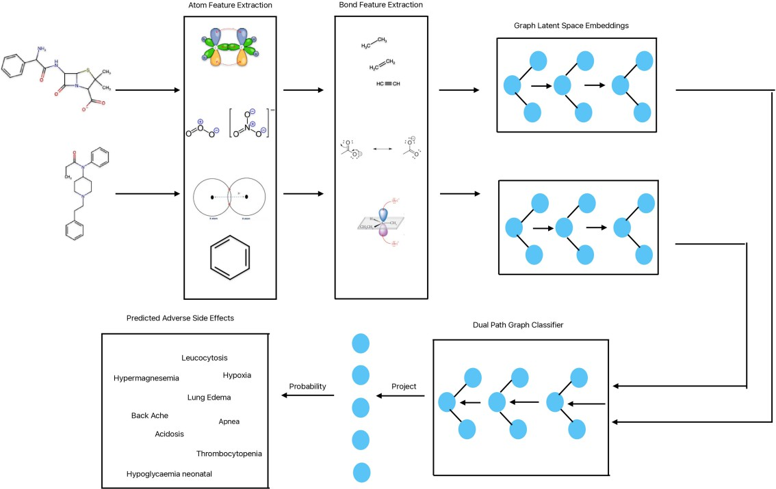

Fig. 4.1: System architecture

4.2.1 Backend (Model Training and Prediction):
    - Use Python-based frameworks like PyTorch Geometric (for GNNs) and TensorFlow/PyTorch for other deep learning tasks.
    - Train models on GPUs to accelerate the learning process.
    - Utilize cloud-based infrastructure for scalability (e.g., AWS, Google Cloud, or Azure for compute and storage).

4.2.2 Frontend (User Interface):
    - Web framework: React.js or Angular.js for frontend, integrated with a backend server (Flask/Django for Python or Node.js).
    - Visualization libraries like D3.js or Cytoscape.js to display interactive graphs. 4.2.3 Database: SQL/NoSQL databases to store drug interaction data, side effects, user history, and system logs.

4.3 DATA FLOW DIAGRAM: 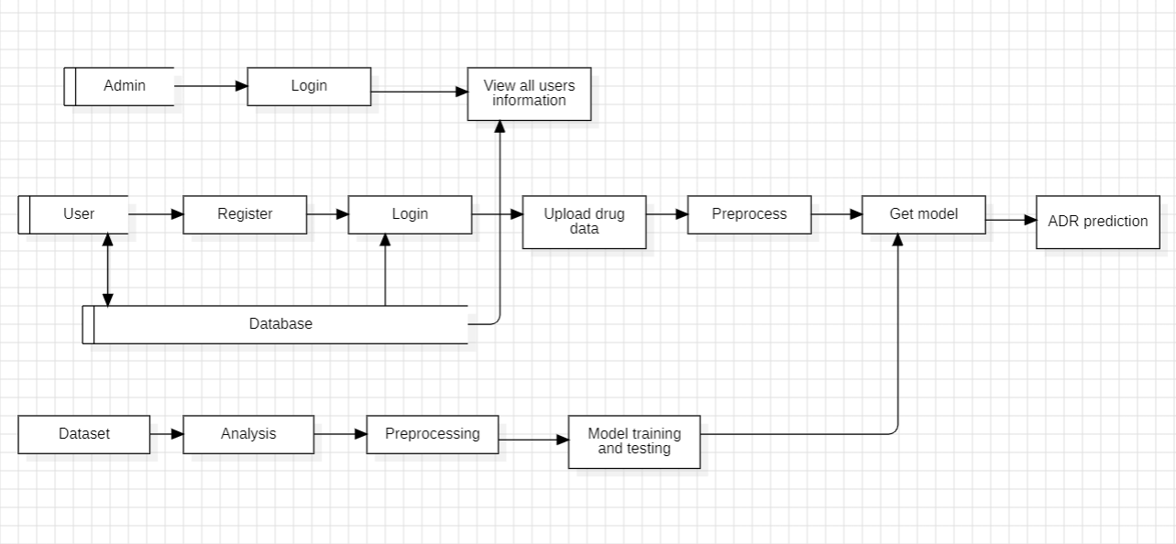

A Data Flow Diagram (DFD) is a graphical representation used to visualize the flow of data within a system. It illustrates how data moves from input to output, showing the processes, data stores, and external entities involved in the system. A DFD helps in understanding how information is processed and where it is stored, making it useful for analyzing and designing systems. It typically includes elements like processes (which transform data), data stores (where data is held), data flows (routes taken by data), and external entities (sources or destinations of data outside the system). By simplifying complex processes into a visual format, DFDs are valuable tools for both technical and non-technical stakeholders in system development.

  - UNIFIED MODELLING LANGUAGE DIAGRAMS

UML is a method for describing the system architecture in detail using the blue print. UML represents a collection of best engineering practice that has proven successful in the modeling of large and complex systems. The UML is very important parts of developing object-oriented software and the software development process. The UML uses mostly graphical notations to express the design of software projects. Using the helps UML helps project teams communicate explore potential designs and validate the architectural design of the software.

4.4.1 USECASE DIAGRAM
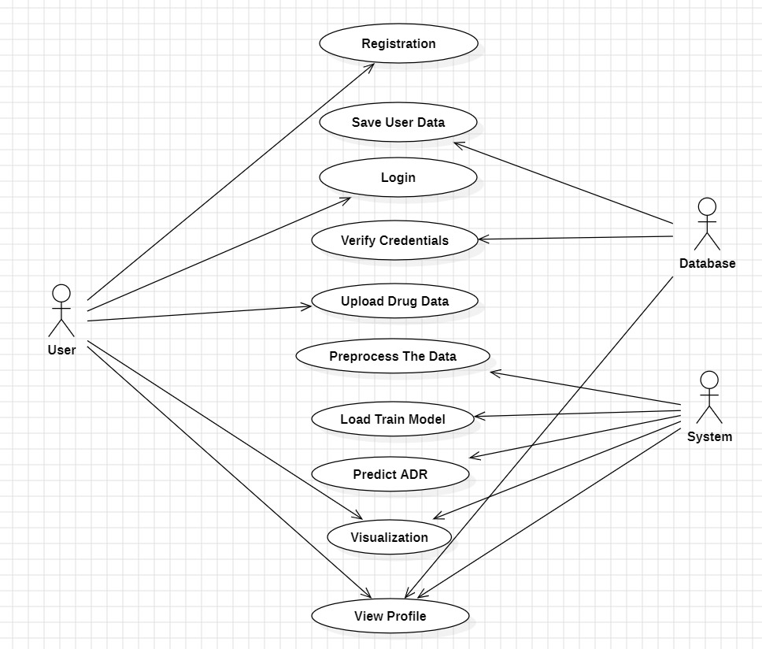

A use case diagram in the Unified Modeling Language (UML) is a type of behavioral diagram defined by and created from a Use-case analysis. Its purpose is to present a graphical overview of the functionality provided by a system in terms of actors, their goals (represented as use cases), and any dependencies between those use cases. The main purpose of a use case diagram is to show what system functions are performed for which actor. Roles of the actors in the system can be depicted.

4.4.2 ACTIVITY DIAGRAM

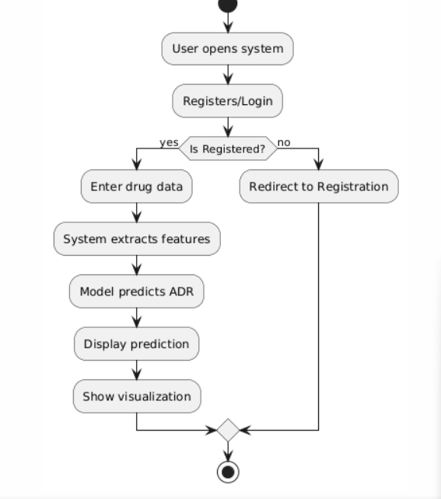

Activity diagrams are graphical representations of work flows of stepwise activities and actions with support for choice, iteration and concurrency. In the Unified Modeling Language, activity diagrams can be used to describe the business and operational step-by-step work flows of components in a system. An activity diagram shows the flow of control.

4.4.3 SEQUENCE DIAGRAM

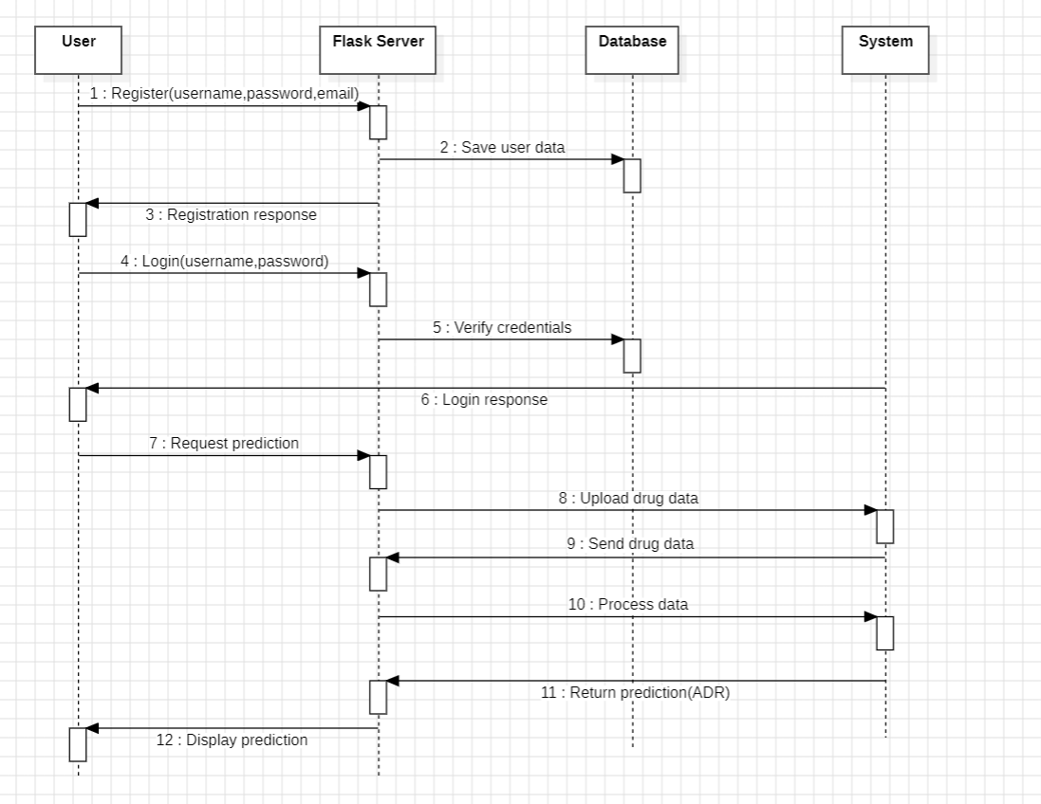A sequence diagram in Unified Modelling Language (UML) is a kind of interaction diagram that shows how processes operate with one another and in what order. It is a construct of a Message Sequence Chart. Sequence diagrams are sometimes called event diagrams, event scenarios, and timing diagram.

4.4.4 CLASS DIAGRAM

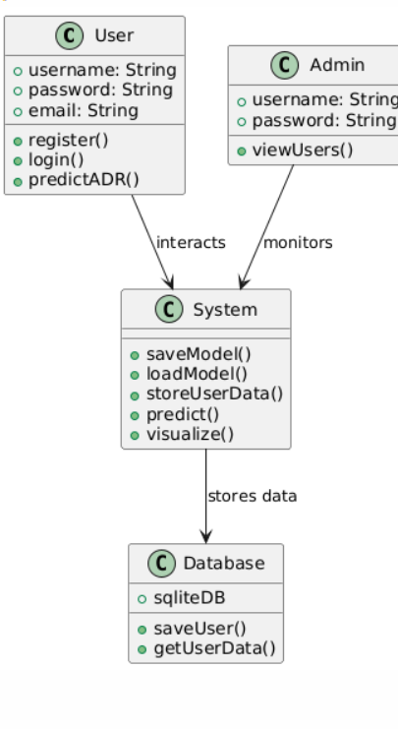

In software engineering, a class diagram in the Unified modelling Language (UML) is a type of static structure diagram that describes the structure of a system by showing the system's classes, their attributes, operations (or methods), and the relationships among the classes. It explains which class contains information.

4.4.5 COMPONENT DIAGRAM

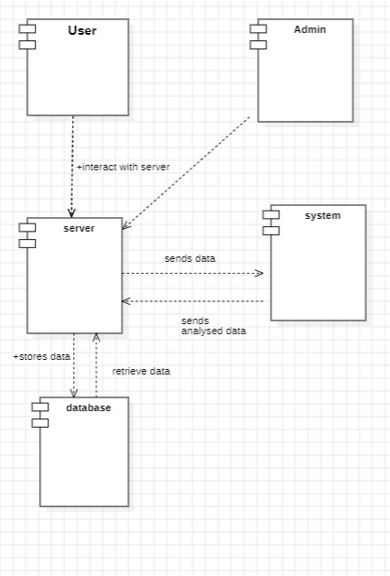

Component-based diagrams are essential tools in software engineering, providing a visual representation of a system’s structure by showcasing its various components and their interactions. These diagrams simplify complex systems, making it easier for developers to design, understand, and communicate the architecture.

4.4.6 COLLABORATION DIAGRAM

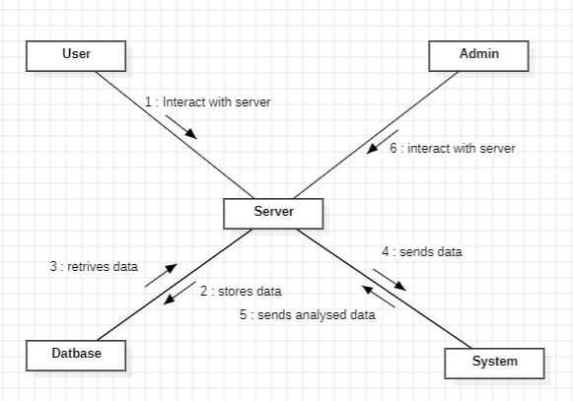

In UML, a Collaboration Diagram is a type of Interaction Diagram that visualizes the interactions and relationships between objects in a system. It shows how objects collaborate to achieve a specific task or behavior. Collaboration diagrams are used to model the dynamic behavior of a system and illustrate the flow of messages between objects during a particular scenario or use case.

SYSTEM IMPLEMENTATION
The system implementation for the project "Adverse Drug Reactions Detection Through Drug Interaction Analysis with Graph Neural Networks and Self-Supervised Learning" involves several key stages designed to effectively model and predict harmful drug interactions. First, relevant data is collected from biomedical databases such as DrugBank, SIDER, and TWOSIDES, which provide information on drug properties, known drug-drug interactions (DDIs), and reported adverse drug reactions (ADRs). This data is then preprocessed to standardize drug names, extract molecular features (e.g., SMILES strings), and encode drug properties into usable formats. A heterogeneous graph is constructed where nodes represent drugs and edges represent known interactions. Each node is enriched with features such as molecular fingerprints or descriptors. A Graph Neural Network (GNN), such as Graph Convolutional Network (GCN) or Graph Attention Network (GAT), is then employed to learn hidden patterns within the graph by propagating information across drug nodes. To further improve the model’s learning capability, self-supervised learning techniques are incorporated. These techniques, such as graph structure prediction or attribute masking, allow the system to learn from unlabeled data by generating auxiliary tasks that guide the model to extract meaningful representations. Finally, the trained model is used to predict potential ADRs based on drug interaction patterns, providing a scalable and intelligent approach to pharmacovigilance and drug safety analysis. Data Acquisition and Preprocessing, Graph Construction, Graph Neural Network Modeling, Self-Supervised Learning Module, and Evaluation & Prediction. The system aims to leverage the representational power of GNNs and the generalization strength of self-supervised learning to accurately predict adverse drug reactions arising from drug-drug interactions.

5.1 MODULES

Data Collection and Preprocessing

Graph Construction

Graph Neural Network (GNN)

Self-Supervised Learning

ADR Prediction

Evaluation and Metrics

Visualization and Reporting

User Interface/API

5.1.1 Data Collection and Preprocessing Module

Acquire and prepare drug-related data for graph construction and model training. Collect data from sources like DrugBank, SIDER, TWOSIDES, and PubChem.Standardize drug identifiers (DrugBank ID, SMILES, PubChem ID). Extract features (molecular fingerprints, SMILES, chemical properties). Encode data into usable numerical formats. Clean, normalize, and validate data entries.

5.1 2 Graph Construction Module

Construct graph-based representations of drug interactions. Create a heterogeneous graph: Nodes: Drugs Edges: Drug-drug interactions. Assign features to nodes (e.g., molecular descriptors). Handle edge types (e.g., synergistic, antagonistic, unknown).

5.1.3 Graph Neural Network (GNN) Modeling Module

Use GNNs to learn embeddings and predict ADRs. Define and configure GNN architecture (e.g., GCN, GAT). Perform message passing and aggregation.Generate drug or interaction-level embeddings. Combine drug embeddings for DDI prediction.Output ADR likelihood scores or classes.

5.1.4 Self-Supervised Learning Module

Pretrain the GNN model without labeled data to enhance learning.Implement pretext tasks such as: Edge masking and prediction, Node feature masking and Graph contrastive learning (positive/negative pairs). Train the model on these tasks to improve embedding quality. Transfer learned embeddings to the ADR prediction task.

5.1.5 ADR Prediction

Classify or rank potential adverse drug reactions from interactions. Input drug pairs or graph segments. Use trained model to output ADR predictions. Perform binary or multi-label classification. Rank interactions by ADR risk score.

5.1.6 Evaluation and Metrics

Assess model performance and ensure reliability. Evaluate using metrics such as: Accuracy, Precision, Recall, F1-ScoreROC-AUC, PR- and AUC. Generate confusion matrix and ROC curves. Perform cross-validation or holdout testing. Log training performance over epochs.

5.1.7 Visualization and Reporting

Present results and patterns in an interpretable format.Visualize graphs (NetworkX, PyVis).Show side effect distributions and prediction probabilities. Plot training loss and accuracy curves. Generate result reports or dashboards (e.g., Streamlit, Flask).

5.1.8 User Interface / API

Allow users to input drug combinations and get ADR predictions.Simple web interface or REST API. Drug input form (single or pair). Display ADR risk results and confidence scores. Backend integration with trained model.

5.2 ALGORITHMS

5.2.1 Graph Convolutional Network (GCN)

Used to perform layer-wise message passing between drug nodes.

Aggregates features from neighbors to learn node embeddings.

Suitable for semi-supervised learning on graphs.

5.2.2 Graph Attention Network (GAT)

Introduces attention mechanisms to weigh neighbor importance.

Improves interpretability and performance over GCN in some settings.

5.2.3 GraphSAGE

Learns embeddings by sampling and aggregating neighborhood information.

Efficient for large graphs, supports inductive learning (i.e., unseen drugs).

5.2.4 Node Attribute Masking

Randomly masks drug features (like chemical properties) and trains the model to reconstruct them.

Forces the model to learn robust internal representations.

5.2.5 Edge Prediction (Link Prediction)

Removes some known interactions and trains the model to predict them.

Helps the model understand the structure of drug relationships.

5.2.6 Graph Contrastive Learning (e.g., GraphCL, DGI)

Generates positive and negative graph views (via augmentations).

Trains the model to bring similar nodes closer in embedding space while pushing dissimilar ones apart.

5.3 TECHNOLOGIES

Frontend: Python with Tkinter / Strealit (GUI)

Backend: Python

Frame work: Flask

Machine Learning Libraries: PyTorch / TensorFlow, DGL/ PyTorch Geometric

Database: SQLite

Other Libraries: Pandas, NumPy, Matplotlib, Scikit-learn

Python with Tkinter / Streamlit (GUI)

The frontend of the application leverages Python-based GUI libraries, primarily Tkinter or Streamlit. Tkinter provides a traditional desktop GUI experience, allowing the creation of interactive windows with buttons, forms, and controls. On the other hand, Streamlit offers a rapid web-based interface for data applications, ideal for visualizing machine learning outputs and providing user interaction in a clean, browser-based layout. Both options enable developers to quickly prototype and deploy user interfaces with minimal overhead.

Python

The backend is implemented in Python, a versatile language well-suited for machine learning and data-driven applications. Python’s readability, vast ecosystem, and seamless integration with scientific libraries make it an ideal choice. The backend handles the logic behind the user interface, interacts with the database, processes data, and manages machine learning workflows, serving as the core of the application’s functionality.

Flask

Flask is a lightweight and flexible web framework used to build the backend API and manage routes, requests, and responses. It supports rapid development and is easy to scale for both simple and complex web applications. Flask integrates smoothly with Python's machine learning libraries, making it ideal for exposing models via RESTful APIs and enabling communication between the frontend interface and backend logic.

PyTorch / TensorFlow, DGL / PyTorch Geometric

For machine learning tasks, the stack incorporates powerful libraries such as PyTorch or TensorFlow for model development and training. These libraries offer robust tools for deep learning, automatic differentiation, and GPU acceleration. Additionally, DGL (Deep Graph Library) and PyTorch Geometric are included to handle graph-based neural network tasks, enabling efficient and scalable learning on graph-structured data, which is essential for applications in social networks, recommendation systems, and more.

SQLite

SQLite is used as the database engine due to its simplicity, lightweight nature, and ease of integration with Python. It stores structured data locally and is ideal for small to medium-scale applications. As a self-contained, serverless solution, SQLite enables quick setup and minimal configuration, which suits desktop or lightweight web applications without the need for complex database management systems.

Other Libraries: Pandas, NumPy, Matplotlib, Scikit-learn

This stack also incorporates essential Python libraries for data manipulation, analysis, and visualization. Pandas is used for handling structured data, NumPy provides efficient numerical operations, and Matplotlib is employed for plotting and visualization of data and results. Scikit-learn complements the stack with a range of machine learning algorithms and tools for preprocessing, model evaluation, and selection, making it indispensable for building and validating predictive models.

Interactive mode programming

This prompt appears when the interpreter is invoked without a script file passed as an argument.

− $ python

Python 2.4.3 (#1, Nov 11 2010, 13:34:43)

[GCC 4.1.2 20080704 (Red Hat 4.1.2-48)] on linux2

Type "help", "copyright", "credits" or "license" for more information

Type the following text at the Python prompt and press the Enter –

>>> print "Hello, Python!" If you are running new version of Python, then you would need to use print statement with parenthesis as in print ("Hello, Python!");. However in Python version 2.4.3, this produces the following result

− Hello,

Script mode programming

The script is executed when the interpreter is invoked with a script parameter, and it runs continuously until it is completed. The interpreter stops working when the script is done.

Let's write a script that runs a basic Python program. Python files have the.py extension. Enter the source code in a test.py file:

Live Demo print \"Hello, Python!\" Let's say you have the Python interpreter configured in the PATH variable. Now try running this program as follows:

$ python test.py This produces the following output:

Hello, Python! Let’s try another way to run a Python script. Here is the modified test.py file –

Live Demo

#!/usr/bin/python print "Hello, Python!"

Let's say you have a Python interpreter available in the /usr/bin directory. Now try running this program as follows:

$ chmod +x test.py # This is to make file executable

$./test.py

This produces the following result –

Hello, Python!

6. CODING

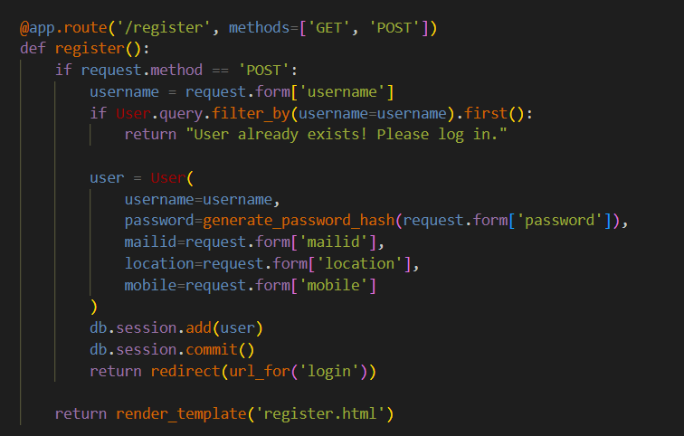

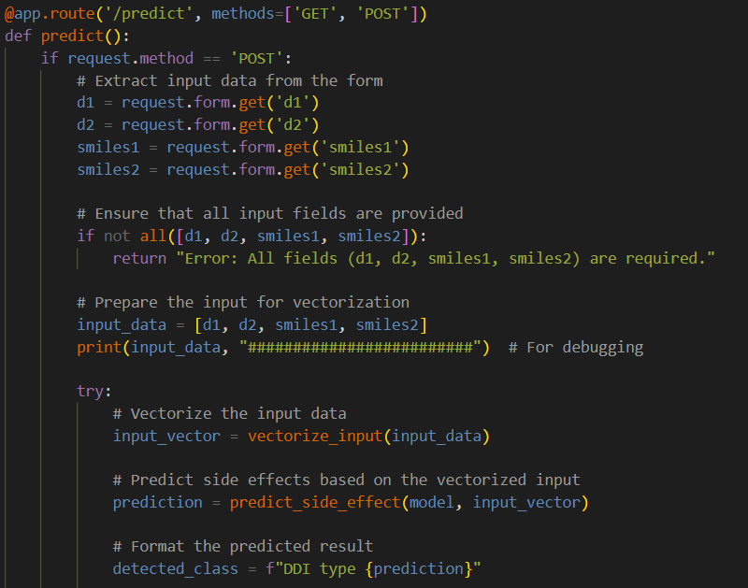

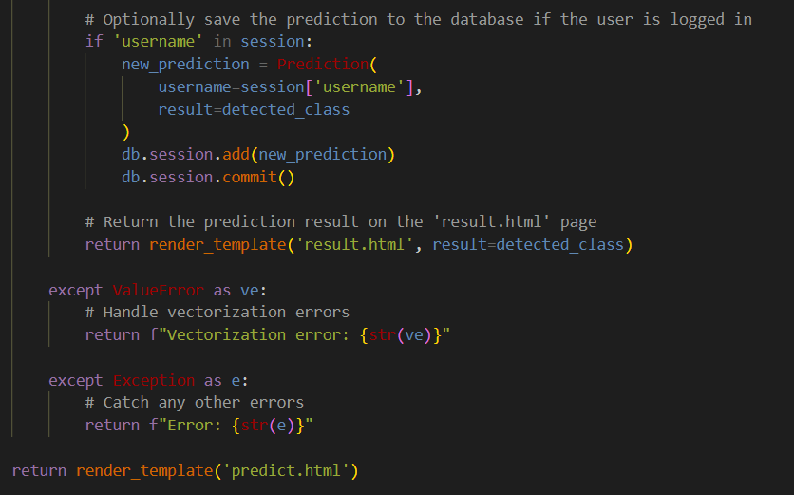

7. SYSTEM TESTING

The reason for testing is to recognize errors.Inspection plans to distinguish any likely deformities or weaknesses in a thing of work, consequently giving a method for assessing the exhibition of individual parts, subassemblies, congregations and items Final.This is a key strategy for assessing programming to guarantee that it meets client assumptions and necessities without unsuitable degrees of error.There are a wide range of kinds of testing, each gathering a particular testing prerequisite.

7.1 TYPES OF TESTS

7.1.1 Unit testing

The most common approach to test planning for unit testing ensures that a program's internal logic works correctly and that the program's inputs produce valid results.Validation must be performed on all internal code paths and decision branches.This includes testing different programming parts of the application.Before integration, it was finished by the decision of a solitary unit.This is an essentially obtrusive test that relies upon understanding its structure.Unit trying assesses a particular application, framework design, or business process at the part level.Unit testing guarantees that every individual way in the business cycle has clear data sources and results and that it works accurately as per archived determinations.

7.1.2 Integration testing

Integration testing is performed to evaluate how well integrated software components function as a unit.These tests are event-based and mainly focus on the primary outcome of the interaction between fields or screens.They show that while unit testing can effectively approve individual parts, the blend of parts stays exact and reliable.The objective of joining testing is to distinguish any potential issues that might emerge from integrating various parts.

7.1.3 Functional test

Functional testing gives deliberate check that the usefulness under test is open as indicated by specialized and business necessities, framework documentation, and client manuals.

Functional testing centers around the accompanying regions:

Valid input: You must accept the recognized classes of valid input.

Invalid input: Some input classes should be ignored.

Features: You must use the designated features.

Output: Identified application exits must be exercised.

Systems/Procedures: It is necessary to use additional systems or procedures.Functional testing focuses on specific requirements, key components, and specialized tests. Additionally, testing should consider data fields, predefined processes, sequential steps, and system scope involved in defining business process flows.Additional tests are identified and the effectiveness of existing tests evaluated before completing functional testing.Framework auditing verifies that all prerequisites are met overall by the integrated programming framework.It checks the configuration to ensure reliable results.Configuration-oriented system integration testing is a description of framework testing.Framework examination emphasizes predetermined process connectivity and coordination goals and depends on process flows and representations.

7.1.4 System Test

The purpose of testing is to discover errors. Testing is the process of trying to discover every conceivable fault or weakness in a work product. It provides a way to check the functionality of components, sub assemblies, assemblies and/or a finished product It is the process of exercising software with the intent of ensuring that the Software system meets its requirements and user expectations and does not fail in an unacceptable manner. There are various types of test. Each test type addresses a specific testing requirement.

7.1.5 White Box Testing

White box testing is a type of programming testing in which the analyst is aware of the inner workings, design and language of the program or in any case, what it is supposed to do.There's a reason.Used to test districts, they are beyond the scope of the black box

7.1.6 Black Box Testing

Performing black box testing in programming implies testing a module without knowing its interior tasks, plan, or language Like different kinds of testing, black box testing must likewise be composed in light of a dependable source, for example, a detail or necessities report.This sort of testing regards the product as a "black box" that can't be seen.Inputs are created and yields are seen regardless of the activity of the product.

7.2 TEST STRATEGY AND APPROACH

Functional testing will be carefully designed and field testing will be performed manually.

Test objectives

- All field entries must be operational.

- Pages must be accessed through the specified link.

- No lag should be experienced in the entry screen, messages, and responses.

Features to be tested

1. Verify that all entries adhere to the correct format.

2. Eliminate any duplicate entries.

3. Ensure that each link guides users to the correct page.

7.2.1 Integration Testing

Programming integration testing includes steadily coordinating at least two composed programming parts into a solitary stage to distinguish interface blunders that might cause mistakes.The objective of integration testing is to guarantee that product applications, framework parts, or significantly more elevated level endeavor programming applications work flawlessly together.

7.2.2 Acceptance Testing

Client acceptance is critical during the testing period of any errand, as it includes broad cooperation with end clients to guarantee that the framework meets useful particulars.

7.3 TEST CASES

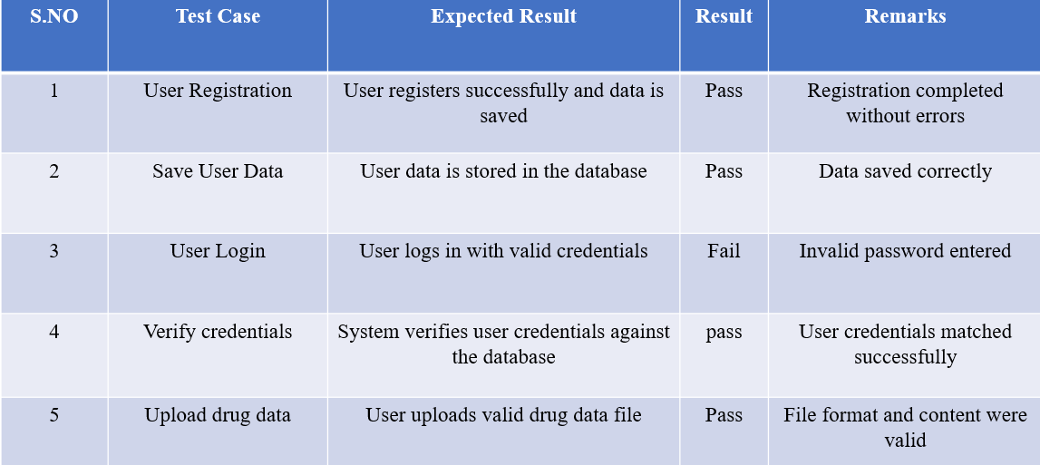

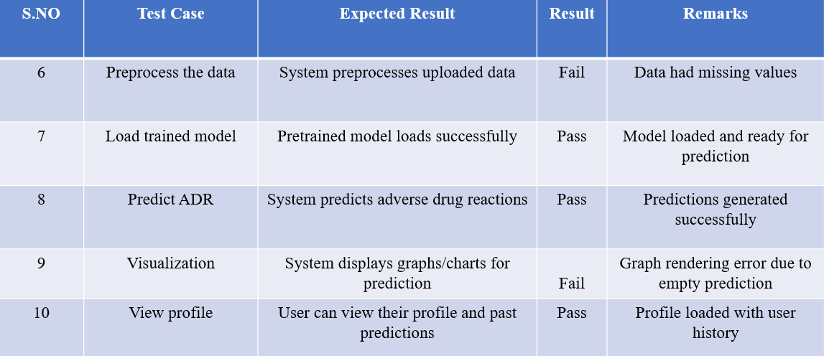

7.4 TEST RESULTS

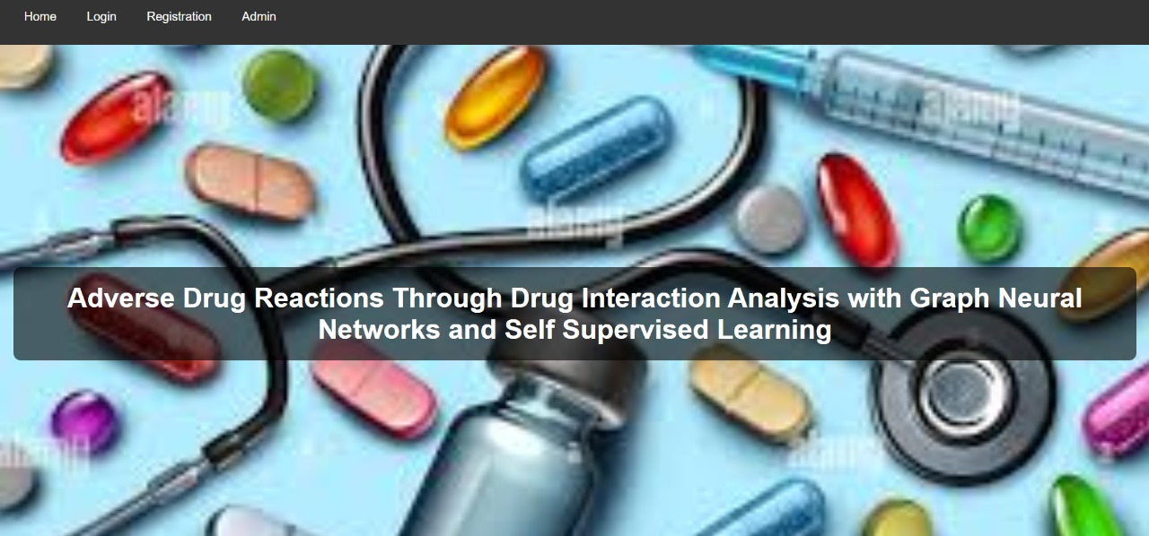

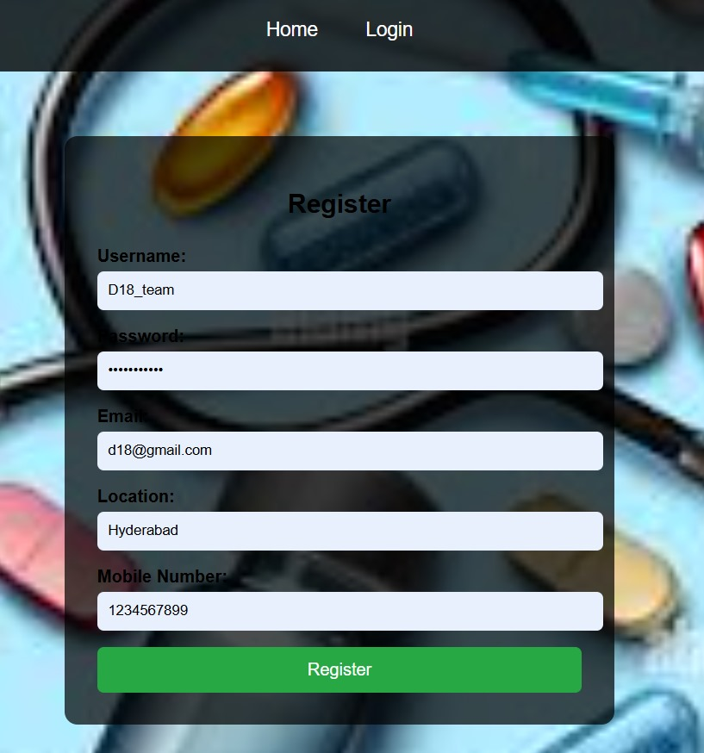

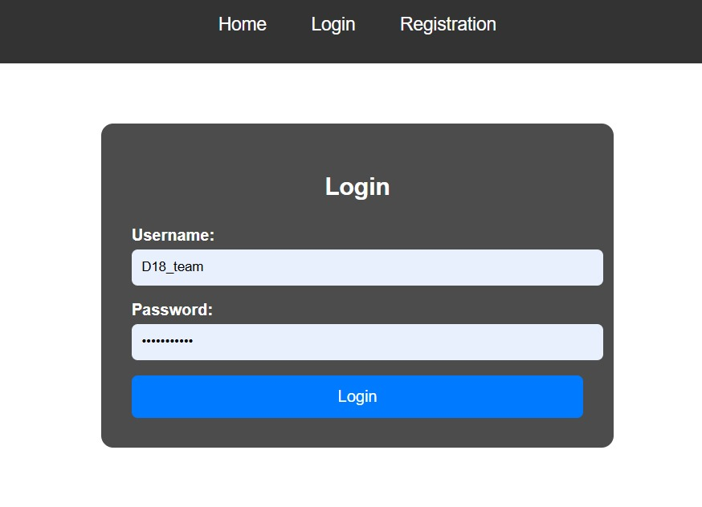

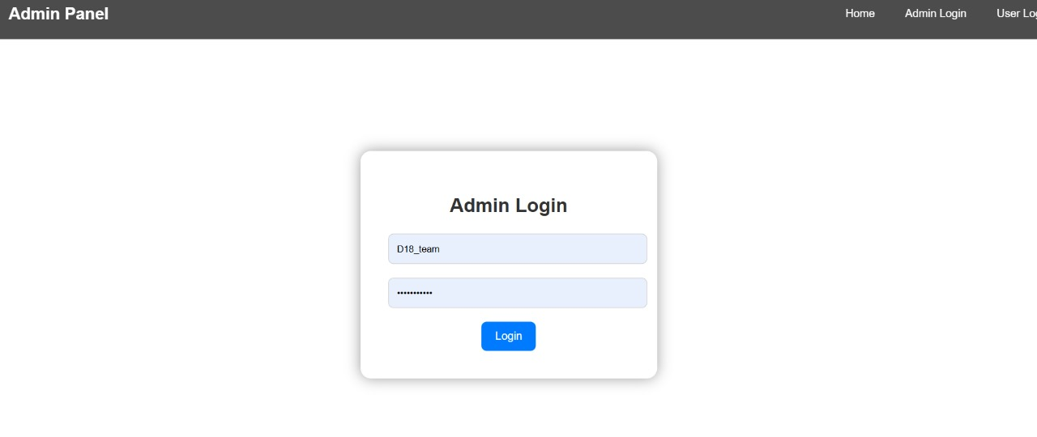

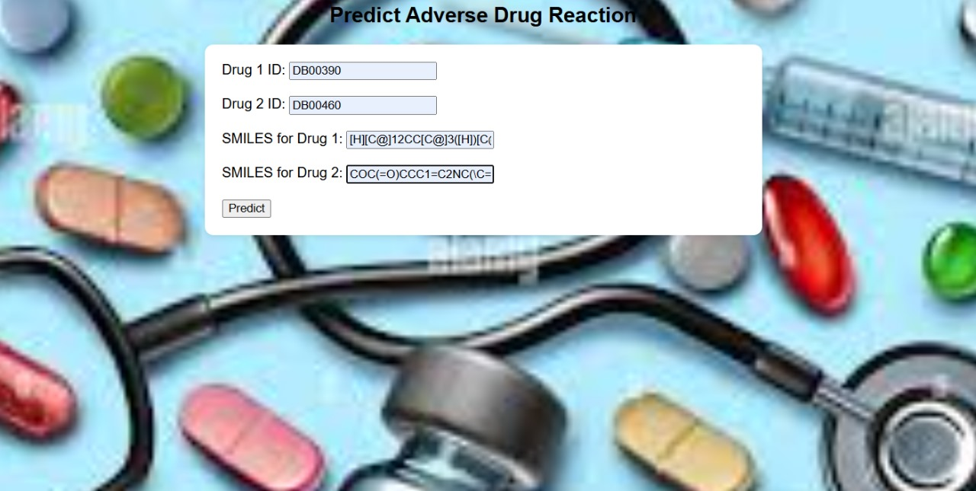

8. LITERATURE SURVEY

TITLE: Adverse drug reactions
AUTHORS: J. J. Coleman and S. K. Pontefract
ABSTRACT: Adverse drug reactions (ADRs) remain a challenge in modern healthcare, particularly given the increasing complexity of therapeutics, an ageing population and rising multimorbidity. This article summarises some of the key facts about ADRs and explores aspects relating to their prevention, diagnosis, reporting and management in current clinical practice.

TITLE: Predicting the frequencies of drug side effects AUTHORS: D. Galeano, S. Li, M. Gerstein and A. Paccanaro
ABSTRACT: A central issue in drug risk-benefit assessment is identifying frequencies of side effects in humans. Currently, frequencies are experimentally determined in randomised controlled clinical trials. We present a machine learning framework for computationally predicting frequencies of drug side effects. Our matrix decomposition algorithm learns latent signatures of drugs and side effects that are both reproducible and biologically interpretable. We show the usefulness of our approach on 759 structurally and therapeutically diverse drugs and 994 side effects from all human physiological systems. Our approach can be applied to any drug for which a small number of side effect frequencies have been identified, in order to predict the frequencies of further, yet unidentified, side effects. We show that our model is informative of the biology underlying drug activity: individual components of the drug signatures are related to the distinct anatomical categories of the drugs and to the specific drug routes of administration.

TITLE: Reported adverse drug reactions in women and men: Aggregated evidence from globally collected individual case reports during half a century AUTHORS: S. Watson, O. Caster, P. A. Rochon and H. den Ruijter

ABSTRACT:

Background
Adverse drug reactions (ADRs) are an important cause of morbidity and mortality. Reports on differences in reporting patterns between women and men exist nationally. The goal of the present study was to assess the global evidence on spontaneous post-marketing ADR reporting differences between reports for women and men.

Methods
We analysed data collected within VigiBase, the WHO global database of individual case safety reports, between 1967-2 January 2018. VigiBase contains more than 18 million reports from the 131 member countries of the WHO Programme for International Drug Monitoring.

Findings
Of the reports with information on sex, 9,056,566 (60.1%) concerned female and 6,012,804 (39.9%) male children and adults. More female ADR reports were submitted in all regions of the world and by all types of reporters. A higher proportion of female reports was seen in all age groups from the age group 12-17 years and older. The largest difference was observed in the age group of 18–44 years and could not be explained by hormonal contraceptive use. The proportion of serious and fatal reports was higher for male reports.

Interpretation
Global post marketing surveillance data on spontaneous reports indicate that women, from puberty and onwards and especially in their reproductive years, report more ADRs than men. However, there is a higher proportion of serious and fatal ADRs among male reports. Our results suggest important underlying sex- related differences in ADRs

TITLE: Drug—Drug interaction through molecular structure similarity analysis
AUTHORS: S. Vilar, R. Harpaz, E. Uriarte, L. Santana, R. Rabadan and C. Friedman

ABSTRACT:

Background
Drug–drug interactions (DDIs) are responsible for many serious adverse events; their detection is crucial for patient safety but is very challenging. Currently, the US Food and Drug Administration and pharmaceutical companies are showing great interest in the development of improved tools for identifying DDIs.

Methods
We present a new methodology applicable on a large scale that identifies novel DDIs based on molecular structural similarity to drugs involved in established DDIs. The underlying assumption is that if drug A and drug B interact to produce a specific biological effect, then drugs similar to drug A (or drug B) are likely to interact with drug B (or drug A) to produce the same effect. DrugBank was used as a resource for collecting 9454 established DDIs. The structural similarity of all pairs of drugs in DrugBank was computed to identify DDI candidates.

Results
The methodology was evaluated using as a gold standard the interactions retrieved from the initial DrugBank database. Results demonstrated an overall sensitivity of 0.68, specificity of 0.96, and precision of 0.26. Additionally, the methodology was also evaluated in an independent test using the Micromedex/Drugdex database.

Conclusion
The proposed methodology is simple, efficient, allows the investigation of large numbers of drugs, and helps highlight the etiology of DDI. A database of 58 403 predicted DDIs with structural evidence is provided as an open resource for investigators seeking to analyze DDIs.

TITLE: Machine Learning Prediction of Cancer Cell Sensitivity to Drugs Based on Genomic and Chemical Properties
AUTHORS: M. P. Menden, F. Iorio, M. Garnett, U. McDermott, C. H. Benes, P.
J. Ballester, et al.
ABSTRACT: Predicting the response of a specific cancer to a therapy is a major goal in modern oncology that should ultimately lead to a personalised treatment. High-throughput screenings of potentially active compounds against a panel of genomically heterogeneous cancer cell lines have unveiled multiple relationships between genomic alterations and drug responses. Various computational approaches have been proposed to predict sensitivity based on genomic features, while others have used the chemical properties of the drugs to ascertain their effect. In an effort to integrate these complementary approaches, we developed machine learning models to predict the response of cancer cell lines to drug treatment, quantified through IC50 values, based on both the genomic features of the cell lines and the chemical properties of the considered drugs. Models predicted IC50 values in a 8-fold cross-validation and an independent blind test with coefficient of determination R² of 0.72 and 0.64 respectively. Furthermore, models were able to predict with comparable accuracy (R² of 0.61) IC50s of cell lines from a tissue not used in the training stage. Our in silico models can be used to optimise the experimental design of drug-cell screenings by estimating a large proportion of missing IC50 values rather than experimentally measuring them. The implications of our results go beyond virtual drug screening design: potentially thousands of drugs could be probed in silico to systematically test their potential efficacy as anti-tumour agents based on their structure, thus providing a computational framework to identify new drug repositioning opportunities as well as ultimately be useful for personalized medicine by linking the genomic traits of patients to drug sensitivity.

TITLE: Predicting potential drug-drug interactions on topological and semantic similarity features using statistical learning
AUTHORS: A. Kastrin, P. Ferk and B. Leskošek

ABSTRACT:
Drug-drug interaction (DDI) is a change in the effect of a drug when patient takes another drug. Characterizing DDIs is extremely important to avoid potential adverse drug reactions. We represent DDIs as a complex network in which nodes refer to drugs and links refer to their potential interactions. Recently, the problem of link prediction has attracted much consideration in scientific community. We represent the process of link prediction as a binary classification task on networks of potential DDIs. We use link prediction techniques for predicting unknown interactions between drugs in five arbitrary chosen large-scale DDI databases, namely DrugBank, KEGG, NDF-RT, SemMedDB, and Twosides. We estimated the performance of link prediction using a series of experiments on DDI networks. We performed link prediction using unsupervised and supervised approach including classification tree, k-nearest neighbors, support vector machine, random forest, and gradient boosting machine classifiers based on topological and semantic similarity features. Supervised approach clearly outperforms unsupervised approach. The Twosides network gained the best prediction performance regarding the area under the precision-recall curve (0.93 for both random forests and gradient boosting machine). The applied methodology can be used as a tool to help researchers to identify potential DDIs. The supervised link prediction approach proved to be promising for potential DDIs prediction and may facilitate the identification of potential DDIs in clinical research.

TITLE: Spectral graph convolutions for population-based disease prediction
AUTHORS: S. Parisot, S. I. Ktena, E. Ferrante, M. Lee, R. G. Moreno,
B. Glocker, et al.

ABSTRACT:
Exploiting the wealth of imaging and non-imaging information for disease prediction tasks requires models capable of representing, at the same time, individual features as well as data associations between subjects from potentially large populations. Graphs provide a natural framework for such tasks, yet previous graph-based approaches focus on pairwise similarities without modelling the subjects’ individual characteristics and features. On the other hand, relying solely on subject-specific imaging feature vectors fails to model the interaction and similarity between subjects, which can reduce performance. In this paper, we introduce the novel concept of Graph Convolutional Networks (GCN) for brain analysis in populations, combining imaging and non-imaging data. We represent populations as a sparse graph where its vertices are associated with image-based feature vectors and the edges encode phenotypic information. This structure was used to train a GCN model on partially labelled graphs, aiming to infer the classes of unlabelled nodes from the node features and pairwise associations between subjects. We demonstrate the potential of the method on the challenging ADNI and ABIDE databases, as a proof of concept of the benefit from integrating contextual information in classification tasks. This has a clear impact on the quality of the predictions, leading to 69.5% accuracy for ABIDE (outperforming the current state of the art of 66.8%) and 77% for ADNI for prediction of MCI conversion, significantly outperforming standard linear classifiers where only individual features are considered.

TITLE: Session-Based social recommendation via dynamic graph attention networks
AUTHORS: W. Song, Z. Xiao, Y. Wang, L. Charlin, M. Zhang and J. Tang

ABSTRACT:
Online communities such as Facebook and Twitter are enormously popular and have become an essential part of the daily life of many of their users. Through these platforms, users can discover and create information that others will then consume. In that context, recommending relevant information to users becomes critical for viability. However, recommendation in online communities is a challenging problem: 1) users' interests are dynamic, and 2) users are influenced by their friends. Moreover, the influencers may be context-dependent. That is, different friends may be relied upon for different topics. Modeling both signals is therefore essential for recommendations. We propose a recommender system for online communities based on a dynamic-graph-attention neural network. We model dynamic user behaviors with a recurrent neural network, and context- dependent social influence with a graph-attention neural network, which dynamically infers the influencers based on users' current interests. The whole model can be efficiently fit on large-scale data. Experimental results on several real-world data sets demonstrate the effectiveness of our proposed approach over several competitive baselines including state-of-the-art models.

TITLE: Applications of self-supervised learning to biomedical signals: A survey
AUTHORS: F. Del Pup and M. Atzori

ABSTRACT:
Over the last decade, deep learning applications in biomedical research have exploded, demonstrating their ability to often outperform previous machine learning approaches in various tasks. However, training deep learning models for biomedical applications requires large amounts of data annotated by experts, whose collection is often time- and cost- prohibitive. Self-Supervised Learning (SSL) has emerged as a prominent solution for such problems, as it allows learning powerful representations from vast unlabeled data by producing supervisory signals directly from the data. The high number of recent works employing the self-supervised learning paradigm for the analysis of biomedical signals (biosignals) can make it difficult for researchers to have a complete picture of the current research state. Therefore, this paper aims at outlining and clarifying the state-of-the-art in the domain. The article: briefly summarizes the nature and acquisition modality of the main biosignals; introduces the self-supervised learning method, focusing on the different pretraining strategies; provides a concise overview of the works employing SSL for the analysis of different types of biosignals; provides an overall analysis of critical aspects to consider when employing SSL to biosignals, also highlighting current open challenges. The analysis of the scientific literature highlights the importance of SSL, confirming its potential to improve models’ performance and robustness, and to promote the integration of deep learning into clinical tasks.

TITLE: Applying Graph Neural Networks to the Decision Version of Graph Combinatorial Optimization Problems
AUTHORS: R. Jovanovic, M. Palk, S. Bayhan and S. Voss

ABSTRACT:
In recent years, there has been a significant increase in the application of graph neural networks on a wide range of different problems. A specially promising direction of research is on graph convolutional neural networks (GCN). This work focuses on the application of GCNs to graph combinatorial optimization problems (GCOPs), specifically on their decision versions. GCNs are applied on the family of GCOPs in which the objective function is directly related to the number of vertices in a graph. The selected problems are the minimum vertex cover, maximum clique, minimum dominating set and graph coloring. In this work, a framework is proposed for solving problems of this type. The performance of this approach is explored for standard multi-layer GCNs using different types of convolutional layers. On top of this, we propose a new structure that is based on graph isomorphism networks. Computational experiments show that this new structure is significantly more efficient than basic structures. To further improve the performance of this method, the use of GCN ensembles is also explored. When using GCNs to generate solution values for GCOPs, they often correspond to non- feasible solutions because they violate the problem boundaries. This issue is addressed by defining an asymmetric loss function that is used during the GCN training. The proposed method is evaluated on a large set of training data consisting of graph solution pairs that can also be accessed online.

TITLE: Graph Neural Networks for Intrusion Detection: A Survey AUTHORS: T. Bilot, N. E. Madhoun, K. A. Agha and A. Zouaoui ABSTRACT:
Cyberattacks represent an ever-growing threat that has become a real priority for most organizations. Attackers use sophisticated attack scenarios to deceive defense systems in order to access private data or cause harm. Machine Learning (ML) and Deep Learning (DL) have demonstrate impressive results for detecting cyberattacks due to their ability to learn generalizable patterns from flat data. However, flat data fail to capture the structural behavior of attacks, which is essential for effective detection. Contrarily, graph structures provide a more robust and abstract view of a system that is difficult for attackers to evade. Recently, Graph Neural Networks (GNNs) have become successful in learning useful representations from the semantic provided by graph-structured data. Intrusions have been detected for years using graphs such as network flow graphs or provenance graphs, and learning representations from these structures can help models understand the structural patterns of attacks, in addition to traditional features. In this survey, we focus on the applications of graph representation learning to the detection of network-based and host-based intrusions, with special attention to GNN methods. For both network and host levels, we present the graph data structures that can be leveraged and we comprehensively review the state-of- the-art papers along with the used datasets. Our analysis reveals that GNNs are particularly efficient in cybersecurity, since they can learn effective representations without requiring any external domain knowledge. We also evaluate the robustness of these techniques based on adversarial attacks. Finally, we discuss the strengths and weaknesses of GNN-based intrusion detection and identify future research directions.

TITLE: DeepH-DTA: Deep Learning for Predicting Drug-Target Interactions: A Case Study of COVID-19 Drug Repurposing
AUTHORS: M. Abdel-Basset, H. Hawash, M. Elhoseny, R. K. Chakrabortty and
M. Ryan

ABSTRACT:
The rapid spread of novel coronavirus pneumonia (COVID-19) has led to a dramatically increased mortality rate worldwide. Despite many efforts, the rapid development of an effective vaccine for this novel virus will take considerable time and relies on the identification of drug-target (DT) interactions utilizing commercially available medication to identify potential inhibitors. Motivated by this, we propose a new framework, called DeepH-DTA, for predicting DT binding affinities for heterogeneous drugs. We propose a heterogeneous graph attention (HGAT) model to learn topological information of compound molecules and bidirectional ConvLSTM layers for modeling spatio-sequential information in simplified molecular-input line-entry system (SMILES) sequences of drug data. For protein sequences, we propose a squeezed-excited dense convolutional network for learning hidden representations within amino acid sequences; while utilizing advanced embedding techniques for encoding both kinds of input sequences. The performance of DeepH-DTA is evaluated through extensive experiments against cutting-edge approaches utilising two public datasets (Davis, and KIBA) which comprise eclectic samples of the kinase protein family and the pertinent inhibitors. DeepH-DTA attains the highest Concordance Index (CI) of 0.924 and 0.927 and also achieved a mean square error (MSE) of 0.195 and 0.111 on the Davis and KIBA datasets respectively. Moreover, a study using FDA- approved drugs from the Drug Bank database is performed using DeepH-DTA to predict the affinity scores of drugs against SARS-CoV-2 amino acid sequences, and the results show that that the model can predict some of the SARS-Cov-2 inhibitors that have been recently approved in many clinical studies.

9. CONCLUSION

Through this study, we explore a wide range of methods to effectively model drug-drug interactions by performing an extensive literature survey. We attempted a deep learning approach using Graph Neural Networks to capture the hidden patterns of each drug by using their spatial and physical characteristics from their molecular structure. Through this approach, we model drug-drug interactions to predict the side effects that it may cause. We divide the proposed framework into several phases and achieve excellent results on the same. The usage of the Graph Variational Autoencoder to pre-train the distribution of each reactant played a major role in the final performance. The overall reconstruction means a square error of only 0.75 for each reactant showing that the autoencoder was able to effectively map the reactants to a highly featured latent space distribution. Further, the similarity in the performance for each reactant showed that the same model configurations could be used, providing simplicity to our proposed approach. The transfer of weights from the reactant distribution task to the downstream classification had a major role in the overall performance. The average performance gain in precision was a massive 25% which showed the need for a trained knowledge base for complex graph-level tasks involving molecular representations.To validate the performance and requirement of our proposed framework, we conduct several experiments using different Graph Neural Network operators and by randomly initializing the weights of the classification model. The precision and accuracy obtained on the test set for these experiments were significantly less than that of our proposed framework. Through our novel approach, we obtain a precision of 75% and an accuracy of 90% on the test dataset. This makes our architecture extremely reliable for side effect prediction considering its likelihood of accurately predicting 3 symptoms with high confidence for every 4 positive instances on unseen data.

10. FUTURE ENHANCEMENTS
1. Incorporation of Real-Time Clinical Data
- Enhancement: Integrate real-world clinical data from electronic health records (EHRs), hospital databases, or pharmacovigilance systems.
- Benefit: Enables the model to capture emerging ADR patterns and adapt to current clinical practices.
2. Multi-Modal Data Integration
- Enhancement: Combine multiple data types (e.g., drug structure, gene expression, patient demographics, and lab results).
- Benefit: Improves prediction accuracy by considering patient-specific and biological context.
3. Personalized ADR Prediction
- Enhancement: Incorporate patient genetics, age, weight, and comorbidities into the model.
- Benefit: Enables personalized medicine by predicting ADRs specific to an individual’s profile.
4. Temporal Graph Modeling
- Enhancement: Extend the static graph to a dynamic or temporal graph neural network.
- Benefit: Models the evolution of drug interactions and ADRs over time, which is important for tracking delayed or long-term side effects.
5. Explainable AI (XAI) Integration
- Enhancement: Add explainability modules (e.g., attention visualizations, saliency maps).
- Benefit: Helps healthcare professionals understand why a prediction was made, increasing trust and transparency.

6. Expansion to Polypharmacy Scenarios
- Enhancement: Extend the model to handle more than two drugs at once (i.e., 3+ drug interactions).
- Benefit: Addresses real-world situations where patients take multiple medications concurrently.
7. Online Learning and Continuous Updates
- Enhancement: Implement online learning algorithms that can update the model incrementally as new data becomes available.
- Benefit: Keeps the model up-to-date without full retraining, making it adaptive and scalable.
8. Integration into Clinical Decision Support Systems (CDSS)
- Enhancement: Develop APIs or interfaces to plug the model into hospital systems.
- Benefit: Enables real-time ADR risk checking when prescribing drugs, supporting safer healthcare practices.
9. Multi-Language & Cross-Population Support
- Enhancement: Train the model using international datasets covering diverse populations and languages.
- Benefit: Improves global applicability and fairness across ethnic and regional boundaries.
10. Deployment as a Cloud-Based Service
- Enhancement: Package the system into a cloud-based application with RESTful APIs or dashboards.
- Benefit: Increases accessibility for researchers, pharmacists, and clinicians without requiring deep technical expertise.

11. REFERENCES
- J.J. Coleman and S. K. Pontefract, ‘‘Adverse drug reactions,’’ Clin. Med., vol. 16, no. 5, p. 481, 2016.
- Jiang, Y. Lin, W. Ren, Z. Fang, Y. Liu, X. Tan, X. Lv, and N. Zhang, ‘‘Adverse drug reactions and correlations with drug–drug interactions: A retrospective study of reports from 2011 to 2020,’’ Frontiers Pharmacol., vol. 13, Aug. 2022, Art. no. 923939.
- D. Galeano, S. Li, M. Gerstein, and A. Paccanaro, ‘‘Predicting the frequencies of drug side effects,’’ Nature Commun., vol. 11, no. 1, p. 4575, Sep. 2020.
- S. Watson, O. Caster, P. A. Rochon, and H. den Ruijter, ‘‘Reported adverse drug reactions in women and men: Aggregated evidence from globally collected individual case reports during half a century,’’ EClinicalMedicine, vol. 17, Dec. 2019, Art. no. 100188.
- M. T. Angamo, L. Chalmers, C. M. Curtain, and L. R. E. Bereznicki, ‘‘Adverse-Drug-Reaction-Related hospitalisations in developed and developing countries: A review of prevalence and contributing factors,’’ Drug Saf., vol. 39, no. 9, pp. 847–857, Sep. 2016.
- C. Kim and N. Tatonetti, ‘‘Prediction of adverse drug reactions associated with drug-drug interactions using hierarchical classification,’’ bioRxiv, Feb. 2021.
- C. Palleria, A. Di Paolo, C. Giofrè, C. Caglioti, G. Leuzzi, A. Siniscalchi, G. De Sarro, and L. Gallelli, ‘‘Pharmacokinetic drug-drug interaction and their implication in clinical management,’’ J. Res. Med. Sciences, vol. 18, no. 7, p. 601, 2013.
- F. Del Pup and M. Atzori, ‘‘Applications of self-supervised learning to biomedical signals: A survey,’’ IEEE Access, vol. 11, pp. 144180–144203, 2023.

- I. D. Mienye and Y. Sun, ‘‘A survey of ensemble learning: Concepts, algorithms, applications, and prospects,’’ IEEE Access, vol. 10, pp. 99129–99149, 2022.
- P. Velič ković, G. Cucurull, A. Casanova, A. Romero, P. Lió, and Y. Bengio, ‘‘Graph attention networks,’’ 2017, arXiv:1710.10903.
- W. Hamilton, Z. Ying, and J. Leskovec, ‘‘Inductive representation learning on large graphs,’’ in Proc. Adv. Neural Inf. Process. Syst., 2017, pp. 1–19.
- R. Jovanovic, M. Palk, S. Bayhan, and S. Voss, ‘‘Applying graph neural networks to the decision version of graph combinatorial optimization problems,’’ IEEE Access, vol. 11, pp. 38534–38547, 2023.
- T. Bilot, N. E. Madhoun, K. A. Agha, and A. Zouaoui, ‘‘Graph neural networks for intrusion detection: A survey,’’ IEEE Access, vol. 11, pp. 49114–49139, 2023.
- A. M. Richard and R. Benigni, ‘‘AI and SAR approaches for predicting chemical carcinogenicity: Survey and status report,’’ SAR QSAR Environ. Res., vol. 13, no. 1, pp. 1–19, Jan. 2002.
- S. Vilar, R. Harpaz, E. Uriarte, L. Santana, R. Rabadan, and C. Friedman, ‘‘Drug—Drug interaction through molecular structure similarity analysis,’’ J. Amer. Med. Inform. Assoc., vol. 19, no. 6, pp. 1066–1074, Nov. 2012.
- M. P. Menden, F. Iorio, M. Garnett, U. McDermott, C. H. Benes, P. J. Ballester, and J. Saez-Rodriguez, ‘‘Machine learning prediction of cancer cell sensitivity to drugs based on genomic and chemical properties,’’ PLoS ONE, vol. 8, no. 4, Apr. 2013, Art. no. e61318.
- A. Kastrin, P. Ferk, and B. Leskošek, ‘‘Predicting potential drug-drug interactions on topological and semantic similarity features using statistical learning,’’ PLoS ONE, vol. 13, no. 5, May 2018, Art. no. e0196865.
- D. Huang, Z. Jiang, L. Zou, and L. Li, ‘‘Drug–drug interaction extraction from biomedical literature using support vector machine and long short term memory networks,’’ Inf. Sci., vols. 415–416, pp. 100–109, Nov. 2017.
- Z.-W. Li, Z.-H. You, X. Chen, L.-P. Li, D.-S. Huang, G.-Y. Yan, R. Nie, and Y.-A. Huang, ‘‘Accurate prediction of protein–protein interactions by integrating potential evolutionary information embedded in PSSM profile and discriminative vector machine classifier,’’ Oncotarget, vol. 8, no. 14, pp. 23638–23649, Apr. 2017.
- F. Scarselli, M. Gori, A. C. Tsoi, M. Hagenbuchner, and G. Monfardini, ‘‘The graph neural network model,’’ IEEE Trans. Neural Netw., vol. 20, no. 1, pp. 61–80, Jan. 2009, doi: 10.1109/TNN.2008.2005605.
- W. Song, Z. Xiao, Y. Wang, L. Charlin, M. Zhang, and J. Tang, ‘‘Sessionbased social recommendation via dynamic graph attention networks,’’ in Proc. 12th ACM Int. Conf. Web Search Data Mining, Jan. 2019, pp. 555–563.
- H. Tak, J.-w. Jung, J. Patino, M. Todisco, and N. Evans, ‘‘Graph attention networks for anti-spoofing,’’ 2021, arXiv:2104.03654.
- G. Qian, A. Abualshour, G. Li, A. Thabet, and B. Ghanem, ‘‘PU-GCN: Point cloud upsampling using graph convolutional networks,’’ in Proc. IEEE/CVF Conf. Comput. Vis. Pattern Recognit. (CVPR), Jun. 2021, pp. 11678–11687.
- S. Parisot, S. I. Ktena, E. Ferrante, M. Lee, R. G. Moreno, B. Glocker, and D. Rueckert, ‘‘Spectral graph convolutions for population-based disease prediction,’’ in Proc. 20th Int. Conf., 2017, pp. 177–185.
- Y. Ma, J. Hao, Y. Yang, H. Li, J. Jin, and G. Chen, ‘‘Spectral-based graph convolutional network for directed graphs,’’ 2019, arXiv:1907.08990.

