1.The Browser
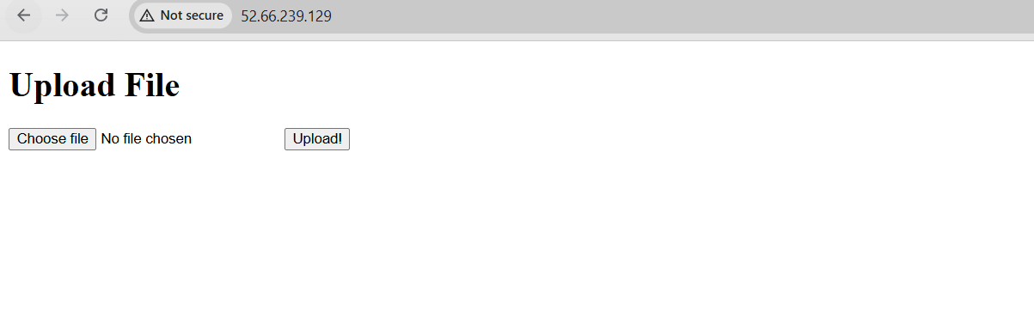
2. pm2 status
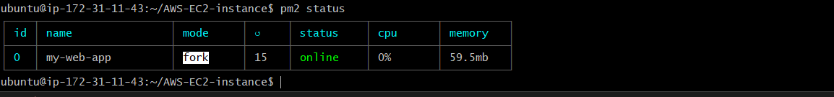

3. NGINX status:
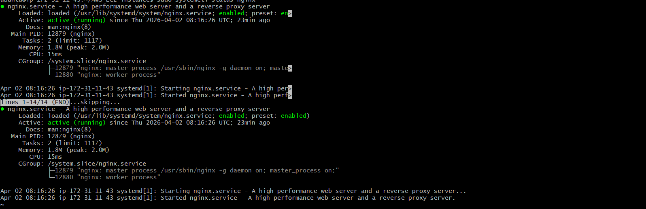

4. AWS server running
