**Luminar Jama Requirement Link Python GUI**

Scope: This document is guidelines to use “Luminar Jama Requirement Link” python GUI.

**Features:**

1. You can create a link (upstream/downstream) between two jama requirements using their API ID mentioned in jama.
2. You can create a links for Multiple jama requirements by feeding excel input file of API ID of requirements.

**Supporting Features:**

1. You can test browse excel fetches correct column by disabling jama linking radio button.
2. You can launch debugger window in Menu Setting>>Debugger Window to understand background processing.
3. You can change jama credentials in Menu Setting>>jama_credentials.

**Procedure:**

**Initial Setup**

|  |  |
| --- | --- |
| 1 | Launch LuJaR.exe |
| 2 | Enter your jama credentials in Setting ->>jama_credentials  Verify jama credentials Setting ->> options |
| 3 | If necessary, launch Debugger window Setting>>Debugger Window |

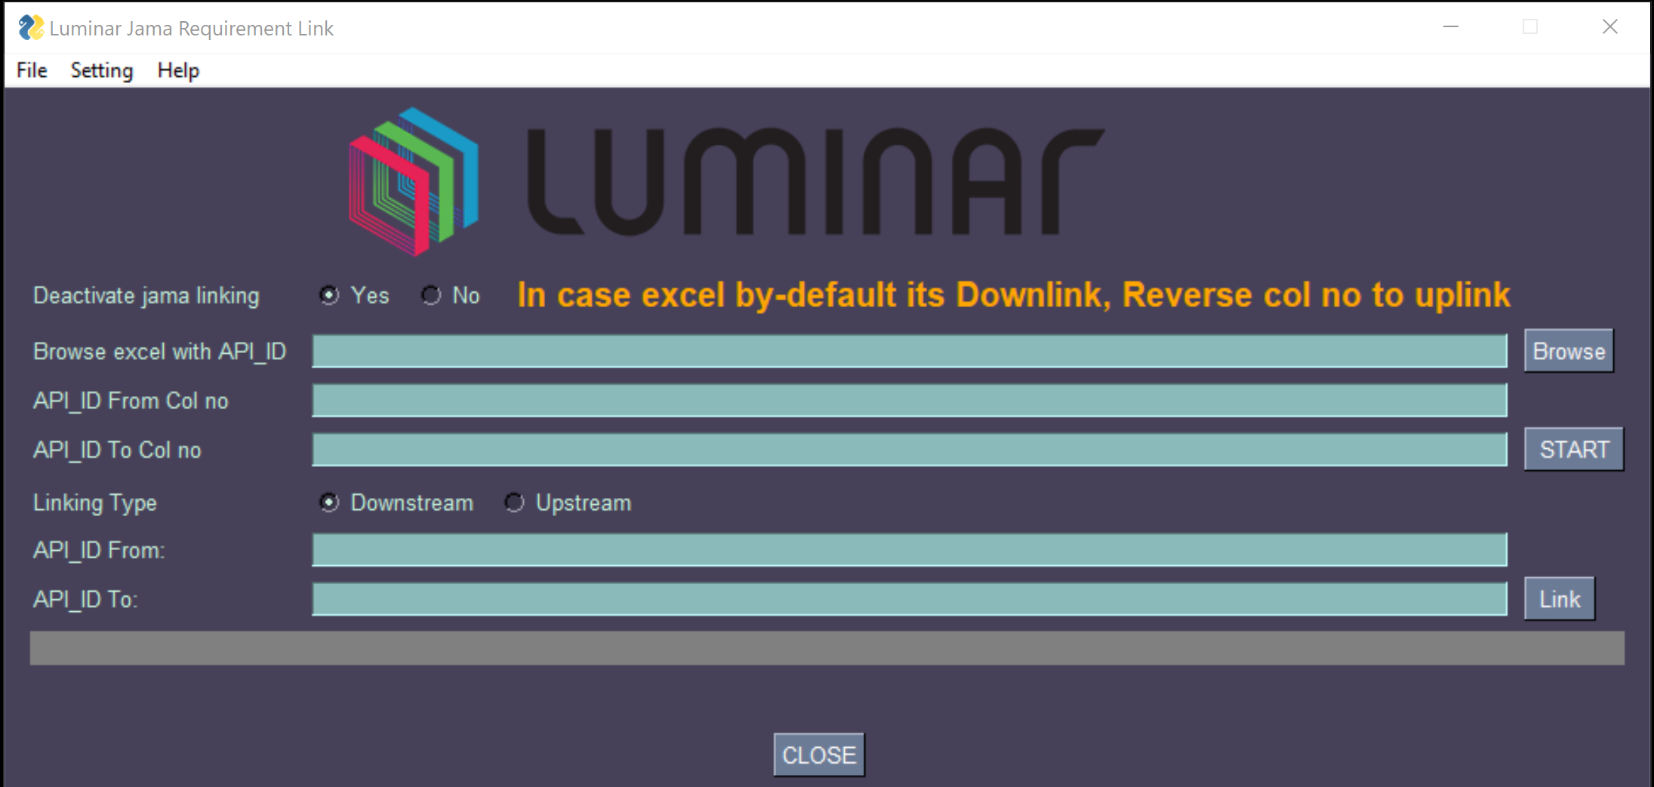

Q. How to add Downstream between two jama requirements?

1. Check API ID of two jama requirements from Jama project.

2. Use following fields to add downstream link

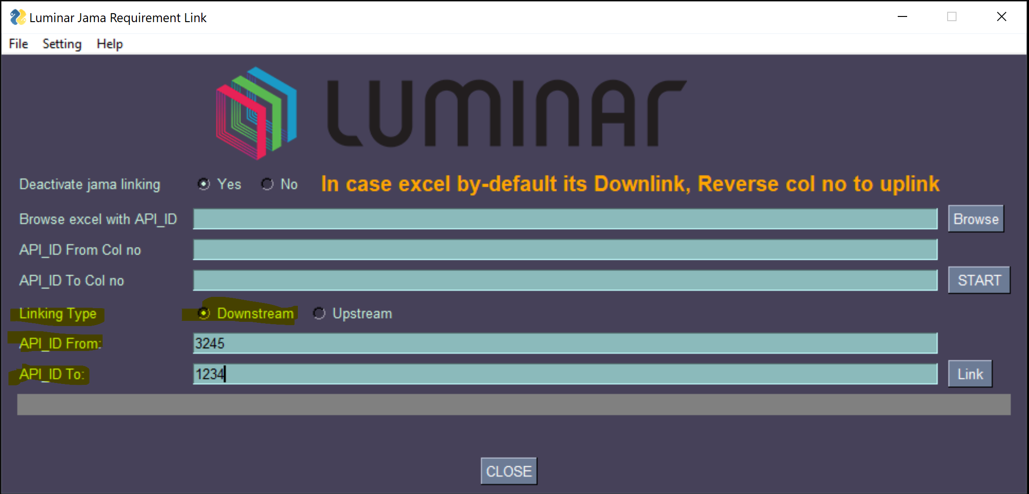

3.By default “**Linking Type**” is “**Downstream**” selection if not select it as you want to add downstream link

4. Enter API ID of in field “**API_ID From**” – e.g 3245 in above image

5. Enter API ID of in field “**API_ID To**” – e.g 1234 in above image

6. Downstream link will be added between **3245 ---- downstream ---🡪 1234**

7. Click on “**Link**” button for linking.

Q. How to add Upstream between two jama requirements?

- change “**Linking Type**” to “**Upstream**” and follow same procedure from steps 4 to 7 in above query.

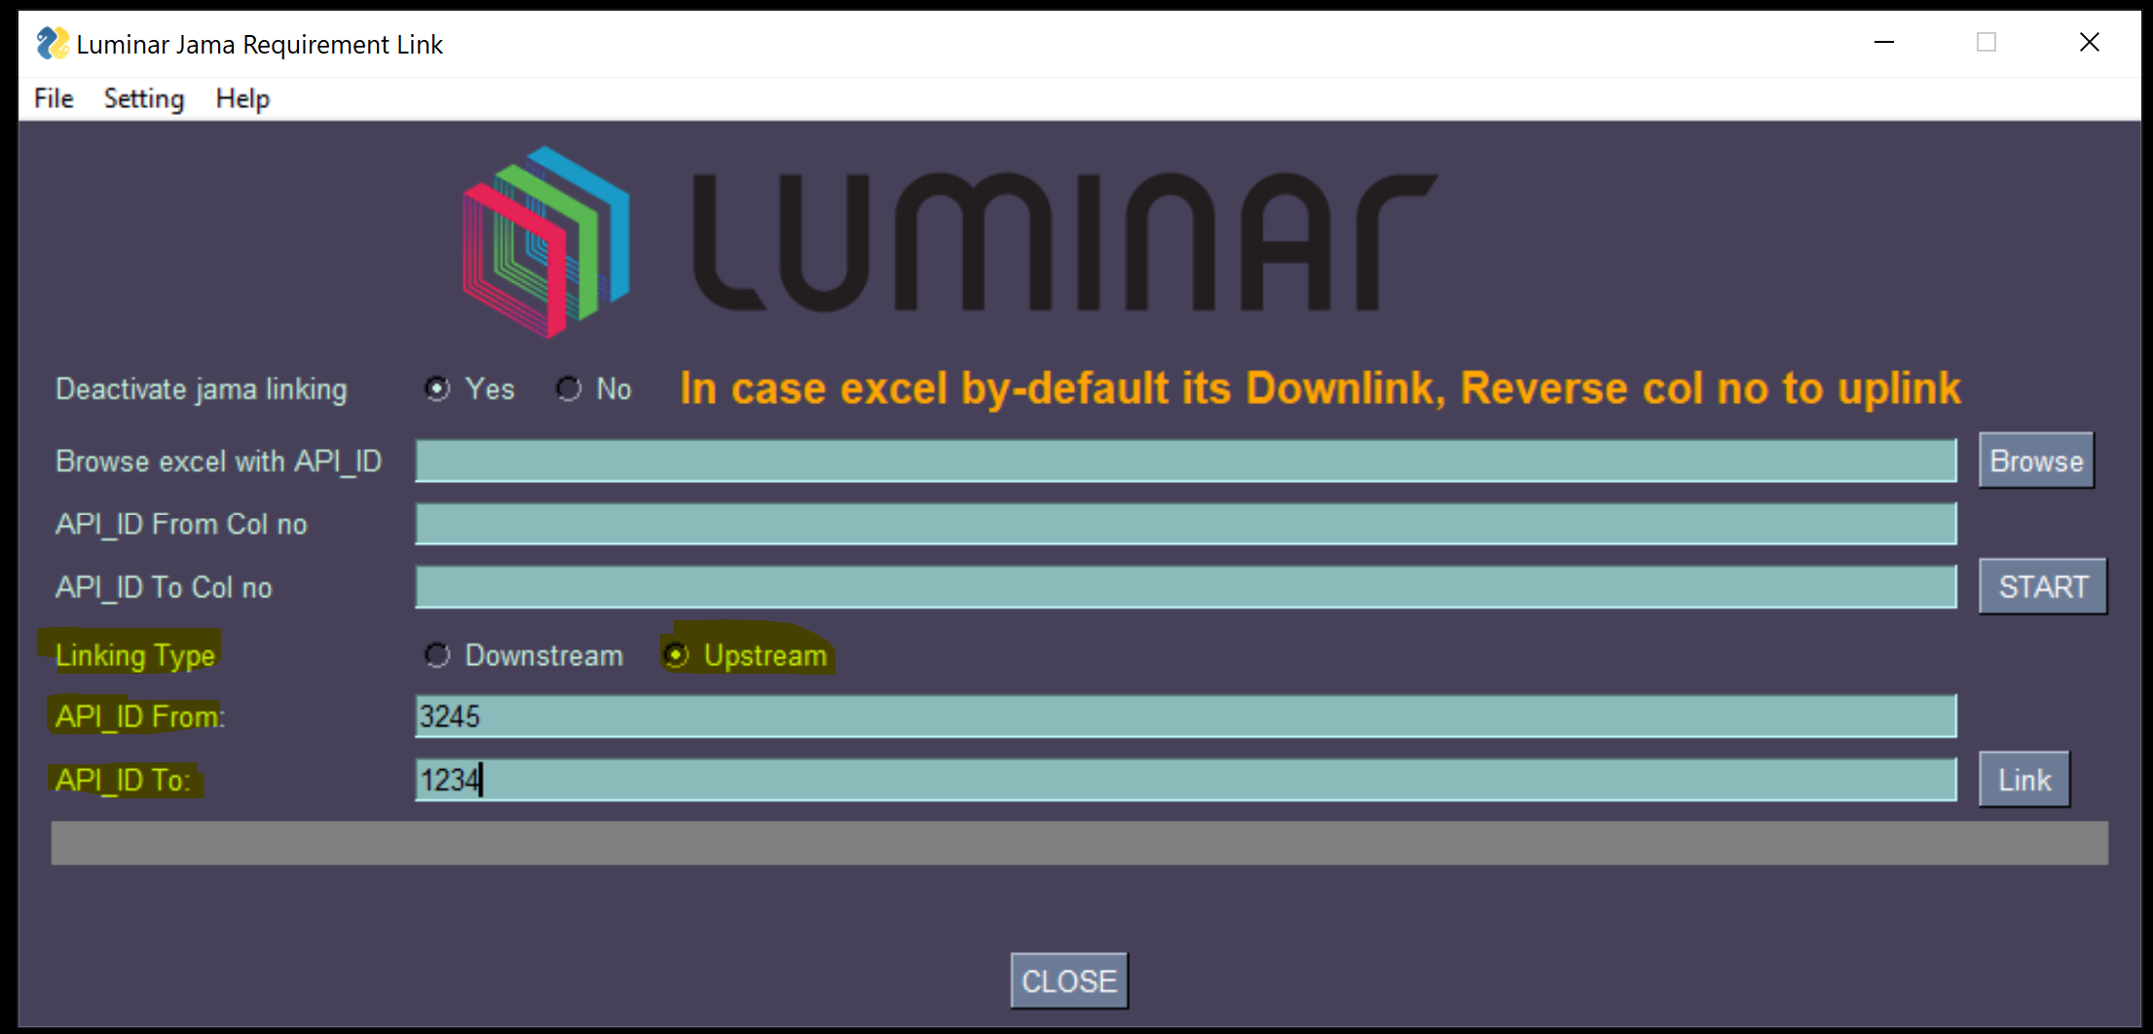

Q. What is “Deactivate jama linking” option?

* This option is useful for debugging purpose. Once you browse excel of API IDs and entering column no, you can check if API_ID are fetched properly.

If you click on “START” button you will see Debug window with information

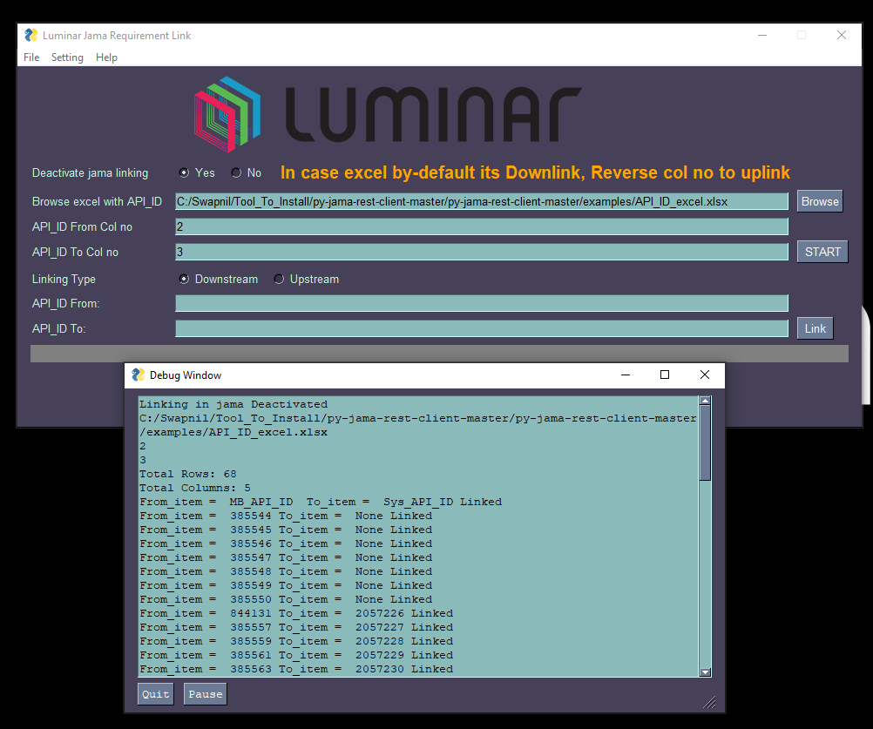

**Note:** You need to select **No if you want to do actual jama linking.**

**Q. what is mean by “In case excel by-default its Downlink, Reverse Col no to uplink”?**

- This text is for information.

Consider you have cust ID – 123 sys ID – 456 and Sw ID – 789

1. You want link cust_ID ----- **Downlink** -🡪 sys ID then **From** --- Downlink🡪 **To**

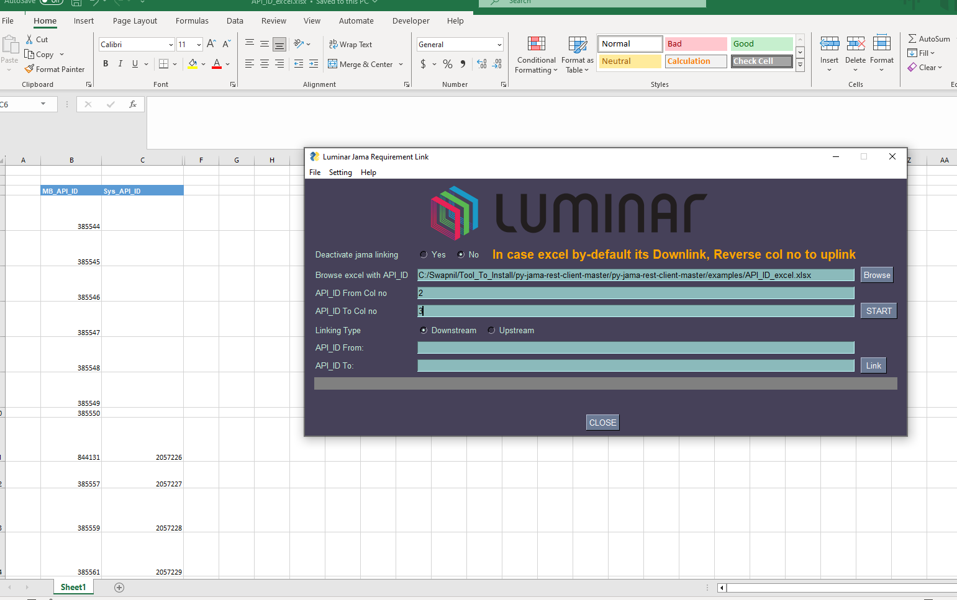

1. Now if you want to uplink

sys_ID ----- **Upnlink** -🡪 Cust_ID then **From** --- Uplink🡪 **To just reverse col no**

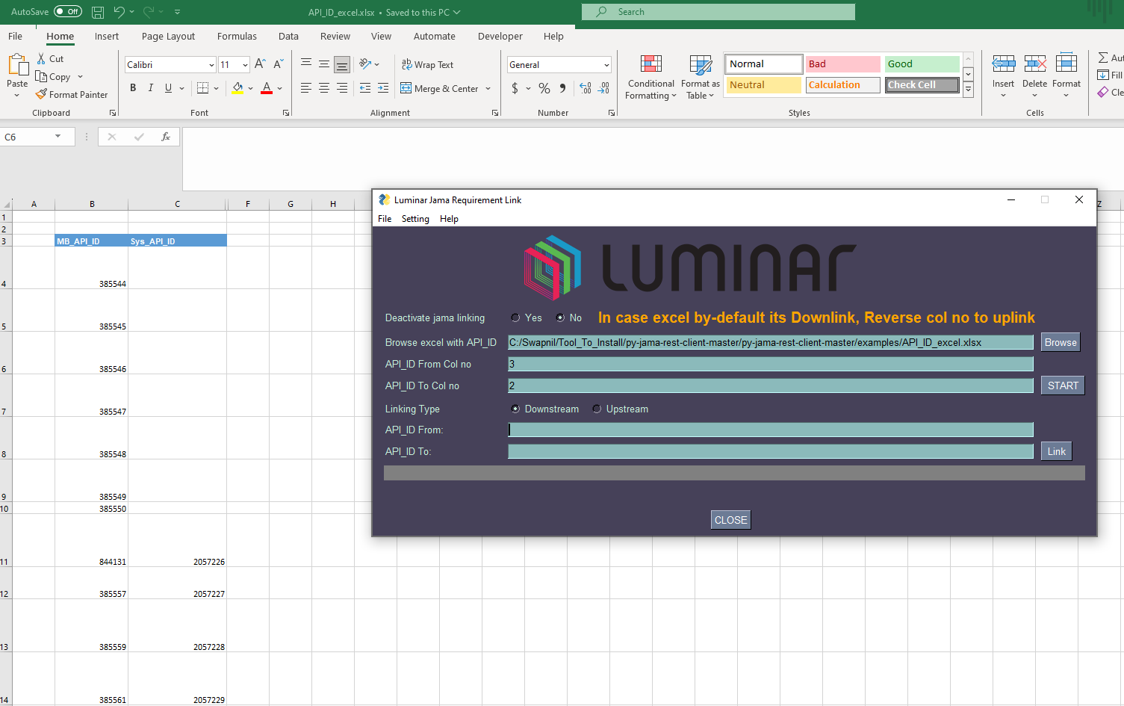

**Q. How to generate jama credentials and enter in gui?**

-

1. Generation of Jama credentials

follow procedure give in link below

<https://help.jamasoftware.com/ah/en/setting-up-your-work-environment/managing-your-profile/set-api-credentials.html>

Note: client secret code will be visible once please copy it and keep it safe

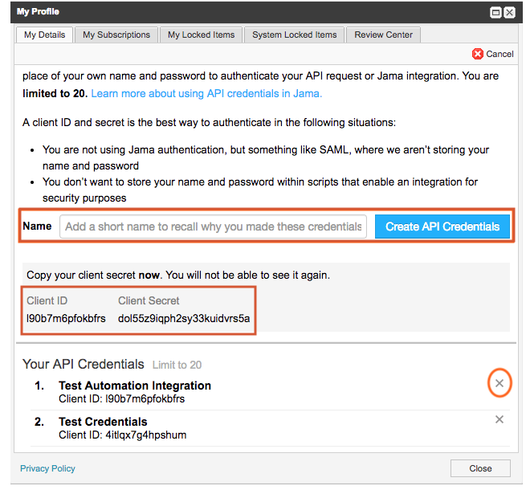

1. Entering credentials in GUI

Go to setting ->> jama_credentials

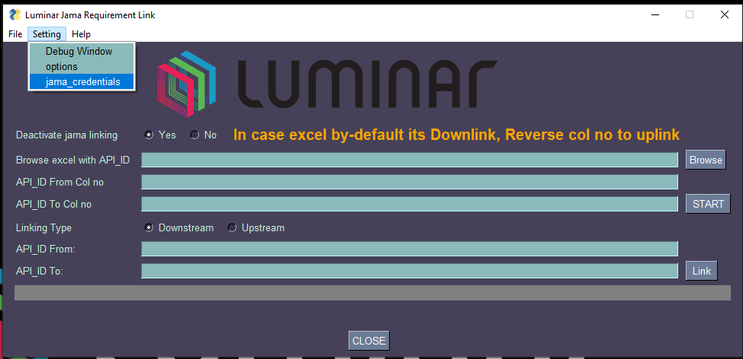

Enter Client ID ->> OK

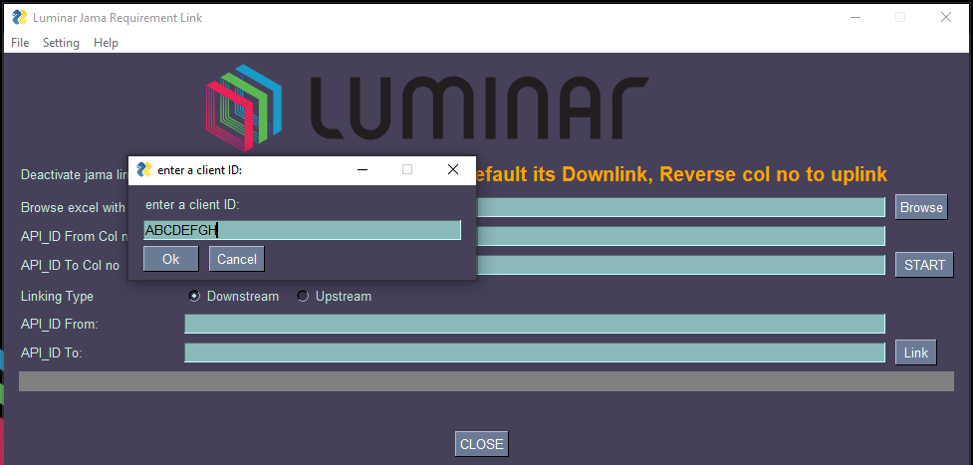

Enter Client secret Code ->> OK

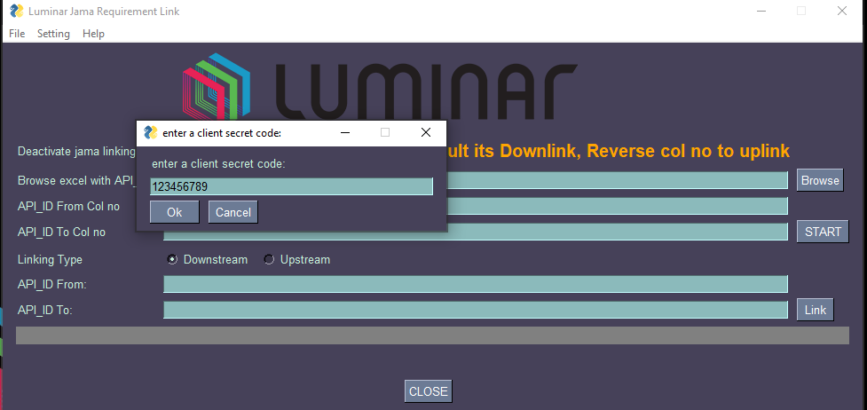

**Q. How do I verify current jama credentials?**

- Go to Setting ->> options . you can see current jama credentials

Dummy Credentials

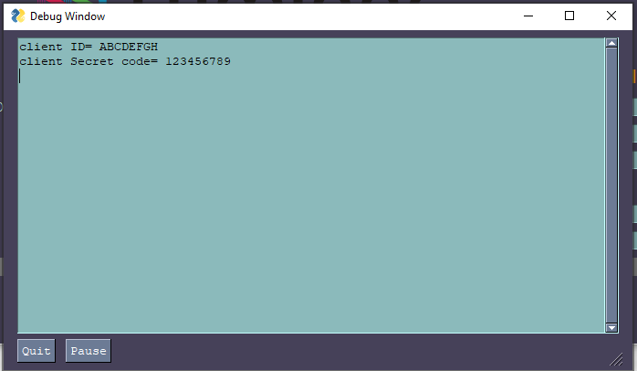

**Q. How do I add jama credentials in GUI?**

->

* Go to Setting ->> Fetch_Jama_Cred
* Enter your details and save

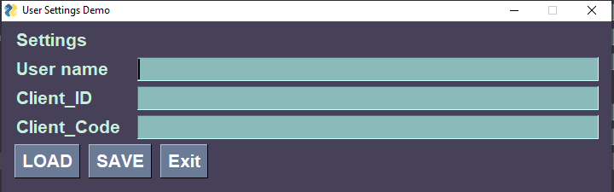

* Or you can click on “Load” to fetch previously stored credentials.

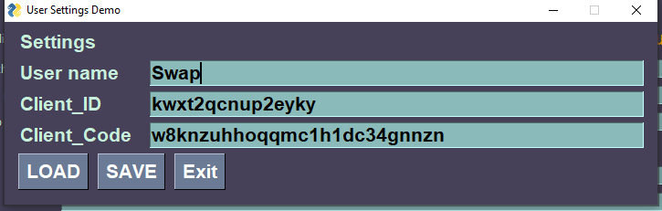

**Q. How to enter jama cred outside of GUI?**

->

Open settings.txt file and replace your data

