**Assignment-1**

**Name: Swapnali Thakur**

**Email : swapnalithakur217@gmail.com**

**Assignment-1**

**Connect and disconnect with login Access:**

• What happens when you login a non-existent users or username?

o Provide Screenshot and What you understand, explain in short brief?

**ANS:** When i try to log in to the CentOs server with non-existent user. User name : **user1** then I came across below error which specified that Login incorrect.

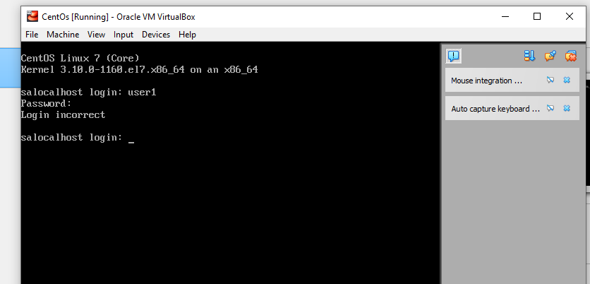

**Assignment-2**

**Password changing**

• Login into your account and then change password?

o Change your password into IneuR0n#42 and hit the Enter key

♣ Explain what happen and give screenshot?

**ANS:** After logininto the centOs server I ran the below command **$ passwd**

After that its prompted for me to entering new password so I have enter the **IneuR0n#42** as password , after entering new password again its prompted me to retype new password then its shows all authentication token updated successfully.

Please check the below screenshot for the same.

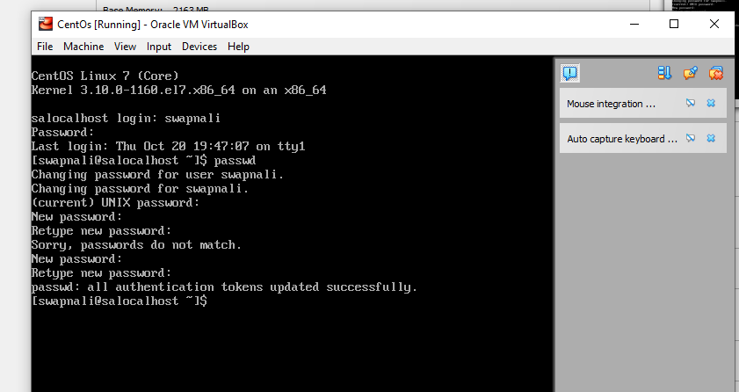

o Try again to change password but use like password 1234 or abcd

♣ Explain what happen and give screenshot?

**ANS:** Afterchanging **centOs** server user password I ran the same command **$ passwd** to change password again. its prompted me for current password after entering current password its prompted me for new password so here I have entered **abcd** as password then its shown me the password is shorter than 8 characters. Added screenshot below foe the same.

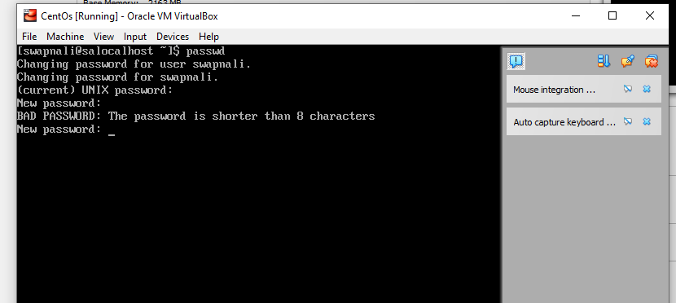

o Try again to change password but now don’t use any password just hit Enter key

♣ Explain what happen and give screenshot?

**ANS:** to changing password again I ran the same command **$ passwd** then without entering any password just entered Enter key its shown me authentication token manipulation error. Added screenshot below for the same.

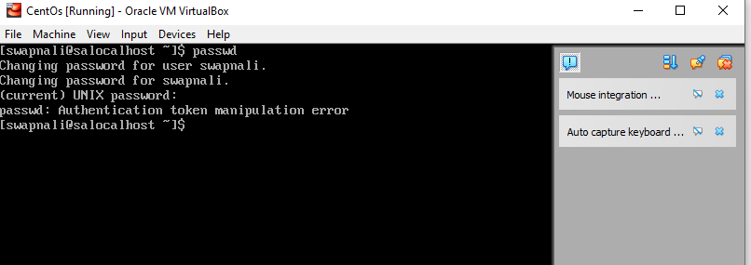

**Assignment-3**

**Working with Directories**

• Enter the command cd / and then ls and then hit Enter key

o Take screenshot and explain what output we got?

**ANS:**  when I entered “cd /” command , directory changed to root (/) directory.

And when I ran “ls” command, command shown the list of the files and folders inside root(/) directory. Added screenshot below.

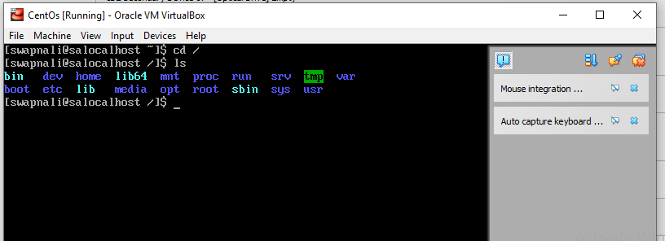

• Enter the command now cd /home and then hit Enter key

o Do ls, provide screenshot and explain what is /home directory used for?

**ANS:**  when I entered “cd /home” command , directory changed from root (/) to home directory.

Added screenshot below.

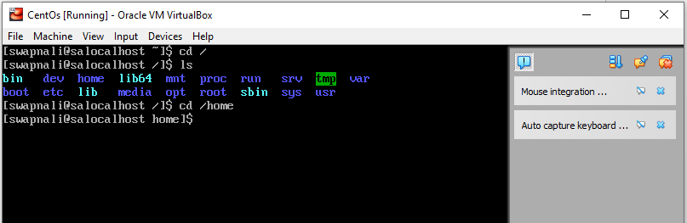

• Enter cd .. and hit Enter key [ Note: here we have space after cd then use double dot]

o Check what happen and give screenshot?

**ANS:**  when I entered “cd ..” command , directory changed from home to root (/) directory.

Added screenshot below.

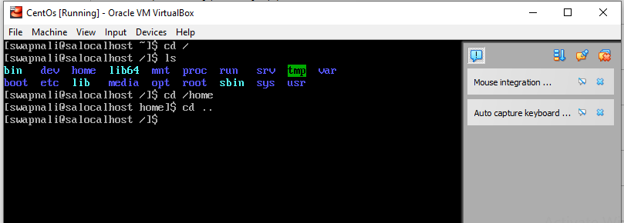

• Now enter cd /var/www/html and then type cd and hit Enter key

o Explain what happen and give screenshot?

**ANS:**  when I entered “cd /var/www/html” command its shown me no such file or directory.

Then I have installed “httpd” package using command “yum install httpd” but it prompted with error.

So I switched into the root user using command “su –“ and ran the same command again and able to install httpd package successfully.

Added screenshot below.

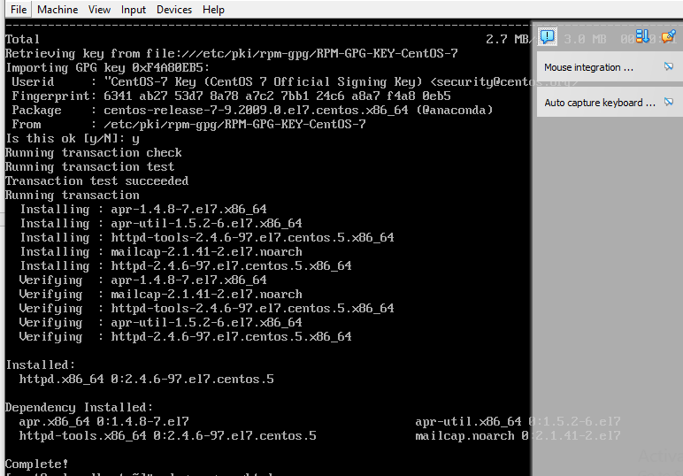

• Now type cd /root and then hit Enter key

o Do ls, check any output we have on screen if yes then take screenshot?

**ANS:**  when I entered “cd /root” command and then “ls” its shown me below file.

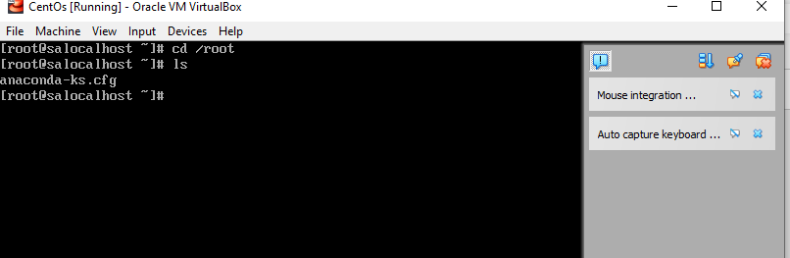

**Assignment-4**

**Working with File Listing**

• Go to cd /etc and type ls o Take screenshot and explain what files you have seeing?

o Take screenshot and explain what different output you found compare to previous command you used?

**ANS:**  here I have login with the user swapnali then entered “cd /etc” command and then “ls” its shown me below list files.

When I use “cd /etc” and take the list then it’s shown all things in the etc (configuration files)

When is use “cd /root” and take the list then its shown files inside root directory.

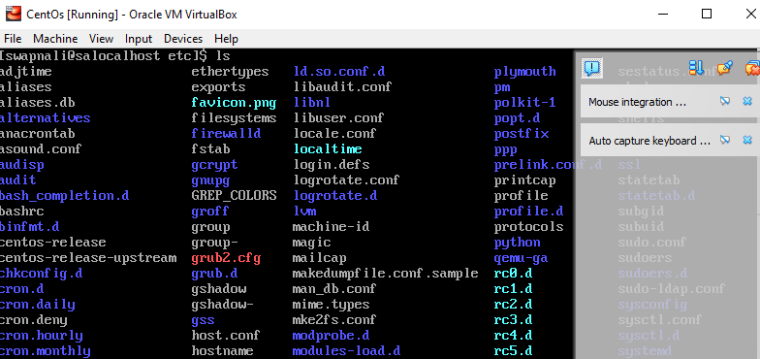

• Then type ls -al and hit Enter key

o Take screenshot and explain what new file or directory you found?

**ANS:** when ran “ls -al” command its shown all files such as hidden files starting with dot (.) with the long listing format.

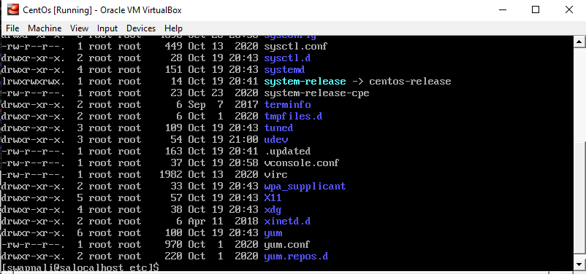

• Then use ls -i and hit Enter key

o Now see what different output its shows and take screenshot?

**ANS:** when ran “ls -i” command some number added before the file name. this are the index number for each file.

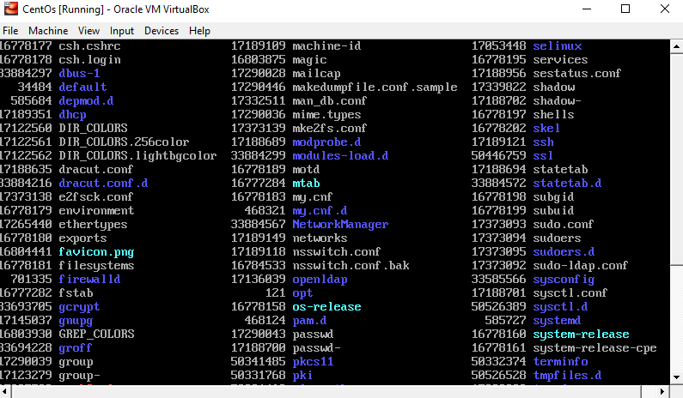

• Then use ls –help and see other options about ls command

o Explore it and try with other attribute we can use with ls command

**ANS:** when ran “ls --help” command its shown me all possible command with description that we can use this “ls” list directory contents.

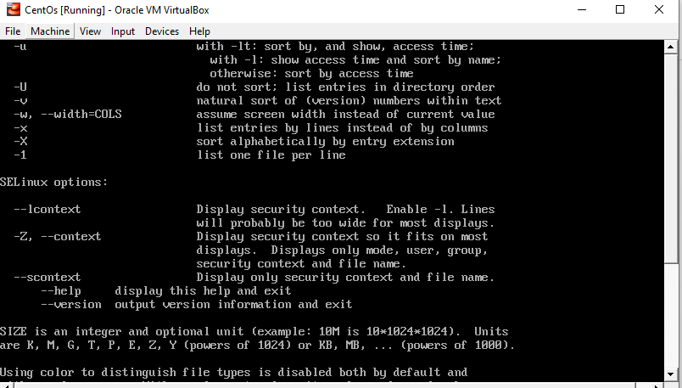

After the I ran “ls -X” command its shown all files sort alphabetically by entry extension.

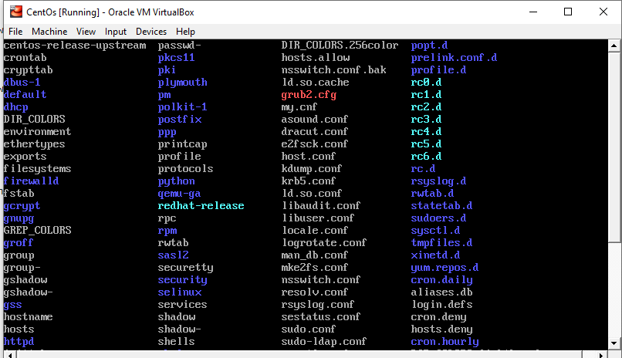

**Assignment-5**

**Know where you are and where you working**

Here we use pwd, cd and ls as combine task to understand where you working on terminal and how you can switch from one directory to another one.

• Open terminal after restart the linux

o Check which location you working, type pwd and take screenshot

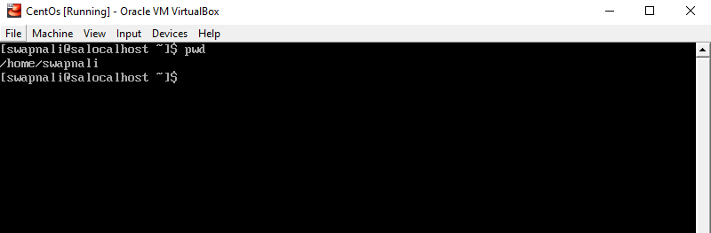

• Now use cd /var and hit Enter key

o Do ls, and see what output comes, give screenshot?

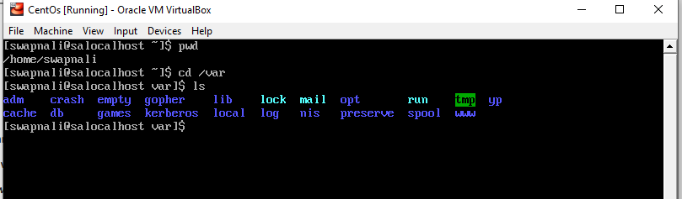

• Do explore other help options of each command to learn more other things we can do with these command