**Linux Basic Commands Assignment**

**Name: Swapnali Thakur**

**Email: swapnalithakur217@gmail.com**

**Assignment Part-3**

**Playing with files**

1. Create a file like nano file1.txt

o Edit some data and then save the file

**ANS**: nano command was not working for me so I have created file using “cat” command and added text into it.

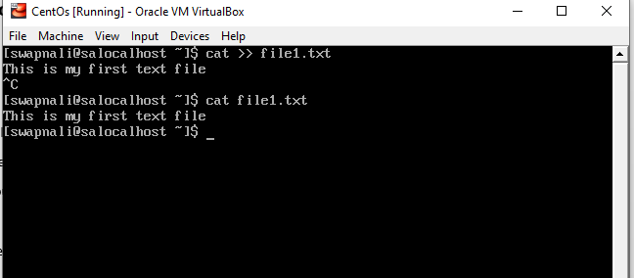

2. Now we will copy date from file1 to new file2

o cp file1.txt file2.txt o Then see the output of file2.txt, cat file2.txt

o Give screenshot

**ANS**: I have created file2.txt using cat command without adding any text into it, then copy file1 text into file2 using “cp” command.

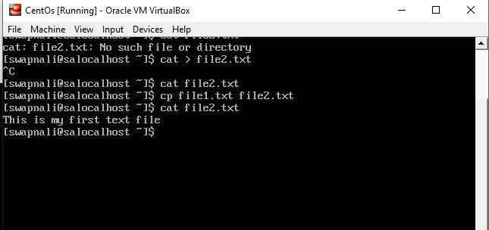

3. Now we will move the file2.txt to new folder /home

o mv file2.txt /home

o Then go to home directory and check ls, file exits or not?

o Given screenshot

ANS: I had login with root user then check list of file inside /home/swapnali/ I found both file1.txt and file2.txt files , then I had move file2.txt file to /home directory using “mv” command.

Then I had check list of file inside /home I was able to find file2.txt inside /home

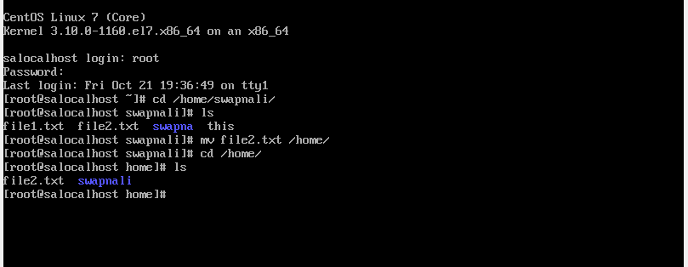

4. Then we create a new file3.txt and file4.txt in home directory and add content in it.

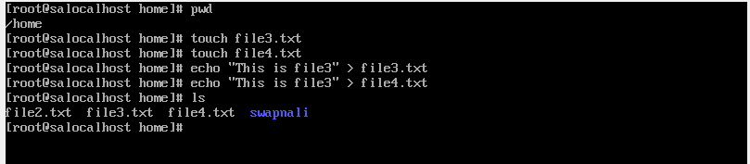

o Now do echo “Hello I am newline” > file3.txt and provide the output of file3.txt

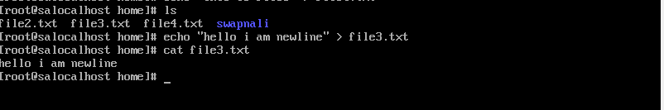

o Now do echo “Hello I am newline” >> file4.txt and provide the output of file4.txt



o Tell the different between both step you follow and the reason behind it

**ANS**: In first step I used > for writing the text into file3.txt, then it remove existing text from file and added new line into it.

In second step I used >> for writing the text into file4.txt, then new line got appended to existing text.

5. For remove a file or directory you can use the below two commands

o To delete a directory - rmdir <any _ directoryname>

