Code :

1. Hysys file opening
2. Pressure variation code
3. Fetch mole fraction(backdoor) object of the ammonia in the outlet of the reactor
4. Data directly stored in xl for each run , overwrite for the same running conditions

Report1:

1. Unknown value of max conversion , on different parameters (equilibrium conversion )
2. Need to know which parameters are actually need to vary for optimisation and correspondingly which output parameters are need to be fetched (
3. Mainly [ pressure ,temperature , feed flowrate ] are varying parameters
4. On basis of the given kinetics and reaction catalyst we should be known about the range of the varying parameters (sumit sir)
5. Ke = Kf/Kb is temperature dependent , lower temperature favours the higher conversion

Stage 2:

1. First try to write the code which will made changes only in the pressure of the streams which are inlet to the PFR , and fetch the mole fraction of the ammonia in outlet stream of the reactor although both inlet streams have same pressure because ammonia inlet stream is just for execution of the reversible kinetics
2. A diagram of a machine

   AI-generated content may be incorrect.
3. So this now are to get some streams data In the top of the excel and with varying pressure of streams and corresponding mole fraction of ammonia in the R1-out  
   Temperature (Reactor-feed)

Temperature (R1-out)

Mole Fraction of Nitrogen (Reactor-feed)

Mole Fraction of Nitrogen (R1-out)

Mole Fraction of Hydrogen (Reactor-feed)

Mole Fraction of Hydrogen (R1-out)

Mole Fraction of Ammonia (Reactor-feed)

Stage 3:

1. Now pressure varying task is done , lets now vary the temperature, similarly I am varying the temperature of the Reactor feed and inlet Ammonia , at a same instant both streams will have the same temperature   
   although whenever you will try to operate in Temperature mode summary data include:  
   Pressure (Reactor-feed)

Pressure (R1-out)

Mole Fraction of Nitrogen (Reactor-feed)

Mole Fraction of Nitrogen (R1-out)

Mole Fraction of Hydrogen (Reactor-feed)

Mole Fraction of Hydrogen (R1-out)

Mole Fraction of Ammonia (Reactor-feed)

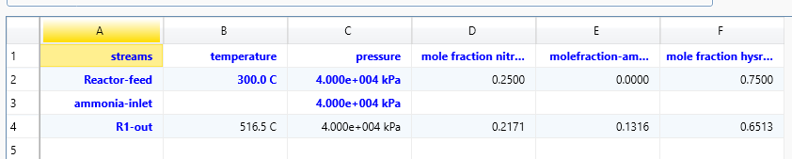

By the use of the above spreadsheet, we are able to get summary data.

Stage 4:

As in the previous what were doing is that we were introducing the min, max value and interval no we will use the library “Sobol”

Now instead of defining the interval we are defining the number of sobol samples:  
scaled value=min+(max−min) ×fraction

Where fractions the are normalised value between the [0 to 1]

These fraction values are called the sobol values.

Stage 5:

Now we are going to improve flowsheet for the separation process there we will go through the further analysis