**Topics: Normal distribution, Functions of Random Variables**

1. The time required for servicing transmissions is normally distributed with *μ* = 45 minutes and *σ* = 8 minutes. The service manager plans to have work begin on the transmission of a customer’s car 10 minutes after the car is dropped off and the customer is told that the car will be ready within 1 hour from drop-off. What is the probability that the service manager cannot meet his commitment?
2. 0.3875
3. 0.2676
4. 0.5
5. 0.6987

Ans : option B

Normal distribution with *μ* = 45 minutes

*σ* = 8 minutes

P(x>50) = 1-p(x<50)

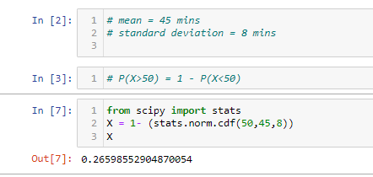

1. The current age (in years) of 400 clerical employees at an insurance claims processing center is normally distributed with mean *μ* = 38 and Standard deviation *σ* =6. For each statement below, please specify True/False. If false, briefly explain why.
2. More employees at the processing center are older than 44 than between 38 and 44.
3. A training program for employees under the age of 30 at the center would be expected to attract about 36 employees.

Ans : A is False and B is True

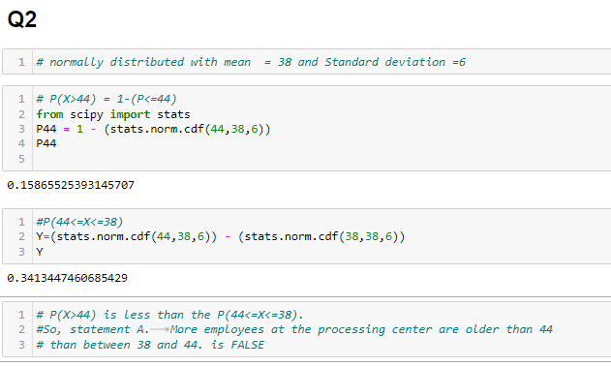

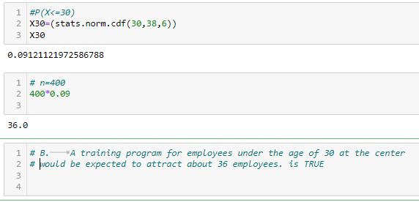

1. If *X1* ~ *N*(μ, σ2) and *X*2 ~ *N*(μ, σ2) are *iid* normal random variables, then what is the difference between 2 *X*1 and *X*1 + *X*2? Discuss both their distributions and parameters.

Ans :

From the properties of normal random variables,

if  and  are two independent identically distributed random variables then

* the sum of normal random variables is given by

,

* and the difference of normal random variables is given by



* When  , the product of X is given by



* When  , the linear combination of X and Y is given by



Given X1 ~ *N*(μ, σ2) and *X*2 ~ *N*(μ, σ2) are independent identically distributed (iid)normal random variables

X1 + X2 ~ N(μ+ μ , σ2 + σ2 ) = N(2μ , 2σ2 )

2X1 ~ N(2μ , 22 σ2 ) = N(2μ , 4σ2 )

Difference between 2X1 and X1+X2 is

2X1 – (X1+X2) = N(2μ-2μ , 4σ2 + 2σ2 ) = N(0, 6σ2 )

The mean of  and  is same but the variance () of   is 2 times more than the variance of .

1. Let X ~ N(100, 202). Find two values, *a* and *b*, symmetric about the mean, such that the probability of the random variable taking a value between them is 0.99.
2. 90.5, 105.9
3. 80.2, 119.8
4. 22, 78
5. 48.5, 151.5
6. 90.1, 109.9

Ans :

Given p(a<x<b) = 0.99, mean =100, Variance = 202, standard deviation = 20

symmetric values for the standard normal distribution such that the area enclosed is 0.99

From the above details, exclude the area of 0.005 in each of the left and right tails.

Hence, need to find the 0.5th and the 99.5th percentiles Z score values

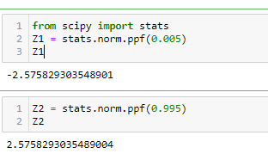

Z= (X- μ) / σ

X - μ = Z σ

X = Z σ + μ

Z = (x - 100)/20 = > x = 20z+100

      a = (20*-2.576) + 100= 48.48

      b = (20*2.576)+100= 151.52

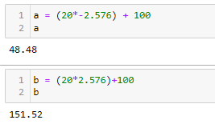

Two values symmetric about mean for the given standard normal distribution are [48.5 ,151.5]

Option is D

1. Consider a company that has two different divisions. The annual profits from the two divisions are independent and have distributions Profit1 ~ N(5, 32) and Profit2 ~ N(7, 42) respectively. Both the profits are in $ Million. Answer the following questions about the total profit of the company in Rupees. Assume that $1 = Rs. 45
   1. Specify a Rupee range (centered on the mean) such that it contains 95% probability for the annual profit of the company.

Ans :

Given Profit1 ~ N(5, 32) and Profit2 ~ N(7, 42)

Total Mean = 5+7 =12 million $

Assume that $1 = Rs. 45

Total mean in rupees = 12 * 45 = Rs. 540 million

Total standard deviation = sqrt(9+16) = sqrt(25) = $ 5 millions

Total standard deviation in rupees = 5 * 45 = Rs. 225 millions

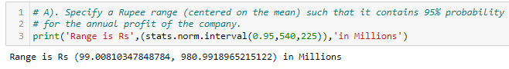

* 1. Specify the 5th percentile of profit (in Rupees) for the company

Ans :

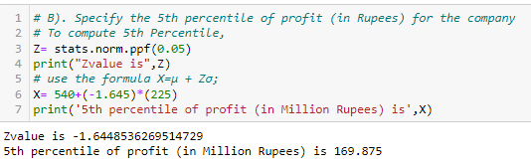

* 1. Which of the two divisions has a larger probability of making a loss in a given year?

Ans : Division 1 has slightly larger probability than division 2 probability of making a loss in a given year.

