Topics: Confidence Intervals

- For each of the following statements, indicate whether it is True/False. If false, explain why.

- The sample size of the survey should at least be a fixed percentage of the population size in order to produce representative results.

Ans: True - The survey should have a specific sample size, a fixed percentage of population that helps to analyze the data well to give more accurate results/model.

- The sampling frame is a list of every item that appears in a survey sample, including those that did not respond to questions.

Ans: False - The sampling frame refers to a list of an item which responds to the question and not the ones which do not respond to the questions.

- Larger surveys convey a more accurate impression of the population than smaller surveys.

Ans: True: The larger conveys a more accurate impression of the population as larger surveys involve large sample size which reduces the chances of error.

- PC Magazine asked all of its readers to participate in a survey of their satisfaction with different brands of electronics. In the 2004 survey, which was included in an issue of the magazine that year, more than 9000 readers rated the products on a scale from 1 to 10. The magazine reported that the average rating assigned by 225 readers to a Kodak compact digital camera was 7.5. For this product, identify the following:

- The population
Ans : All Readers of PC Magazine
- The parameter of interest
Ans : average rating of product , scale
- The sampling frame
Ans : 9000 readers
- The sample size
Ans : 225 readers
- The sampling design
Ans : Sampling design is a mathematical function that gives you the probability of any given sample being drawn.
Population → Sampling Frame → sampling method → sample size

Response to the product

- Any potential sources of bias or other problems with the survey or sample
Ans : Marginal error, Confidence level

- For each of the following statements, indicate whether it is True/False. If false, explain why.

- If the 95% confidence interval for the average purchase of customers at a department store is $50 to $110, then $100 is a plausible value for the population mean at this level of confidence.

Ans : True

The 95% confidence interval for the average purchase of customers at a department store is $50 to $110. Which means that there is a 95% chance that the population mean will fall between $50 and $110. Hence, as $100 falls between $50 and $110, it is a plausible value for the population mean at this confidence level.

- If the 95% confidence interval for the number of moviegoers who purchase concessions is 30% to 45%, this means that fewer than half of all moviegoers purchase concessions.

Ans : True

The 95% confidence interval for the number of moviegoers who purchase concessions is 30% to 45%, this means that there is a 95% chance that only 30 to 45 % of moviegoers purchase concessions, which is less than 50%. Hence, we can infer that fewer than half of all the moviegoers purchase concessions.

- The 95% Confidence-Interval for μ only applies if the sample data are nearly normally distributed.

Ans : True

- What are the chances that ?

- ¼
- ½
- ¾
- 1

Ans : option D

- In January 2005, a company that monitors Internet traffic (WebSideStory) reported that its sampling revealed that the Mozilla Firefox browser launched in 2004 had grabbed a 4.6% share of the market.

- If the sample were based on 2,000 users, could Microsoft conclude that Mozilla has a less than 5% share of the market? → False

- WebSideStory claims that its sample includes all the daily Internet users. If that’s the case, then can Microsoft conclude that Mozilla has a less than 5% share of the market? → True

Ans :
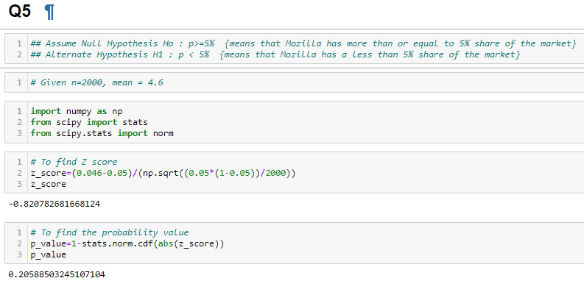

p_value = (0.2058) > (α = 0.05) ; So we can Accept Null Hypothesis i.e. Mozilla market share > 5% Thus, Microsoft can’t conclude that Mozilla has a less than 5% share of the market.

Given : WebSideStory claims that its sample includes all the daily Internet users.
This means that the 4.6% is the population percentage. Comparing it with Microsoft's claim that Mozilla has a less than 5% share of the whole market is True.
Hence, we can conclude that Mozilla has a less than 5% share of the market.

- A book publisher monitors the size of shipments of its textbooks to university bookstores. For a sample of texts used at various schools, the 95% confidence interval for the size of the shipment was 250 ± 45 books. Which, if any, of the following interpretations of this interval are correct?

Ans :
Given that,
the 95% confidence interval for the size of the shipment was 250-45 and 250+45 books.
= 205 and 295

- All shipments are between 205 and 295 books. → Incorrect

- 95% of shipments are between 205 and 295 books. → correct

- The procedure that produced this interval generates ranges that hold the population mean for 95% of samples. → correct

- If we get another sample, then we can be 95% sure that the mean of this second sample is between 205 and 295. → correct

- We can be 95% confident that the range 160 to 340 holds the population mean. → Incorrect

- Which is shorter: a 95% z-interval or a 95% t-interval for μ if we know that σ =s?

- The z-interval is shorter
- The t-interval is shorter
- Both are equal
- We cannot say

Ans : option A

95 % confidence interval for mean is shorter for z-interval because t-critical is greater than z-critical value.

Questions 8 and 9 are based on the following: To prepare a report on the economy, analysts need to estimate the percentage of businesses that plan to hire additional employees in the next 60 days.

- How many randomly selected employers (minimum number) must we contact in order to guarantee a margin of error of no more than 4% (at 95% confidence)?

- 600
- 400
- 550
- 1000

Ans : option A

Finding Sample Size for Estimating a Population Proportion

n=(z/M)^{2 *} p~(1−p~)

M is the margin of error
p~ is an estimated value of the proportion

If we have no preconceived idea of the value of the population proportion, then we use p~=0.50 because it is most conservative and it will give use the largest sample size calculation.

Z value for 95% confidence is 1.96
Margin of error is 4% = 0.04

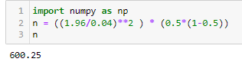

n = 600

600 randomly selected employers (minimum number) must we contact in order to guarantee a margin of error of no more than 4% (at 95% confidence)

- Suppose we want the above margin of error to be based on a 98% confidence level. What sample size (minimum) must we now use?

- 1000
- 757
- 848
- 543

Ans : option C

Finding Sample Size for Estimating a Population Proportion

n=(z/M)^{2 *} p~(1−p~)

M is the margin of error
p~ is an estimated value of the proportion

If we have no preconceived idea of the value of the population proportion, then we use p~=0.50 because it is most conservative and it will give use the largest sample size calculation.

Z value for 98% confidence is 2.326
Margin of error is 4% = 0.04

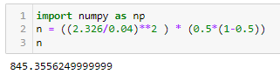

n = 845

sample size we must use is 845

