Follow these steps to raise account ID form to whitelist in GitHub Proxy List

- Raise a new account ID form from our CLIntune sharepoint.
https://clintune.sharepoint.com/sites/Forms/FRM_ID_Review_Auto/_layouts/15/FormServer.aspx?XsnLocation=https://clintune.sharepoint.com/sites/Forms/FRM_ID_Review_Auto/Account%20ID%20Form/Forms/template.xsn&SaveLocation=https%3A%2F%2Fclintune%2Esharepoint%2Ecom%2Fsites%2FForms%2FFRM%5FID%5FReview%5FAuto%2FAccount%20ID%20Form&ClientInstalled=false&DefaultItemOpen=1&Source=https%3A%2F%2Fclintune%2Esharepoint%2Ecom%2Fsites%2FForms%2FFRM%5FID%5FReview%5FAuto%2FAccount%2520ID%2520Form%2FForms%2FAllItems%2Easpx
- Fill up the information as per the sample account ID form as below. {Change the userid accordingly }

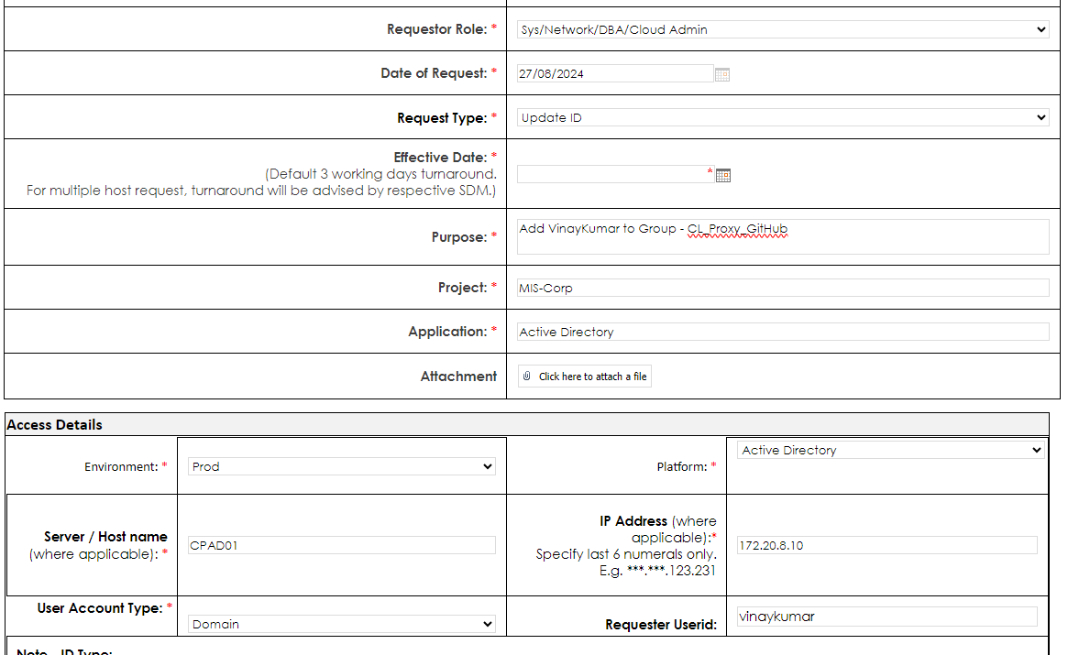

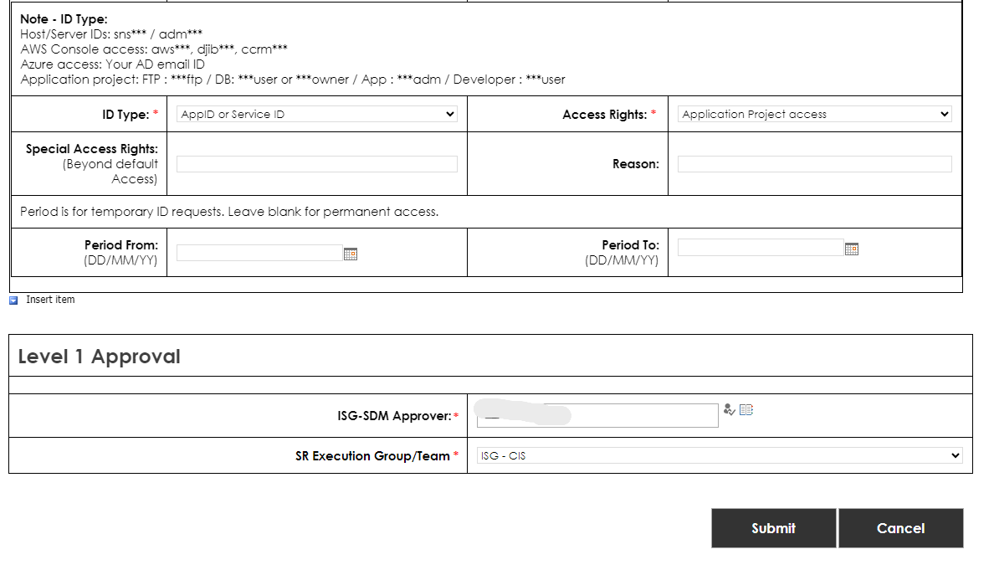
- Choose “Raymond John, Villarmino” as ISG-SDM Approver.
- Once approved let me know in Teams/Email with SR #.

