After running the agent as administrator
Run the config.cmd
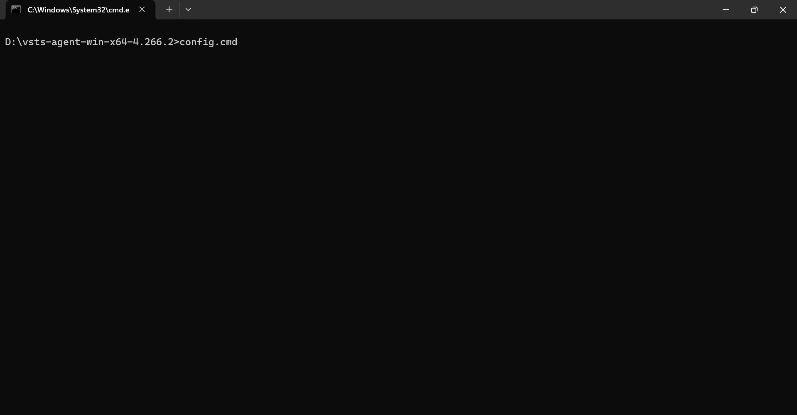
After running the cmd
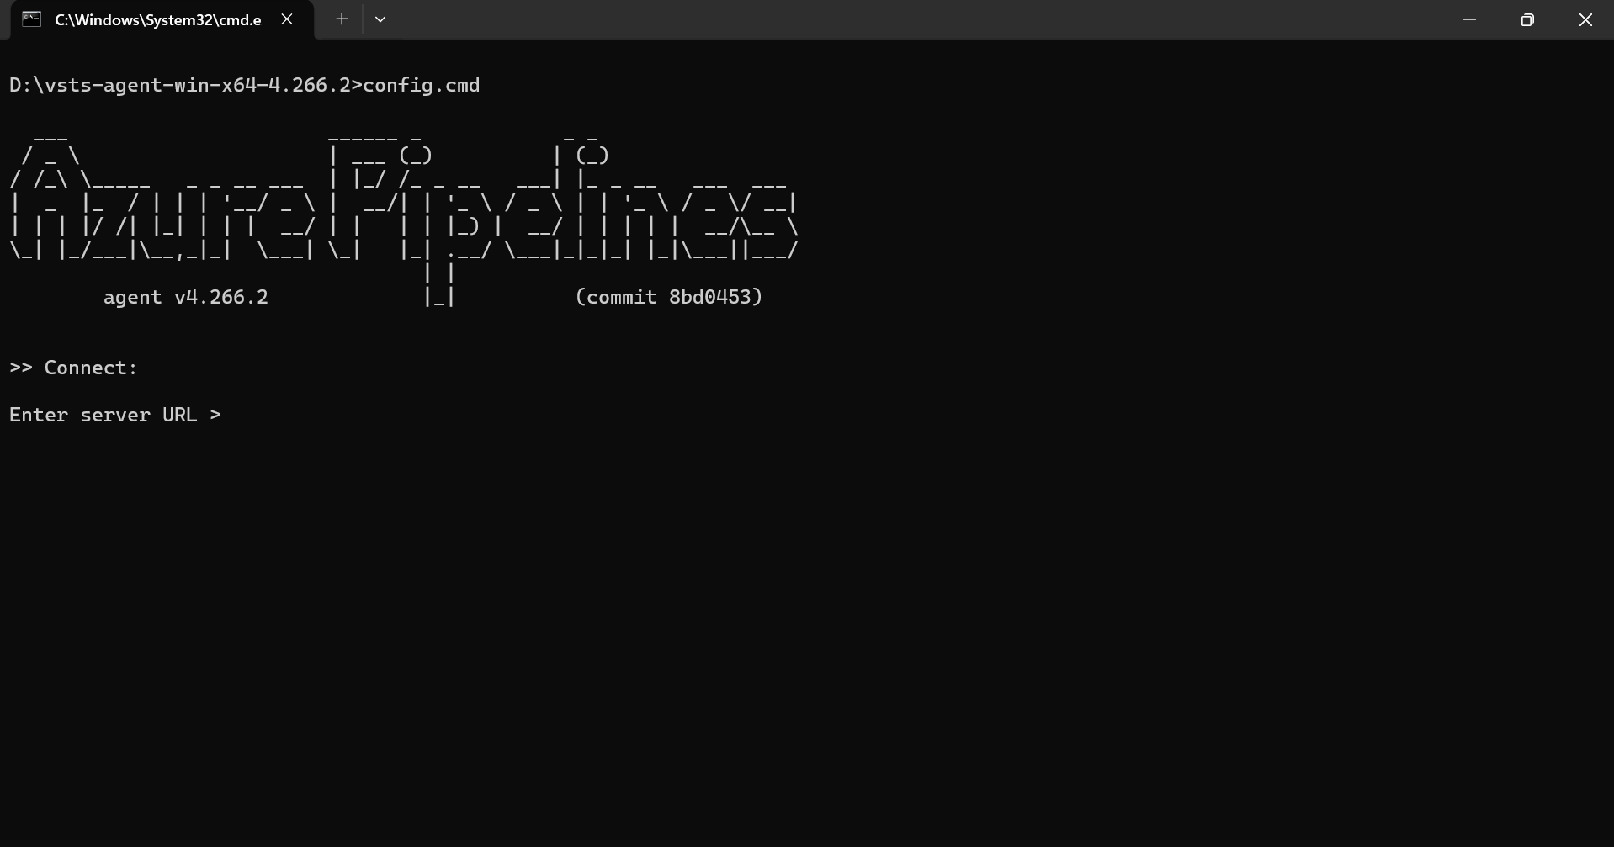
You’ll be prompted for:
- Server URL
https://dev.azure.com/crimsonlogic
- Choose Authentication type → PAT (Personal Access Tokent)
- Enter the Personal Access Token
- Agent pool (usually Default)
- Agent name (any unique name)

In the command prompt follow the below steps (refer the below screenshot for more details):
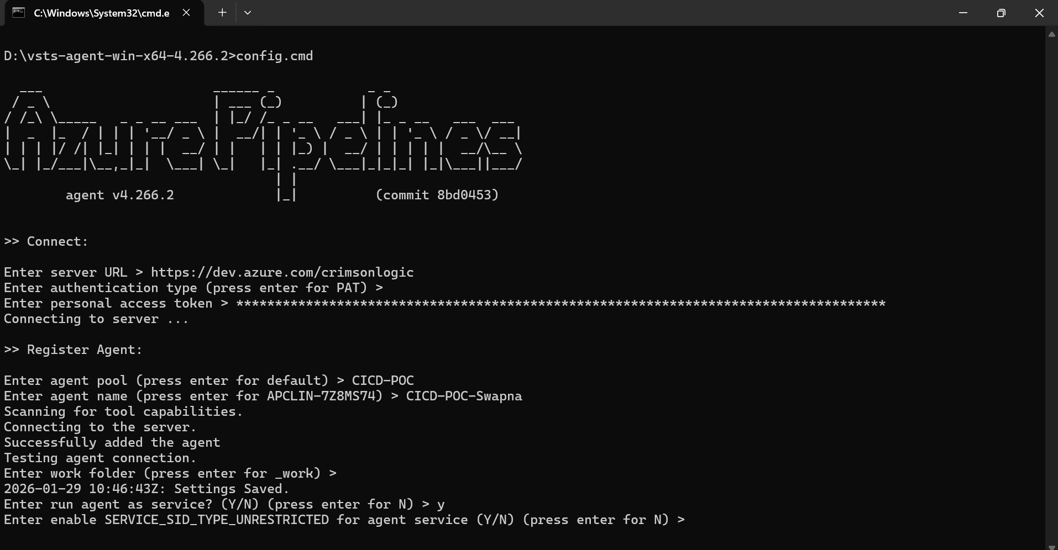
Enter server URL > https://dev.azure.com/crimsonlogic
Enter authentication type (press enter for PAT) >
Enter personal access token >
Connecting to server ...
>> Register Agent:
Enter agent pool (press enter for default) > CICD-POC
Enter agent name (press enter for APCLIN-7Z8MS74) > CICD-POC-Swapna
Scanning for tool capabilities.
Connecting to the server.

Successfully added the agent
Testing agent connection.

After completing the above steps, the command prompt window will be closed automatically.
Once window is closed go to windows button → run and type services.msc
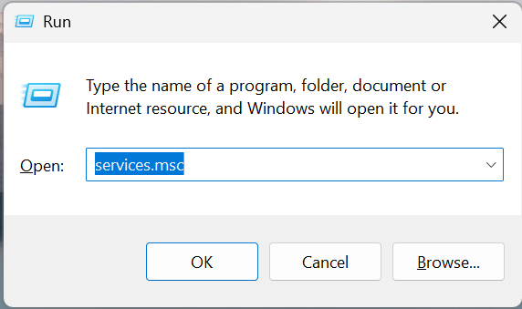

Search for VSTS service running and will be found with agent name created (if it’s not running, please start the service)

