Git Revert vs Git Rebase
Audience: Beginner Developers / Graduate Associates
Contents: Concepts, diagrams, Git Bash command illustrations, hands-on labs, real-world scenarios, and practice questions with answers.

1. Git Commit History Diagrams
Before Revert
A ── B ── C ── D (HEAD)
git revert C
A ── B ── C ── D ── E
↑
E reverses C
Before Rebase
main: A ── B ── C
\
feature: D ── E
After git rebase main
A ── B ── C ── D' ── E'

2. Git Bash Command Illustrations
The following are terminal-style illustrations of expected Git Bash output (not actual screenshots).
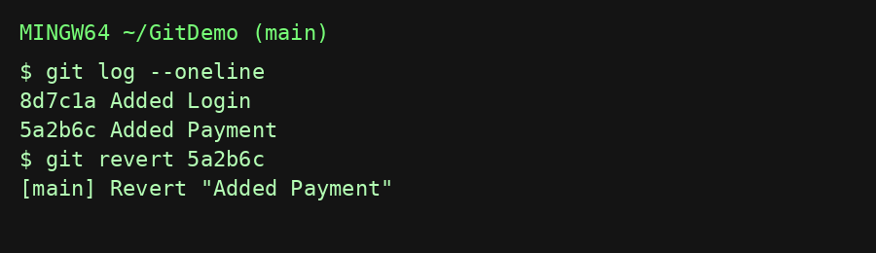
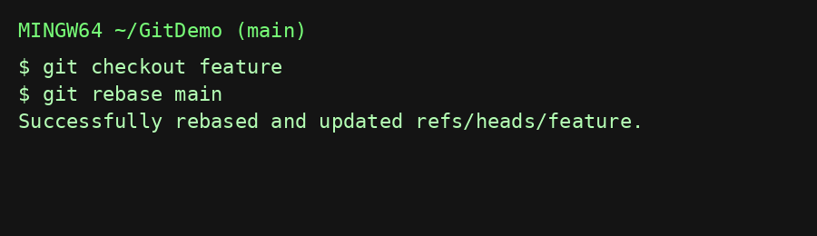

3. Hands-on Lab Exercises
- Lab 1: Create a repository, make four commits, then revert the third commit. Verify that history is preserved.
- Lab 2: Create main and feature branches. Add commits to both, then rebase feature onto main and resolve conflicts.
- Lab 3: Perform an interactive rebase to squash three small commits into one.

4. Real-world Scenarios
Scenario 1: A bug reaches production. The fix must preserve history because multiple developers have already pulled the code.
Answer: Use git revert.
Scenario 2: You have five messy local commits before opening a Pull Request.
Answer: Use interactive rebase to squash and clean up commits.
Scenario 3: Your feature branch is behind main.
Answer: Rebase your local feature branch onto main before creating the PR (if your team's workflow allows history rewriting).

5. Practice Questions with Answers
- When should git revert be preferred?
Answer: On shared/public branches to safely undo changes.
- Does git rebase create new commit IDs?
Answer: Yes. Replayed commits receive new commit hashes.
- Which command preserves history?
Answer: git revert.
- Which command rewrites history?
Answer: git rebase.
- How do you cancel a rebase?
Answer: git rebase --abort

6. Best Practices
• Use git revert on main/master.
• Avoid rebasing commits already pushed to shared branches.
• Resolve conflicts carefully during rebase.
• Use interactive rebase before submitting pull requests to keep history clean.

