Javascript

14/05/2025

Javascript: JavaScript is a interpreted programming language used to create dynamic and interactive content on websites.
It runs in the browser and allows developers to control webpage behavior, respond to user actions, and manipulate HTML and CSS.

Console:
In JavaScript, the console is used to display messages, debug code, and log information to the browser's developer console.
The console.log(--) function in JavaScript is used to print messages or values to the browser's console. It's mainly used for debugging and testing code.
Uses of console.log(--):
- Display variable values
- Check code flow
- Debug errors
- Log function outputs
Example:
<script>
Console.log(“Hello World”);
</script>
Document.write(----)
The document.write() method in JavaScript is used to write text, HTML, or JavaScript code directly into the HTML document.
Example:
<script>
Document.write(“Hello”);
</script>

Variable
A variable is a named container used to store data values that can be referenced and manipulated in a program.



- Variables can store different types of data like numbers, strings, objects, etc.
- JavaScript uses var, let, and const to declare variables.
- The value of a variable can change (except when declared with const).
Examples:
var age = 25;
let city = "New York";
const country = "USA";

Difference between var,let, and const:


Examples:
1.var
var age = 20;
var age = 30;
2.let
let age = 10;
age = 20;
age = 30;
3.const
const age = 10;

15/05/2025

Data Types:

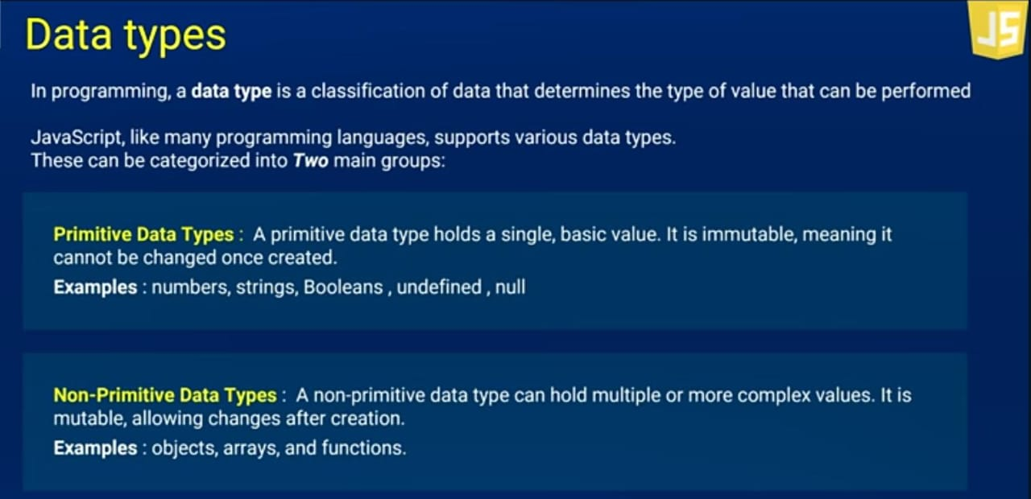

Primitive Data Types

- Numbers: Represents numeric values (both integers and decimals).
Ex: let age = 30;
Console.log(age);
- String: Represents text or collection of characters.
Ex: let name = “swapna”;
Console.log(name);
- Boolean: Represents either true or false.
Ex: let isStudent = true;
Console.log(isStudent);
- Undefined: A variable that has been declared but not assigned a value.
Ex: let x;
console.log(x); // undefined
- Null: Represents an intentional absence of any value.
Ex: let data = null;
Console.log(data);
- Symbol: Represents a unique and immutable identifier.
Ex: let id = symbol(“id”);
Console.log(id);

16/05/2025

Today Class is about Non-Primitive Data Types such as Arrays, Objects.

Non-Primitive Data Types
In JavaScript, non-primitive data types (also known as reference types) are more complex data structures that store collections of values or more complex entities.

1.Array:
An array in JavaScript is a special type of object used to store ordered collections of values. These values can be of any data type—including numbers, strings, objects, functions, or even other arrays.

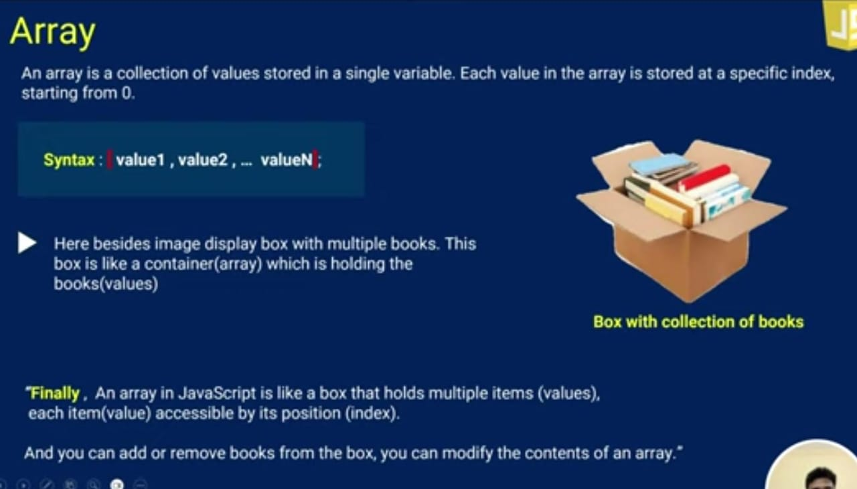

Example:
Let studentNames = [“Swapna”, “Sindhu”, “Sandya”, “Mouni”, “Madhu”];
Console.log(studentNames);
Console.log(studentNames[0]);
2.Objects:
In JavaScript, an object is a non-primitive data type used to store key-value pairs (also known as properties). It's one of the most fundamental building blocks in JavaScript.

Example:
let studentDetails = {Persion1: {Name: “Swapna”, Age: 22, Course: “BTech”},
Persion2: {Name: “Sindhu”, Age: 23, Course: “BTech”},
Persion3: {Name: “Mouni”, Age: 23, Course: “BTech”}};
Console.log(studentDetails[1].Name);



