## **Creating an Angular 7 Project**

## **Step 1: Create a new project with following command**

$ ng new angular7-portfolio

## **Step 2: Creating Angular Components**

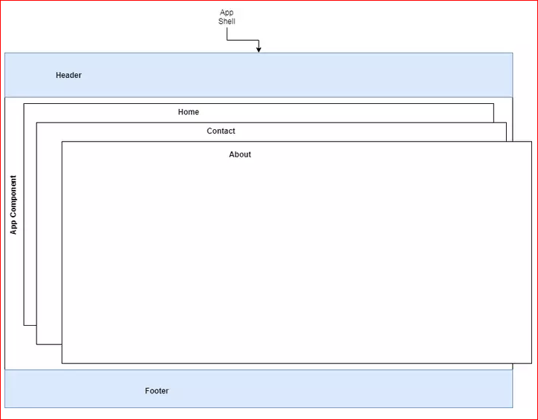

Angular uses components everywhere so to have multiple pages, you need to create components. You can also use components for specific parts of your page(s) that can be unique in each page or common between multiple pages. For example, we could have a **home**, **about** and **contact** components that represent the corresponding pages and **header** and **footer** components that are common between all the other components so we'll create them once and have Angular load them all the time whatever the current path is by simply adding them to our **application shell** which is simply the main application component with the associated src/app/app.component.html template tha hosts <router-outlet>.

**Step 3:**

Head back to your terminal, navigate inside your project's root folder and run these commands to create the mentioned components:

$ cd angular7-portfolio

$ ng g c header

$ ng g c footer

$ ng g c home

$ ng g c about

$ ng g c contact

The CLI will generate the files for these components and the minimal required code for declaring each component and its corresponding template.

For example for the header component the CLI will create the src/app/header/header.component.html, src/app/header/header.component.spec.ts, src/app/header/header.component.ts and src/app/header/header.component.css files.

The components that will be created are:

* HeaderComponent in the src/app/header/ folder,
* FooterComponent in the src/app/footer/ folder,
* HomeComponent in the src/app/home/ folder,
* AboutComponent in the src/app/about/ folder,
* ContactComponent in the src/app/contact/ folder.

Those components will be imported and add to the main application module in the src/app/app.module.ts file by the CLI in your behalf.

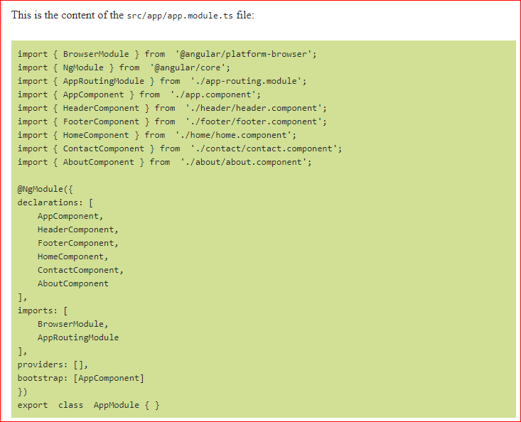

**Step 4:**

## **Styling our Components with Bootstrap 4**

For styling our components we'll be using Bootstrap 4. The most popular CSS framework in the world. In your terminal run the following command to install Bootstrap 4 from npm:

$ npm install bootstrap --save

**Step 5:**

Open the angular.json file and add ./node_modules/bootstrap/dist/css/bootstrap.min.css to the styles array:

"styles": [

"src/styles.css",

"./node_modules/bootstrap/dist/css/bootstrap.min.css"

],

**Step 6:**

Open the src/app/header/header.component.html file and create a Bootstrap 4 nav header using the following code:

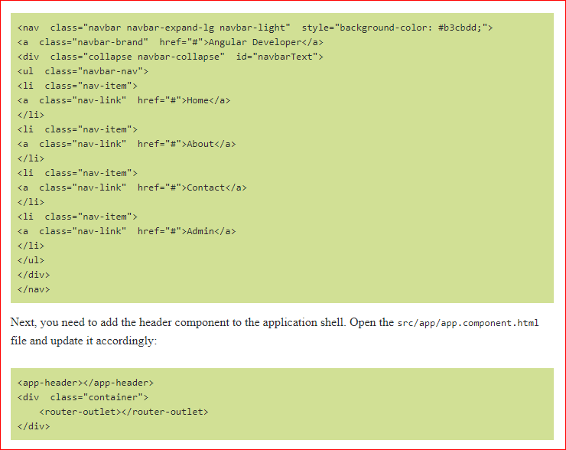

Next, you need to add the header component to the application shell. Open the src/app/app.component.html file and update it accordingly:

<app-header></app-header>

<div class="container">

<router-outlet></router-outlet>

</div>

Next, open the src/app/footer/footer.component.htmlfile and add a Bootstrap 4 footer component:

**Step 7:**

## **Adding Routing & Navigation**

We want to load our home, about, contact and admin components when we click on the links on the navigation header.

First we need to assign the components to their corresponding paths. You need to open the src/app-routing.module.ts file and add the following imports:

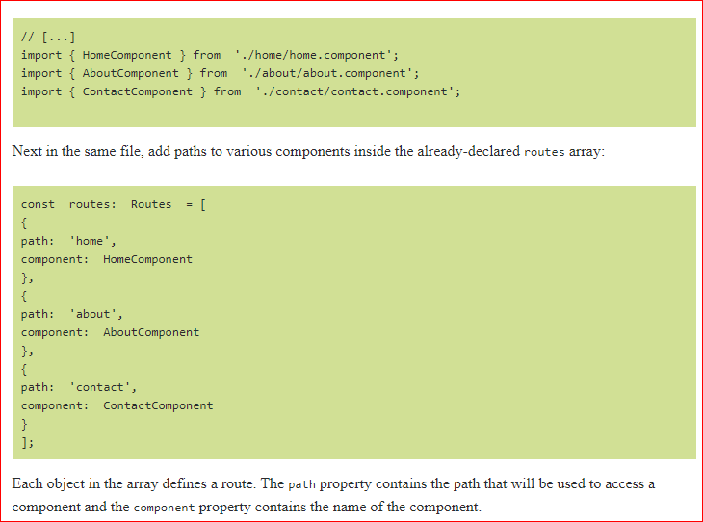

**Step 8:**

