**eTRAC APP Approach Note - Android**

**Splash Screen:**

When user launches the application into the device, this screen will display with ViaSat Logo and application name as eTRAC Application. This screen will displays for 3 seconds, after 3 seconds it goes to Accept and Decline Screen if the app is first time launching or user not accepted ViaSat Terms and Condition, otherwise it goes to Internet Check Screen for the internet availability check.

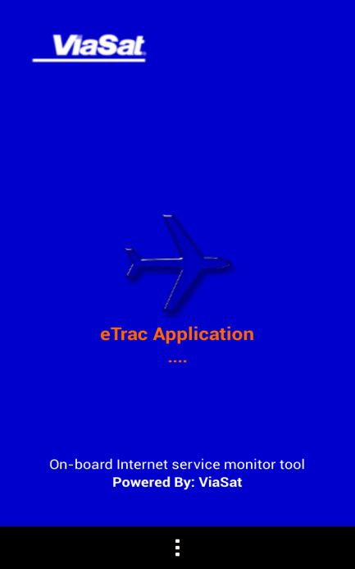**Figure 1: Splash Screen**

**Accept and Decline Screen:**

This screen will display ViaSat Terms and Condition. If user accept the term and condition, then it goes to Internet Check Screen for the internet availability. If user declines the ViaSat Terms and Condition, app display alert message and it stays on same screen until user accept the terms and condition.

If user accepts ViaSat application terms and condition, then this screen will not be appeared in subsequent app launch.

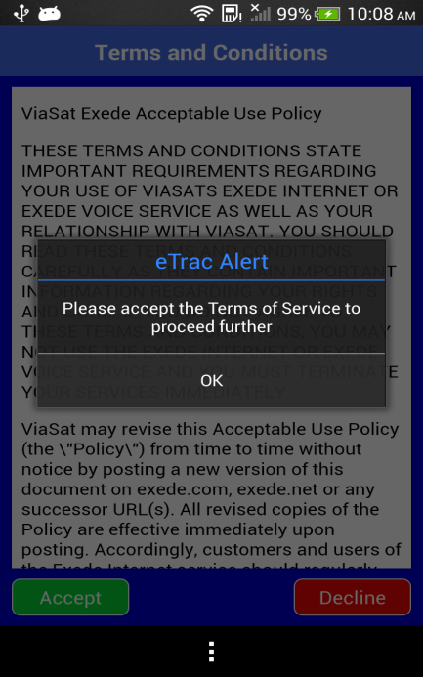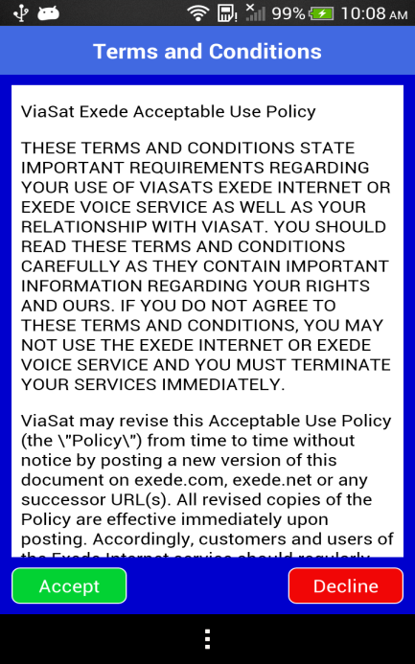

**Figure 2: Accept and Decline Screens**

**Internet Connection Check Screen:**

This screen appears to user and it start check internet availability on the device. While it checks internet in background, it display message to user as “Checking for internet connection”. It checks internet by checking the device is connected to WiFi network or not, if devices is not connected to any WiFi network, it goes to Internet error screen. If devices is connected to WiFi network, then it ping predefine IPs (www.google.com.www.cmcltd.com). It waits for 30sec to get response from its ping.

If response of ping gets success then it goes to Register Flight Screen. If no response has received with in 30sec, redirect to Internet error screen.

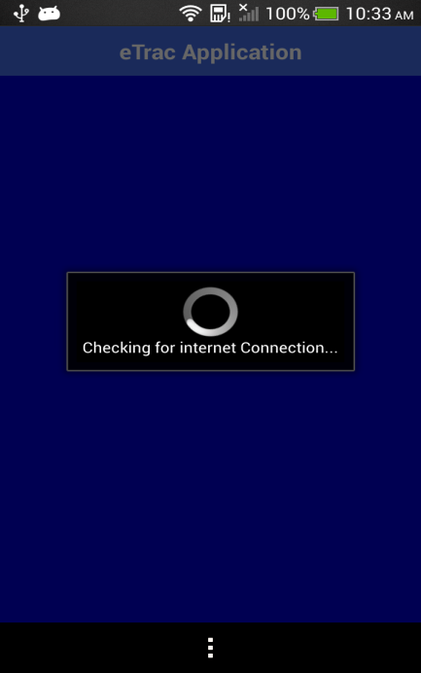

**Figure 3: Internet Connection Check Screen**

**Internet error Screen:**

If device is not connected to any WiFi network, this screen appears to user with an alert message shows that “Device is not connected to WiFi Router. Do you want to enable WIFI?”, along with two options “OK” And “CANCEL”. If user clicks “CANCEL” alert message will be dismisses, and stays in the same screen. If user clicks “OK”, alert message will be dismisses and navigates the user to devices default WIFI Settings Screen, If devices is connected to WiFi network and if no response has received with in 30sec, its display alert message to user as “Internet connection is not available”, along with “OK” option, if user clicks “OK” alert message will be dismisses, and stays in the same screen. Here in this screen there is another button i.e. “Try again”, by clicking this button user can initiate the internet check again in this screen. If internet check is success, it goes to Register Flight Screen.

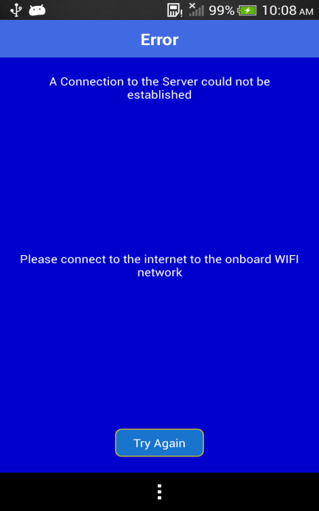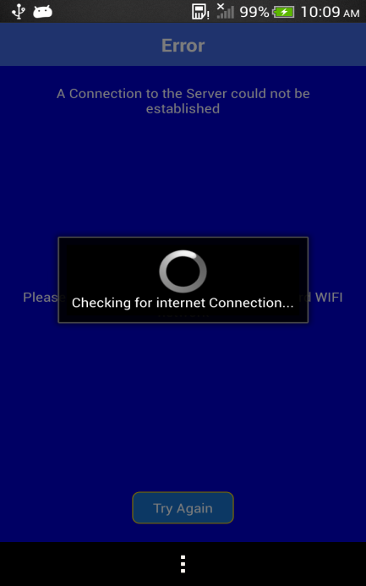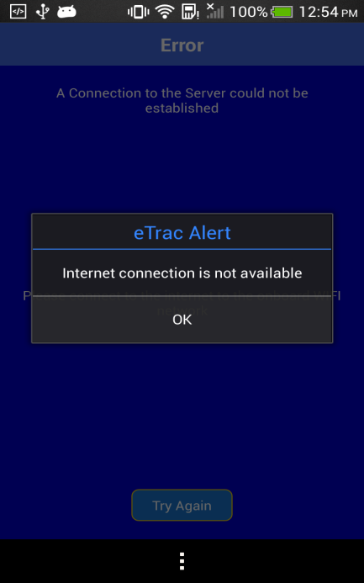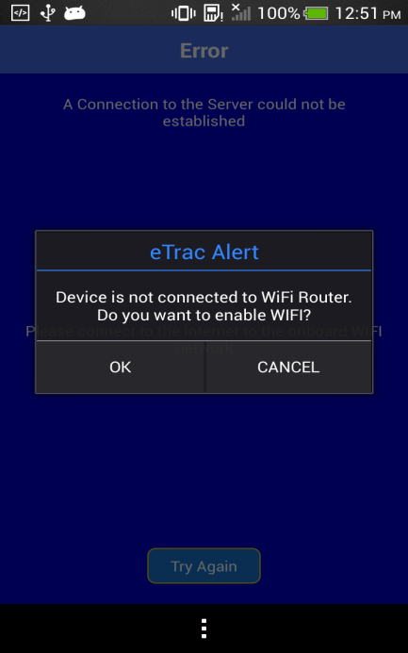

**Figure 4: Internet Error Screens**

**Register Flight Screen:**

Here in this screen app will checks weather the GPS is enabled are not, if GPS is not enable then it will show Alert message as “GPS not enable. Do You want to go to settings menu?”, along with two options as “Settings” which navigates the user to GPS Settings screen and the other is “Cancel” which dismisses the alert and stays in the same screen.

To perform various internet related test operation using eTRAC application, user has to register the flight by filling following details,

1. Email ID

2. Flight ID

3. Provider Name

4. Service Details

5. User Comments

This screen has two buttons, “Submit” & “Clear All”.

Here in this screen Email ID, Flight ID and User Comments fields are used take user inputs from keypad, where as Provider Name and Service Details are dropdowns, to allow the user to select an option from available options.

User Comments field is optional, and Email ID field becomes as optional if selected Provider Name is “Anonymous”.

If user click on “Clear All”, all entered field will be cleared.

If user clicks on Submit button, app validates all fields.

If validation failed, app will show error message to user for updating correct field.

If validation got succeed, then internet check will runs in background, if internet check fails then it shows appropriate alert to user, if internet check is also succeed then app will store all fields data into its device data base and also update fields data to ViaSat server by calling Server API which are exposed from ViaSat server, and navigates the user to Test Menu Screen.

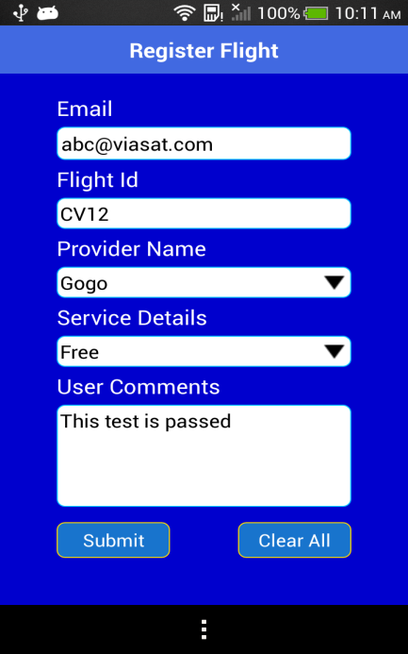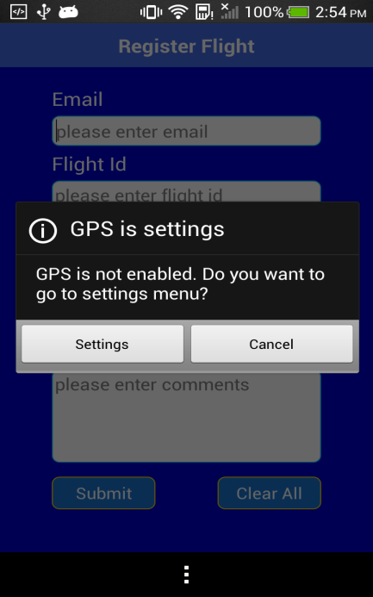

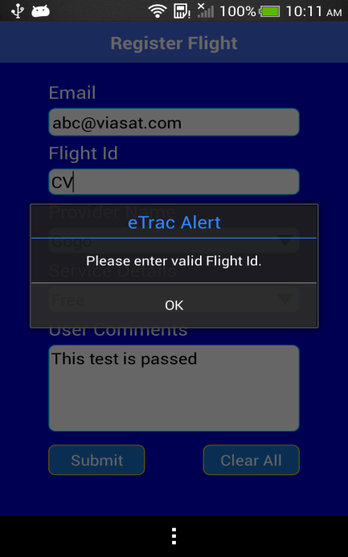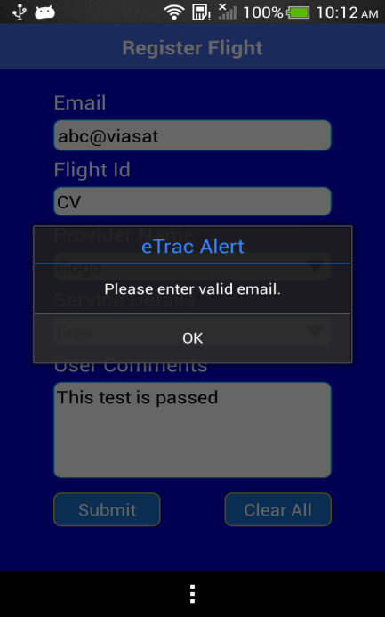

**Figure 5: Register Flight Screens**

**Test Menu Screen:**

This screen has below option to run various automated test cases and to view test result.

1. Run All Tests

2. Speed Test

3. WebPage Load Timer

4. Send Byte Count Measurement

5. Throughput

6. Video Load Timer

7. Test Results

8. Router Details

Here in this screen, when user clicks on any test case, it will checks the internet in background (except Test Results case), if internet check fails, then it shows appropriate alert message to user. If the Internet check is succeed then only corresponding test will runs. Internet Check will be kept on running in background While Running each test.

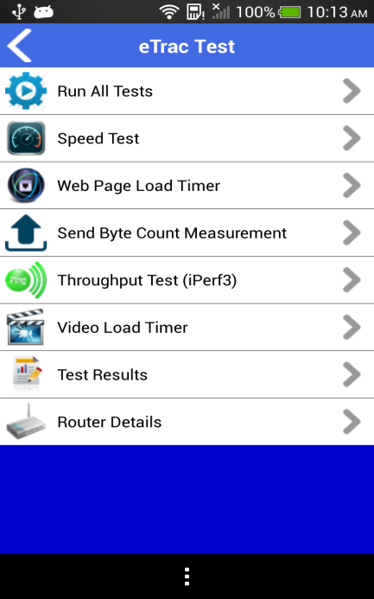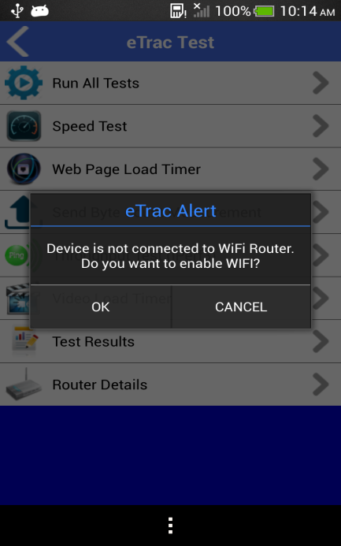

**Figure 6: Test Menu Screens**

If user is navigated from Register Flight screen to Test Menu screen, after 1Sec it will run “Run All Tests” Case Automatically.

**Run All Tests:**

In this test case following test will be run sequentially and after completion of all tests, it will display the test result on Test Result screen.

Automated test cases are - Speed Test, Webpage Load Timer, Throughput Test (iPerf), and Video Test. While individual test are running under automated test cases, corresponding test screen will be shown to user.

While Test is running, if internet connection is not available, then automated test will be aborted and it will come back to Menu Screen and display alert message to user.

**Speed Test Screen:**

To perform speed test, test invoke below HTML link from test logic and show the result on WebView.

Link: http://speedtest.via-satellite.net/eTRAC/speedof.html

Afetr complet loading, to get the result from HTML link, below JavaScript is invoked from test logic to get below details.

* Download Time
* Upload Time
* Ping Time
* Jitter

wvSpeedTest.loadUrl("<javascript:alert(document.getElementById('download').innerHTML>)");

wvSpeedTest.loadUrl("<javascript:alert(document.getElementById('upload').innerHTML>)");

wvSpeedTest.loadUrl("<javascript:alert(document.getElementById('ping').innerHTML>)");

wvSpeedTest.loadUrl("<javascript:alert(document.getElementById('jitter').innerHTML>)");

After successful of the speed test, we get below result from Speed Test Server and show to user as Alert Message and also update the result to device internal database and test result also published to ViaSat server.

While test is performing, if internet check fails, test will be aborted and user will be redirected to Test Menu Screen and appropriate failure alert message will be shown to user, and there will be no update on test result.

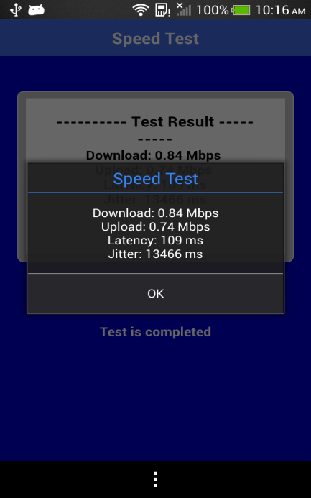

**Figure 7: Speed Test Screen**

**Web Page Load Timer Screen:**

WebPage Load Timer Test, before starting this test, it gets web links which are need to be load from below link:

Link: [http://speedtest.via-satellite.net/eTRAC/content/webPageTimer.json](http://speedtest.via-satellite.net/etrac/content/webPageTimer.json)

Response Message From ViaSat Server:

{

"response":"success",

"webPageTimer": {

"timeout":"120.0",

"numURLs":"10",

"url0":"http://www.wikipedia.org",

"url1":"http://www.about.com",

"url2":"http://www.google.com",

"url3":"http://www.linkedin.com",

"url4":"http://www.yahoo.com",

"url5":"http://www.yelp.com",

"url6":"http://www.pinterest.com",

"url7":"http://www.bing.com",

"url8":"http://www.viasat.com",

"url9":"http://www.outlook.com"

}

}

After getting web links, loads those web links to WebView. While each page loading, it calculates the loading time that page on web view.

Each WebPage load time is accumulated and test logic calculate the average load time based on number of pages load by the test.

Average load time updated to device data base and also published to ViaSat server. After competition of WebPage Load, shows alert message with Total Loaded Webpages count, Total Webpage Load time and average load time.

While test is performing, if internet check fails, test will be aborted and user will be redirected to Test Menu Screen and appropriate failure alert message will be shown to user, and there will be no update on test result.

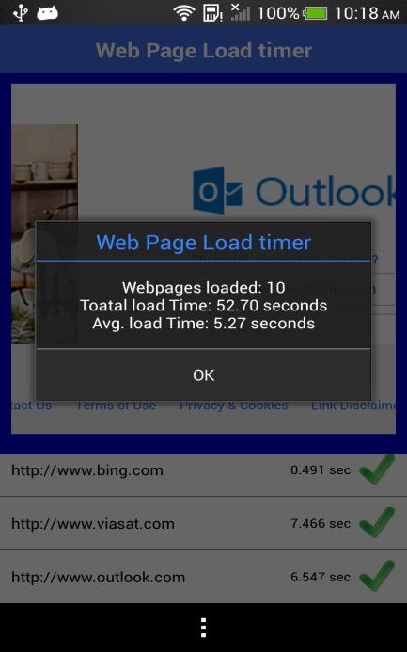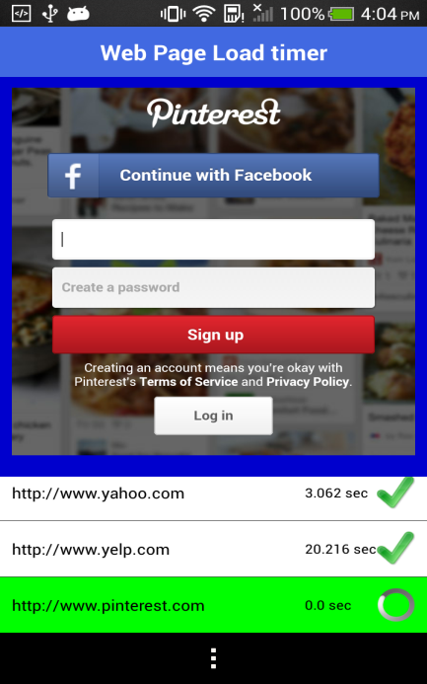

**Figure 8: WebPage Load Timer Screens**

**Send Byte Count Measurement:**

Here in this test app invokes Android system call to get the device received byte count and transmitted byte count, and shows the information to user through alert message and test result also published to ViaSat server.

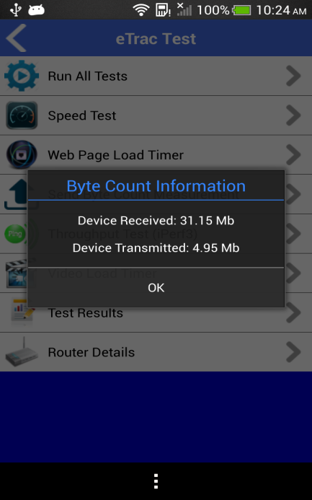**Figure 7: Send Byte Count Measurement Screen**

**Throughput (iPerf) Test Screen:**

Throughput Test is based on iPerf client. Test script calls third-party iPerf library and gets back the response from the iPerf Server. After getting the response, it parses the result and display to user as alert message and also publishes the result to ViaSat Server.

Before starting the iPerf client, it gets the iPerf server details from below link.

Link: <http://speedtest.via-satellite.net/eTRAC/content/iperf.json>

Response Message From ViaSat Server:

{

"response": "success",

"iperf3Servers": {

"numServers": "2",

"servers": [

{

"description": "iMAC(internal)",

"ip": "172.24.4.178",

"port": "5201",

"timeout":"30"

},

{

"description": "Amazon(cloud)",

"ip": "54.208.183.22",

"port": "5201",

"timeout":"60"

}

]

}

}

Based on selected iPerf server the test will be runs. While test is performing, if internet check fails, test will be aborted and user will be redirected to Test Menu Screen and appropriate failure alert message will be shown to user, and there will be no update on test result.

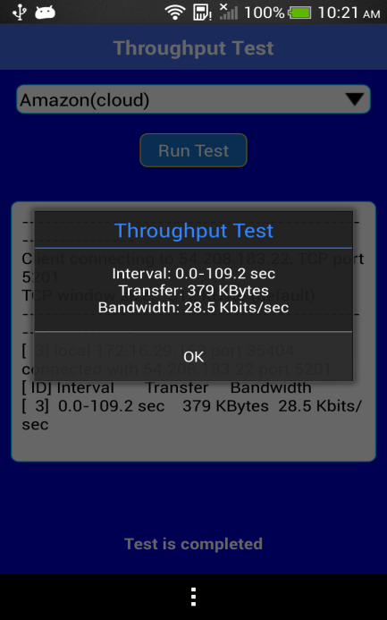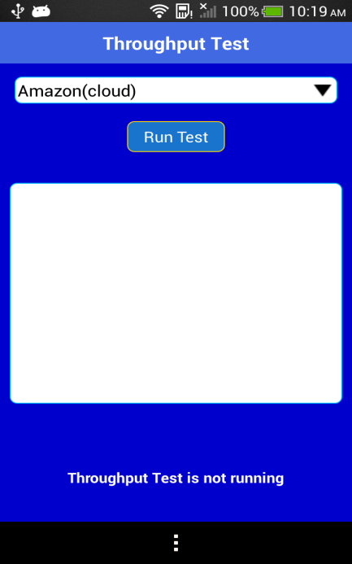**Figure 10: Throughput Test Screens**

**Video Load Timer Test Screen:**

For Video Load Timer test, app call below YouTube link and display video on WebView. While displaying video on webview, app disables all user interaction to control the video.

Link: [http://speedtest.via-satellite.net/eTRAC/youtube.html](http://speedtest.via-satellite.net/etrac/youtube.html)

While video is playing and displaying on WebView, video gets buffered. Below script is used to evaluate Javascript functions to get below details on video load after video is completed.

• Initial Video Quality

• Initial Buffer Time

• Video ID

wvVideoLoadTest.loadUrl("<javascript:alert(getInitialQuality>())");

wvVideoLoadTest.loadUrl("<javascript:alert(getInitialBufferTime>())");

wvVideoLoadTest.loadUrl("javascript:alert(getVideoId())");

After successful of the test, show to user as Alert Message and also update the result to device internal database and test result also published to ViaSat server.

While test is performing, if internet check fails, test will be aborted and user will be redirected to Test Menu Screen and appropriate failure alert message will be shown to user, and there will be no update on test result.

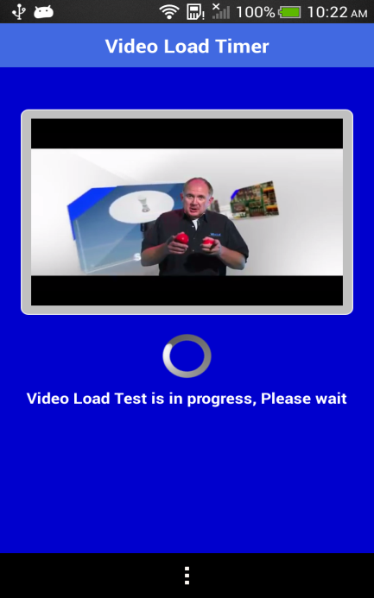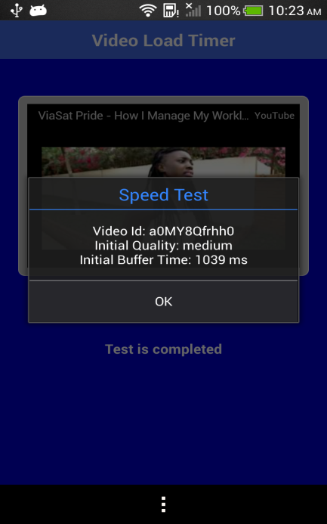

**Figure 11: Video Load Timer Screens**

**Router Details:**

While user clicks on Router Details, test app invokes Android system call to get the current connected router information and Internet Service Provider Details using following Links,

<http://ip-api.com/json>

http://ipinfo.io/json

<http://www.telize.com/geoip>

After getting details, it shows to user as popup screen as below.

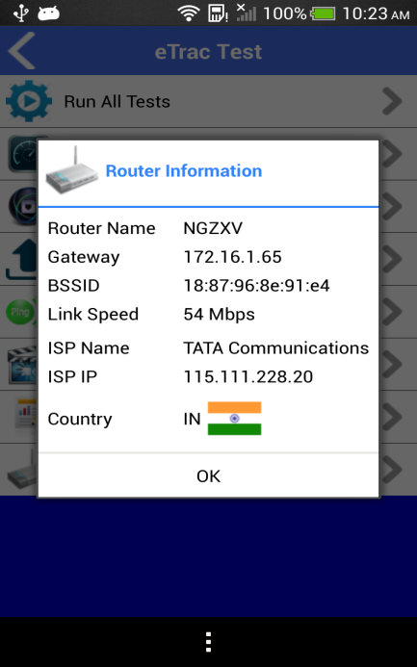

**Figure 12: Router Info Response Screen**

**Test Result Screen:**

Test Result screen displays the current automated test result after performing the automated test.

If user clicks on “Result Database”, it displays the all test results which are performed by user earlier. It contains recent 10 records of test results.

It displays the average of below test result which is performed by user on the device.

* Ping Time (msec)
* Upload Speed (Mbps)
* Download Speed (Mbps)
* WebPage Load Time (sec)
* Video Buffer Time (sec)

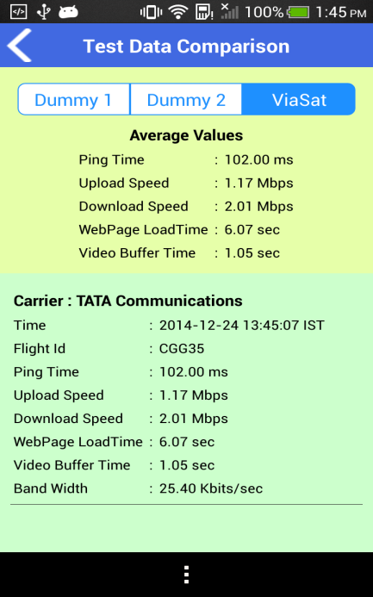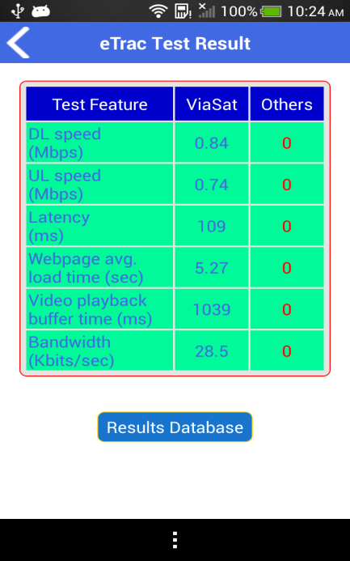**Figure 13: Test Result Screens**