Assignment – 1

• Install Power BI Desktop and share the final screenshot of the report view page which appears when power desktop starts.

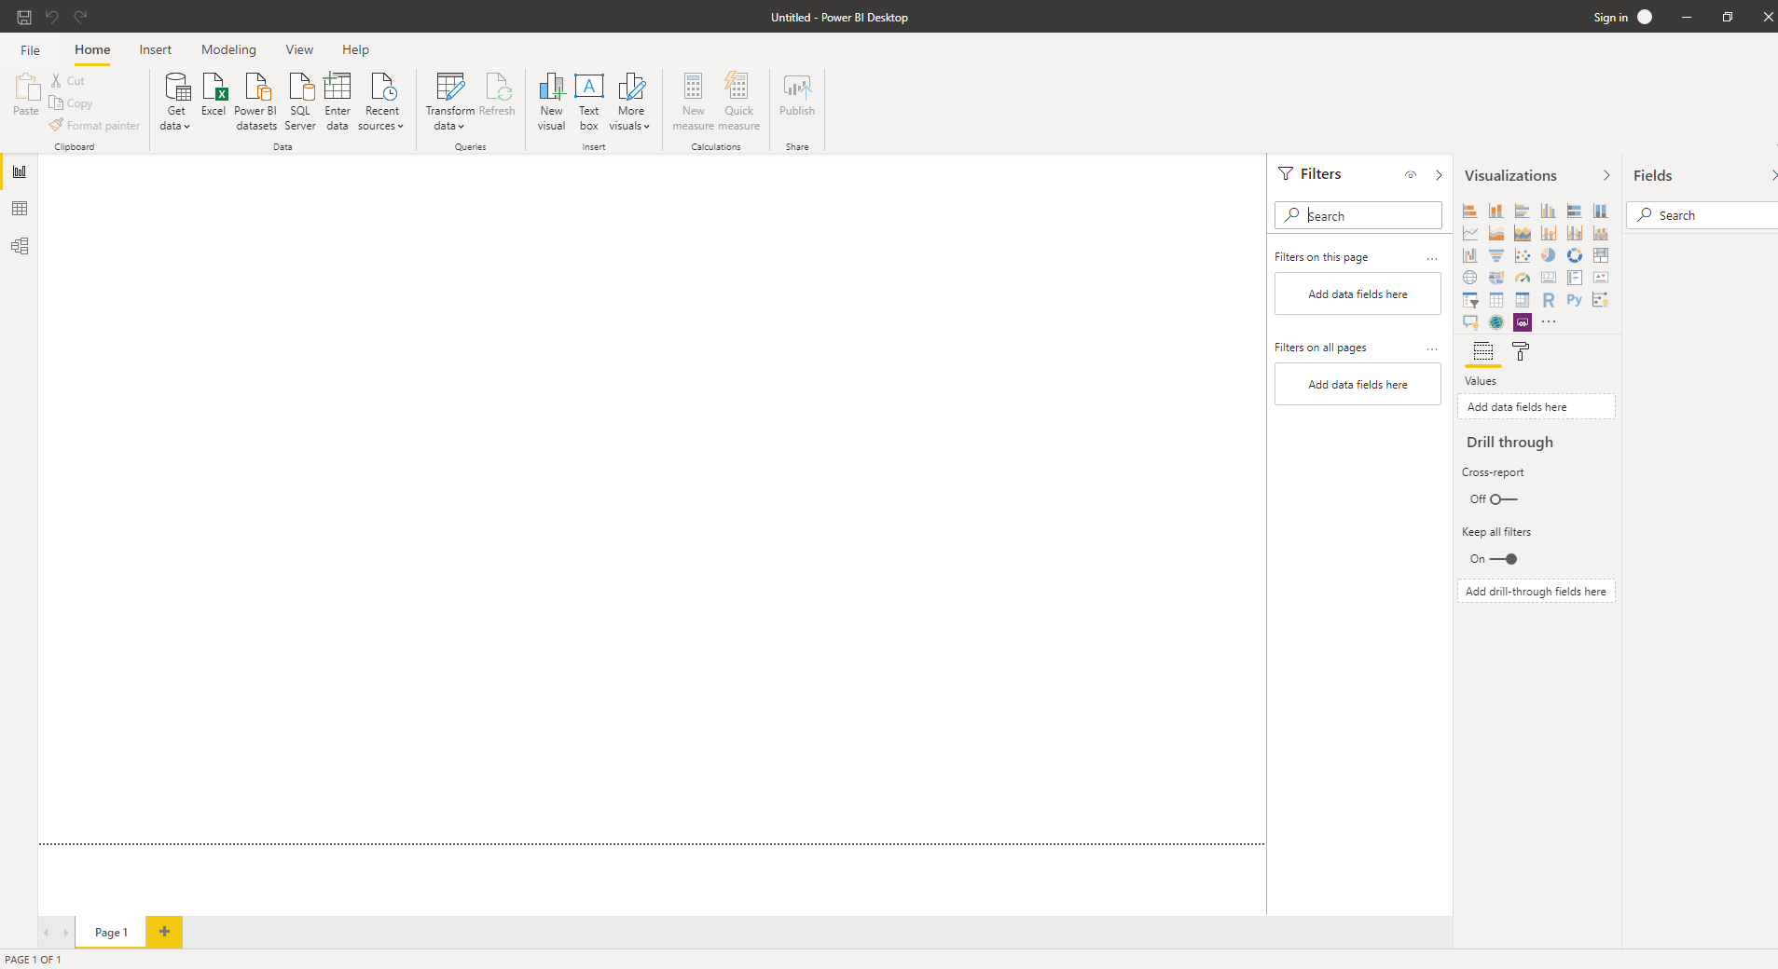

Prepare a document and with the following screenshot − Report View − Data View − Model View − Power Query Editor − Advance Editor

Report view – When you first load data in Power BI Desktop, you'll see the Report view with a blank canvas. We can create any number of report pages with visualizations.



Data View - Data view helps you inspect, explore, and understand data in your Power BI Desktop model. It's different from how you view tables, columns, and data in Power Query Editor. With Data view, you're looking at your data after it has been loaded into the model. When you're modeling your data, sometimes you want to see what's actually in a table or column without creating a visual on the report canvas. You might want to see right down to the row level.

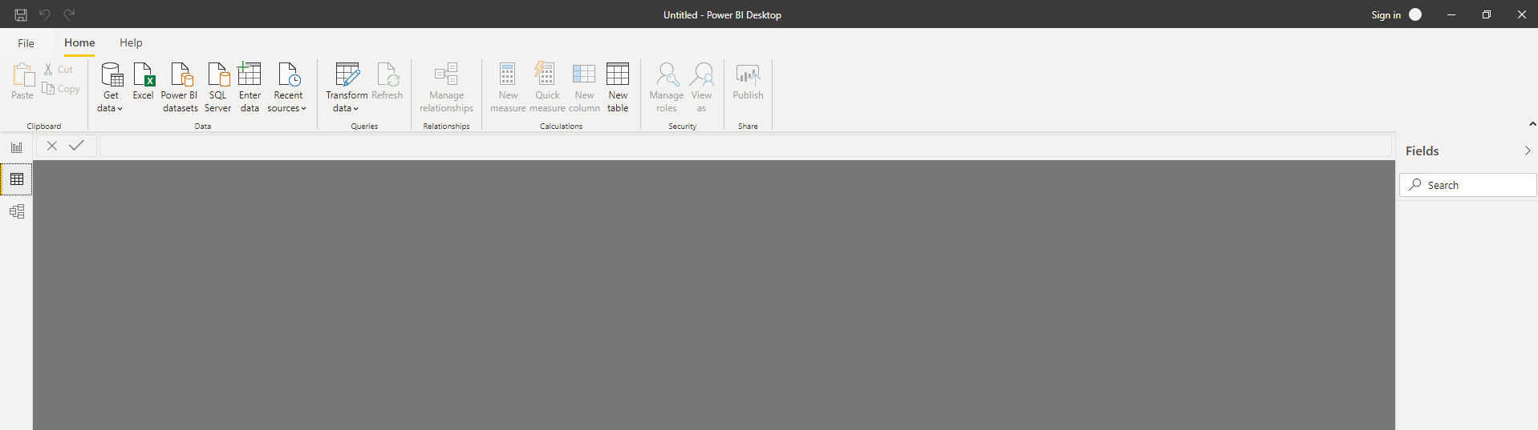

Model View - Model view shows all of the tables, columns, and relationships in your model. This view can be especially helpful when your model has complex relationships between many tables. You can double-click a relationship to open it in the Edit Relationship dialog box.

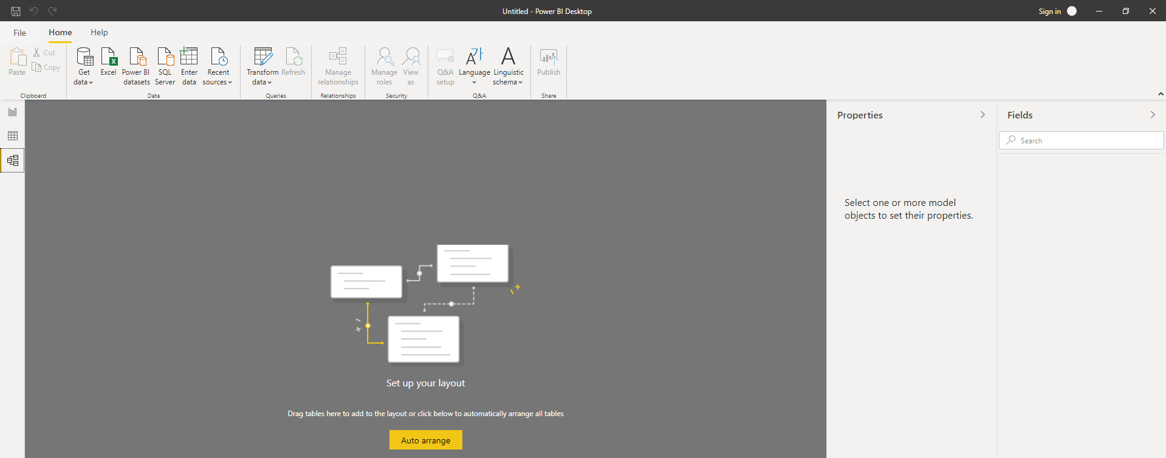

Power Query Editor - Query Editor in Power BI is a very useful tool to transform data before it is actually loaded into the Power BI environment. The Query Editor plays the role of an intermediate data container where you can modify data by selecting rows and columns, splitting rows and columns etc. The changes made by the Query Editor in Power BI are not reflected in the actual dataset. Once you have pre-processed the data and have transformed it into the required format, you can load the data into the Power BI environment.

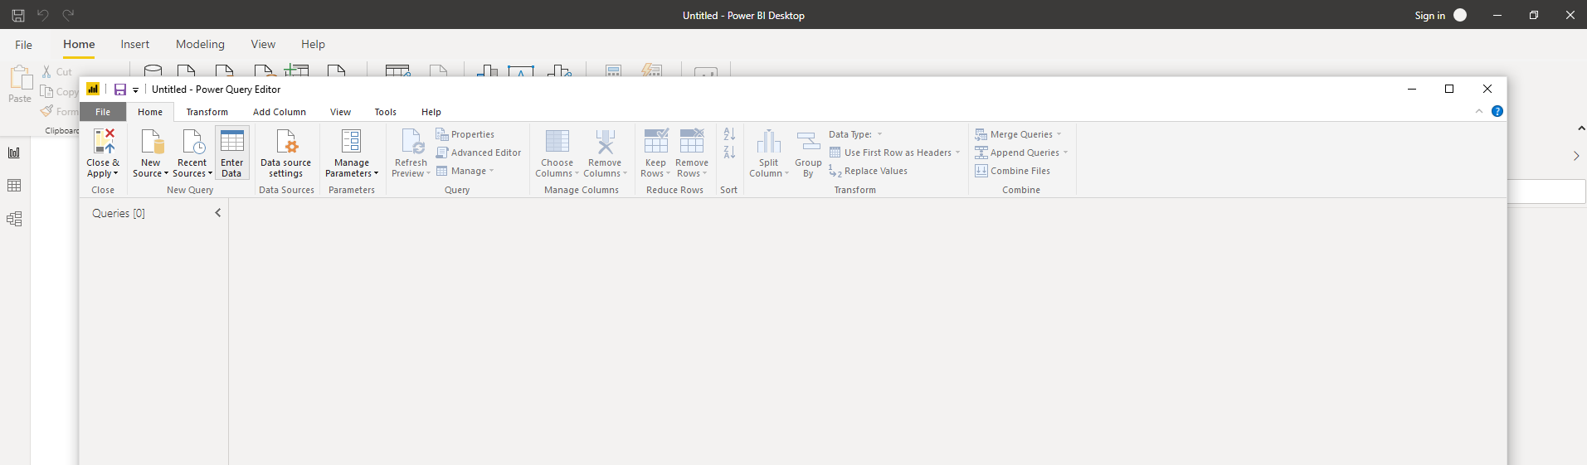

Advance Editor - The Advanced Editor lets you see the code that Power Query Editor is creating with each step. It also lets you create your own shaping code. To launch the advanced editor, select View from the ribbon, then select Advanced Editor. A window appears, showing the existing query code.

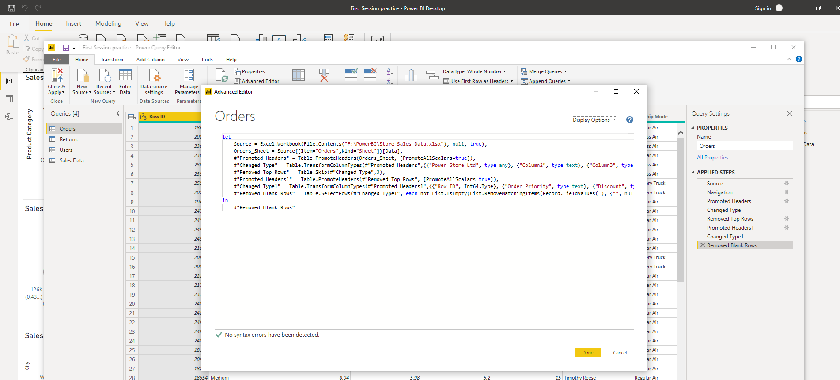

Prepare a document with details of the following along with their price − Power BI Desktop − Power BI Pro − Power BI Premium

Power BI Desktop - This is used to create reports and data visualizations on the dataset. This offering is free to any single user and includes data cleaning and preparation, custom visualizations and the ability to publish to the Power BI service. With Power BI Desktop, you can connect to multiple different sources of data, and combine them (often called modeling) into a data model. This data model lets you build visuals, and collections of visuals you can share as reports, with other people inside your organization. The most common uses for Power BI Desktop are as follows:

* Connect to data
* Transform and clean that data, to create a data model
* Create visuals, such as charts or graphs, that provide visual representations of the data
* Create reports that are collections of visuals, on one or more report pages
* Share reports with others by using the Power BI service

Power BI Pro: The Pro plan costs $9.99/user/month. It includes data collaboration, data governance, building dashboards with a 360-degree real-time view and the ability to publish reports anywhere. Users can try it a free trial for 60 days before purchasing the subscription. Power BI Pro is an individual user license that lets users read and interacts with reports and dashboards that others have published to the Power BI service. Users with this license type can share content and collaborate with other Power BI Pro users. Only Power BI Pro users can publish or share content with other users or consume content that's created by others.

Power BI Premium: The Premium plan starts at $4,995 a month per dedicated cloud compute and storage resource. You can use Power BI Premium to get dedicated and enhanced resources for your organization, so users in your organization can use the Power BI service with better performance and responsiveness.