Connect to the Store Sales Data and do the following: -

− Remove all the blank rows. − Update the column header if they are not updated − Create a text table and show the sales in terms of Customers/Product Category/Regions

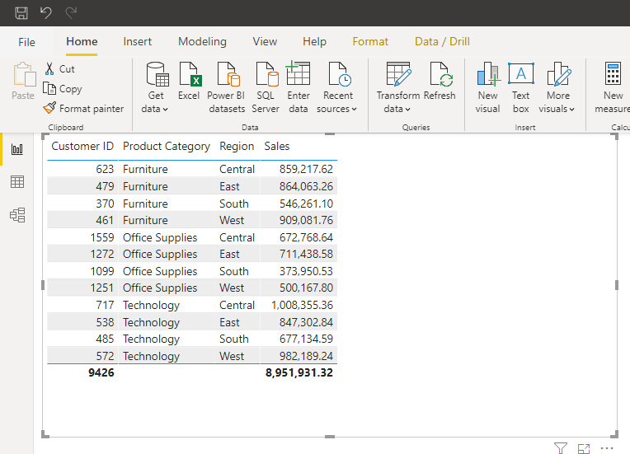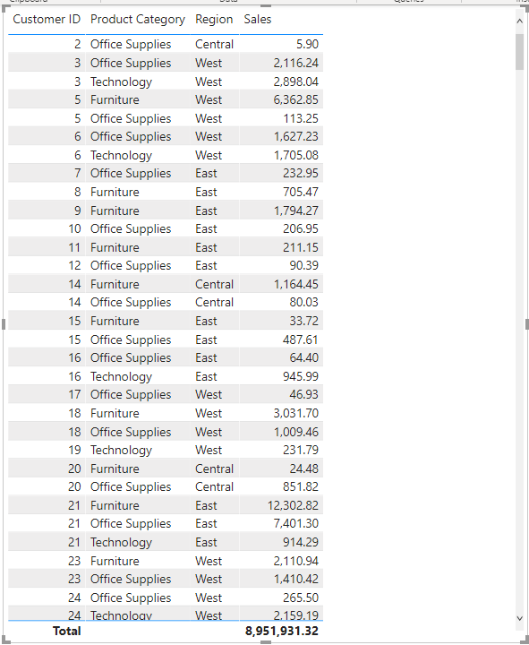

Create a line and Clustered Column Chart showing the Sales and Discount as per the State or Province

− Format the bars and line with different colors

– Which state has the highest sales in terms Technology?

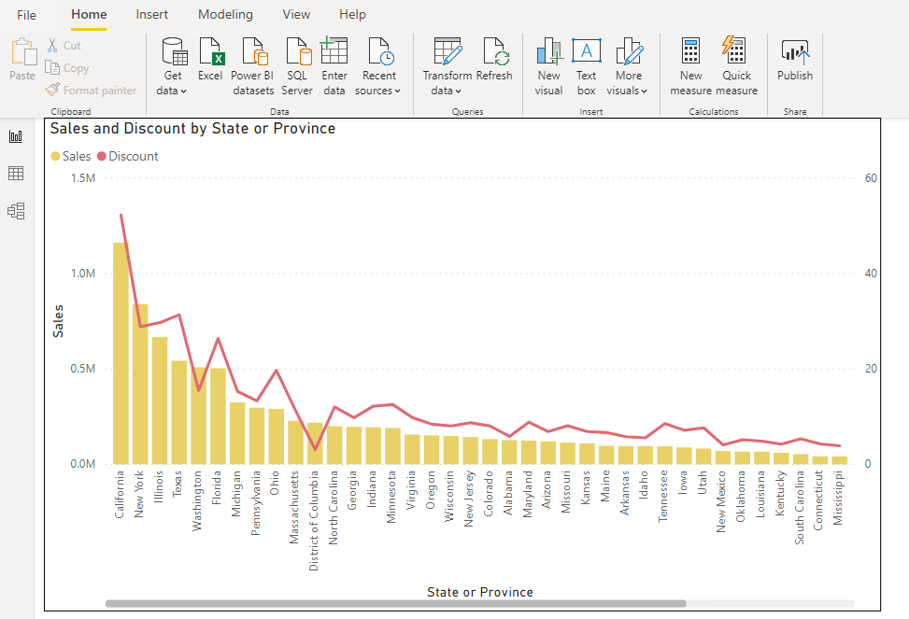

New York has the highest sales in terms Technology

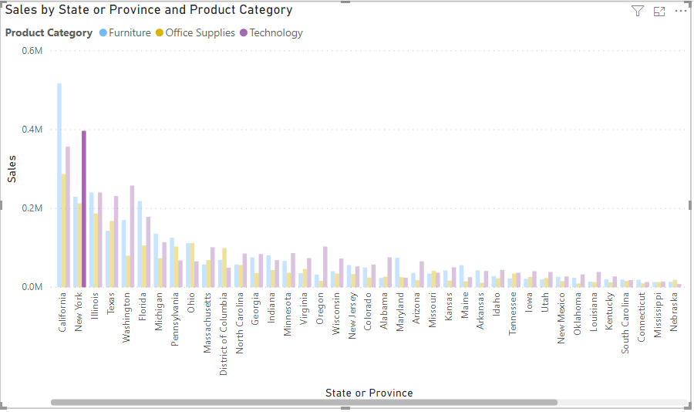

Create a Donut Chart showing sales in terms of Product category

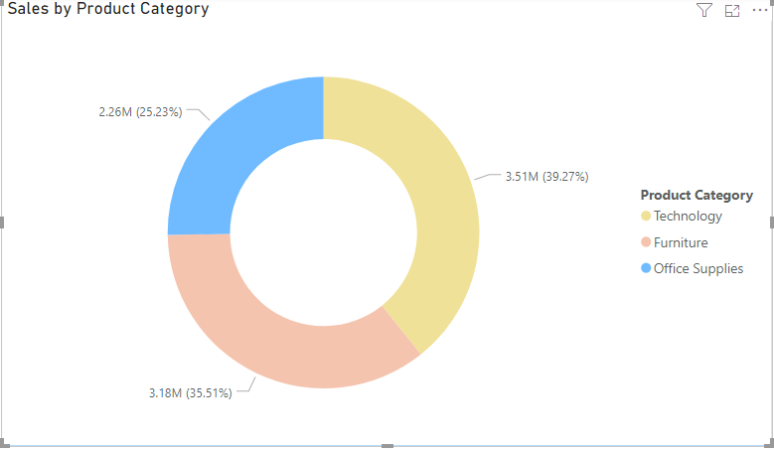

Create a Slicer and show the regions in dropdown. See how all the visuals mentioned above behaving when a particular region is selected.

When Central is selected.

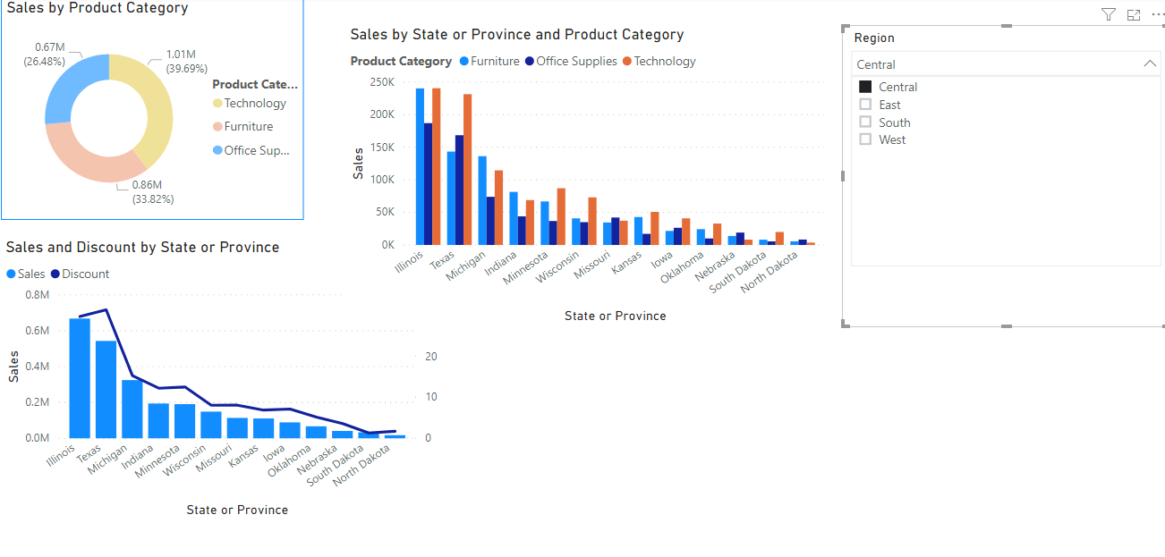

When East is selected.

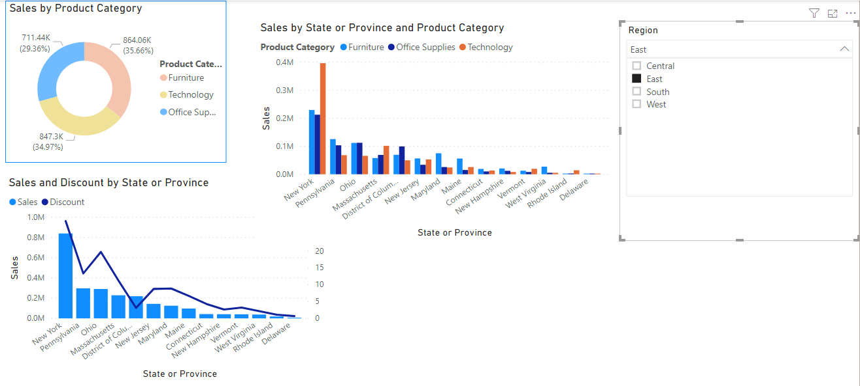

When South is selected

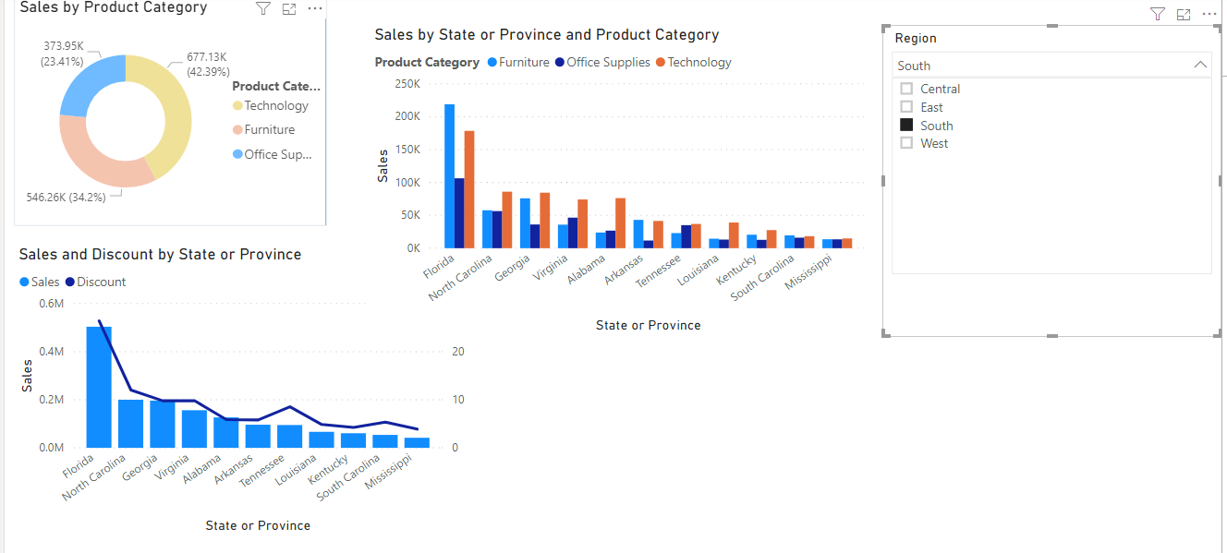

When West is selected

