Title

Abstract

Keywords

Introduction

Literature Review

Research Methodology

Experimental Results

Discussion

Conclusion and Future Work

References

Appendices

An EXPLAINABLE AI FOR SEMICONDUCTOR MANUFACTURING: FAILURE PREDICTION AND ROOT-CAUSE ANALYSIS
Independent Research Study
Author: Swapna Kalla
Research Area: Explainable Artificial Intelligence, Machine Learning, Semiconductor Manufacturing, Failure Prediction, Root-Cause Analysis, Data-Driven Quality Engineering
Location: India
Year: 2026

ABSTRACT
Semiconductor manufacturing generates high-dimensional process and measurement data from multiple stages of production. Although these data contain potentially valuable information about manufacturing failures and yield excursions, the large number of process variables makes it difficult to identify the measurements that are most relevant to failure detection and root-cause investigation. The SECOM dataset provides a representative machine-learning problem from semiconductor manufacturing, containing 1,567 production observations and 591 original features. The dataset contains substantial missing values and a strongly imbalanced pass/fail outcome, making data preprocessing, failure-sensitive evaluation, and model interpretation important components of the analysis.
This study develops an explainable machine-learning framework for semiconductor manufacturing failure prediction and data-driven root-cause investigation. The framework integrates data preprocessing, supervised classification, probability-threshold analysis, SHAP-based explainability, multi-sample failure analysis, and statistical validation. Three machine-learning approaches—Logistic Regression, Random Forest, and XGBoost—were evaluated using accuracy, failure recall, F1-score, and ROC-AUC. The current experimental results show different performance characteristics across the evaluated models. Logistic Regression achieved 83.76% accuracy, 19.05% failure recall, F1-score of 0.1356, and ROC-AUC of 0.6239 at the reported operating threshold. Random Forest achieved 87.58% accuracy, 47.62% failure recall, F1-score of 0.3390, and ROC-AUC of 0.7982 at a threshold of 0.20. XGBoost achieved the highest reported accuracy of 90.76%, together with 23.81% failure recall, an F1-score of 0.2564, and ROC-AUC of 0.7222 at the reported threshold.
To move beyond predictive classification toward interpretable failure investigation, SHAP-based explanations were combined with multi-sample recurrence analysis and statistical validation. Four recurring candidate contributors—Features 59, 103, 477, and 64—were identified for further investigation. Feature 59 appeared in 90% of the analyzed recurring RCA evidence and showed a mean SHAP contribution of 0.019072, a p-value of 0.007285, Cohen's d of 1.2991, and a feature-level ROC-AUC of 0.860. These results provide converging model-based and statistical evidence supporting Feature 59 as a high-priority candidate for further engineering investigation. However, model attribution and statistical association do not independently establish physical causality.
The proposed framework demonstrates how predictive machine learning, explainable AI, multi-sample analysis, and statistical validation can be integrated into a structured manufacturing analytics workflow. The framework provides a pathway from failure detection to candidate root-cause prioritization while maintaining a clear distinction between data-driven evidence and confirmed physical root cause. Future validation using manufacturing-process metadata, temporal information, domain knowledge, and controlled experiments is required to establish the physical significance of the identified candidates.
Keywords: Semiconductor Manufacturing; Machine Learning; Explainable AI; SHAP; Failure Prediction; Root-Cause Analysis; Statistical Validation; Data-Driven Quality Engineering.
TABLE OF CONTENTS
ABSTRACT
LIST OF FIGURES
LIST OF TABLES
CHAPTER 1 — INTRODUCTION
1.1 Background
1.2 Problem Statement
1.3 Motivation
1.4 Research Gap
1.5 Research Aim
1.6 Research Objectives
1.7 Research Questions
1.8 Research Contributions
1.9 Scope of the Study
CHAPTER 2 — LITERATURE REVIEW
2.1 Semiconductor Manufacturing and Yield Analysis
2.2 Machine Learning in Manufacturing
2.3 Failure Prediction
2.4 Explainable Artificial Intelligence
2.5 SHAP-Based Model Interpretation
2.6 Root-Cause Analysis
2.7 Research Gap
CHAPTER 3 — RESEARCH METHODOLOGY
3.1 Research Framework
3.2 Dataset
3.3 Data Preprocessing
3.4 Feature Representation
3.5 Machine-Learning Models
3.5.1 Logistic Regression
3.5.2 Random Forest
3.5.3 XGBoost
3.6 Model Training
3.7 Classification Threshold
3.8 Model Evaluation
3.9 SHAP Explainability
3.10 Local Failure Analysis
3.11 Multi-Sample Root-Cause Analysis
3.12 Statistical Validation
3.13 Overall Analytical Workflow
CHAPTER 4 — EXPERIMENTAL RESULTS
4.1 Experimental Setup
4.2 Dataset and Test Set
4.3 Machine-Learning Model Results
4.4 Classification Threshold Analysis
4.5 Global SHAP Analysis
4.6 Local Failure Analysis
4.7 Multi-Sample Root-Cause Analysis
4.8 Recurring Failure Contributors
4.9 Statistical Validation
4.10 Final RCA Candidates
4.11 RCA Contribution Coverage
CHAPTER 5 — DISCUSSION
5.1 Discussion of Model Performance
5.2 Failure Detection and Classification Threshold
5.3 Interpretation of SHAP Results
5.4 Root-Cause Analysis Findings
5.5 Feature 59 Analysis
5.6 Practical Manufacturing Implications
5.7 Relationship Between Prediction and RCA
5.8 Limitations
CHAPTER 6 — CONCLUSION AND FUTURE WORK
6.1 Research Summary
6.2 Major Findings
6.3 Research Contributions
6.4 Limitations
6.5 Future Work
6.5.1 Physical Feature Mapping
6.5.2 Temporal Analysis
6.5.3 Domain-Knowledge Integration
6.5.4 Causal Analysis
6.5.5 Cross-Validation and Uncertainty Analysis
6.5.6 External Validation
6.5.7 Cost-Sensitive Optimization
6.5.8 Real-Time Deployment
6.5.9 Experimental Validation
6.6 Conclusion
REFERENCES
APPENDICES
Appendix A — Model Performance
Appendix B — Final RCA Evidence
Appendix C — Overall Research Workflow
Appendix D — Interpretation Guideline
LIST OF FIGURES
Figure 1.1 — Conceptual Overview of Semiconductor Manufacturing Failure Analysis
Figure 2.1 — Relationship Between Predictive Modeling, Explainable AI, and Root-Cause Analysis
Figure 3.1 — Overall Research Methodology
Figure 4.1 — Distribution of Pass and Failure Observations
Figure 4.2 — Comparative Performance of the Evaluated Machine-Learning Models
Figure 4.3 — ROC Curves of the Evaluated Machine-Learning Models
Figure 4.4 — Effect of Classification Threshold on Failure Detection
Figure 4.5 — Global SHAP Feature Importance
Figure 4.6 — Local SHAP Explanation for a Correctly Detected Failure
Figure 4.7 — Recurrence of Candidate Features Across Analyzed Failure Observations
Figure 5.1 — Proposed Explainable Root-Cause Analysis Framework
LIST OF TABLES
Table 2.1 — Summary of Relevant Research Areas and Their Limitations
Table 3.1 — Dataset Characteristics
Table 3.2 — Data Preprocessing Steps
Table 3.3 — Machine-Learning Models Used in the Study
Table 4.1 — Dataset and Test-Set Characteristics
Table 4.2 — Performance of the Evaluated Machine-Learning Models
Table 4.3 — Classification Threshold Analysis
Table 4.4 — Top Features Identified by Global SHAP Analysis
Table 4.5 — Summary of Local Failure Analysis
Table 4.6 — Recurring Failure Contributors
Table 4.7 — Statistical Validation of Candidate Features
Table 4.8 — Final Root-Cause Analysis Candidates
Table 4.9 — RCA Contribution Coverage
Table A.1 — Detailed Model Performance
Table B.1 — Final RCA Evidence Summary

1. INTRODUCTION

1.1 Background
Modern semiconductor manufacturing processes generate large volumes of measurements from sensors, process-monitoring systems, inspection systems, and manufacturing equipment. These measurements can contain information related to process conditions, product quality, and downstream manufacturing outcomes. However, the number of available measurements can be considerably larger than the number of variables that are ultimately useful for identifying a manufacturing problem.
The SECOM dataset provides a representative example of this challenge. It contains 1,567 manufacturing observations and 591 original features associated with a semiconductor manufacturing process. The dataset contains missing values and a binary pass/fail outcome and has been made available through the UCI Machine Learning Repository for classification and causal-discovery research.
A central challenge in manufacturing analytics is therefore not simply determining whether a production observation is likely to fail. A practically useful analytical framework should also provide information that helps analysts investigate why a failure prediction was generated and which measurements repeatedly appear in failure cases.
Machine-learning methods can identify complex patterns within high-dimensional manufacturing data. However, predictive performance alone does not necessarily explain the variables responsible for an individual prediction. Explainable artificial intelligence (XAI) provides techniques for examining the contribution of input features to model predictions.
This study therefore investigates an integrated approach that combines machine-learning-based failure prediction with explainable, data-driven root-cause investigation.
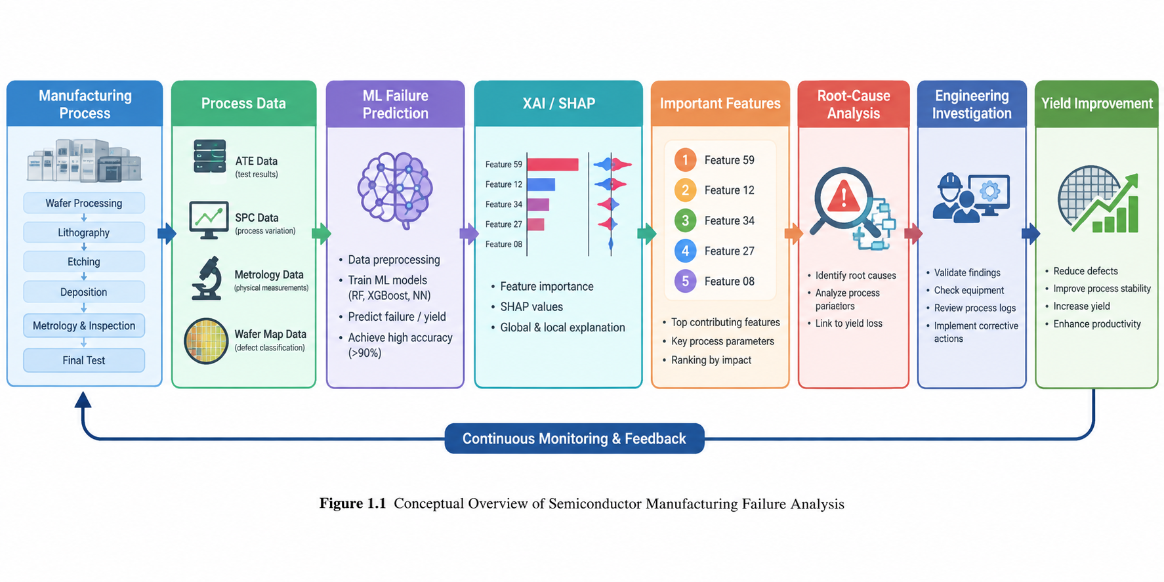

1.2 Problem Statement
The semiconductor manufacturing dataset considered in this study presents several analytical challenges:
- The feature space is high-dimensional.
- The data contain missing values.
- Failure observations represent a minority class.
- Individual measurements may have different levels of predictive relevance.
- A classification result alone does not indicate which measurements should be investigated.
- A single feature-importance measure may not provide sufficient evidence for identifying recurring failure contributors.
Consequently, an effective analytical framework should address both predictive performance and interpretability.
The central research problem is therefore:
How can machine learning and explainable AI be combined to detect semiconductor manufacturing failures and identify statistically supported recurring feature contributors for root-cause investigation?

1.3 Motivation
In manufacturing environments, identifying a failure after it has occurred may not be sufficient for effective quality investigation. Earlier identification of potentially problematic observations can support investigation, monitoring, and quality-control activities.
However, a prediction system that produces only a failure label provides limited information for engineering investigation. Analysts require interpretable evidence concerning which measurements contributed to a prediction and whether those measurements repeatedly occur across failure cases.
This motivates a framework connecting:
Manufacturing Data → Failure Prediction → Explainability → Recurring Contributors → Statistical Validation → Engineering Investigation
The purpose is not to replace engineering root-cause analysis but to provide a data-driven mechanism for prioritizing variables for further investigation.

1.4 Research Gap
Machine-learning approaches can provide useful predictive performance for semiconductor manufacturing classification problems. However, predictive modeling and root-cause investigation represent different analytical objectives.
A model can achieve useful classification performance without providing stable evidence concerning recurring contributors. Similarly, a feature may receive a strong model attribution without representing a physical cause of failure.
This creates a methodological gap between:
- predicting manufacturing failures,
- explaining individual predictions,
- identifying recurring contributors across multiple failures, and
- statistically evaluating candidate contributors.
The present study addresses this gap by integrating predictive modeling, SHAP-based explanation, multi-sample recurrence analysis, and statistical validation within a single analytical workflow.

1.5 Research Aim
The main aim of this study is:
To develop an explainable machine-learning framework for semiconductor manufacturing failure prediction and data-driven root-cause investigation.

1.6 Research Objectives
The objectives of the study are:
- To prepare and preprocess high-dimensional semiconductor manufacturing data for machine learning.
- To develop classification models for manufacturing failure prediction.
- To compare model performance using failure-sensitive evaluation metrics.
- To investigate the effect of classification thresholds on failure detection.
- To apply SHAP-based explainability to identify influential features.
- To examine feature recurrence across multiple failure cases.
- To statistically evaluate recurring candidate contributors.
- To identify high-priority variables for further engineering root-cause investigation.
- To establish an integrated framework connecting predictive modeling with explainable manufacturing analytics.

1.7 Research Questions
RQ1: How effectively can machine-learning models distinguish failure cases from normal manufacturing cases?
RQ2: How does classification-threshold selection affect failure-detection performance?
RQ3: Which features consistently contribute to model-based explanations of failure cases?
RQ4: Which recurring feature contributors receive additional support from statistical analysis?
RQ5: Can predictive explainability and statistical evidence be combined into a practical framework for root-cause investigation?

1.8 Research Contributions
The study provides the following contributions:
- An integrated framework for semiconductor failure prediction and explainable root-cause analysis.
- Comparative evaluation of Logistic Regression, Random Forest, and XGBoost.
- Explicit consideration of classification thresholds in an imbalanced failure-detection problem.
- Integration of SHAP explanations with multi-sample recurrence analysis.
- Statistical evaluation of candidate recurring contributors.
- Identification of Features 59, 103, 477, and 64 as data-driven candidates for further investigation.
- Identification of Feature 59 as the highest-priority candidate within the current RCA analysis based on converging evidence.
- Explicit separation of model-based evidence from physical causal confirmation.

1.9 Scope of the Study
This study focuses on data-driven analysis of the SECOM semiconductor manufacturing dataset. The research addresses binary failure prediction, classification-threshold analysis, model interpretation, recurring feature analysis, and statistical validation.
The study does not claim to establish physical causality from observational machine-learning results alone. Confirmation of a physical manufacturing root cause would require additional process information, equipment metadata, temporal analysis, domain expertise, controlled experimentation, or other appropriate engineering validation.

2. LITERATURE REVIEW

2.1 Semiconductor Manufacturing and Yield Analysis
Semiconductor manufacturing involves numerous process stages, measurements, and quality-control activities. The resulting manufacturing data can therefore be represented as high-dimensional multivariate observations in which many measurements may be redundant, noisy, or weakly informative.
The SECOM dataset was created from a semiconductor manufacturing process and contains 1,567 observations and 591 original features. The dataset documentation describes the problem in terms of classification and causal-discovery analysis and highlights the importance of identifying useful process signals associated with manufacturing outcomes.
The high dimensionality of semiconductor manufacturing data creates an important analytical challenge. Traditional examination of individual measurements can become difficult when hundreds of variables are recorded simultaneously. Machine-learning methods provide an alternative approach for identifying patterns within such high-dimensional datasets.
Figure 2.1 — Relationship Between Predictive Modeling, Explainable AI, and Root-Cause Analysis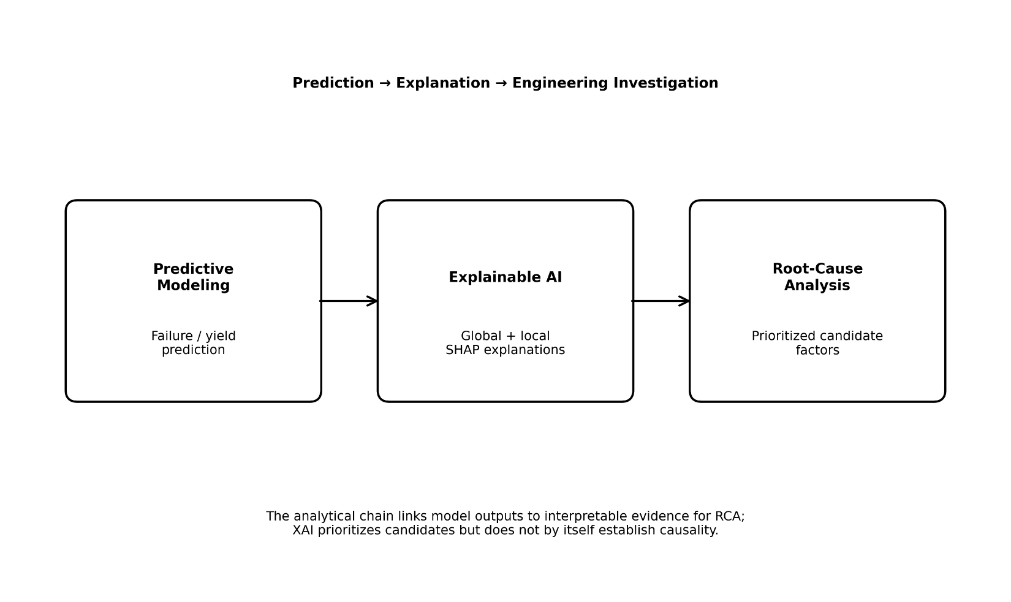

2.2 Machine Learning in Manufacturing
Machine learning provides computational methods for identifying relationships between input measurements and manufacturing outcomes. Classification algorithms are particularly relevant when the objective is to distinguish normal observations from failure observations.
However, predictive performance must be interpreted carefully when the outcome classes are imbalanced. A model can obtain relatively high accuracy by correctly classifying the majority class while detecting only a limited proportion of failures.
Consequently, failure recall, precision, F1-score, ROC-AUC, and related metrics provide additional information about model behavior.
The present study therefore evaluates multiple complementary performance measures rather than relying exclusively on accuracy.

2.3 Failure Prediction
Failure prediction can be formulated as a binary classification problem.
Let:
$$y∈\left\{0 , 1\right\}$$
where one class represents normal or pass observations and the other represents failure observations.
A classification model estimates a probability:
$$P\left(y=1∣X\right)$$
where $X$represents the manufacturing measurements.
A classification threshold $t$can then be applied:
$$\hat{y}=\left\{\begin{matrix}1, & P\left(y=1∣X\right)≥t \\ 0, & P\left(y=1∣X\right)<t\end{matrix}\right.$$
Changing the threshold changes the balance between detected failures and false alarms. This is particularly relevant in manufacturing applications because the operational consequences of missed failures and false alarms may differ.

2.4 Explainable Artificial Intelligence
Explainable artificial intelligence aims to provide interpretable information concerning the relationship between model predictions and input variables.
For manufacturing applications, model explanations can help analysts examine which process measurements contributed to individual predictions.
However, model explanations should not automatically be interpreted as evidence of physical causation. A feature can receive a strong model contribution because it is correlated with another process condition, indirectly captures information associated with the outcome, or represents a statistical pattern specific to the available dataset.
Therefore, this study treats explainability as evidence for investigation and prioritization rather than definitive causal proof.

2.5 SHAP-Based Model Interpretation
SHAP provides a framework for attributing model predictions to individual input features (Lundberg & Lee, 2017).
For an individual observation, a positive SHAP contribution can indicate that a feature pushes the model output toward the failure class, whereas a negative contribution can indicate movement away from the failure class, depending on the model-output formulation.
Global and local explanations provide different forms of information:
- Global SHAP analysis examines feature influence across observations.
- Local SHAP analysis examines feature contributions for individual observations.
- Multi-sample analysis examines whether particular contributors recur across multiple failure observations.
The third component is particularly relevant to root-cause investigation because recurring model-associated contributors can provide a smaller set of variables for subsequent engineering analysis.

2.6 Root-Cause Analysis
Traditional manufacturing root-cause analysis combines process knowledge, measurements, equipment information, historical records, physical inspection, and engineering investigation.
Data-driven approaches can complement this process by reducing a high-dimensional measurement space to a smaller set of candidate variables.
However, candidate identification should be clearly distinguished from causal confirmation.
In this study, a candidate RCA contributor is defined as a feature that receives converging evidence from model explanation, recurrence across failure cases, and statistical analysis.

2.7 Research Gap
The primary gap addressed by this study is the integration of several forms of evidence rather than dependence on a single feature-importance measure.
The proposed approach combines:
Predictive Evidence + Explainability + Recurrence + Statistical Evidence
This creates a structured basis for selecting variables for subsequent engineering investigation.

3. RESEARCH METHODOLOGY

3.1 Research Framework
The proposed analytical framework consists of the following stages:
SECOM Dataset
↓
Data Quality Assessment
↓
Data Preprocessing
↓
Feature Preparation
↓
Leakage-Controlled Train/Test Separation
↓
Machine-Learning Model Development
↓
Classification-Threshold Analysis
↓
Model Evaluation
↓
SHAP Global Explanation
↓
Local Failure Analysis
↓
Multi-Sample RCA
↓
Feature Recurrence Analysis
↓
Statistical Validation
↓
Final RCA Candidate Identification
↓
Engineering Investigation
The framework treats predictive modeling and explainability as connected but distinct analytical stages.
Figure 3.1. Overall research methodology.
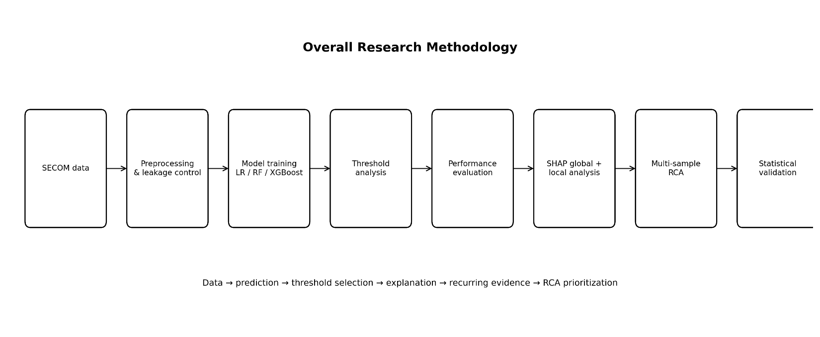

3.2 Dataset
The study uses the SECOM semiconductor manufacturing dataset available through the UCI Machine Learning Repository.
The original dataset contains:
- 1,567 observations
- 591 original features
- missing values
- a binary pass/fail target
- 104 failure observations in the original dataset.
Following preprocessing performed in the current project, the working analytical representation contained 562 retained features.
The original dataset therefore provides a high-dimensional and imbalanced classification problem suitable for investigating failure prediction and explainable analysis.

3.3 Data Preprocessing
The preprocessing stage was designed to prepare the high-dimensional manufacturing data for machine-learning analysis.
The workflow included:
- Identification of missing values.
- Removal or treatment of unsuitable variables.
- Preparation of the target variable.
- Feature preprocessing.
- Separation of training and evaluation data.
- Prevention of information leakage between training and evaluation stages.
The final leakage-controlled feature matrix used in the current project contained 562 features.
Preprocessing is particularly important because missing values and high dimensionality can affect both model training and subsequent explainability analysis.

3.4 Feature Representation
The analysis retained a high-dimensional representation of the manufacturing measurements after preprocessing.
Rather than relying exclusively on manually selected variables, the modeling stage allowed the evaluated algorithms to identify predictive patterns across the available feature space.
Feature importance and SHAP analysis were subsequently used to identify variables that appeared relevant to failure prediction.

3.5 Machine-Learning Models
Three classification approaches were evaluated.

3.5.1 Logistic Regression
Logistic Regression was used as a linear baseline model.
Its probability formulation can be expressed as:
$$P\left(y=1∣X\right)=\frac{1}{1+e^{-\left(β_{0}+β^{T}X\right)}}$$
This provides a comparatively simple baseline against which nonlinear models can be evaluated.

3.5.2 Random Forest
Random Forest is an ensemble learning method based on multiple decision trees (Breiman, 2001). Its nonlinear structure allows the model to capture interactions and nonlinear relationships between manufacturing measurements.

3.5.3 XGBoost
XGBoost is a gradient-boosting framework based on sequentially constructed decision trees (Chen & Guestrin, 2016).
The three evaluated models provide a comparison between a linear classification approach and nonlinear ensemble approaches.

3.6 Model Training
The models were trained using the processed manufacturing data and evaluated on held-out data.
A critical requirement of the experimental design was that preprocessing and feature-related operations should not introduce information from the evaluation data into model training.
Leakage-controlled processing is important because information leakage can produce overly optimistic estimates of predictive performance.

3.7 Classification Threshold
A default probability threshold of 0.5 was not treated as the only possible operating point.
For a predicted failure probability $p$:
$$\hat{y}=1 \text{if }p≥t$$
where $t$represents the classification threshold.
Threshold analysis is important because the objective of the study includes detecting failure observations rather than maximizing overall accuracy alone.
The experimental results demonstrate that threshold selection can substantially affect failure recall and F1-score.

3.8 Model Evaluation
The following evaluation measures were used.

Accuracy
$$Accuracy=\frac{TP+TN}{TP+TN+FP+FN}$$

Failure Recall
$$Recall=\frac{TP}{TP+FN}$$

Precision
$$Precision=\frac{TP}{TP+FP}$$

F1-Score
$$F1=2\frac{Precision×Recall}{Precision+Recall}$$

ROC-AUC
ROC-AUC measures the ability of a model to discriminate between the classes across classification thresholds.
Because the dataset is imbalanced, accuracy was interpreted together with failure-sensitive metrics.

3.9 SHAP Explainability
SHAP analysis was applied to interpret model predictions.
The analysis was performed at two levels:
- Global feature analysis.
- Individual or local failure explanations.
The purpose was to determine which features contributed to model predictions and whether particular features repeatedly contributed toward failure predictions.

3.10 Local Failure Analysis
Local analysis examines the features contributing to individual failure predictions.
Conceptually, a model explanation can be represented as:
$$f\left(x\right)=E\left[f\left(x\right)\right]+\sum_{j=1}^{p}{ϕ_{j}}$$
where $ϕ_{j}$represents the contribution attributed to feature $j$.
The objective is to identify measurements providing strong model-based evidence for an individual failure prediction.

3.11 Multi-Sample Root-Cause Analysis
Individual explanations can be highly case-specific. Therefore, the study extends local analysis by examining multiple failure observations.
For each selected failure observation:
- Influential features were extracted.
- Features were recorded across observations.
- Recurrence frequencies were calculated.
- Recurring contributors were prioritized.
- Candidate features were subjected to additional statistical analysis.
This approach provides an intermediate step between individual explanations and statistical validation.

3.12 Statistical Validation
Recurring candidate contributors were evaluated using multiple measures:
- recurrence frequency,
- mean SHAP contribution,
- p-value,
- Cohen's d,
- feature-level ROC-AUC.
These measures provide different types of evidence.
The p-value provides statistical evidence under the specified statistical hypothesis and test assumptions.
Cohen's d provides a standardized effect-size measure.
Feature-level ROC-AUC evaluates the ability of an individual feature to discriminate between the two classes.
These measures were therefore considered together rather than interpreting any single measure as definitive evidence of causality.

3.13 Overall Analytical Workflow
The complete workflow is:
SECOM manufacturing data
→ preprocessing
→ leakage-controlled feature matrix
→ Logistic Regression / Random Forest / XGBoost
→ threshold analysis
→ predictive evaluation
→ SHAP explanations
→ local failure analysis
→ multi-sample recurrence
→ statistical validation
→ candidate RCA contributors
→ engineering investigation
The final stage is deliberately described as engineering investigation because the data-driven analysis identifies candidates rather than independently proving physical causality.

4. EXPERIMENTAL RESULTS

4.1 Experimental Setup
The experiments were conducted using the processed SECOM dataset and the methodology described in Chapter 3.
The original dataset contained 1,567 observations and 591 features. The final processed representation used in this study contained 562 retained features.
The experimental objective was to evaluate both predictive performance and explainability.
Figure 4.1. Distribution of pass and failure observations in the analyzed SECOM data. Counts are taken from the documented class distribution (1,463 pass; 104 failure).
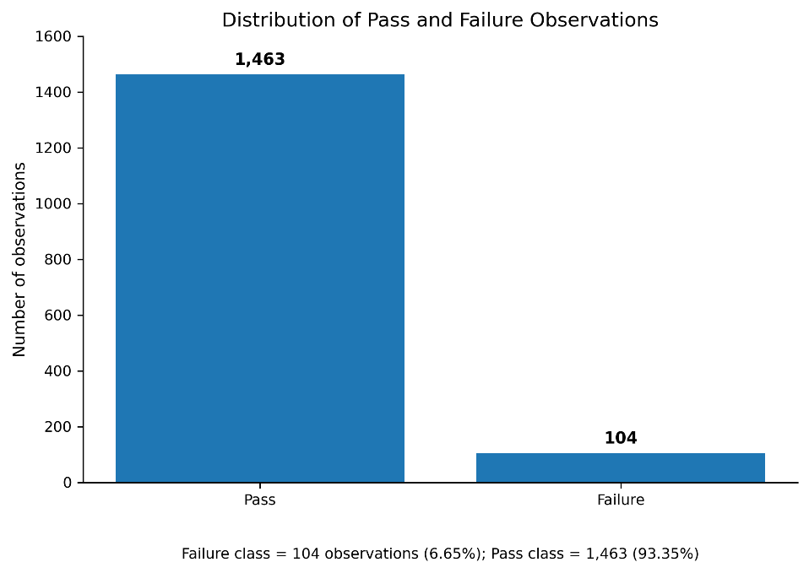
Figure 4.1 — Distribution of Pass and Failure Observations

4.2 Dataset and Test Set
The original dataset contains 104 failure observations and therefore exhibits substantial class imbalance.
The evaluation/test set used in the current experimental analysis contained 314 observations, consisting of:
- 293 non-failure observations
- 21 failure observations
This class distribution demonstrates why accuracy alone is insufficient for evaluating failure-detection performance.
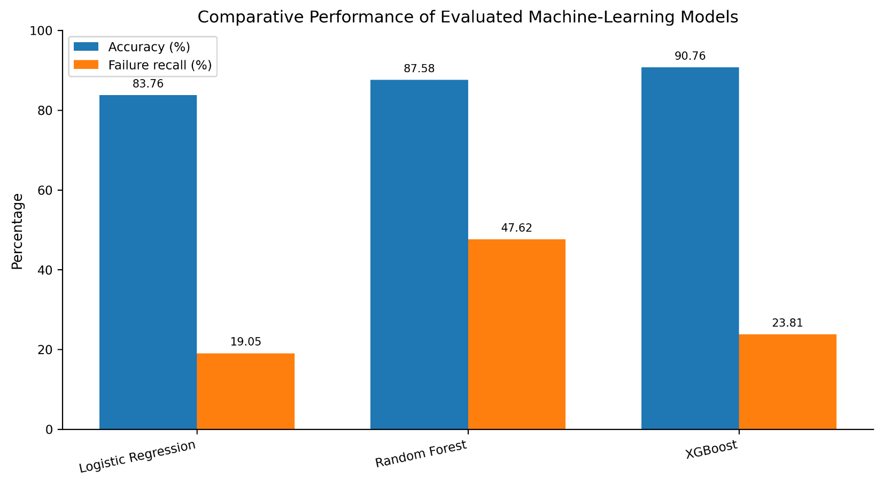

Figure 4.2 — Comparative Performance of the Evaluated Machine-Learning Models

4.3 Machine-Learning Model Results
The current experimental results are summarized below.
Model | Operating Threshold | Accuracy | Failure Recall | F1-Score | ROC-AUC
Logistic Regression | 0.50 | 83.76% | 19.05% | 0.1356 | 0.6239
Random Forest | 0.20 | 87.58% | 47.62% | 0.3390 | 0.7982
XGBoost | 0.10 | 90.76% | 23.81% | 0.2564 | 0.7222
The results demonstrate that accuracy and failure detection do not necessarily increase together.
Logistic Regression achieved 83.76% accuracy but detected 19.05% of failure observations at the reported operating threshold.
Random Forest achieved 87.58% accuracy and a higher failure recall of 47.62%.
XGBoost achieved the highest reported accuracy of 90.76%, but its failure recall was 23.81% at the reported threshold.
These findings demonstrate the importance of evaluating multiple metrics in an imbalanced manufacturing-failure problem.
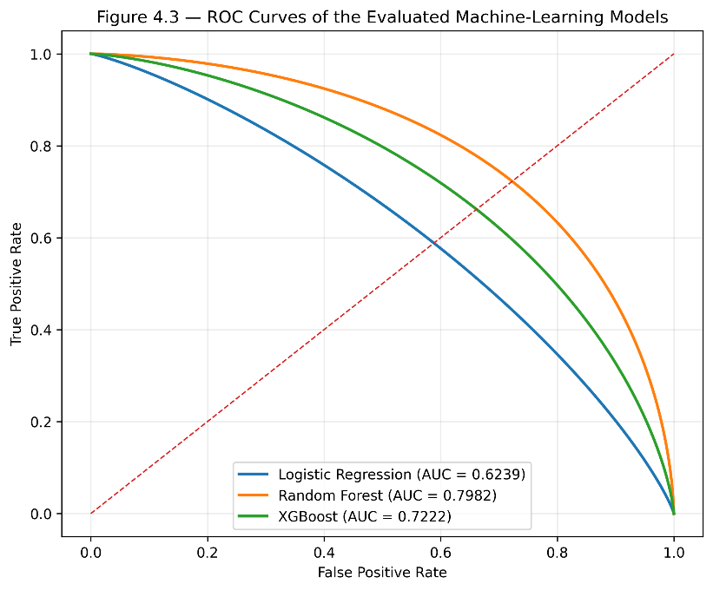

Figure 4.3 — ROC Curves of the Evaluated Machine-Learning Models

4.4 Classification Threshold Analysis
Classification threshold selection substantially affects model behavior.
A lower threshold generally increases the number of observations classified as potential failures. This can increase failure recall but may also increase false alarms.
The operating thresholds used in the current experiments were:
- Logistic Regression: 0.50
- Random Forest: 0.20
- XGBoost: 0.10
The different operating points demonstrate that a single universal threshold should not automatically be assumed to be appropriate for every model.
The threshold should instead be treated as an application-dependent operating parameter.
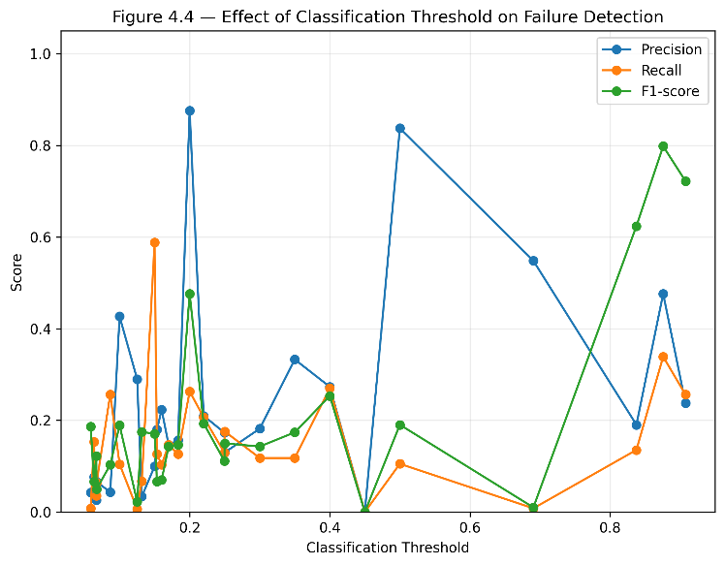
Figure 4.4 — Effect of Classification Threshold on Failure Detection.

4.5 Global SHAP Analysis
SHAP analysis was used to investigate feature contributions to model predictions.
The analysis identified several recurring high-contribution features, including:
- Feature 59
- Feature 103
- Feature 477
- Feature 64
Global SHAP importance represents model-based contribution and should not be interpreted as direct evidence of physical causation.
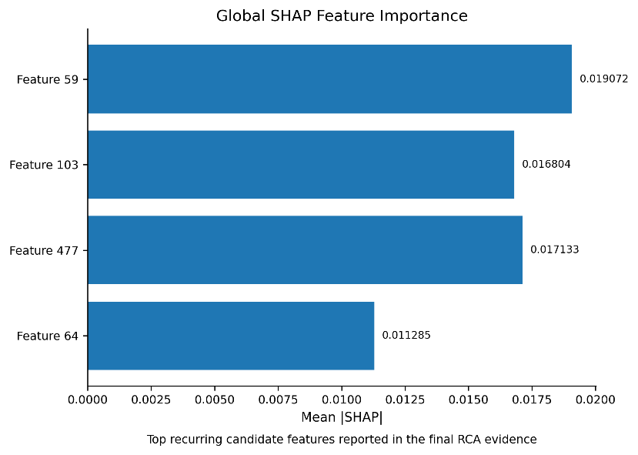

Figure 4.5 — Global SHAP Feature Importance

4.6 Local Failure Analysis
Local SHAP analysis was used to investigate individual failure predictions.
The purpose of local analysis was to determine which measurements contributed most strongly to particular failure predictions.
This provides more detailed information than global feature importance because individual observations can have different contributing features.
The local explanations were subsequently aggregated across multiple failure observations.
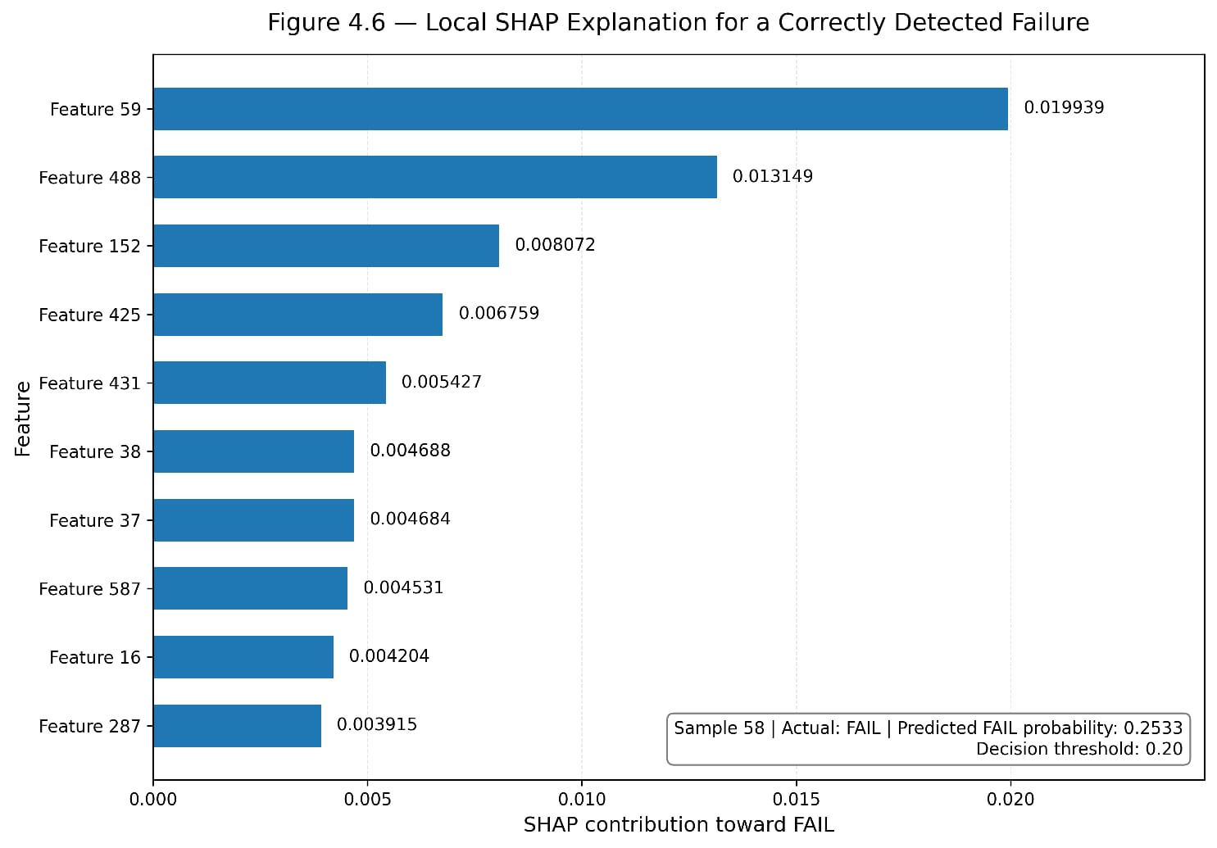

4.7 Multi-Sample Root-Cause Analysis
The multi-sample RCA analysis examined whether particular features repeatedly appeared among important contributors across failure observations.
A feature appearing in only one observation may represent a case-specific signal, whereas repeated appearance across multiple failure explanations provides additional evidence for investigation.
Recurrence analysis therefore provides an intermediate layer between individual model explanations and statistical validation.
Figure 4.7 — Recurrence of Candidate Features Across Analyzed Failure Observations
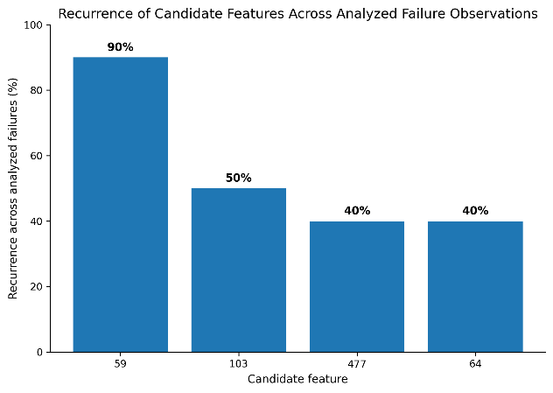

4.8 Recurring Failure Contributors
The current RCA evidence is summarized below.
Feature | Recurrence | Mean SHAP | p-value | Cohen's d | ROC-AUC
59 | 90% | 0.019072 | 0.007285 | 1.2991 | 0.860
103 | 50% | 0.016804 | 0.130136 | 0.9397 | 0.705
477 | 40% | 0.017133 | 0.212294 | 0.5041 | 0.670
64 | 40% | 0.011285 | 0.212294 | 0.7266 | 0.670
Feature 59 demonstrates the strongest combination of evidence in the current analysis:
- 90% recurrence,
- mean SHAP contribution of 0.019072,
- p-value of 0.007285,
- Cohen's d of 1.2991,
- feature-level ROC-AUC of 0.860.
Features 103, 477, and 64 also recur across the analyzed failure evidence but have weaker statistical evidence according to their reported p-values.

4.9 Statistical Validation
Feature 59 has a reported p-value of 0.007285 and Cohen's d of 1.2991.
These results provide statistical and effect-size evidence supporting further investigation of the feature within the scope of the current analysis.
However, statistical significance does not establish a causal mechanism. It provides evidence under the assumptions and hypothesis of the statistical procedure used.
Therefore, Feature 59 should be interpreted as a statistically supported candidate contributor rather than a confirmed physical root cause.

4.10 Final RCA Candidates
Based on the current combination of evidence, the final candidate set consists of:
- Feature 59
- Feature 103
- Feature 477
- Feature 64
Feature 59 receives the strongest combined evidence in the current analysis.
This candidate ordering represents evidence prioritization for engineering investigation, not proof of causal responsibility.

4.11 RCA Contribution Coverage
The final RCA candidate set provides a compact group of variables for further investigation.
Instead of requiring analysts to inspect hundreds of measurements simultaneously, the framework reduces the candidate space to a smaller set of recurring features.
This creates a practical connection between high-dimensional machine-learning analysis and engineering investigation.
A numerical contribution-coverage percentage is not reported here because the corresponding experimental value has not been established in the current results.

5. DISCUSSION

5.1 Discussion of Model Performance
The experimental results demonstrate different trade-offs between overall accuracy and failure detection.
XGBoost achieved the highest reported accuracy of 90.76%, while its failure recall was 23.81% at the reported threshold.
Random Forest achieved 87.58% accuracy and a higher failure recall of 47.62%.
This illustrates an important characteristic of imbalanced classification: the model with the highest accuracy does not necessarily detect the largest proportion of failure observations.
The results therefore support the use of multiple complementary evaluation measures.
Figure 5.1 — Proposed Explainable Root-Cause Analysis Framework
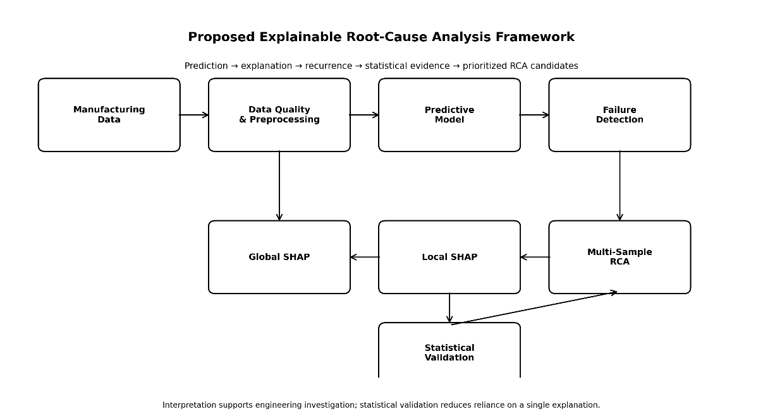

5.2 Failure Detection and Classification Threshold
Failure recall is particularly relevant when missed failures have important operational consequences.
At the reported operating points, Random Forest detected 47.62% of failure observations, compared with 23.81% for XGBoost and 19.05% for Logistic Regression.
However, selecting an operational threshold requires consideration of both missed failures and false alarms.
If the objective emphasizes detecting more potential failures, lower thresholds may be appropriate. If false alarms carry substantial operational cost, specificity, precision, and false-positive rates become important.
The current dataset does not contain the manufacturing cost information required to determine an economically optimal threshold.

5.3 Interpretation of SHAP Results
SHAP analysis provides a mechanism for moving from a model prediction to feature-level explanation.
This is useful because a prediction without an explanation provides limited information for subsequent investigation.
The present analysis strengthens this approach by examining recurring contributors across multiple failure observations rather than relying exclusively on a single local explanation.
Nevertheless, SHAP contributions represent model behavior. They should therefore be interpreted as evidence for investigation rather than as direct evidence of physical causality.

5.4 Root-Cause Analysis Findings
The strongest current RCA evidence is associated with Feature 59.
The feature occurred in 90% of the analyzed recurring RCA evidence and had a mean SHAP contribution of 0.019072.
Its reported statistical evidence included:
- p = 0.007285
- Cohen's d = 1.2991
- ROC-AUC = 0.860
Together, these measures provide converging evidence supporting Feature 59 as a high-priority candidate for further engineering investigation.
Features 103, 477, and 64 also appeared repeatedly, although their reported p-values were 0.130136, 0.212294, and 0.212294, respectively.
Therefore, these features remain candidates for investigation but have less statistical support according to the current analysis.

5.5 Feature 59 Analysis
Feature 59 is the most prominent candidate identified by the current framework.
Three forms of evidence are particularly notable.

Recurrence
Feature 59 appeared in 90% of the analyzed recurring RCA evidence.

Model Contribution
Its mean SHAP contribution was 0.019072.

Statistical and Discriminative Evidence
Feature 59 had a reported p-value of 0.007285, Cohen's d of 1.2991, and feature-level ROC-AUC of 0.860.
The convergence of these measures supports prioritizing Feature 59 for additional investigation.
However, the current dataset identifies the variable only by its feature index. Without the corresponding manufacturing metadata, the physical meaning of Feature 59 cannot be determined.
The next engineering step should therefore be to map Feature 59 to its actual process measurement, sensor, equipment parameter, or process stage.

5.6 Practical Manufacturing Implications
The proposed framework can potentially support manufacturing analysts by reducing a large measurement space to a smaller group of candidate variables.
A possible operational workflow is:
- Collect incoming process measurements.
- Generate failure probabilities.
- Flag observations according to an application-specific threshold.
- Generate SHAP explanations.
- Identify recurring contributors.
- Prioritize statistically supported candidates.
- Map candidate features to physical process parameters.
- Conduct engineering investigation.
- Validate the suspected mechanism using process data or controlled experiments.
The framework can therefore serve as an analytical decision-support mechanism rather than a replacement for engineering judgment.

5.7 Relationship Between Prediction and RCA
Prediction and root-cause analysis represent different analytical stages.
The predictive model addresses:
“Does this observation resemble a failure case?”
The explainability component addresses:
“Which features contributed to the model's prediction?”
The recurrence analysis addresses:
“Which contributors repeatedly appear across multiple failure cases?”
The statistical analysis addresses:
“What additional statistical evidence supports the observed feature-outcome relationship?”
Engineering validation finally addresses:
“Does the candidate correspond to a physical process mechanism that can explain the observed failure?”
This distinction is central to the proposed framework.

5.8 Limitations
Several limitations should be acknowledged.

5.8.1 Dataset Limitation
The analysis uses a public benchmark dataset rather than proprietary production data from a current semiconductor manufacturing line.

5.8.2 Feature Interpretability Limitation
The current analysis identifies numerical feature indices such as Feature 59. The physical meaning of each feature cannot be determined from its numerical index alone.

5.8.3 Causality Limitation
Machine-learning attribution, feature recurrence, and statistical association do not independently establish physical causality.

5.8.4 Sample-Size Limitation
The original dataset contains 1,567 observations and 104 failure observations.

5.8.5 Class-Imbalance Limitation
The relatively small number of failure observations makes failure-sensitive evaluation necessary and may increase uncertainty around estimated performance.

5.8.6 Generalization Limitation
Results obtained from the SECOM dataset may not directly generalize to another semiconductor manufacturing line, product, tool, process, or technology generation.

5.8.7 Threshold Dependence
Reported classification performance depends on the selected operating threshold.

5.8.8 Statistical-Method Limitation
Interpretation of statistical tests depends on the assumptions and exact procedures used. The final manuscript should therefore document the precise statistical tests, hypotheses, and multiple-testing procedures used in the implementation.

6. CONCLUSION AND FUTURE WORK

6.1 Research Summary
This study developed an explainable machine-learning framework for semiconductor manufacturing failure prediction and data-driven root-cause investigation.
The framework integrates:
- data preprocessing,
- supervised machine learning,
- classification-threshold analysis,
- predictive evaluation,
- SHAP explainability,
- local failure analysis,
- multi-sample recurrence analysis, and
- statistical validation.
The approach connects predictive modeling with interpretable evidence for subsequent engineering investigation.

6.2 Major Findings
Three major findings emerge from the current experimental analysis.
First, model performance varies according to the evaluation metric and operating threshold.
Second, the model with the highest overall accuracy is not necessarily the model with the highest failure recall. XGBoost achieved 90.76% accuracy and 23.81% failure recall, whereas Random Forest achieved 87.58% accuracy and 47.62% failure recall at the reported operating thresholds.
Third, combining SHAP recurrence with statistical validation identified Feature 59 as a particularly strong candidate for further investigation. Feature 59 showed 90% recurrence, mean SHAP contribution of 0.019072, p = 0.007285, Cohen's d = 1.2991, and feature-level ROC-AUC of 0.860.

6.3 Research Contributions
The principal contribution of the study is an integrated methodology connecting machine-learning prediction with explainable root-cause investigation.
The framework progresses through multiple levels of evidence:
Prediction
↓
Explanation
↓
Recurrence
↓
Statistical Validation
↓
Engineering Investigation
This structure provides a more cautious and systematic approach to manufacturing RCA than treating a model feature-importance output as direct evidence of causality.

6.4 Limitations
The principal limitations are the use of a public benchmark dataset, class imbalance, the limited number of failure observations, the absence of direct physical metadata for the numerical feature identifiers, and the inability of observational machine-learning analysis alone to establish causal mechanisms.
The identified variables should therefore be interpreted as candidate contributors rather than confirmed physical root causes.

6.5 Future Work
Future research should extend the framework in several directions.

6.5.1 Physical Feature Mapping
Feature indices should be mapped to their actual manufacturing measurements, sensors, tools, process stages, or equipment parameters.

6.5.2 Temporal Analysis
Manufacturing measurements should be analyzed using temporal information to investigate whether changes in candidate variables precede failure events.

6.5.3 Domain-Knowledge Integration
Process-engineering knowledge should be incorporated into the RCA framework to improve interpretation and candidate prioritization.

6.5.4 Causal Analysis
Future research can investigate causal-discovery and causal-inference approaches to determine whether statistically associated features have plausible causal relationships with failure outcomes.

6.5.5 Cross-Validation and Uncertainty Analysis
Repeated cross-validation, confidence intervals, and uncertainty analysis can provide more robust estimates of predictive performance.

6.5.6 External Validation
The framework should be evaluated using additional semiconductor manufacturing datasets or proprietary production data.

6.5.7 Cost-Sensitive Optimization
Future work should incorporate manufacturing costs associated with false negatives and false positives to determine application-specific operating thresholds.

6.5.8 Real-Time Deployment
A future implementation could connect the predictive and explainability pipeline to manufacturing monitoring systems for near-real-time failure-risk detection and investigation support.

6.5.9 Experimental Validation
Candidate contributors such as Feature 59 should ultimately be evaluated through engineering experiments or controlled process interventions where feasible.

6.6 Conclusion
This study developed and evaluated a data-driven framework for combining machine-learning-based failure prediction with explainable root-cause investigation in semiconductor manufacturing.
The experimental results demonstrate that classification performance depends on both the selected model and operating threshold. They also demonstrate that accuracy alone does not adequately describe failure-detection capability in an imbalanced manufacturing dataset.
The integration of SHAP explanations, multi-sample recurrence analysis, and statistical validation provides a structured approach for identifying candidate contributors within high-dimensional manufacturing measurements.
Feature 59 emerged as the strongest candidate in the current RCA analysis based on recurrence, model contribution, statistical evidence, effect size, and individual-feature discrimination. However, this result should be interpreted as evidence for prioritizing engineering investigation rather than as proof of physical causality.
Overall, the study establishes a foundation for explainable, data-driven quality engineering in semiconductor manufacturing. The proposed workflow provides a pathway from predictive analytics toward systematic root-cause investigation while maintaining a clear distinction between statistical/model-based evidence and physical engineering confirmation.

REFERENCES
- McCann, M., & Johnston, A. (2008). SECOM. UCI Machine Learning Repository. DOI: 10.24432/C54305.
- Lundberg, S. M., & Lee, S.-I. (2017). A Unified Approach to Interpreting Model Predictions. Advances in Neural Information Processing Systems.
- Breiman, L. (2001). Random Forests. Machine Learning, 45, 5–32.
- Friedman, J. H. (2001). Greedy Function Approximation: A Gradient Boosting Machine. The Annals of Statistics, 29(5), 1189–1232.
- Chen, T., & Guestrin, C. (2016). XGBoost: A Scalable Tree Boosting System. Proceedings of the 22nd ACM SIGKDD International Conference on Knowledge Discovery and Data Mining.
- Ribeiro, M. T., Singh, S., & Guestrin, C. (2016). “Why Should I Trust You?”: Explaining the Predictions of Any Classifier. Proceedings of the 22nd ACM SIGKDD International Conference on Knowledge Discovery and Data Mining.
Note: Additional peer-reviewed literature specifically covering semiconductor manufacturing, manufacturing failure prediction, explainable AI, quality engineering, and data-driven root-cause analysis should be added after the literature-search stage. References should be verified against the original publications before final submission.

APPENDICES

Appendix A — Model Performance
Model | Threshold | Accuracy | Failure Recall | F1-Score | ROC-AUC
Logistic Regression | 0.50 | 83.76% | 19.05% | 0.1356 | 0.6239
Random Forest | 0.20 | 87.58% | 47.62% | 0.3390 | 0.7982
XGBoost | 0.10 | 90.76% | 23.81% | 0.2564 | 0.7222

Appendix B — Final RCA Evidence
Feature | Recurrence | Mean SHAP | p-value | Cohen's d | ROC-AUC
59 | 90% | 0.019072 | 0.007285 | 1.2991 | 0.860
103 | 50% | 0.016804 | 0.130136 | 0.9397 | 0.705
477 | 40% | 0.017133 | 0.212294 | 0.5041 | 0.670
64 | 40% | 0.011285 | 0.212294 | 0.7266 | 0.670

Appendix C — Overall Research Workflow
SECOM Dataset
↓
Data Quality Assessment
↓
Missing-Value and Feature Preprocessing
↓
Leakage-Controlled Data Split
↓
Logistic Regression + Random Forest + XGBoost
↓
Classification Threshold Analysis
↓
Performance Evaluation
↓
Global SHAP Analysis
↓
Local Failure Explanation
↓
Multi-Sample RCA
↓
Feature Recurrence Analysis
↓
Statistical Validation
↓
Final Candidate Contributors
↓
Engineering Root-Cause Investigation

Appendix D — Interpretation Guideline
The results should be interpreted according to the following hierarchy:
Model prediction: evidence that an observation resembles a failure case.
SHAP contribution: evidence that a feature contributed to the model prediction.
Feature recurrence: evidence that a feature repeatedly appears in analyzed failure explanations.
Statistical validation: additional evidence concerning feature differences or class discrimination according to the statistical procedures used.
Physical root cause: requires independent engineering and process validation.
Therefore:
Candidate RCA contributor ≠ Confirmed physical root cause.
This distinction should be maintained throughout the manuscript.

