**Q1. Are the HTML tags and elements the same things?**

1. The HTML tags and elements are not the same things.

**Tags:**

The HTML tags holds the Elements. Tags are enclosed with an angular brackets < >. Some tags have opening and closing tags. Some tags are self closed tags which doesnot need any closingS tag.

e.g. Opening and closing tags:

<html> </html>

<body> </body>

Self closed tags:

<br>  used for break the line

<hr> used for horizontal line

**Elements:**

The HTML elements holds the content. It is defined by open and close tag. Some elements don’t need any closing tag which is called void element. In HTML an element keeps inside another element is called nested element.

e.g.

start tag         content            endtag

         |                   |                       |

       <p>      this is content        </p>

**Q.2. What are Tags and attributes in HTML?**

**Ans-** Attributes are used to define the characteristics or additional information of an element. It is      placed inside an element opening tag. Attributes contains two parts name and value which is written in pair like: name=”value”.

e.g.

align=”center”

**Wrdti;.**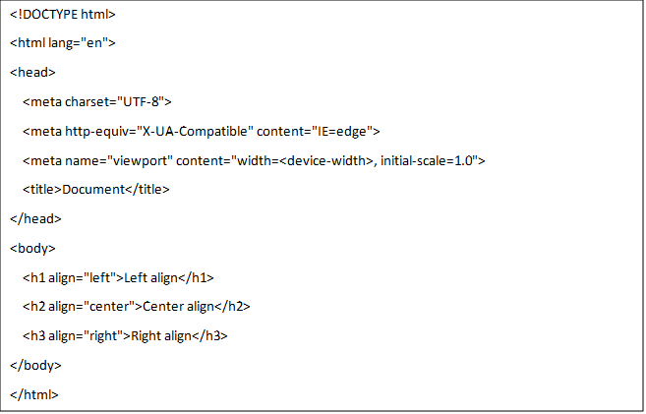

**Output**:

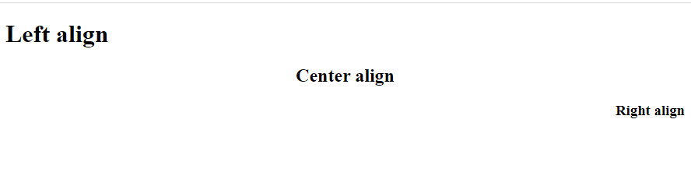

**Q.3. What are void elements in HTML?**

**A-** Some elements have only start tag and don’t have any content within it, are called void          elements. Void elements don’t need to be closed. <br>, <hr>, <img> are the examples of void elements.

e.g.

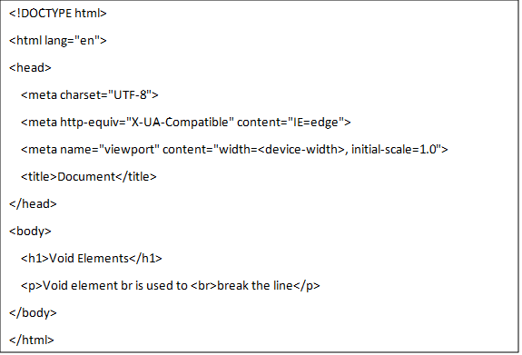

**Output:**

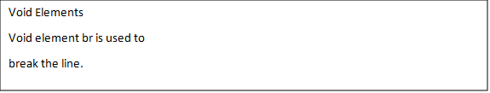

**Q.4. What are HTML Entities?**

**A-** Entities are used to define special symbols in HTML. Entities can be used with its name or numeric charater reference. It stars with ampersand (&) and ends with semicolon (;).

e.g.

&copy;     -  This is used for copyright

&#128517;   - This is used for emoji.

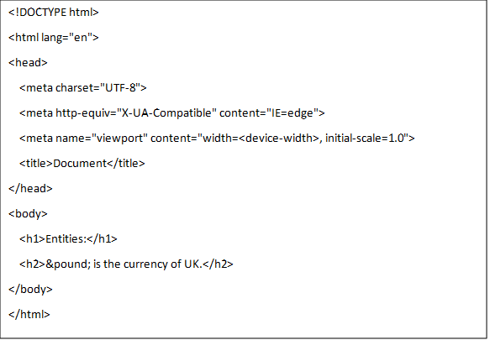

**Output:**

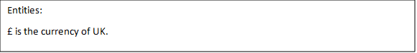

**Q.5. What are the different types of list in HTML?**

**A- List:**

In HTML list is used to show an information in listed format. There are three ways to specify the  list.

1.Ordered List

2.Unordered List

3.Data List

1.Ordered List:

An ordered list is used to show the list by numbers or alphabets. In HTML <ol></ol> tag is used for ordered list and <li></li> tag is used to show  an options in the list. The type attribute is used to specify the number or alphabet.

e.g.

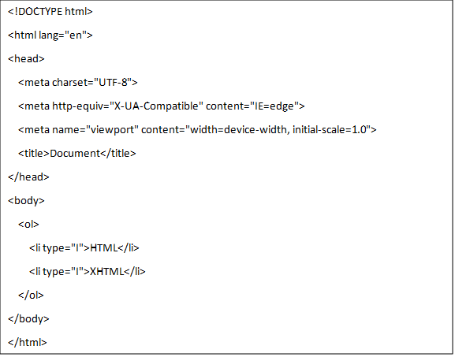

**Output:**

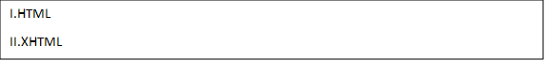

2.Unordered List:

An unordered list is used to specify an information which doesnot have any sequence. It specifies with bullets. In HTML <ul></ul> tag is used for unordered list. Bydefault it shows disc bullet. There is Type attribute to specify types of bullets.

e.g.

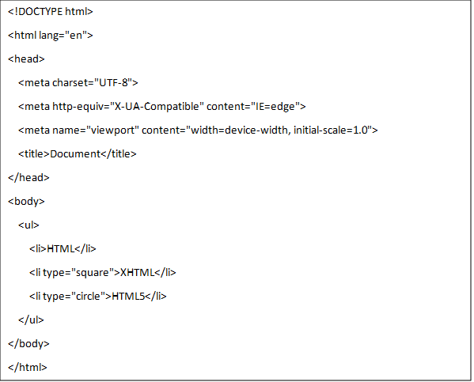

**Output:**

* HTML
* XHTML
* HTML5

3. Data List:

Data list is used to specify an information in particular format like dictionary or encyclopedia.

In HTML <dl></dl> tag is used for data list. There are two more tags are used in data list i.e.

  <dt></dt> for data term and <dd></dd> for data defination.

e.g.

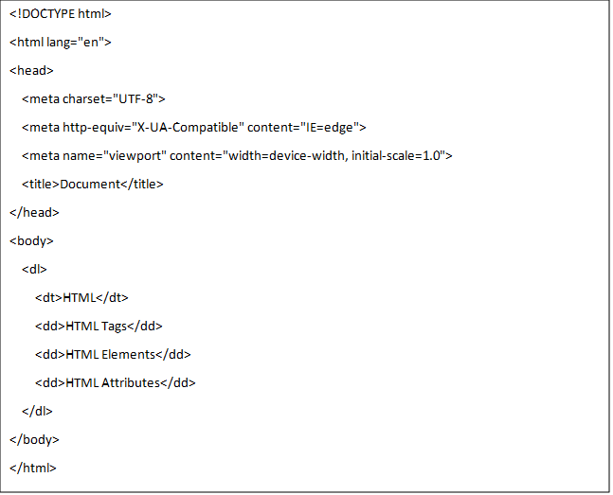

**Output:**

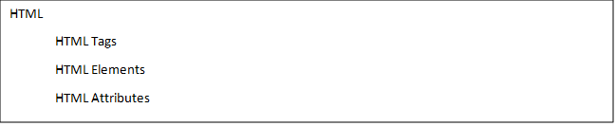

**Q.6. What is the class attribute in HTML?**

**A-** The class attribute is used to specify a class for an HTML element. Multiple HTML elements can share the same class. The class attribute is often used to point to a class name in a style sheet.

**Q.7. What is the difference between the ‘id’ attribute and the ‘class’ attribute of HTML elements?**

**A-** id atrribute-

1. The id attribute is a unique identifier that is usedto specify the document.

2.It is used by CSS and javascript to perform a certain task for a unique element.

3.In CSS the id attribute is written using the “#” symbol followed by id.

     Class attribute-

1.The class attribute is used to specify one or more class names for an HTML element.

2.The class attribute can be used on any  HTML element.

3.The class name can be used by CSS and Javascript to perform certain tasks for elements with the specified class name.

4.The class name in CSS stylesheet using “ . ” symbol.

**Q.8. What are the various formatting tags in HTML?**

**A-** In HTML Formating tags are used to specify an information in particular format like bold, italic, underlined, etc. Formatting tags are as below.

1. <b></b>  -It is used to specify information in bold format. <strong></strong> tag is also used to bold the text.

2.<i></i> -It is used to specify text in italic form. <em></em>is used as alternative for italic form.

3. <u></u>  - It is used to underline particular  text.  <ins></ins> is used as alternative for underlined form.

4. <del></del> -It is used to specify deleted text. <strike></strike> is used as alternative for deleted text.

5. <mark></mark> -This is used to mark a particular sentence in information.

6. <sub></sub> - This is used to specify subscript text.

7.<sup></sup> -This is  used to specify superscript text.

**Example of formatting tag:**

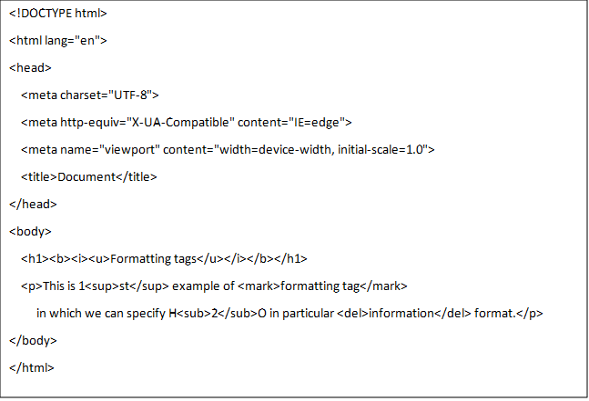

**Output:**

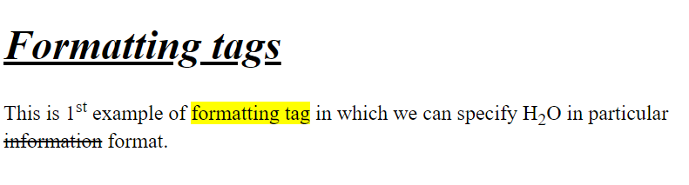**Q.9. How is cell padding different from cell spacing?**

**A-1.** Cell padding specifies the space between border of a table cell and its content, while cell spacing specifies the space between cells or the edges of adjacent cells.

2. In HTML <table> tag is used to define the cellpadding and cellspacing.

3.  In <table> tag type attribute is set to ‘cellpadding’ to specify space between table cell and its content while ‘cell spacing’ to specify space between adjacent cells.

4. The default cellpaddingvalue is 1 whereas, the default cellspacing value is 2.

e.g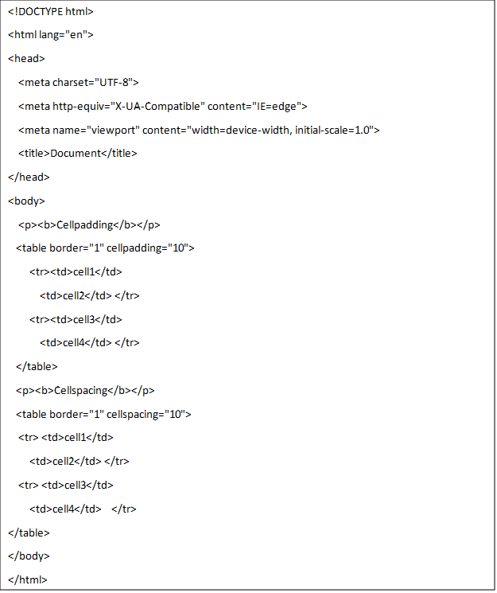

**Output:**

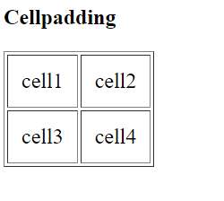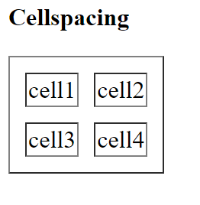

**------------------------------------------------------------------------------------------------------------------------------------------**

**Q.10. How can we club two or more rows or columns into a single row or column in HTML table?**

**A-** In HTML table, <tr></tr> tag is used to specify the row and <td></td> tag is used to specify the column. We have to club two or more  rows into single row then we’ll have to use rowspan attribute with its value in <td></td>tag. Put row numbers in value you want to merge.

e.g.   <td rowspan=”2”></td>

 We use colspan attribute with its value in <td></td> tag to merge two or more column in single column.

e.g.  <td colspan=”2”></td>

**Example of rowspan and colspan in table:**

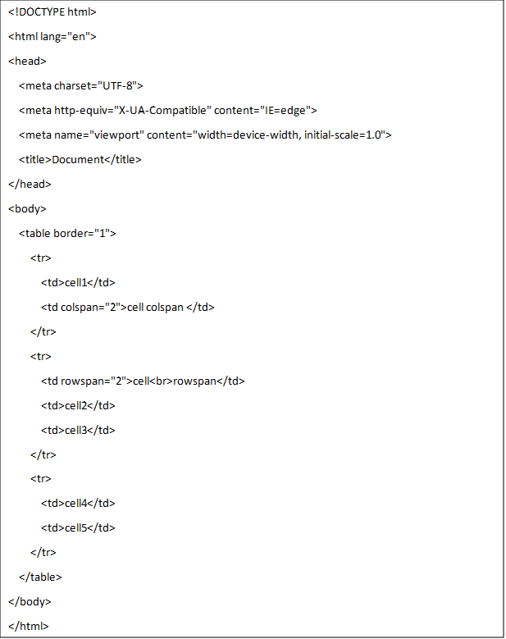

**Output:**

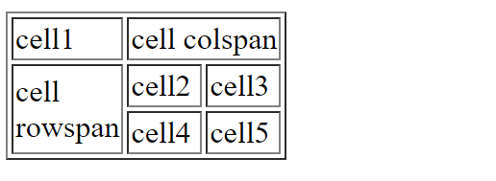

**------------------------------------------------------------------------------------------------------------------------------------------**

**Q.11. What is the difference between a block level element and an inline element?**

**A-** Difference between block level and inline element

|  |  |
| --- | --- |
| **Block level Element** | **Inline Element** |
| 1.Block elements always starts from a new line.  2.Block level occupies the entire width with their sufficiency.  3.Block element don’t allow other element next to it.  4.block element have top and bottom margin.  5. Examples are <h1>-<h6>,<hr>,<p> etc. | 1.Inline element don’t starts in a new line.  2.Inline element occupies only required width with their sufficiency.  3.Inline elements allows other elements next to it.  4.Inline element don’t have top and bottom margin.  5.<b>,<I>,<sup>,<sub>,etc.. |

**Example of block and inline element:**

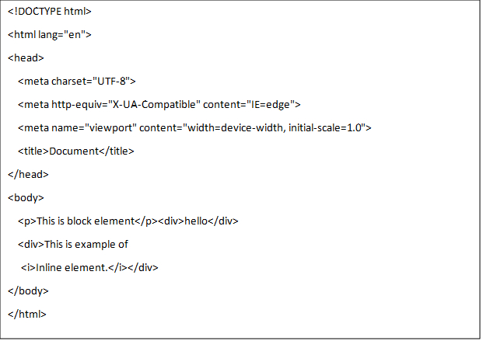

**Output:**

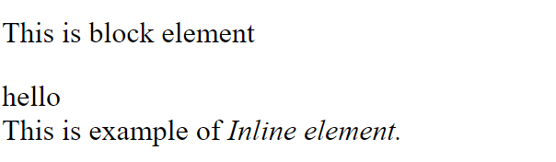

**Q.12. How to create a Hyperlink in HTML?**

**A-** Hyperlink is used to go from one page to another in a webpage. There is anchor tag <a></a> used to create a hyperlink. In anchor tag there is href attribute used to indicate the destination of link.

e.g. <a href=”url”>Home</a>

Target attribute is also used in anchor tag, which specifies where to open the linked document.  The target attribute having four values.

1. _self- It is default value. It opens the document in the same window.

2. _blank- Opens the document in a new window or tab.

3. _parent- Opens the document in pop up window.

4. _top- Opens the document in the full body of the window.

**Q.13. What is the use of an iframe tag?**

**A-** The HTML <iframe> tag specifies an inline frame. An inline frame is used to embed another document within the current HTML document. The <iframe> tag contains src attribute which defines the URL of the page to embed.

e.g. <iframe src=” URL”></iframe>

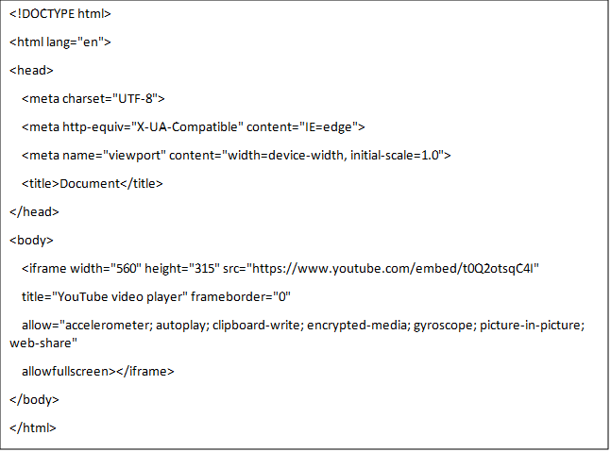**Output** 

**Q.14. What is the use of span tag? Expain with example?**

**A-** The <span> tag is used to mark up a part of a text ofr a part of a document . This is an inline element.

e.g.

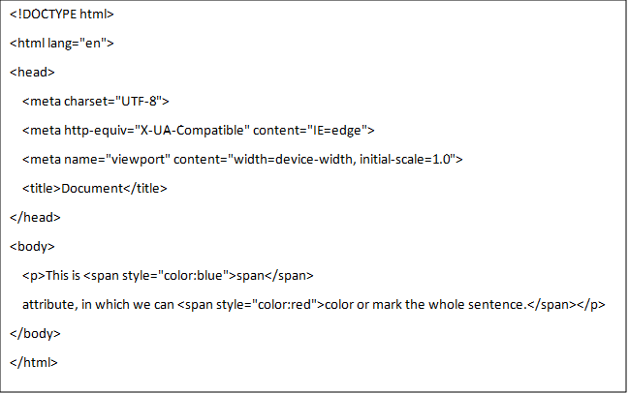

**Output:**

C:\Users\Admin\AppData\Local\Microsoft\Windows\INetCache\Content.MSO\6DE2826B.tmp

**Q.15. How to insert a picture into a backgroud image of a web page?**

**A-** The <img> tag is used to embed an image in an HTML page. Images can be linked to web pages. The <img> tag has main two attributes.

1. src – Specifies the path to the image.

2. alt – Specifies an alternate text for an image.

**e.g.** <img src=”path of image” alt=”alternate text for image”>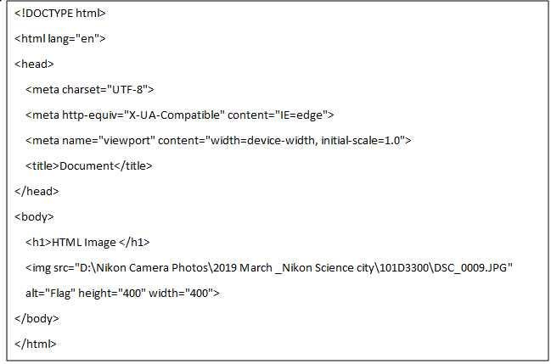

**Output:**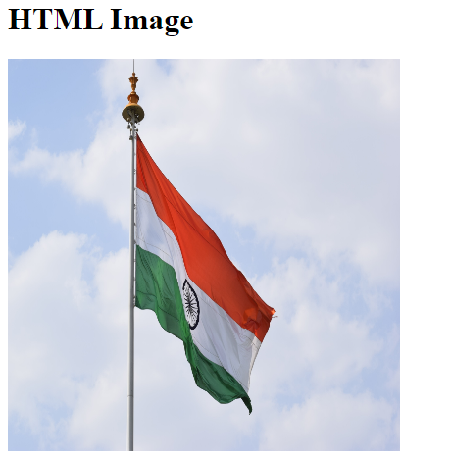

**Q.16. How are active links different from normal link?**

**A-** In HTML we can use <a> tag to specify link to any webpage. Link is used to move from one page to another page. In HTML href attribute is used to set the path to link in <a> tag.

e.g. <a href=”url”></a>

When we set link to any webpage by  using <a> tag the normal link will show in blue in colour with underline it. Whereas, an active link will turn into red colour with underline if you left or right click any one of the links visited or unvisited.

e.g.

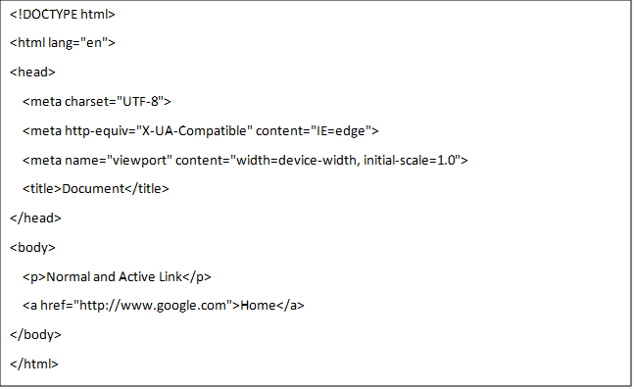

**Output:**

This is normal link.                                                                                                   This is Active link.

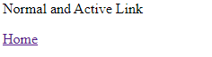                  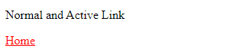

**Q.17. What are the different tags to separate sections of text?**

**A-** The different tags to separate sections of text are:

1. Paragraph tag-

The paragraph tag <p></p> tag is used to specify the text into different paragraph. Each paragraph of text should be used separate <p></p> tag.

2. Horizontal line tag-

<hr> tag is used to separate the text or paragraph of document by horizontal line.

3.  Line break tag-

<br> tag is used to break the line of the document.

 e.g.

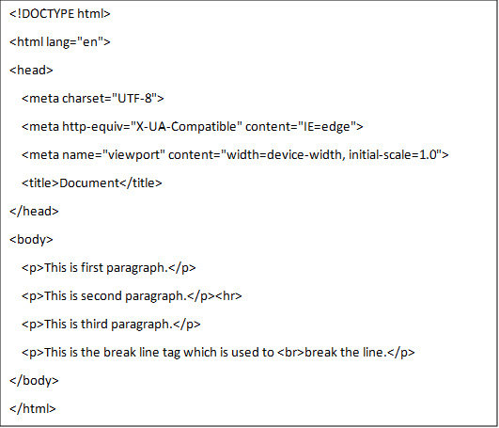

**Output:**

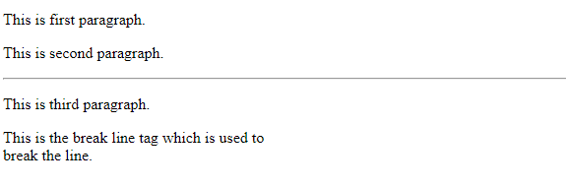

------------------------------------------------------------------------------------------------------------------------------------------

**Q.18. What is the difference between HTML and XHTML?**

**A-** Difference between HTML and XHTML

|  |  |
| --- | --- |
| **HTML** | **XHTML** |
| 1.HTML stands for Hypertext Markup Language.  2.It is used to create websites and web applications.  3.All tags and attributes arenot necessarily to be in lower case or upper case.  4.Doctype is not necessary to write at the top.  5.In HTML, file name extension used are .html, .htm | 1.XHTML stands for Extensible Hypertext Markup Language.  2.It is stricter and more standerdized version of HTML.  3.All tags and attributes should be in lower case.  4. Doctype is very necessary to write at the top of file.  5.File name extension are .xhtml, .xht, .xml. |

**Q.19. What are logical and physical tags in HTML?**

**A-** Logical Tag-

Logical tags are used todisplay the text according to the logical styles.

e.g.

<pre> -tag is used to define preformatted text.

<ins> - used to define inserted text.

<del> -used to define deleted text.

<strong> - used to define strong text.

Physical Tag-

Physical tags are used to provide actual physical formatting to the text.

e.g.

<b> -used to define bold text.

<i> - used to define Italic text.

<sup> -used to define superscripted text.

<sub>- used to define subscripted text.

<u> - used to define underline text.