**HR-BOT : A RECRUITMENT CHATBOT**

**Abstract:**

The growing need of machine learning and AI can effectively be applied to the recruitment process to ease the human life and make the process more cost effective, quick and unbiased. As the recruitment process is being perplexed day by day, sometimes it becomes really tough for a company to go through the all the entire resumes manually and shortlist the candidates based on company requirements for personal interviews. Eventually companies sometimes hire agencies to do this, and end up spending a huge amount of time and money. Here the interview chatbots come into play.

We are building the **HR-BOT** to **automate the initial screening process by chatting with the candidates online and asking relevant questions so that a company can spend less time going through thousands of resumes and shortlist them faster**. It’s not possible for human recruiters to work 24/7 while a chatbot can serve the queries and effectively takes interviews of several candidates at a time without asking for a leave.

**What is Chatbot?**

A chatbot is an intelligent piece of software that is capable of communicating and performing actions similar to a human. Chatbots are used a lot in customer interaction, marketing on social network sites and instantly messaging the client. There are two basic types of chatbot models based on how they are built; Retrieval based and Generative based models.

1. Retrieval based Chatbots: A retrieval-based chatbot uses predefined input patterns and responses. It then uses some type of heuristic approach to select the appropriate response. It is widely used in the industry to make goal-oriented chatbots where we can customize the tone and flow of the chatbot to drive our customers with the best experience.

#### 2. Generative based Chatbots: Generative models are not based on some predefined responses.They are based on seq 2 seq neural networks. It is the same idea as machine translation. In machine translation, we translate the source code from one language to another language but here, we are going to transform input into an output. It needs a large amount of data and it is based on Deep Neural networks.

**Methodology:**

The basic training tools that will be used are:

- Python 3

- Natural Language Processing Tool-kit (nltk)

- Tensorflow 1.15

- Tflearn

- SQlite

* The platform used for training the model is Google Colab .
* We are using tflearn(a wrapper above tensorflow) to create this chatbot. .
* The language which we used primarily is python3.

PREPROCESSING THE DATA: For training the model we have created a .JSON file(i.e the intents file) containing a bunch of messages related to interview purpose that the user is likely to type and mapped them to a group of appropriate responses.

With this data we will be training a neural network to take the words in a sentence and classify it as one of the tags in our file.

Then simply one response from this tag will be shown to the user as a reply.

This in short describes the context/concept of the query and provides answers accordingly.

**The golden rule here applies, more data, better results.**

We have also used the concepts of Natural Language Processing like word stemming, word tokenizing and creating bag_of_words to make our “HR-BOT” more accurate in finding general meaning behind the question asked.

DEVELOPING AND TRAINING THE MODEL:

We will be using tensorflow deep neural networks with 2 hidden layers. The goal of our network will be to look at a bag of words and give a class that they belong to.

After setting up the model, we will fit the data to our model, defining the number of epochs.

MAKING PREDICTIONS:

Ideally we want to generate a response to any sentence the user types in . To do this, during the actual execution of our “HR-BOT” the process to generate a response will look like the following:-

Get some input from the user ➤ Convert it to a bag of words ➤ Get a prediction from our model ➤ Find the most probable class ➤ Pick a response from that class ➤ Show as response.

**Selection on the basis of criteria:**

Record the received answers of the user during the interview ➤ Relate the answers with the criteria of the organisation ➤ If matches, select the candidate and send him confirmation mail for next round. / If that doesn't match, the candidate is not selected, and gets a response accordingly.

This is the overall methodology we will be following for our “HR-BOT” .

DEPLOYMENT: The last part would be to deploy the whole model over cloud or web APIs.

**Block Diagram of the program:**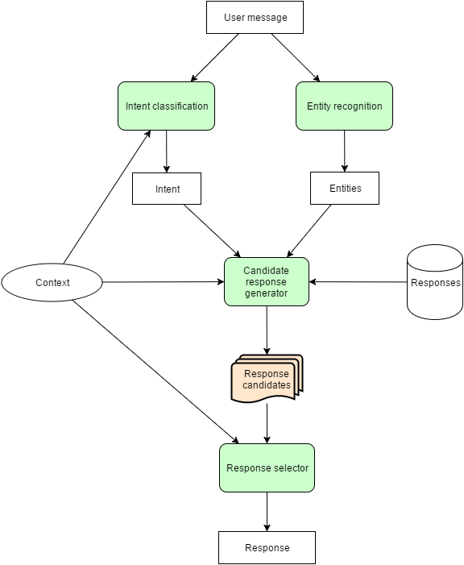

By asking skills, experience etc relevant questions, the chatbot would be able to categorize the job applicant as an eligible one or not.

**The entire workflow of the chatbot:**

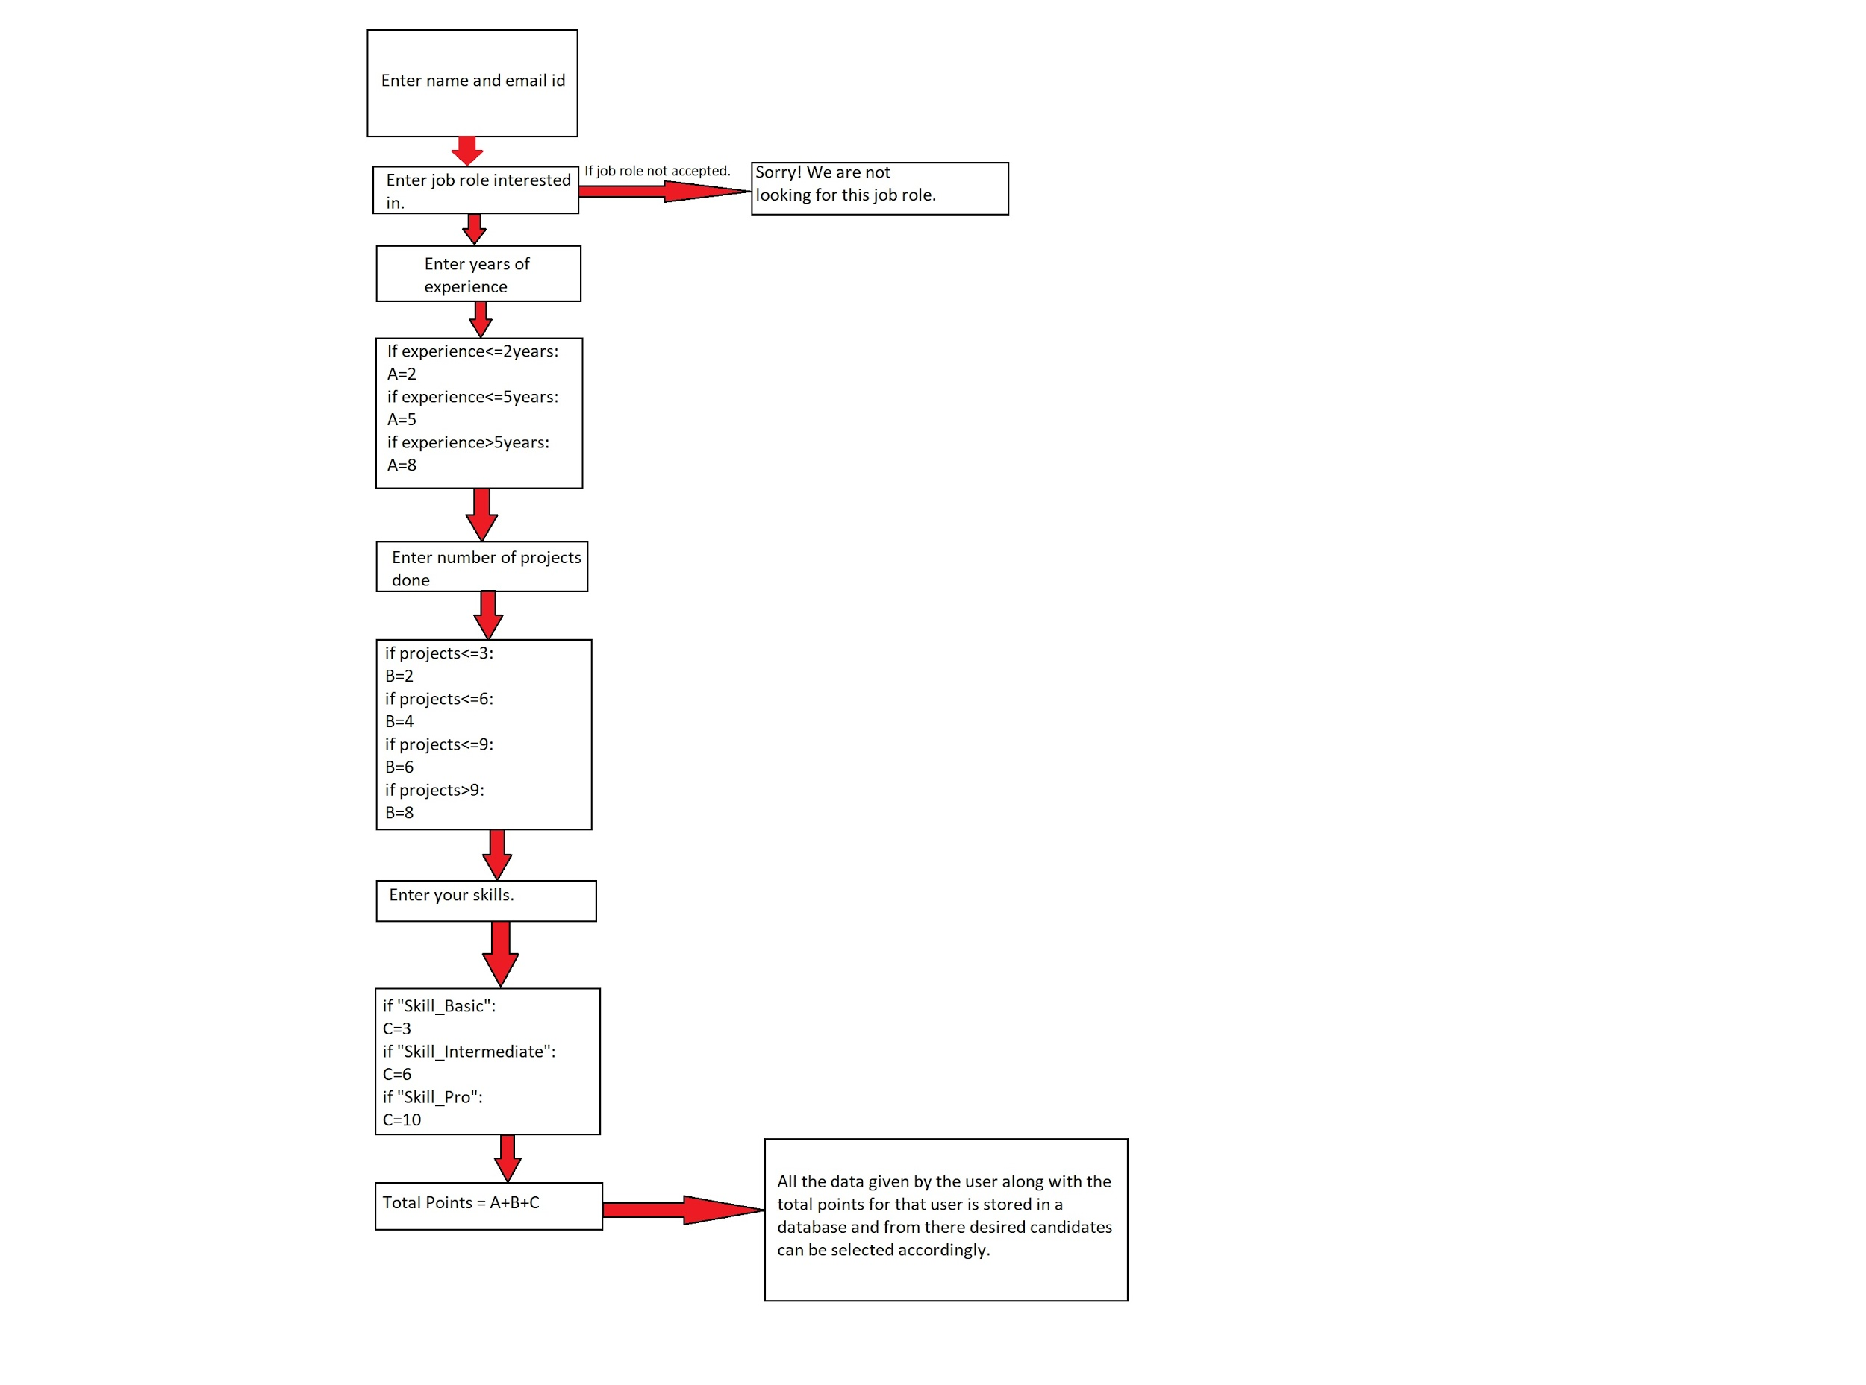

**1. Training The Model**

Run the ‘**HR_Trained_Bot.py**’ file.

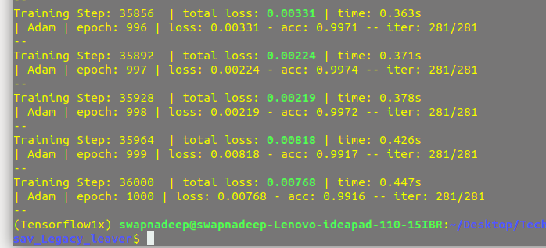

**2. Create The SQlite Database.**

Run the ‘**create_db.py**’, that creates ‘**HR_bot.db**’ database file within the same directory.

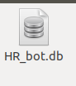

**3. Run The Main Application ChatBot**

Run the ‘**app.py**’ file,

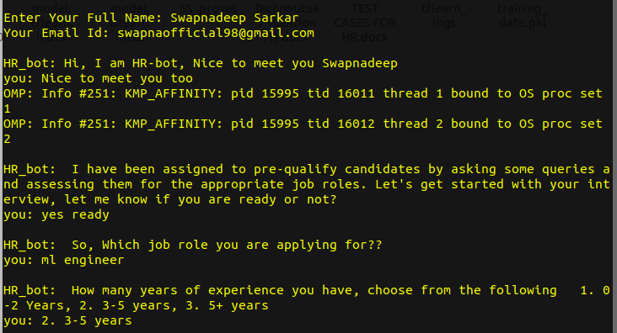 Eg1 :

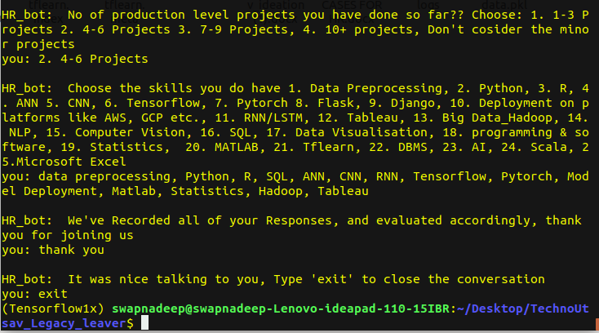

The application asks several questions as shown above, and evaluates accordingly and after exiting it stores your details in the database

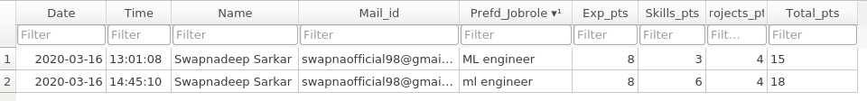The above conversation resulted the 2nd entry in the data base.

Eg 2: Another conversation:

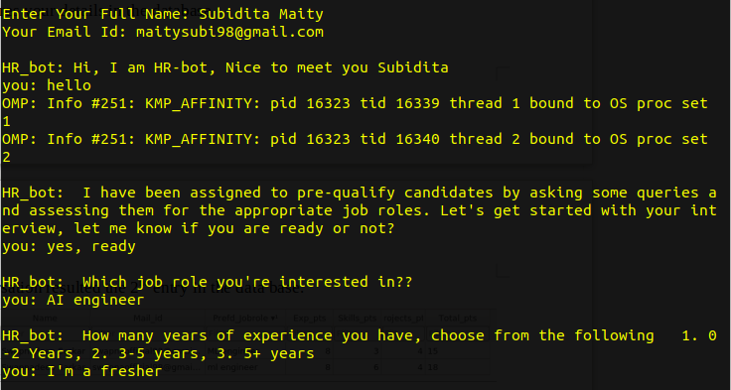

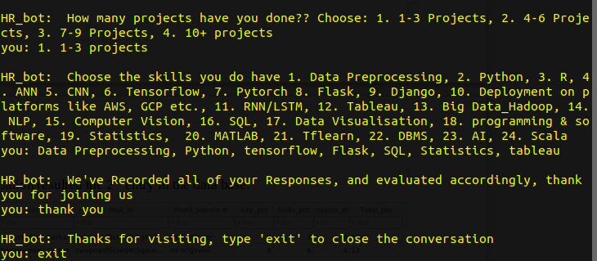

And the table gets updated as follows.

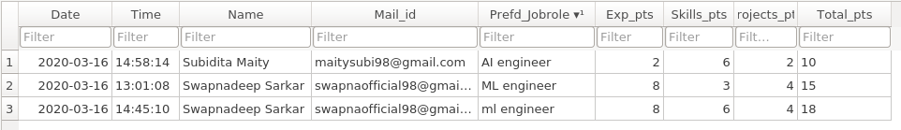

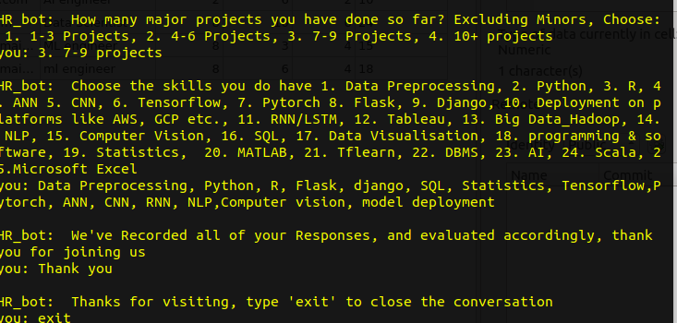Eg 3: Another candidate:

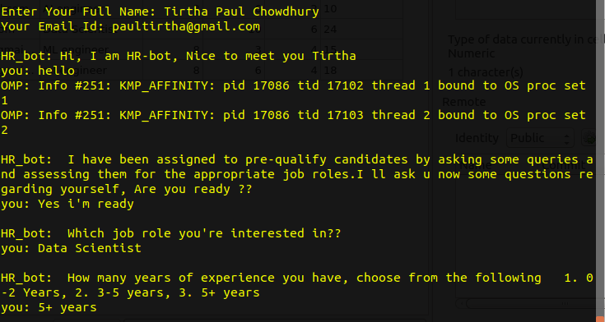

And the table gets updated :

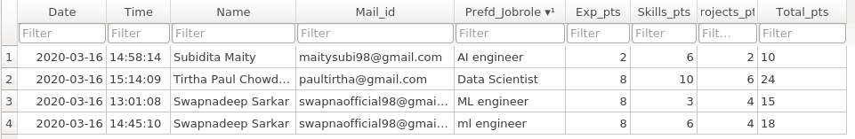

**NOTE:**

For the sake of *this round i.e. proving our concept* about the project, we’ve used **SQlite database** which creates a database within the local machine.

However in the next round, for *deployment on the cloud*, we would use cloud server type Database such as **MySQL, POSTGRE e**tc.

**Application:**

The *points table* created as shown above can be used to shortlist candidates automatically without going through tens of thousands of resumes. Based upon company’s requirements and vaccancies(say 20 seats vaccancy), the company can retrieve top performing candidates (say Top 20) data and can invite them for personal interview.

And even they can select candudates categorically as fresher, intermediate and experienced just by performing some simple SQL operations ( *say, for selecting only freshers, SELECT the top candidates having experience points ‘2’, as 2 point was assigned for freshers*).

The advantages and further scope of works are as follows:

1. **Scheduling Human Interviews:**  Chatbots can assist in automatically scheduling personal interviews or skype calls between the candidates and the recruiters efficiently.

2. **Informing Candidates:** Chatbots are appropriate to inform the candidates about their selection or next steps in the Process.

3. **Familiar Interfaces:** Chatbots are accessible on familiar interfaces so that candidates can deal with the pre- interview sessions at the comfort of home.

4. **Availability:** Chatbots can provide the interview and query session anytime preferable to the candidates. So it’s convenient to automate the interview session.

5. **Unbiased Selection:** Chatbots are software programs so don’t judge anyone on the basis of their appearance, thus making the selection process more unbiased and speedy.

Apart from the aforementioned applications chatbots also work as a mediator between candidates and human recruiters which makes the process more convenient from both the way. It’s a smarter way to handle the huge amount of job applicants by applying the Machine Learning and Deep Learning which helps in saving time and money.

____________