mysql> create database Assignment1;

Query OK, 1 row affected (0.01 sec)

mysql> use Assignment1;

Database changed

mysql> create table Member(

Member_Id int(5),

Member_Name varchar(30),

Member_address varchar(50),

Acc_Open_date date,

Membership_type enum("Lifetime","Annual"),

Penalty_Amount int(7));

Query OK, 0 rows affected (0.02 sec)

mysql> create table Book(

-> Book_No int(6),

-> Book_Name varchar(30),

-> Author_name varchar(30),

-> cost int(7),

-> Category char(10)

-> );

Query OK, 0 rows affected (0.02 sec)

mysql> create table Issue(

-> Lib_Issue_Id int(10),

-> Book_No int(6),

-> Member_Id int(5),

-> Issue_Date Date,

-> Return_date Date

-> );

Query OK, 0 rows affected (0.02 sec)

mysql> show tables;

+-----------------------+

| Tables_in_assignment1 |

+-----------------------+

| book |

| issue |

| member |

+-----------------------+

3 rows in set (0.00 sec)

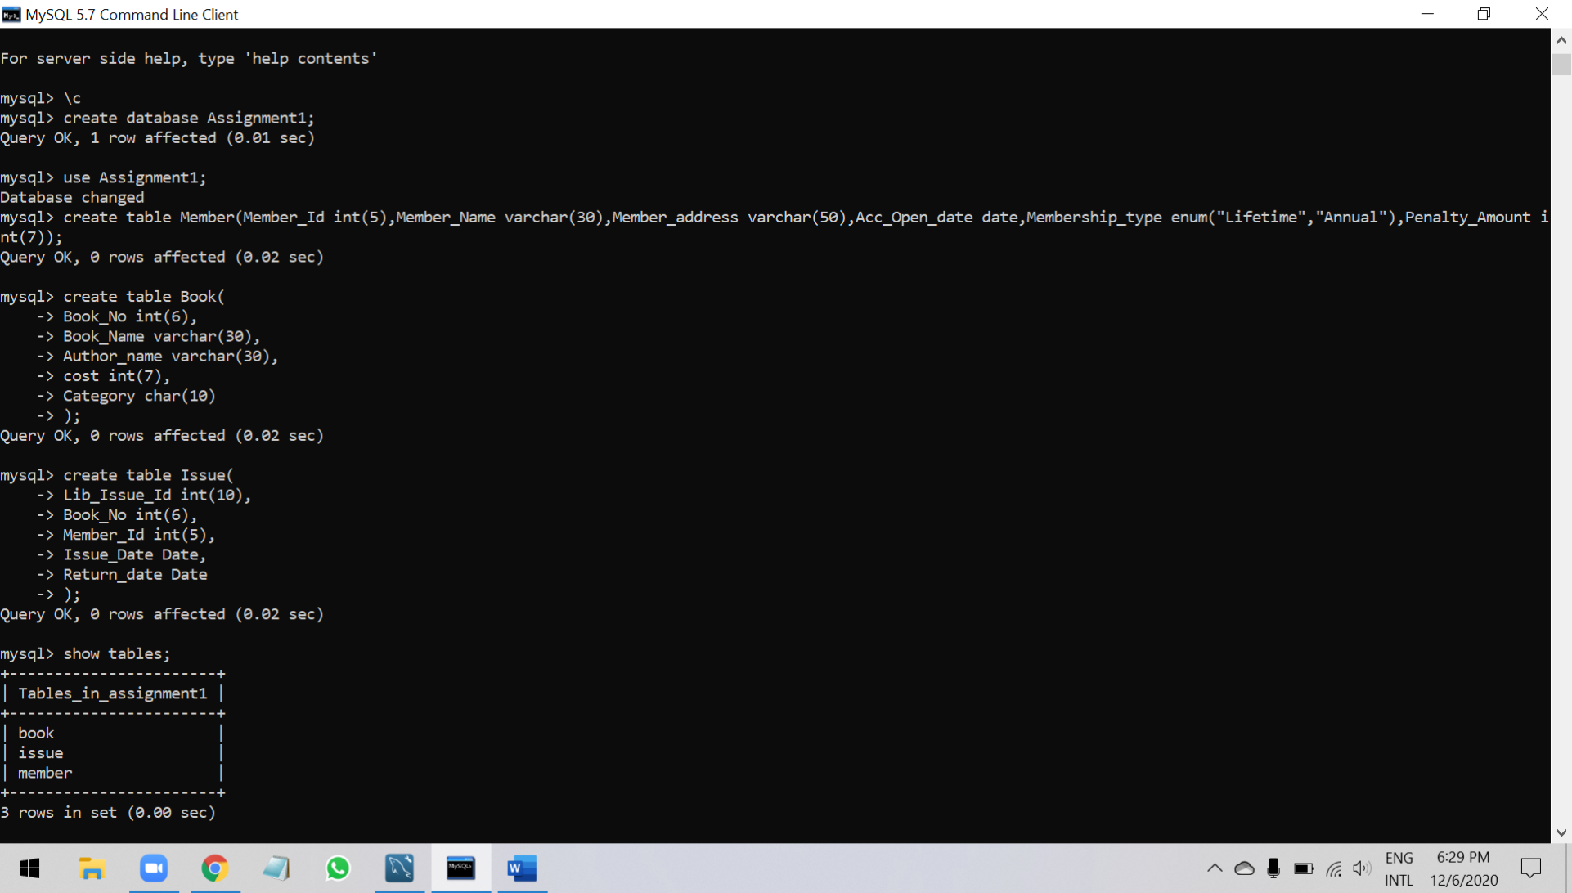

mysql> Select * from Member;

Empty set (0.00 sec)

mysql> Select * from book;

Empty set (0.00 sec)

mysql> Select * from issue;

Empty set (0.00 sec)

mysql> desc member;

+-----------------+---------------------------+------+-----+---------+-------+

| Field | Type | Null | Key | Default | Extra |

+-----------------+---------------------------+------+-----+---------+-------+

| Member_Id | int(5) | YES | | NULL | |

| Member_Name | varchar(30) | YES | | NULL | |

| Member_address | varchar(50) | YES | | NULL | |

| Acc_Open_date | date | YES | | NULL | |

| Membership_type | enum('Lifetime','Annual') | YES | | NULL | |

| Penalty_Amount | int(7) | YES | | NULL | |

+-----------------+---------------------------+------+-----+---------+-------+

6 rows in set (0.00 sec)

mysql> desc book;

+-------------+-------------+------+-----+---------+-------+

| Field | Type | Null | Key | Default | Extra |

+-------------+-------------+------+-----+---------+-------+

| Book_No | int(6) | YES | | NULL | |

| Book_Name | varchar(30) | YES | | NULL | |

| Author_name | varchar(30) | YES | | NULL | |

| cost | int(7) | YES | | NULL | |

| Category | char(10) | YES | | NULL | |

+-------------+-------------+------+-----+---------+-------+

5 rows in set (0.00 sec)

mysql> desc issue;

+--------------+---------+------+-----+---------+-------+

| Field | Type | Null | Key | Default | Extra |

+--------------+---------+------+-----+---------+-------+

| Lib_Issue_Id | int(10) | YES | | NULL | |

| Book_No | int(6) | YES | | NULL | |

| Member_Id | int(5) | YES | | NULL | |

| Issue_Date | date | YES | | NULL | |

| Return_date | date | YES | | NULL | |

+--------------+---------+------+-----+---------+-------+

5 rows in set (0.00 sec)

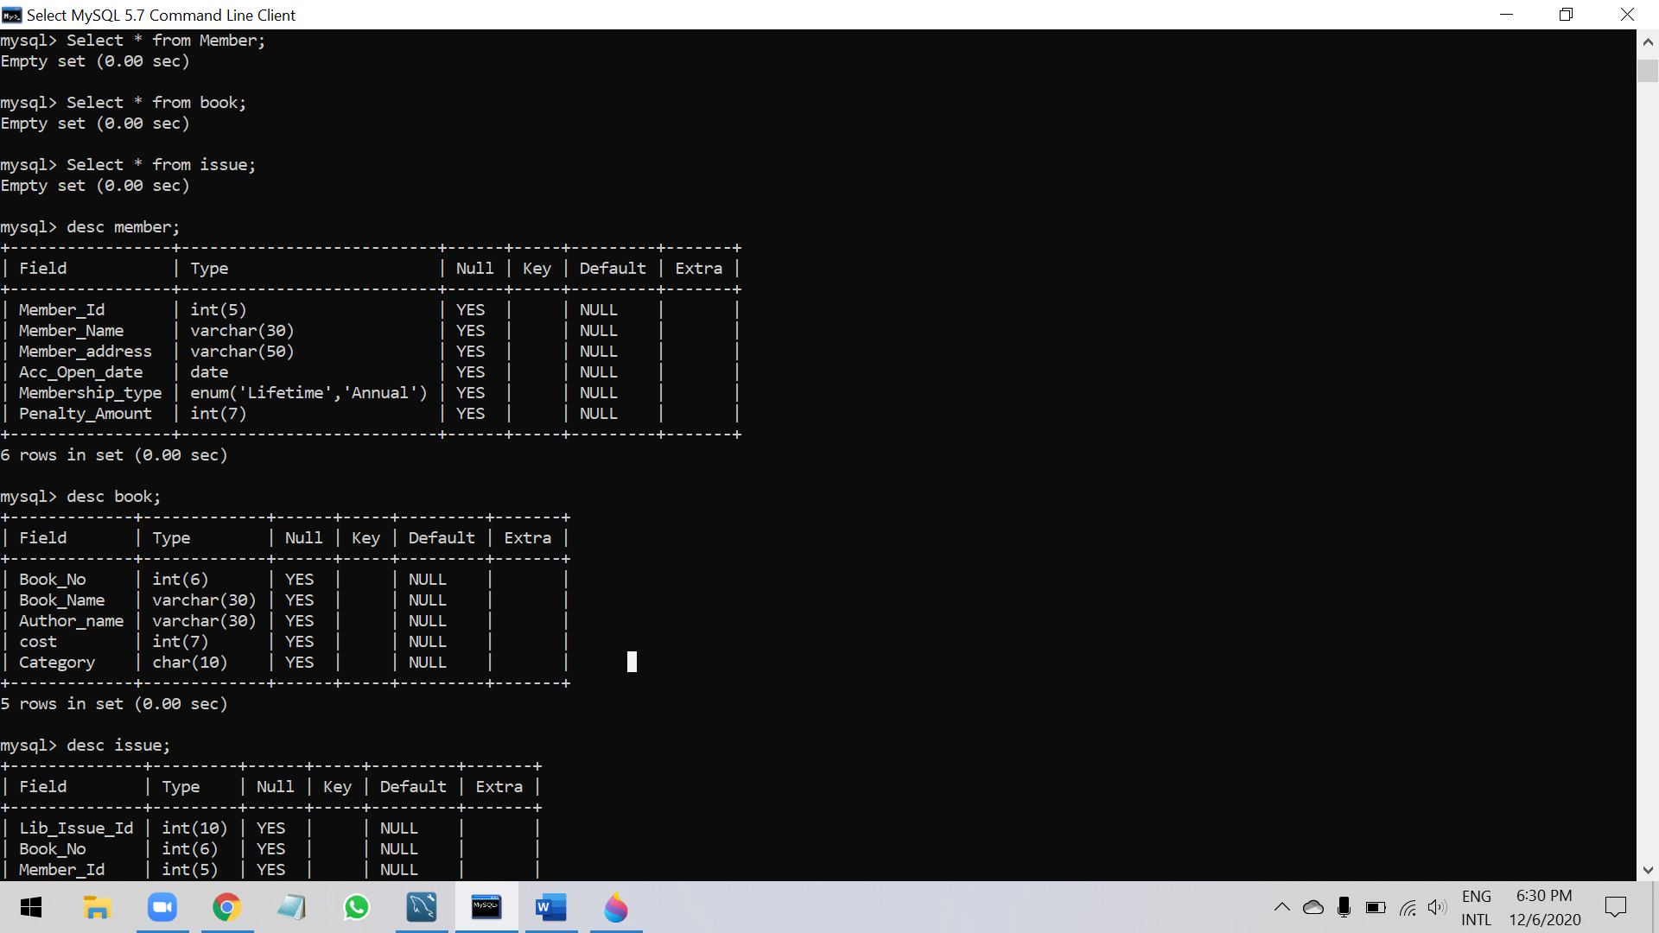

mysql> Alter table Member Drop column Penalty_Amount ;

Query OK, 0 rows affected (0.03 sec)

Records: 0 Duplicates: 0 Warnings: 0

mysql> select * from Member;

Empty set (0.00 sec)

mysql> desc Member;

+-----------------+---------------------------+------+-----+---------+-------+

| Field | Type | Null | Key | Default | Extra |

+-----------------+---------------------------+------+-----+---------+-------+

| Member_Id | int(5) | YES | | NULL | |

| Member_Name | varchar(30) | YES | | NULL | |

| Member_address | varchar(50) | YES | | NULL | |

| Acc_Open_date | date | YES | | NULL | |

| Membership_type | enum('Lifetime','Annual') | YES | | NULL | |

+-----------------+---------------------------+------+-----+---------+-------+

5 rows in set (0.00 sec)

mysql> Insert into member values(1,'Richa sharma','Pune',"2005-12-10",'Lifetime');

Query OK, 1 row affected (0.01 sec)

mysql> Insert into member values(2,'Garima Sen','Pune',current_date(),'Annual');

Query OK, 1 row affected (0.00 sec)

mysql> select * from Member;

+-----------+--------------+----------------+---------------+-----------------+

| Member_Id | Member_Name | Member_address | Acc_Open_date | Membership_type |

+-----------+--------------+----------------+---------------+-----------------+

| 1 | Richa sharma | Pune | 2005-12-10 | Lifetime |

| 2 | Garima Sen | Pune | 2020-12-06 | Annual |

+-----------+--------------+----------------+---------------+-----------------+

2 rows in set (0.00 sec)

mysql> Insert into member values(3,'Abdas ','Pune',current_date(),'Annual');

Query OK, 1 row affected (0.01 sec)

mysql> Insert into member values(4,'vika ','Pune',current_date(),'Annual');

Query OK, 1 row affected (0.01 sec)

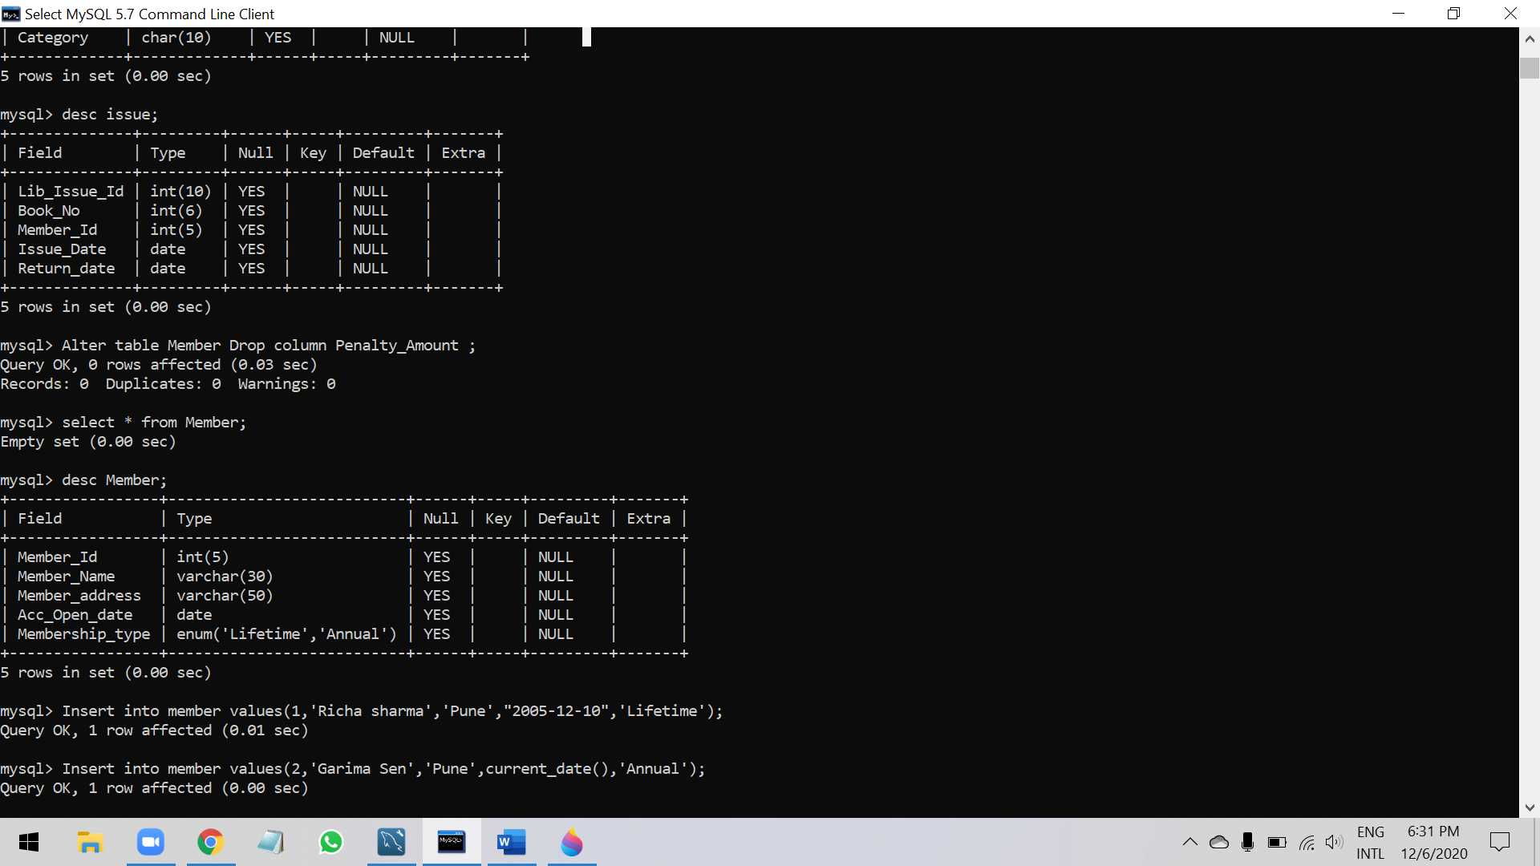

mysql> Insert into member values(5,'sachin ','Pune',"2020-11-05",'Lifetime');

Query OK, 1 row affected (0.01 sec)

mysql> Insert into member values(6,'komal ','Mumbai',current_date(),'Annual');

Query OK, 1 row affected (0.00 sec)

mysql> Insert into member values(7,'Ramesh ','Nashik',"2020-01-02",'Annual');

Query OK, 1 row affected (0.00 sec)

mysql> select * from Member;

+-----------+--------------+----------------+---------------+-----------------+

| Member_Id | Member_Name | Member_address | Acc_Open_date | Membership_type |

+-----------+--------------+----------------+---------------+-----------------+

| 1 | Richa sharma | Pune | 2005-12-10 | Lifetime |

| 2 | Garima Sen | Pune | 2020-12-06 | Annual |

| 3 | Abdas | Pune | 2020-12-06 | Annual |

| 4 | vika | Pune | 2020-12-06 | Annual |

| 5 | sachin | Pune | 2020-11-05 | Lifetime |

| 6 | komal | Mumbai | 2020-12-06 | Annual |

| 7 | Ramesh | Nashik | 2020-01-02 | Annual |

+-----------+--------------+----------------+---------------+-----------------+

7 rows in set (0.00 sec)

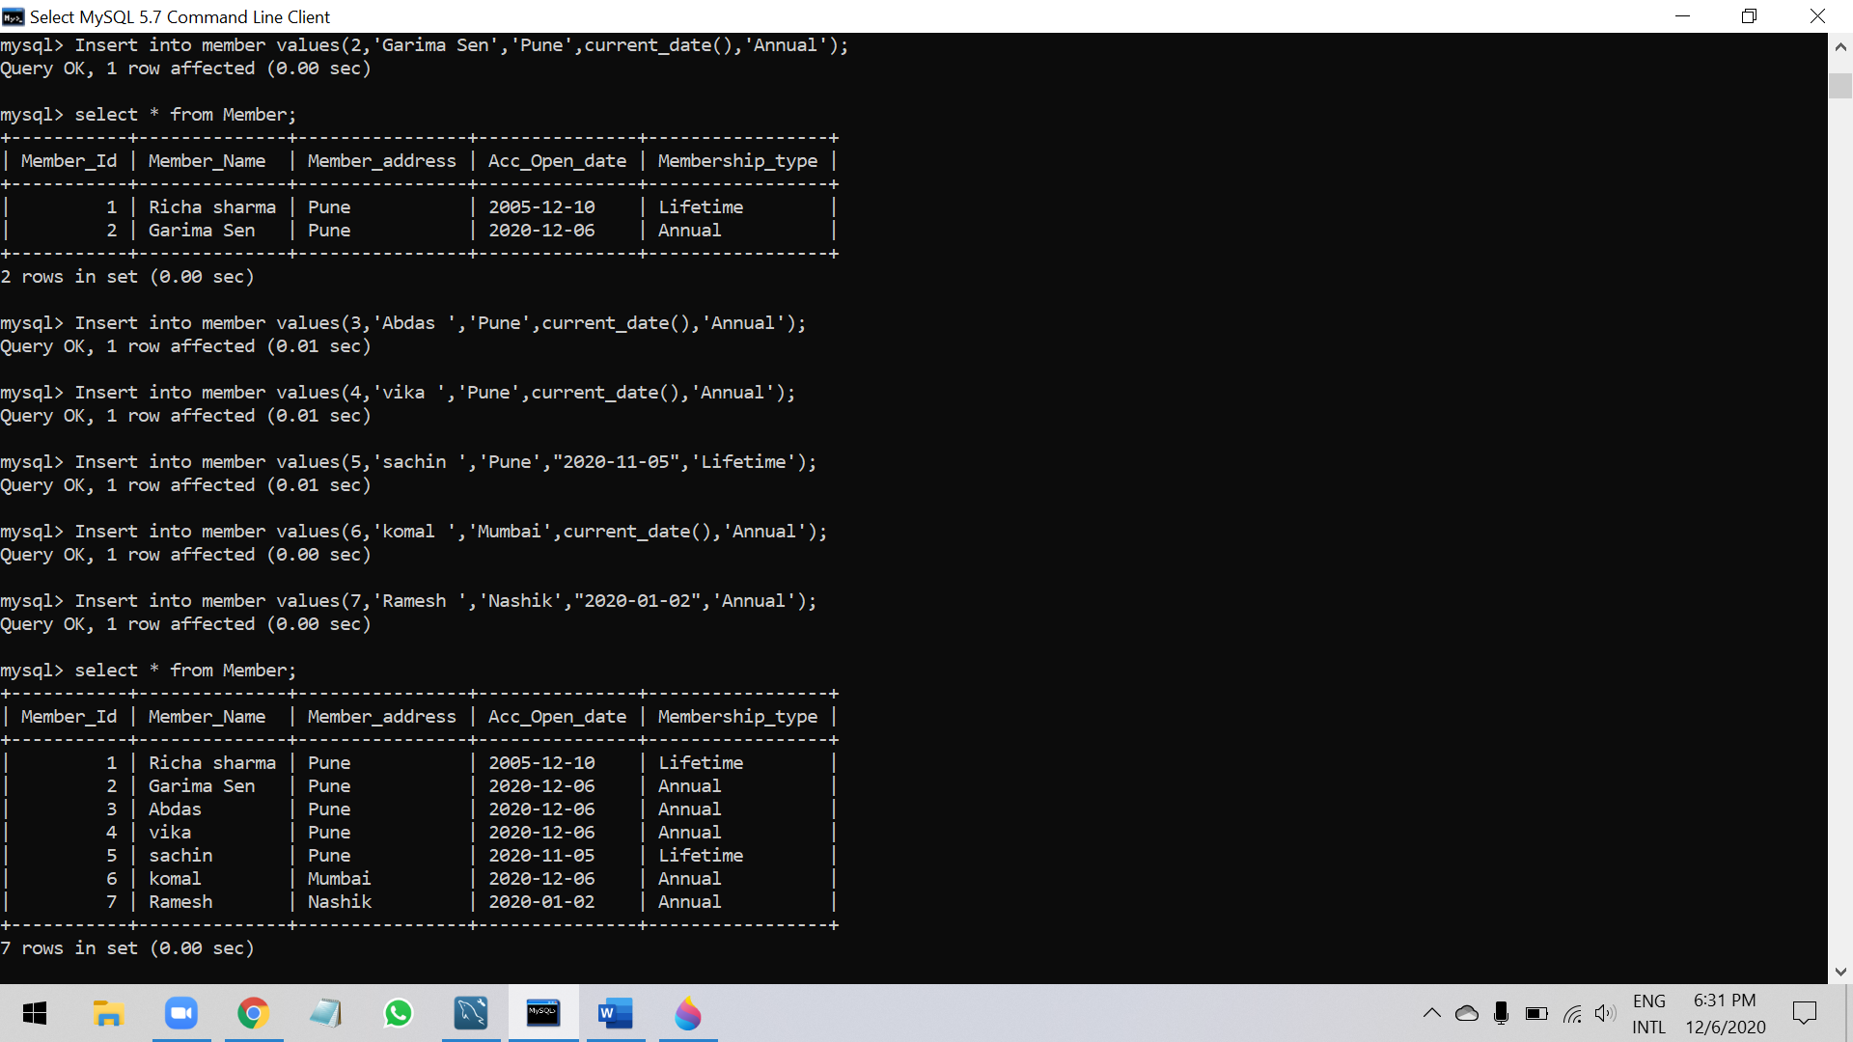

mysql> Insert into Book values(101,'Let us C','Denis Ritchie',450,'System');

Query OK, 1 row affected (0.00 sec)

mysql> Insert into Book values(102,'Oracle - Complete Ref','Loni',550,'Database');

Query OK, 1 row affected (0.00 sec)

mysql> Insert into Book values(103,'Mastering SQL','Loni',250,'Database');

Query OK, 1 row affected (0.01 sec)

mysql> Insert into Book values(104,'PL SQL-Ref','ScottUrman',750,'Database');

Query OK, 1 row affected (0.00 sec)

mysql> select * from Book;

+---------+-----------------------+---------------+------+----------+

| Book_No | Book_Name | Author_name | cost | Category |

+---------+-----------------------+---------------+------+----------+

| 101 | Let us C | Denis Ritchie | 450 | System |

| 102 | Oracle - Complete Ref | Loni | 550 | Database |

| 103 | Mastering SQL | Loni | 250 | Database |

| 104 | PL SQL-Ref | ScottUrman | 750 | Database |

+---------+-----------------------+---------------+------+----------+

4 rows in set (0.00 sec)

mysql> SET SQL_SAFE_UPDATES=0;

Query OK, 0 rows affected (0.00 sec)

mysql> Update Book set cost = 300 ,category = "RDBMS" where Book_No =103;

Query OK, 1 row affected (0.00 sec)

Rows matched: 1 Changed: 1 Warnings: 0

mysql> Select * from Book;

+---------+-----------------------+---------------+------+----------+

| Book_No | Book_Name | Author_name | cost | Category |

+---------+-----------------------+---------------+------+----------+

| 101 | Let us C | Denis Ritchie | 450 | System |

| 102 | Oracle - Complete Ref | Loni | 550 | Database |

| 103 | Mastering SQL | Loni | 300 | RDBMS |

| 104 | PL SQL-Ref | ScottUrman | 750 | Database |

+---------+-----------------------+---------------+------+----------+

4 rows in set (0.00 sec)

mysql> Drop table Issue;

Query OK, 0 rows affected (0.01 sec)

mysql> show tables;

+-----------------------+

| Tables_in_assignment1 |

+-----------------------+

| book |

| member |

+-----------------------+

2 rows in set (0.00 sec)

mysql> create table Issue(

-> Lib_Issue_Id int(8),

-> Book_No int(4),

-> Member_ID int(3),

-> Issue_Date Date,

-> Return_Date Date

-> );

Query OK, 0 rows affected (0.02 sec)

mysql> select * from Issue;

Empty set (0.00 sec)

