Question Number1:

Deploying a website on localhost using apache2 & Creating a DNS name for this website as ‘awesomeweb’.

1. Using WAMP Server to Deploy Website on Localhost.
2. Have put the Folder named “**awesomeweb**” which has my webserver file details into “C:\wamp64\www” to store the website file.
3. Updated file “httpd-vhosts.conf” to add the Route/path & the DNS name which is “**awesomeweb**” in the path “C:\wamp64\bin\apache\apache2.4.54.2\conf\extra”.

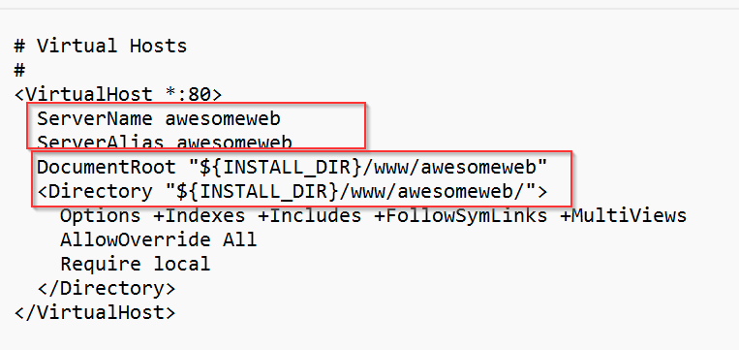

1. Also made changed in “httpd.conf” file to update the path or route details. This file present in “C:\wamp64\bin\apache\apache2.4.54.2\conf” path.

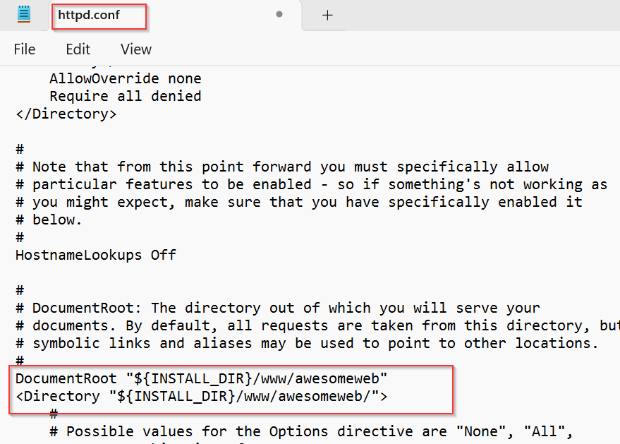

1. Also Changed the name from localhost to “**awesomeweb” in our computer’s host file. The path for that file is “C:\Windows\System32\drivers\etc”. The File name is “hosts”**

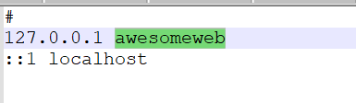

8. Now “restart all services or refresh” the WAMP icon then in (in default) webpage, type “awesomeweb” you will be able to host “awesomeweb” as Domain name.

