**Intern Name:** Swapnil Dixit  
**Date:** 26/09/2025  
**Tool Used:** Windows Defender Firewall (on Windows)

**🎯 Objective**

Learn to Configure and test basic firewall rules to allow or block traffic.

**🖥️ Environment Details**

| **Parameter** | **Value** |
| --- | --- |
| Operating System | Windows 10 |
| Scanner Tool | Windows Defender Firewall |

**1. Open firewall configuration tool (Windows Firewall or terminal for UFW).**

**2.List current firewall rules.**

**3.Add a rule to block inbound traffic on a specific port (e.g., 23 for Telnet).**

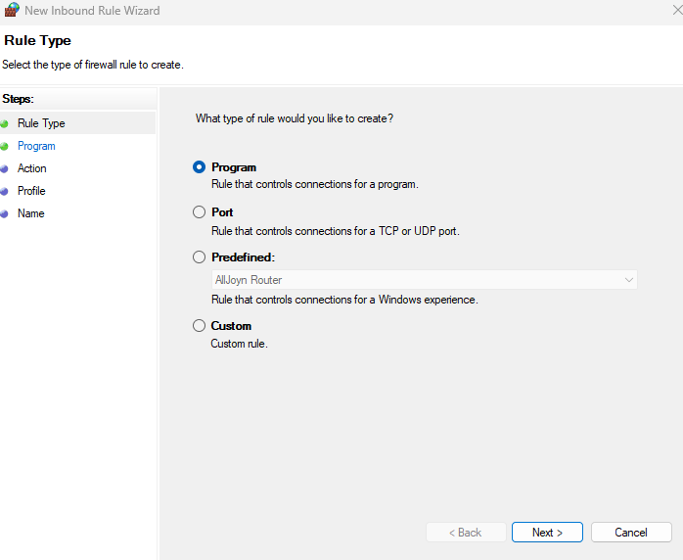

**4.Test the rule by attempting to connect to that port locally or remotely.**

While testing Telnet – I got to know my windows are not having Telent installed.  
Enabled it from windows features and installed.

**5.Add rule to allow SSH (port 22).**

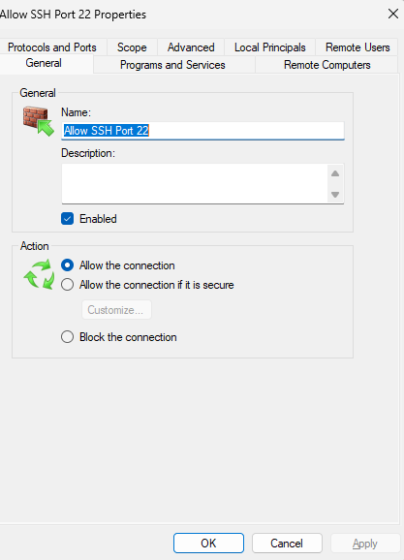

**6.Remove the test block rule to restore original state.**

**8.Summarize how firewall filters traffic.**

A firewall filters network traffic based on defined rules that check packet headers, connection states, IP addresses, ports, and protocols. It ensures only authorized traffic passes through while blocking harmful or unauthorized traffic to protect the network from threats like intrusions, malware, and denial-of-service (DoS) attacks. As we saw different filters like Inbound rules, outbound rules. The firewall inspects the **header** information of each packet (e.g., source IP, destination IP, protocol, source and destination ports), then it compares the rules.

**✅ Conclusion**

With the increasing sophistication of cyber threats, firewalls—whether packet-filtering, stateful, or next-gen—serve as a critical line of defense in maintaining the integrity, confidentiality, and availability of a network. Properly configuring and maintaining firewalls is crucial for safeguarding systems against external and internal attacks, ensuring secure communication, and upholding organizational security policies.