**Use Case:** Remote Patient Monitoring using SVC

**Objectives:**

1. Financial:
   1. **Reduced costs** borne by patients
      1. Hospitalization fees reduced
      2. Transportation fees reduced
   2. **More revenue** for healthcare providers (Hospitals/Clinics/etc)  
      **Customer-base extended** to patients not within premises
2. Value to Customer:
   1. Allows for **post-critical monitoring to be done remotely** (at home)
   2. **Reduced contact** with infected patients (by reduced visits to the hospital/clinic)
   3. ML implementation **accounts for variations** in individuals’ stable readings
   4. **Faster response time** when patient requires assistance

**ARCHITECTURE OF RPM**

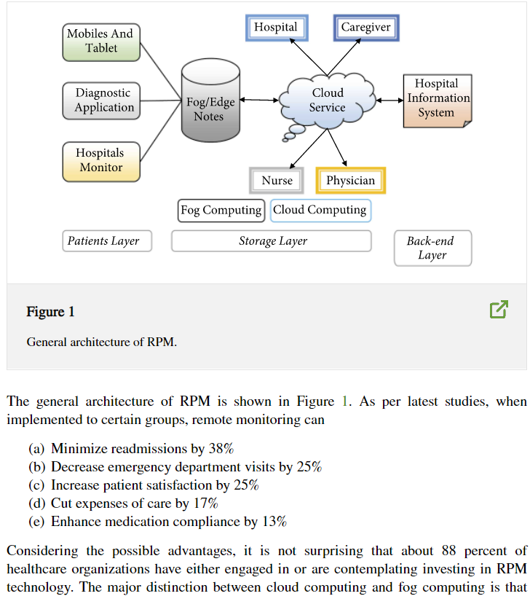

**FLOW OF WORK**

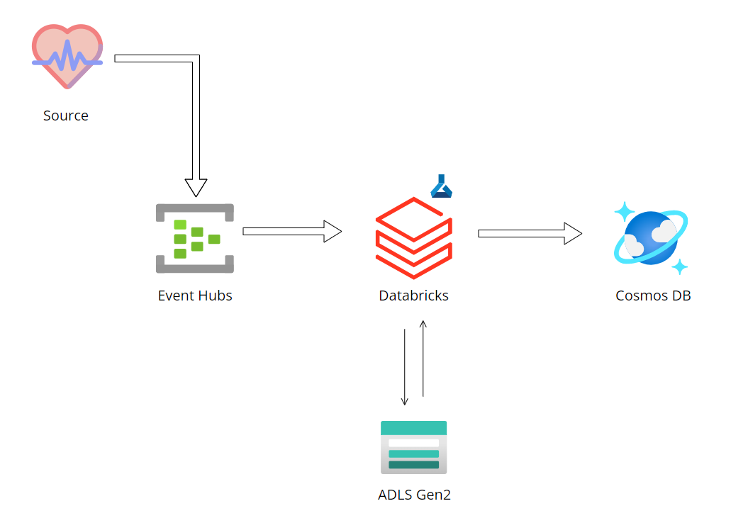

https://www.hindawi.com/journals/jfq/2022/6274092/

**ADVANTAGES OF RPM:**

* **Remote monitoring**: Real-time remote monitoring via connected IoT devices and smart alerts can diagnose illnesses, treat diseases and save lives in case of a medical emergency.
* **Prevention**: Smart sensors analyze health conditions, lifestyle choices and the environment and recommend preventative measures, which will reduce the occurrence of diseases and acute states.
* **Reduction of healthcare costs**: IoT reduces costly visits to doctors and hospital admissions and makes testing more affordable.
* The remote health monitoring system is especially useful to monitor patients with chronic diseases. Most chronic diseases are incurable, so it is necessary to monitor the state of the patient while at home, and quickly respond if health indicators worsen

**DISADVANTAGES OF RPM:**

* **Privacy of Data**  
  Privacy is the biggest challenge with IoT, as all the connected devices transfer data in real-time. Personal data can be hacked if this end to end connection is not secure. Criminals can use this personal data of others for their own benefits.
* **Accuracy**  
  Accuracy issues may come due to handling such massive data in real-time.
* **Cost**  
  IoT may reduce the cost for diagnosis and treatment for patients, But the cost of installing all the devices and their maintenance is quite high.

# **4 Remote Patient Monitoring Stats You Need to Know:**

## Millions of Patients Are Already Using Remote Patient Monitoring Tools

According to a survey conducted by Insider Intelligence, more than [23 million patients](https://www.msimsi.com/remote-monitoring-study/) were already using remote patient monitoring tools and services in 2020. Furthermore, this number is expected to rise, with more than 30 million people expected to use these same tools and services by 2024.

This trend indicates that there is a significant amount of demand for remote patient monitoring, and that the growth potential is there.

## The Vast Majority of Patients Favor Remote Patient Monitoring

According to a survey from [MSI International](https://www.prweb.com/releases/msi_international_study_americans_view_remote_monitoring_of_health_favorably/prweb17988771.htm), more than 80% of people in the United States are in favor of remote patient monitoring. Most people want to see it incorporated as a standard service in healthcare. It’s obvious that patients realize the wide variety of benefits this can provide them.

Examples include:

* Reduced trips to the doctor’s office
* Less time taken off from work or school
* Real-time data for doctors and nurses to make better decisions
* Improved health outcomes

## Remote Patient Monitoring Systems Increase Patient Satisfaction Scores

A comprehensive remote patient monitoring system is likely to be accepted by patients. The[University of Pittsburgh](https://www.healthcareitnews.com/news/upmc-remote-patient-monitoring-helps-reduce-er-utilization-and-hospital-readmissions) medical system reported that patient satisfaction scores rose to over 90% after they provided patients with equipment and tablets used for remote patient monitoring.

This trend is a sign that patients are very likely to accept medical-grade wearable devices that can collect data in real-time and help their medical providers make better decisions.

## Most Physicians Are Already Investing in Remote Patient Monitoring Devices

Though there is naturally [some skepticism](https://www.beckershospitalreview.com/digital-health/despite-growing-demand-some-physicians-are-skeptical-about-healthcare-wearables-3-report-insights.html), many doctors are already on board with remote patient monitoring devices as well. According to a 2019 survey that was published by [Spyglass Consulting Group](https://www.spyglass-consulting.com/wp_RPM_2019.html), close to 90% of healthcare providers surveyed had indicated that they were already investing in remote patient monitoring technologies. A lot of medical practices are already moving in that direction.

**Implementation:**

**Key Notes:**

1. Monitoring Systems **do not diagnose patients.** Merely monitors patient’s condition and provides alerts when condition meets a condition (e.g.: IF heartrate < 60: alert())
2. Proposed system aims to:
   1. Set limit conditions per patient
   2. Analyse readings in real-time to predict decline in condition, allowing for early detection.

**Hardware:**

* Smartwatches
  + Google Fit compatible devices
    - Allows for exporting data captured by device
    - Compatible with wider range of devices
* Proprietary solution (Using MC and sensors)
  + Requires manufacturing
  + Will be cheaper (for purchase) and more effective

**Training Dataset:**

<https://mimic.mit.edu>

**Conceptual References:**

<https://ieeexplore.ieee.org/abstract/document/9431926>

**Microsoft Services References:**

<https://docs.microsoft.com/en-us/industry/healthcare/overview>

<https://github.com/microsoft/health-architectures>

<https://docs.microsoft.com/en-us/azure/healthcare-apis/fhir/overview>

<https://docs.microsoft.com/en-us/azure/architecture/example-scenario/mch-health/medical-data-insights>

<https://docs.microsoft.com/en-us/industry/healthcare/patient-engagement>