**Pokémon Battle API**

**Overview**

The Pokémon Battle API provides a set of endpoints to interact with Pokémon data and manage battle simulations. This API allows users to:

List Pokémon with pagination.

Initiate battles between Pokémon asynchronously.

Check the status of ongoing battles and retrieve results.

**API Endpoints**

**1. Listing Pokémon**

Endpoint: /pokemons

Method: GET

Query Parameters:

* page (integer, required): Page number to retrieve.
* pageSize (integer, required): Number of Pokémon per page.

Response Example:

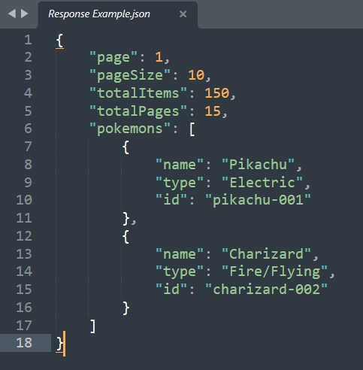

**2. Initiate Battle**

Endpoint: /battle

Method: POST

Request Body:

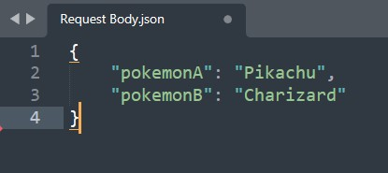

Response Example:

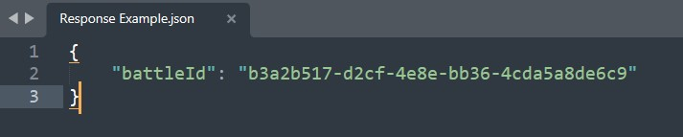

**3. Battle Status**

Endpoint: /battle/{battleId}

Method: GET

Request Example:

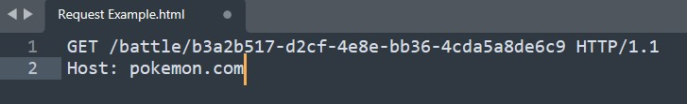

Response Example:

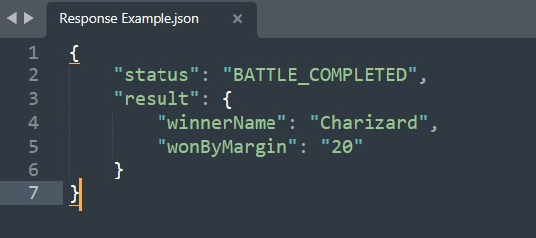

**Setup:**

**Prerequisites**

* Python 3.12.3
* Go 1.13
* Docker (for containerized deployment)

**Installation**

**1. Python Setup:**

Install dependencies:

* pip install -r requirements.txt

Run the application:

* python app.py

**2. Go Setup:**

Build the application:

* go build -o pokemon-battle-api

Run the application

* ./pokemon-battle-api

**Docker Setup**

Build the Docker Image:

* docker build -t pokemon-battle-api.

Run the Docker Container:

* docker run -p 5000:5000 pokemon-battle-api

**Testing**

**1. Python Tests**

Install testing dependencies

* pip install pytest

Run tests:

* pytest --cov=app

**2. Go Tests**

Run tests

* go test -v ./...

**Contact**

For any questions or feedback, please reach out to [powarswap@gmail.com](mailto:powarswap@gmail.com)