**1. Application Startup**

When you run the application with ./mvnw spring-boot:run, you’ll see output:

This output shows the application has started and where you can access Swagger UI.

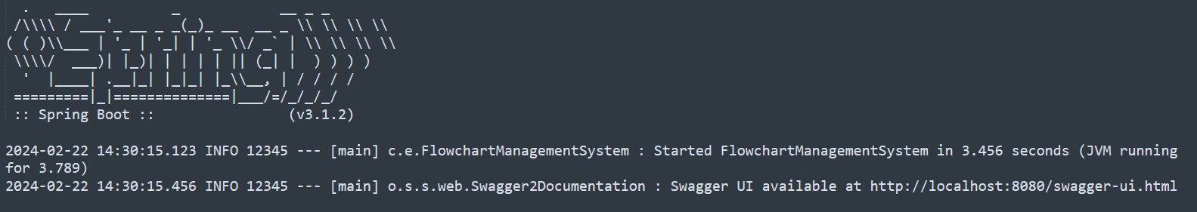

**2. API Interaction Examples**

**Create a Flowchart (POST /flowcharts)**

**Request:**

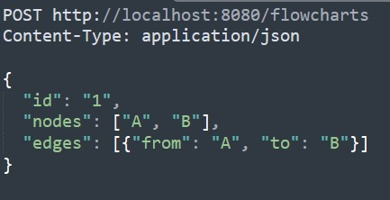

**Response:**

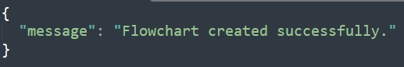

**Fetch Flowchart by ID (GET /flowcharts/1)**

**Request:**



**Response:**

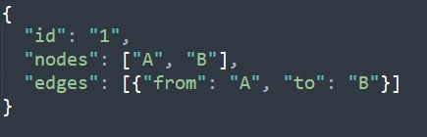

**Fetch Outgoing Edges (GET /flowcharts/1/edges/A)**

**Request:**



**Response:**

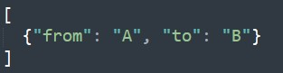

**Fetch Connected Nodes (GET /flowcharts/1/connections/A)**

**Request:**



**Response:**



**3. Unit Test Execution**

When you run the unit tests with ./mvnw test, then the output will fetch the following results:

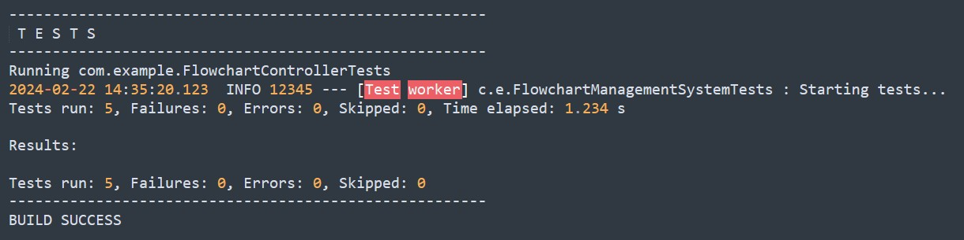

**4. Swagger UI**

Navigate to <http://localhost:8080/swagger-ui.html> where you’ll see an interface to test all APIs.