Swapnil Pramanik, S24CSEU2214, Batch-84
Date – 25th September 2026

Assignment solution link - https://github.com/Swapnil-Pramanik/SCSE3040-Lab/tree/main/P05-config-tests
Contents of config.yaml -
data:
path: ../data/delivery_times.csv
features:
- distance_km
- prep_time_min
- traffic_level
- rain
target: delivery_min

split:
test_size: 0.2
seed: 42

model:
name: linear_regression

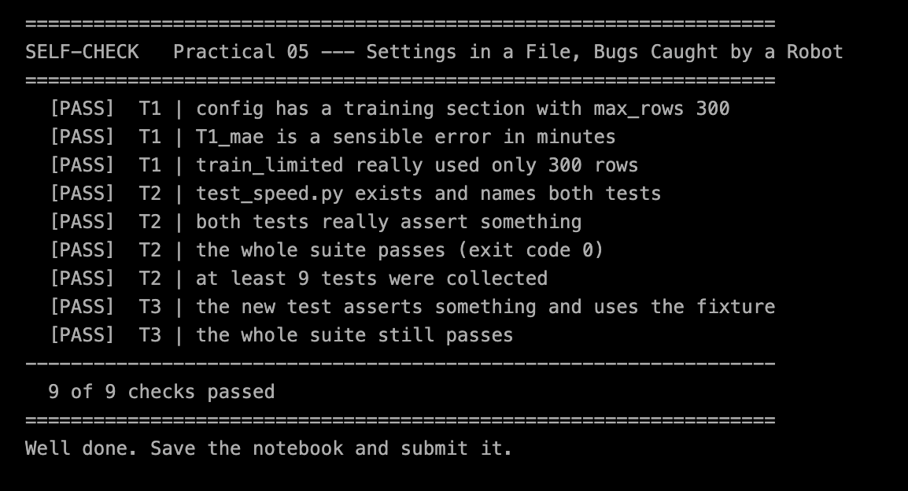
Pytest results –

