Swapnil Pramanik, S24CSEU2214, Batch – 84
Date – 2nd October 2026
Assignment solution link - https://github.com/Swapnil-Pramanik/SCSE3040-Lab/tree/main/P06-mlflow
MLFlow UI –
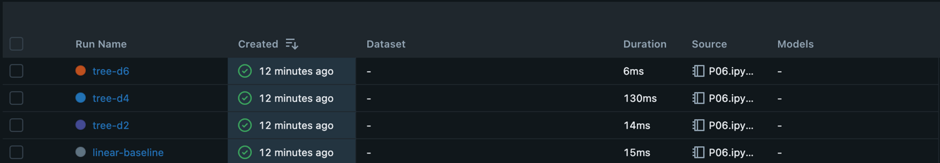
linear-baseline –
tree-d2 –
tree-d4 –
tree-d6 –

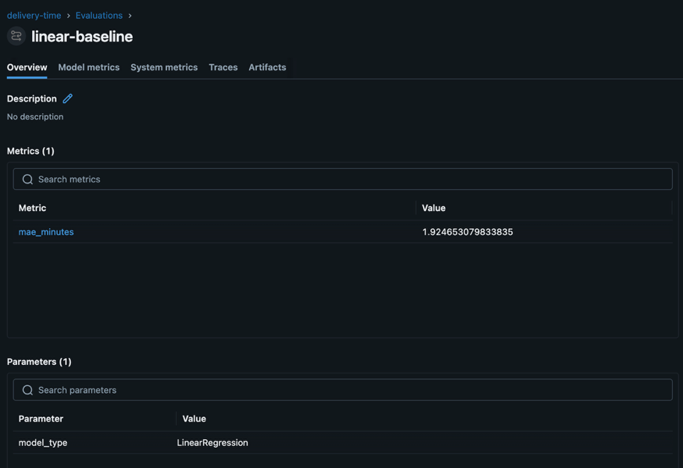
Best Run – linear-baseline

Run id - 77736c94391842c9829d47e2b49cb91c

