1.**Highest Common Factor (H.C.F.) or Greatest Common Measure (G.C.M.) or Greatest Common Divisor  (G.C.D.)**: The H.C.F. of two or more than two numbers is the greatest number that divided each of them  exactly. There are two methods of finding the H.C.F. of a given set of numbers:

**Factorization Method:** Express the each one of the given numbers as the product of prime factors. The product of common factors gives us the HCF.

**E.g. Find the H.C.F of 804 and 420**

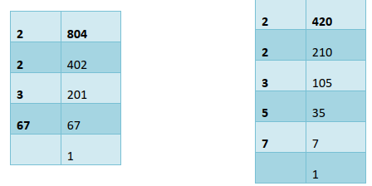

Factors: 2 x 2 x 3 x 67                                                  Factors: 2 x 2 x 3 x 5 x 7

Common Prime factors are 2, 2, and 3

**H.C.F.= 2 x 2 x 3 = 12**

**Division Method:** Suppose we have to find the H.C.F. of two given numbers, divide the larger by the smaller one. Now, divide the divisor by the remainder. Repeat the process of dividing the preceding number by the remainder last obtained till zero is obtained as remainder. The last divisor is required H.C.F.   
  
**E.g. Find the H.C.F of 804 and 210**  
  
804 / 210 -----210 x 3 = 630 (Remainder is 174)    
  
210/174---- 174 x 1 = 174 (Remainder is 36)   
  
174/36 ---- 36 x 4 = 144 (Remainder is 30)  
  
36/30 ---- 30 x 1 = 30 (Remainder is 6)   
  
30/6 ---- 6x 5 = 30 (Remainder is 0)   
  
**Hence HCF is 6**  
  
Finding the H.C.F. of more than two numbers: Suppose we have to find the H.C.F. of three numbers, then, H.C.F. of [(H.C.F. of any two) and (the third number)] gives the H.C.F. of three given number. Similarly, the H.C.F. of more than three numbers may be obtained.

**E.g. Find the HCF of 20, 36 and 100**  
  
Then first we can find HCF of 20 and 36,

HCF of 20 and 36 will be 5

Now we can find HCF of 4 and 100

HCF of 100 and 4 is 4

Hence HCF of 20, 36 and 100 is 4

**2. Least Common Multiple (L.C.M.):** The least number which is exactly divisible by each one of the given

numbers is called their L.C.M.

**Factorization Method:** Start prime factorization of the numbers with common multiples. Then, L.C.M. is the  product of all the factors

Eg. Find the LCM of 24, 30, 16

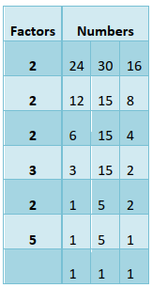

**Note:** If the greatest number of the given number is a multiple of all remaining numbers then greatest number is LCM. E.g. Find the LCM of 24, 4 and 8

Here greatest number is 24 and it is a multiple of 4 and 8 hence LCM = 24

3. **Product of two numbers = Product of their H.C.F. and L.C.M.**

4. **Co-prime Numbers**: Two numbers are said to be co-prime,**if their H.C.F. is 1. & LCM= Number(1) x  Number(2)**

5. If in between 2 numbers, one number is multiple of other then their **HCF is smaller No and LCM is  Larger No.**

6. **H.C.F. and L.C.M. of Decimal Fractions:**

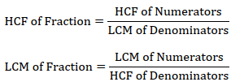

Remainder Based Problem

• If X is the remainder in each case when N is divided by x, y, z then the number is

**N = K * [LCM (x, y, z)] + X, here K is a natural number**

• If A, B, C are the remainders when N is divided by x, y, z and x − A = y − B = z −C = P then the number is

**N = K * [LCM (x, y, z)] – P**