A Project Report on

**“Ice-cream Parlour Management System”**

**By**

|  |  |
| --- | --- |
| **Mr. Swapnil Valwe** | **200940581034** |
| **Ms. Meghna Patil** | **200940381049** |



**C-DAC Mumbai**

**ABSTRACT**

Management of Ice-Cream Parlour could be a tedious task on paper. To overcome this, there is advancement in Database Management System to create databases and manage it with ease.

In “Ice-Cream Parlour Management System” We have created an Entity-Relationship (ER) Diagram to map out the conceptual view of the Database. We have created 9 tables in a database. We have performed various Queries and have used Stored Procedures, Functions, Triggers, Cursors and Handlers to the best of our knowledge.

Hence this small project on Ice-Cream Parlour Management System would be useful for the better management.

**Keywords**-ER Diagram, Conceptual View,9 tables, Queries and have used Stored Procedures, Functions, Triggers, Cursors and Handlers.

**Entity Relationship (ER) Diagram:**

**Shapes Used in ER Diagram:**

Denotes Attributes of the Table.

Denotes Entities of the Table.

Denotes Weak Entity of the Table.

Denotes Relationships between the two Entities.

Denotes Link between Entity, attributes Relations.

**ER Model For Ice-Cream Parlour Management System:**

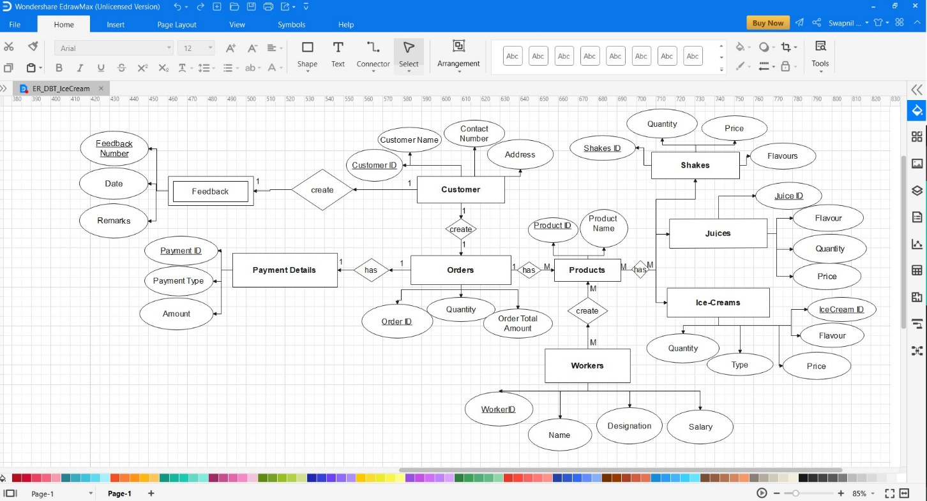

**Number of Tables:**

|  |  |  |
| --- | --- | --- |
| **Sr. No.** | **Table Name** | **No. of the Attributes.** |
| 1. | Customer | 4 |
| 2. | Products | 2+3(Foreign keys) |
| 3. | Ice-Creams | 5 |
| 4. | Juices | 4 |
| 5. | Shakes | 4 |
| 6. | Orders | 3+1(Foreign Key) |
| 7. | Workers | 4 |
| 8. | Payment Details | 3+1(Foreign Key) |
| 9. | Feedback | 3+1(Foreign Key) |

**Schema and Queries:**

create database Ice_Cream_Parlour;

use Ice_Cream_Parlour;

1. **Customer:**

create table Customer_Details(Customer_ID int primary key unique not null, Customer_Name varchar(50),Contact_No numeric(11),Address varchar(50));

insert into customer_details values(1201, 'MEGHNA PATIL', 6573528737, "SION"),

(1202, 'UDIT NEMADE', 539753795, "DADAR"),

(1203, 'SWAPNIL ANDHALE', 3856783267, "ANDHERI"),

(1204, 'TEJAS RANE', 9287389683, "DOMBIVLI"),

(1205, 'TANUJA PATIL', 1384536875, "BORIVALI"),

(1206, 'UNNATI TAPPE', 86738495273, "COLABA"),

(1207, 'MRUNALI DESHMUKH', 85398265483, "GHATKOPAR"),

(1208, 'MANOJ BHOYE', 36329759358, "THANE"),

(1209, 'UMESH CHAUDHARY', 7862387468, "MULUND"),

(1210, 'SWAPNIL VALWE', 8276863857, "BANDRA");

insert into customer_details values (1212, 'KIRTI ROY', 9337568347, "MATUNGA");

|  |  |  |
| --- | --- | --- |
| **Customer** | | |
| Name | Data-Type | Description |
|  |  |  |
| Customer_ID | Int | Primary Key |
| Customer_Name | Varchar | Name of the Customers |
| Contact Number | numeric | Phone number |
| Address | varchar | Address of the customers |

1. **Orders:**

create table Orders(Order_ID int primary key unique not null,Order_Quantity numeric(5),Order_total_Amount numeric(4), Customer_ID int, Product_ID int);

alter table Orders add constraint Customer_ID_FK1 foreign key (Customer_ID) references Customer_Details(Customer_ID);

alter table Orders add constraint Product_ID_FK1 foreign key (Product_ID) references Products(Product_ID);

insert into Orders values (9001, 4, 390, 1201, 1001),

(9002, 3, 280, 1204, 2001),

(9003, 2, 200, 1202, 2004),

(9004, 5, 430, 1206, 1005),

(9005, 7, 890, 1209, 3001);

select * from Orders;

|  |  |  |
| --- | --- | --- |
| **Orders** | | |
| Name | Data-Type | Description |
|  |  |  |
| Order_ID | Int | Primary Key |
| Order_Quantity | Numeric | Quantity of the ordered Products |
| Order_Total_Amount | numeric | Total Price |
| Customer-ID | Int | Foreign Key |
| Product_ID | Int | Foreign Key |

1. **Ice-Cream:**

create table Ice_Cream(Ice_Cream_ID int primary key not null unique, Flavours varchar(50),Price numeric(4),Type varchar(50),Quantity numeric(5));

insert into Ice_Cream values (101,'VANILLA',40,'CUP',70);

insert into Ice_Cream values (102,'BUTTERSCOTCH',180,'FAMILYPACK',30);

insert into Ice_Cream values (103,'ANJEER',200,'COCKTAILS',54);

insert into Ice_Cream values (104,'REDVELVET',80,'CORNETTO',60);

insert into Ice_Cream values (105,'MINT',50,'SCOOP',45);

|  |  |  |
| --- | --- | --- |
| **Ice-Cream** | | |
| Name | Data-Type | Description |
|  |  |  |
| Ice_Cream_ID | Int | Primary Key |
| Flavours | Varchar | Flavour of the Ice-Cream |
| Price | numeric | Amount |
| Type | Varchar | Type of Ice-Cream |
| Quantity | varchar | Quantity of the Ice-Cream |

1. **Juices:**

create table Juices(Juice_ID int primary key unique not null,Flavour varchar(50),Price numeric(5),Quantity varchar(10));

insert into Juices values(200,'APPLE',120,'full'),

(201,'PINEAPPLE',50,'HALF'),

(202,'KIWI',150,'FULL'),

(203,'SWEETLIME',100,'FULL'),

(204,'ORANGE',45,'HALF'),

(205,'WATERMELON',110,'FULL');

|  |  |  |
| --- | --- | --- |
| **Juices** | | |
| Name | Data-Type | Description |
|  |  |  |
| Juice_ID | Int | Primary Key |
| Flavour | Varchar | Flavour of the Juice |
| Price | numeric | Amount |
| Quantity | varchar | Half or Full |

1. **Shakes:**

create table Shakes(Shakes_ID int primary key not null unique,Flavours varchar(50),Price numeric(5),Quantity varchar(10));

insert into Shakes values(300,'BADAM',90,'FULL'),

(301,'STRAWBERRY',70,'HALF'),

(302,'OREO',180,'FULL'),

(303,'WHITECHOCOLATE',150,'FULL'),

(304,'COLD-COFEE',80,'HALF');

|  |  |  |
| --- | --- | --- |
| **Shakes** | | |
| Name | Data-Type | Description |
|  |  |  |
| Shakes_ID | Int | Primary Key |
| Flavour | Varchar | Flavour of the Shakes |
| Price | numeric | Amount |
| Quantity | varchar | Half or Full |

1. **Orders:**

create table Orders(Order_ID int primary key unique not null,Order_Quantity numeric(5),Order_total_Amount numeric(4), Customer_ID int, Product_ID int);

alter table Orders add constraint Customer_ID_FK1 foreign key (Customer_ID) references Customer_Details(Customer_ID);

alter table Orders add constraint Product_ID_FK1 foreign key (Product_ID) references Products(Product_ID);

insert into Orders values (9001, 4, 390, 1201, 1001),

(9002, 3, 280, 1204, 2001),

(9003, 2, 200, 1202, 2004),

(9004, 5, 430, 1206, 1005),

(9005, 7, 890, 1209, 3001);

select * from Orders;

|  |  |  |
| --- | --- | --- |
| **Orders** | | |
| Name | Data-Type | Description |
|  |  |  |
| Customer_ID | Int | Primary Key |
| Customer_Name | Varchar | Name of the Customers |
| Contact Number | numeric | Phone number |
| Address | varchar | Address of the customers |
| Product_ID | Int | Foreign Key |
| Customer_ID | Int | Foreign Key |

1. **Workers:**

create table Workers(Worker_ID int primary key unique not null,Worker_Name varchar(50),Worker_Designation varchar(50),Worker_Salary numeric(5));

insert into Workers values(20000,'SUHAS','CASHIER',18000),

(20001,'SHYAM','HELPER',1000),

(20002,'RAJ','BARISTA',14000),

(20003, 'SUPEKAR', 'MANAGER',25000);

|  |  |  |
| --- | --- | --- |
| **Workers** | | |
| Name | Data-Type | Description |
|  |  |  |
| Worker_ID | Int | Primary Key |
| Worker_Name | Varchar | Name of the Worker |
| Worker_Designation | varchar | Post of the Worker |
| Worker_Salary | numeric | Pay of the Worker |

1. **Payment Details:**

create table Payment_Details(Payment_ID int primary key unique not null, Payment_Type varchar(40),Amount numeric(5), Order_ID int);

alter table Payment_Details add constraint Order_ID_FK foreign key (Order_ID) references Orders(Order_ID);

insert into Payment_Details values (8011, "CC", 430, 9004),

(8012, "Gpay", 890, 9005),

(8013, "Cash", 200, 9003),

(8014, "Debit Card", 390, 9001),

(8015, "PhonePay", 280, 9002);

select * from payment_details;

|  |  |  |
| --- | --- | --- |
| **Payment Details** | | |
| Name | Data-Type | Description |
|  |  |  |
| Payment_ID | Int | Primary Key |
| Payment_Type | Varchar | Payment Type |
| Amount | numeric | Amount of the Order |
| Order_ID | varchar | Foreign Key |

1. **Feedback:**

create table Feedback(FeedBack_number int primary key unique not null, date date,Remark varchar(50), Customer_ID int);

alter table Feedback add constraint Customer_ID_FK foreign key (Customer_ID) references Customer_Details(Customer_ID);

insert into feedback values(1, '2019-06-26', "VERY GOOD", 1201),

(2, '2019-08-12', "GOOD", 1203),

(3, '2020-03-05', "VERY GOOD", 1206),

(4, '2020-07-21', "OKAY", 1210);

SELECT * FROM FEEDBACK;

SELECT * FROM CUSTOMER_dETAILS INNER JOIN FEEDBACK ON customer_details.CUSTOMER_id = FEEDBACK.CUSTOMER_ID;

|  |  |  |
| --- | --- | --- |
| **Feedback** | | |
| Name | Data-Type | Description |
|  |  |  |
| Feedback_number | Int | Primary Key |
| Remark | Varchar | Remark from the Customer |
| date | date | Date of the feeback |
| Customer_ID | int | Foreign Key |

**Stored Procedure for adding values into Customer_details:**

delimiter //

create procedure Add_Customer (

in Customer_ID int (5),

in Customer_name varchar(50),

in Contact_no int (10),

in Place varchar(20)

)

begin

insert into customer_Details values (customer_ID, Customer_name, contact_no, place);

end //

call add_Customer (1214, 'UDBHAV GARG', 375938759, 'DELHI');

**Using Functions for showing Customer_Details**

delimiter &&

CREATE FUNCTION show_CustomerDetails(

) returns int(50)

begin

declare abcd int(10);

set abcd =

(select count(Customer_name) from Customer_Details);

return abcd;

end &&

select show_CustomerDetails();

**Using triggers for increasing counter**

set @counter = 13;

delimiter $$

create trigger countofCustomers after insert on Customer_Details

for each row

begin

set @counter = @counter + 1;

end $$

select @counter;

**cursor 1 to show JuiceDetails using JuiceID**

DELIMITER &&

CREATE PROCEDURE SHOW_JuicesDetails(IN ID int)

BEGIN

DECLARE FLAVOURS VARCHAR(20);

DECLARE PRICES INT(5);

DECLARE FLAG INT(2);

DECLARE SHOW_CURSOR CURSOR FOR

SELECT FLAVOUR, PRICE FROM JUICES WHERE JUICE_ID = ID;

DECLARE CONTINUE HANDLER FOR NOT FOUND SET FLAG=1;

OPEN SHOW_CURSOR;

SET FLAG=0;

FETCH SHOW_CURSOR INTO FLAVOURS, PRICES;

WHILE(FLAG=0)

DO

FETCH SHOW_CURSOR INTO FLAVOURS, PRICES;

SELECT FLAVOURS AS 'FLAVOUR',PRICES AS 'PRICE';

END WHILE;

CLOSE SHOW_CURSOR;

END &&

DELIMITER ;

CALL SHOW_JUICESDETAILS(200);

**cursor 2 to show JuiceDetails using Quantity**

DELIMITER &&

CREATE PROCEDURE SHOW_QUANTITY(IN QUANTITY_CURSOR varchar(20))

BEGIN

DECLARE FLAVOURS VARCHAR(20);

DECLARE PRICES INT(5);

DECLARE FLAG INT(2);

DECLARE SHOW_CURSOR CURSOR FOR

SELECT FLAVOUR, PRICE FROM JUICES WHERE QUANTITY = QUANTITY_CURSOR;

DECLARE CONTINUE HANDLER FOR NOT FOUND SET FLAG=1;

OPEN SHOW_CURSOR;

SET FLAG=0;

FETCH SHOW_CURSOR INTO FLAVOURS, PRICES;

WHILE(FLAG=0)

DO

FETCH SHOW_CURSOR INTO FLAVOURS, PRICES;

SELECT FLAVOURS AS 'FLAVOUR',PRICES AS 'PRICE';

END WHILE;

CLOSE SHOW_CURSOR;

END &&

DELIMITER ;

CALL SHOW_QUANTITY("FULL");