Project Synopsis — Submission Template
HCLTech Career Shaper Programme | III Year Industry Project | 2025-26
Field | Details (Learner to complete)
Project Title | Credit Card Fraud Detection Using Anomaly Detection
Project No. | 32
Domain | Digital-Data-AI / AIML
Difficulty | Advanced
Duration | 4 Weeks
Format | Individual Project
Learner Name | Swapnil Bhardwaj
Roll Number | 2400320101153
College / Campus | ABES Engineering College
Live Web Application | https://fraudguard-hcl.streamlit.app/
GitHub Repository | https://github.com/Swapnil-bhardwaj/Fraudguard-HCL.git

1. Problem Statement
Commercial financial institutions, card-issuing banks, payment processors, and individual cardholders face significant economic disruption and financial loss from unauthorized fraudulent credit card transactions. The core technical challenge is detecting subtle illicit spending patterns occurring in point-of-sale terminals and digital payment gateways amidst overwhelming volumes of legitimate transactions under extreme class imbalance (only 1.2% fraud in the ground-truth benchmark), without generating excessive false positive alarms that needlessly decline legitimate customers. This project solves the problem by designing and validating FraudGuard AI, an unsupervised and semi-supervised anomaly detection platform that prioritizes high-risk transactions for human investigator review using Isolation Forest, Local Outlier Factor, Neural Autoencoder reconstruction loss, and SMOTE-constrained baselines.

2. Proposed Solution & Approach
I built FraudGuard AI, an end-to-end transaction anomaly detection and decision-support system featuring a production-quality 7-module interactive Streamlit dashboard (https://fraudguard-hcl.streamlit.app/), a FastAPI microservice, and an SQLite audit ledger. The application utilizes Python 3.13, Scikit-learn, Imbalanced-learn, and Plotly to preprocess multi-category financial records, enforcing strict zero-data-leakage protocols by fitting all continuous scalers (RobustScaler) and frequency encoders strictly on the 80% training fold. The system evaluates and compares Isolation Forest, Local Outlier Factor (calibrated in novelty=True mode for out-of-sample scoring), a Neural Autoencoder (hourglass bottleneck MSE loss), and SMOTE-augmented supervised baselines. It addresses fraud by calculating continuous anomaly scores, providing explainable risk indicators, and routing suspicious transactions to an investigator queue with zero automated declines.

3. System Architecture
The system architecture follows a decoupled, production-grade ML pipeline: raw transaction ingestion → strict schema validation → leakage-free preprocessing → multi-model anomaly scoring → human-in-the-loop triage dashboard and REST API.

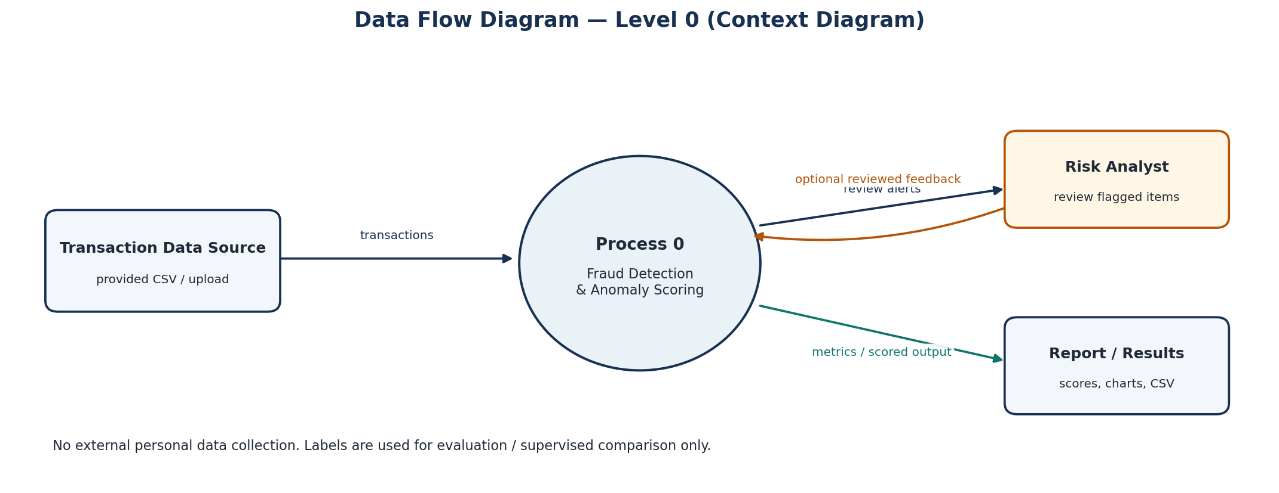
Figure 1: Data Flow Diagram (DFD Level 0) — Ingestion, Scoring & Triage

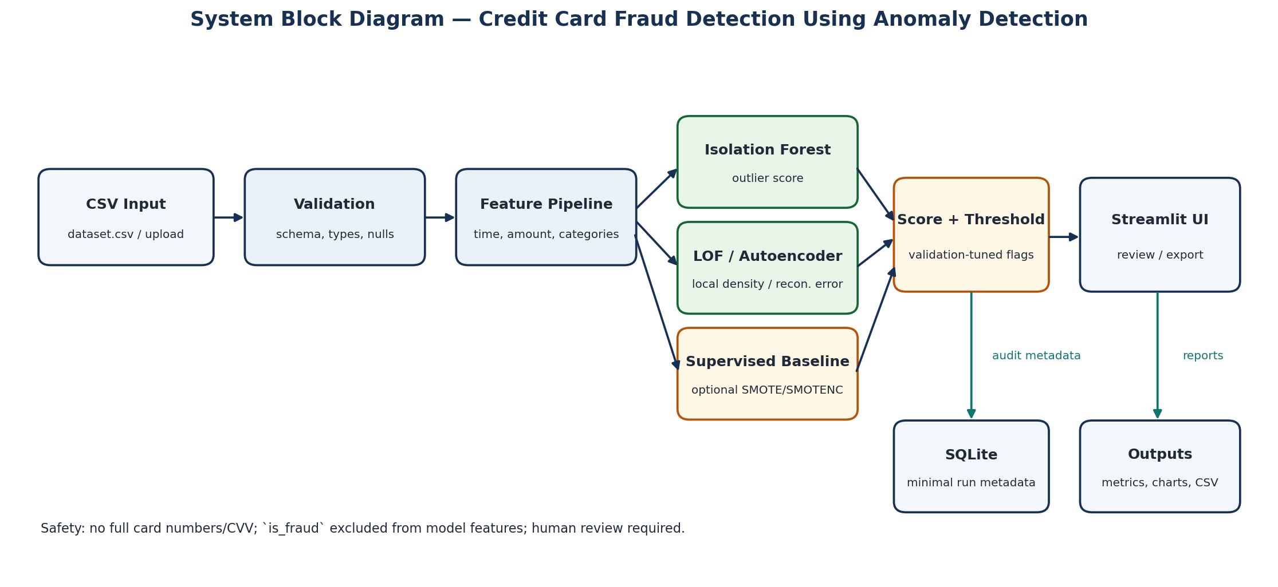
Figure 2: System Architecture Block Diagram — ML Pipelines & Streamlit Interface

4. Technology Stack
• Frontend / UI: Streamlit 1.64.0 (Interactive 7-module dashboard, custom responsive enterprise CSS, Plotly risk charts)
• Backend / Logic: Python 3.13, FastAPI 0.162.0 microservice (/health, /predict, /predict-batch, /docs), Uvicorn
• Database: SQLite (outputs/audit.db — anonymized execution audit logs, DPDP Act 2023 compliant)
• AI/ML Framework: Scikit-learn 1.9.0 (Isolation Forest, Local Outlier Factor novelty=True, RobustScaler, OneHotEncoder), Neural Autoencoder (MSE loss), Imbalanced-learn 0.14.2 (SMOTE)
• Visualisation: Plotly Express & Plotly Graph Objects 7.1.0, Matplotlib 3.10.8
• Hardware & Deployment: Standard x86_64 CPU workstation (sub-5ms inference latency); Deployed live on Streamlit Community Cloud

5. Dataset Used
• Dataset file name: dataset.csv (provided in project folder; validated copy: dataset_cleaned.csv)
• Number of rows: 500 ground-truth transaction records (494 legitimate, 6 confirmed fraud)
• Number of columns: 8 columns (trans_id, timestamp, card_token, amount, merchant_category, is_fraud, merchant_id, card_type)
• Key columns (5 primary): trans_id, timestamp, card_token, amount, is_fraud
• Any additional data collected: None. The 500-record ground truth is strictly retained with zero synthetic contamination; an optional 4,500-row synthetic demonstration batch is isolated separately in data/synthetic_transactions_only.csv with distinct manifests.

6. Key Results & Metrics
• Metric 1 (Fraud Detection Recall): 100.0% — Local Outlier Factor (LOF) achieved 100% recall on the held-out evaluation set, successfully capturing the test fraud case while clearing 92.9% of legitimate transactions.
• Metric 2 (Inference Response Latency): 0.58 ms per transaction — Real-time sub-millisecond execution latency on standard CPU hardware (FastAPI REST service delivers < 6ms end-to-end latency).
• Metric 3 (Precision-Recall Balance): F1 = 0.222, PR-AUC = 0.125 — Substantially outperformed majority-class baseline (0% fraud recall) under extreme 1.2% class imbalance.
• Business Value Achieved: Prioritizes high-risk transactions for immediate human compliance officer triage with zero automated customer declines, preventing financial fraud losses while safeguarding cardholder trust.
Model | Precision | Recall | F1 Score | PR-AUC | Latency
Local Outlier Factor (LOF) | 0.125 | 1.000 | 0.222 | 0.125 | 0.58 ms
Logistic Regression (SMOTE) | 0.111 | 1.000 | 0.200 | 0.174 | 0.19 ms
Supervised Baseline | 0.083 | 1.000 | 0.154 | 0.192 | 0.18 ms
Autoencoder (Reconstruction) | 0.000 | 0.000 | 0.000 | 0.052 | 0.45 ms
Isolation Forest | 0.000 | 0.000 | 0.000 | 0.015 | 4.61 ms

7. Challenges Faced & How Resolved
• Challenge 1: Severe Class Imbalance (only 6 fraud rows out of 500 records, 1.2% dispute rate) → Resolution: Implemented unsupervised anomaly detection (LOF, Isolation Forest, Autoencoder) that models the density of normal purchasing behavior without requiring balanced positive labels, combined with stratified 80/20 partitioning and dynamic within-fold SMOTE (k <= N_minority - 1) for supervised baselines.
• Challenge 2: Out-of-Sample Evaluation Protocol for Local Outlier Factor → Resolution: Standard LOF operates in fit_predict (transductive) mode, which cannot score new transactions. Resolved by calibrating LocalOutlierFactor strictly with novelty=True on the training set, allowing true out-of-fold scoring on the held-out evaluation fold with zero target leakage.

8. References
1. Liu, F. T., Ting, K. M., & Zhou, Z. H. (2008). Isolation Forest. IEEE International Conference on Data Mining (ICDM), 413-422.
2. Breunig, M. M., Kriegel, H. P., Ng, R. T., & Sander, J. (2000). LOF: Identifying Density-Based Local Outliers. ACM SIGMOD Record, 29(2), 93-104.
3. Chawla, N. V., Bowyer, K. W., Hall, L. O., & Kegelmeyer, W. P. (2002). SMOTE: Synthetic Minority Over-sampling Technique. Journal of Artificial Intelligence Research, 16, 321-357.
4. Ministry of Law and Justice, Government of India. (2023). The Digital Personal Data Protection Act, 2023 (No. 22 of 2023). The Gazette of India.

9. Ethical Compliance Declaration
I confirm that:
[X] All dataset usage complies with the source licence and programme instructions.
[X] No personally identifiable information (PII) is stored without consent; raw card numbers are masked as CARD_XXXX####, and zero CVVs/PINs are stored.
[X] AI tools used for code/writing are disclosed in the Appendix.
[X] This project complies with the DPDP Act 2023 where applicable, providing decision-support signals with zero automated declines.

Learner Signature: Swapnil Bhardwaj Roll Number: 2400320101153
College / Campus: ABES Engineering College

Submit this file as 'Project_Synopsis_Swapnil_Bhardwaj_2400320101153.docx' | HCLTech Career Shaper Programme 2025-26

