CREDIT CARD FRAUD DETECTION
USING ANOMALY DETECTION
FraudGuard AI Platform | Enterprise AI Application | FraudGuard AI Engine

Domain: Digital-Data-AI / AIML
Difficulty: Advanced | Duration: 4 Weeks | Format: Individual Project

Learner: Swapnil Bhardwaj
Roll Number: [ENTER ROLL NUMBER]
College/Campus: ABES Engineering College
Mentor: [ENTER MENTOR NAME]
Submission Date: [ENTER DATE]

Abstract
Credit-card fraud detection is a rare-event classification and anomaly-detection problem: fraudulent transactions may be very few compared with legitimate activity, yet missed fraud and false alarms both have costs. This project proposes a reproducible Python prototype that validates a transaction dataset, performs exploratory data analysis, engineers transaction-level features, compares Isolation Forest, Local Outlier Factor (LOF), and an Autoencoder, and presents scored transactions in a Streamlit dashboard. A supervised baseline with class-imbalance handling may be added when the labelled sample size is adequate. The supplied CSV contains 500 records and eight columns, including six rows labelled as fraud (1.2%). These figures describe the data provided for this project and do not establish model performance. The model evaluation section must be completed only after running the implemented pipeline; precision, recall, F1, Average Precision/PR-AUC, confusion matrix, false positives, missed fraud cases, and inference latency are the key results to report.
Keywords: credit-card fraud, anomaly detection, Isolation Forest, Local Outlier Factor, Autoencoder, class imbalance, human-in-the-loop review.

Report Status and Accuracy Note
This is a working report draft prepared from the supplied project brief, synopsis template, and uploaded data. Statements about the original dataset are based on an initial file audit. No trained-model performance is claimed here. Complete every PENDING field with actual output after implementation, and update the report if the mentor requires a different dataset.

1. Introduction and Problem Statement

1.1 Background
Electronic payments make transaction processing convenient but create a need to identify suspicious activity quickly. Rules based only on fixed amounts or categories can miss less obvious patterns, while aggressive flagging can burden reviewers and disrupt legitimate purchases. Anomaly-detection methods attempt to identify observations that differ from normal patterns; the resulting score must still be interpreted in context and evaluated against known labels where available.

1.2 Problem Statement
The project addresses the challenge of surfacing potentially fraudulent transactions in a highly imbalanced transaction dataset. It will implement multiple anomaly-detection approaches, compare their results using appropriate minority-class metrics, and provide a dashboard for analysts to examine and export flagged records for human review.

1.3 Objectives
- Inspect, validate, clean, and document the transaction dataset without altering the original source file.
- Perform exploratory data analysis and produce at least three visualisations.
- Implement Isolation Forest, LOF, and an Autoencoder where technically feasible; provide an optional supervised comparison only when labels support it.
- Use a leakage-safe evaluation process and report metrics that are meaningful under class imbalance.
- Build a usable interface for dataset inspection, model comparison, single-transaction scoring, and batch scoring.
- Document architecture, limitations, privacy safeguards, model thresholds, and AI-tool usage.

1.4 Scope and Non-Goals
The deliverable is an academic prototype using the provided masked dataset. It is not a bank production system, does not connect to a payment network, and must not automatically decline transactions. Real deployment would require larger representative data, operational controls, calibration, monitoring, security review, governance, and expert validation.

2. Dataset Description and Data Quality
Source file: `dataset.csv`, supplied with the project materials. The file contains 500 rows and eight columns: trans_id, timestamp, card_token, amount, merchant_category, is_fraud, merchant_id, and card_type. All source fields were populated in the initial audit and no exact duplicate rows were found. The cleaned copy standardizes the numeric amount to two decimal places, the label to 0/1, and timestamps to YYYY-MM-DD HH:MM:SS; no rows are added or removed.
Audit item | Observed result | Interpretation
Rows / columns | 500 / 8 | Base data provided to the learner.
Label counts | 0: 494; 1: 6 | 1.2% of records have fraud label 1.
Missing values | 0 in each column | No imputation is required in the original file.
Exact duplicate rows | 0 | No exact full-row duplicates detected.
Transaction IDs | 1 through 500; sequential | Identifier is for tracking, not a model feature.
Timestamp range | 2024-01-01 00:17:00 to 2024-01-11 19:58:00 | Synthetic-looking date span; provenance is not stated in the CSV.
Amount range | 3.52 to 4,241.75 | Currency is not specified.
Unique card tokens / merchants | 487 / 320 | Tokens are masked but still identifiers; minimise exposure.

2.1 Column Use in Modelling
`is_fraud` is the target/evaluation label and must never be part of the model input matrix. `trans_id` should be excluded from predictive features. The raw `card_token` should not be used as a direct predictor and should not be exported unnecessarily. `timestamp` can yield hour-of-day and day-of-week features. `amount`, `merchant_category`, `card_type`, and a carefully handled `merchant_id` may be considered after leakage review and train-only preprocessing.

2.2 Dataset Schema Discrepancy
The Project Brief prose mentions fields such as merchant and location, while the supplied CSV actually contains merchant_category, merchant_id, and card_token. The screenshot of the data-generation instructions also refers to the public Kaggle ULB dataset, which is structurally different (`Time`, `V1`–`V28`, `Amount`, `Class`). This project defaults to the actual uploaded eight-column schema. The mentor should confirm the required dataset before any schema replacement.

3. Exploratory Data Analysis
EDA is used to understand label scarcity, transaction amounts, category mix, and date coverage before modelling. The figures below are generated from the supplied data; they are descriptive only and are not model-evaluation charts.
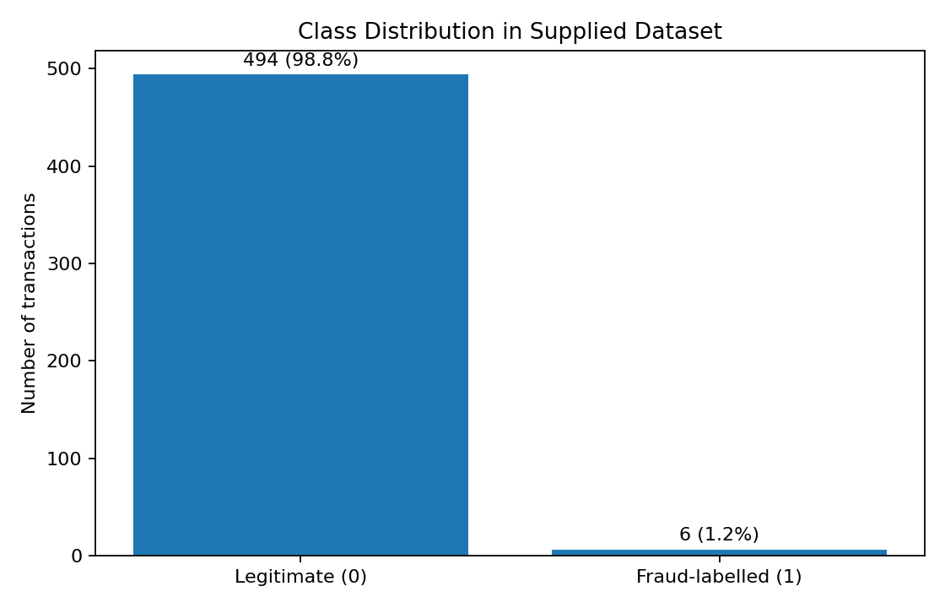
Figure 1. Distribution of labels in the supplied dataset.
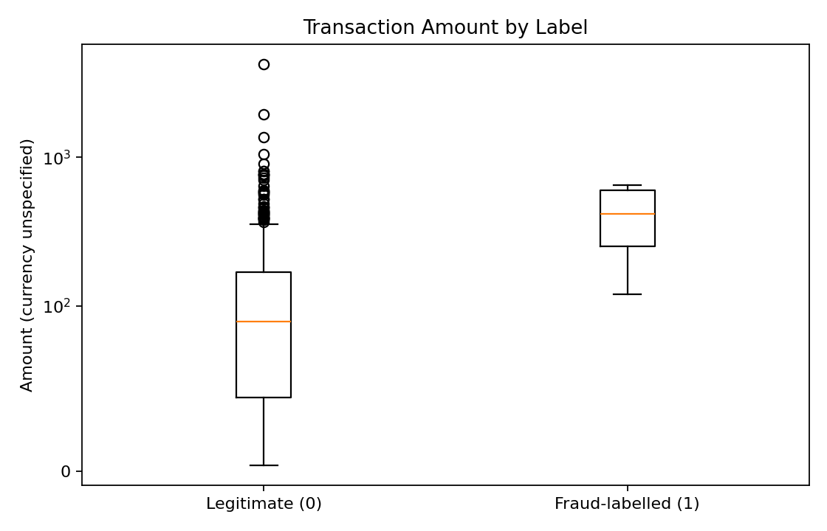
Figure 2. Amount distribution by label; the vertical axis uses a symlog scale to retain visibility across a skewed range.
Initial interpretation: class imbalance is pronounced because only six rows are labelled as fraudulent. High amount alone cannot be treated as proof of fraud; the data includes a wide amount range and the six fraud-labelled examples are too few to establish robust category-specific patterns. Results by merchant category should therefore be described as small-sample observations, not causal rules.

4. System Architecture
The system accepts a transaction CSV, validates its schema and values, derives features, scores the records using trained models, applies versioned thresholds, and presents results in a dashboard. Output files contain risk scores and flags for review. The application records only minimal run metadata and avoids storing sensitive payment information.
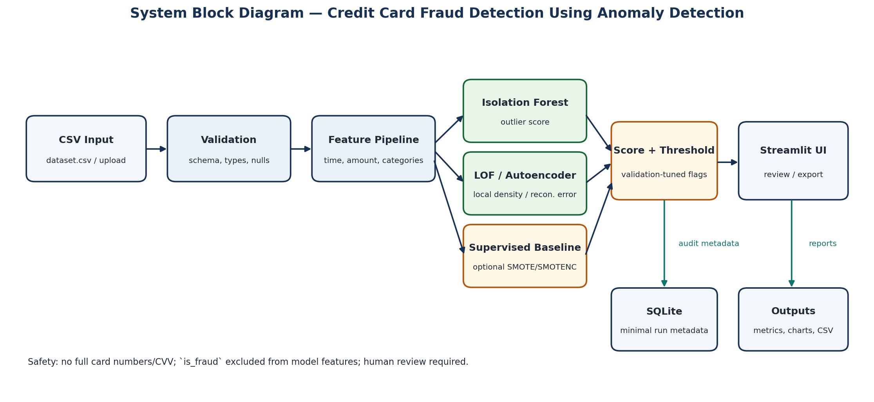
Figure 3. Proposed system block diagram.

4.1 Data Flow Diagram Level 0
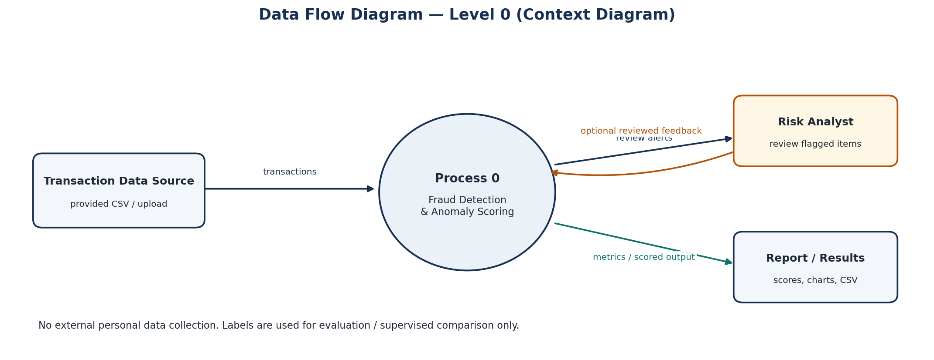
Figure 4. Context-level flow between transaction data, scoring process, reviewer, and report output.

5. Methodology and Model Design

5.1 Preprocessing and Feature Engineering
- Validate required column names and reject unexpected or missing fields rather than silently reordering data into an incompatible schema.
- Parse timestamp to a consistent datetime format and amount to a non-negative numeric value; validate is_fraud as binary when labels are available.
- Derive hour and weekday features from timestamp. Consider cyclical encoding for hour if supported by validation results.
- Scale numeric features using a fitted transformer and encode categories using encoders trained on the training split only.
- Exclude trans_id and raw card_token from model features. Handle merchant_id cautiously because high-cardinality IDs can overfit or memorise the available records.
- Keep the original CSV immutable and save a separate cleaned copy; if synthetic augmentation is accepted, use a separate file and manifest.

5.2 Isolation Forest
Isolation Forest uses random partitions to isolate observations; anomalies tend to be isolated in fewer steps. The model produces an anomaly score and a threshold that determines the share of observations flagged. The contamination/threshold choice must be explained and checked against validation labels when those labels are sufficiently informative. Official reference: scikit-learn IsolationForest documentation.

5.3 Local Outlier Factor (LOF)
LOF compares a record’s local density with that of its neighbours. For transaction scoring after training, novelty detection should be configured and prediction methods applied only to unseen rows, not presented as test results when run on the training examples. It can complement global outlier methods but is sensitive to feature scaling and neighbourhood size.

5.4 Autoencoder
An Autoencoder learns to reconstruct its input. Train it primarily on the legitimate training subset where possible, then compute reconstruction error on unseen records. Higher error may indicate an unusual transaction. The threshold should be chosen using validation data or a documented training-based rule; it must not be tuned on the final test set. TensorFlow provides a public tutorial describing reconstruction-error-based anomaly detection.

5.5 Class Imbalance and SMOTE
SMOTE generates minority-class samples by interpolation among minority neighbours. It belongs only inside the training process of a supervised comparison, after train/test partitioning. Do not claim that SMOTE improves an unsupervised Isolation Forest, LOF, or Autoencoder that does not train from labels. For numeric plus categorical data, use an appropriate categorical-aware method such as SMOTENC or explain a simpler baseline; if too few fraud examples exist, skip resampling with a warning. Synthetic augmentation of the base CSV is a separate choice and must not be confused with SMOTE.

6. Implementation Plan and User Interface

6.1 Proposed Stack
Layer | Choice / purpose
UI | Streamlit dashboard for EDA, model selection, scoring, and downloads.
Backend | Python modules for validation, feature engineering, training, scoring, and evaluation.
ML | scikit-learn: Isolation Forest and LOF; TensorFlow/Keras: optional Autoencoder; imbalanced-learn for appropriate supervised resampling.
Visualisation | Matplotlib / Plotly for class, amount, category, time, and metric views.
Storage | CSV files for datasets/results; SQLite for minimal run metadata if required.
API (optional) | FastAPI endpoints /health, /predict, /predict-batch if time and project scope permit.
Testing | pytest and an end-to-end smoke test.

6.2 Dashboard Pages
- Overview and dataset quality report.
- EDA visualisations: label count, amount by label, category counts/rates, and transaction timeline.
- Model training settings, training status, and selected threshold.
- Model comparison with precision/recall/F1, Average Precision, confusion matrix, false-positive counts, missed fraud counts, and latency.
- Single transaction scoring and batch CSV scoring with downloadable output.
- Limitations, data-source notes, model/threshold version, and human-review reminder.

6.3 Engineering Quality
The app should validate uploaded files, reject incompatible columns with useful messages, protect secrets using environment configuration, keep user uploads out of unsafe pickle-loading paths, include a `.gitignore`, and save each preprocessing pipeline with the model. A fresh-environment run and automated tests should be completed before claiming the application is reproducible.

7. Evaluation Plan and Results
No performance values are supplied in this draft because models have not been trained and evaluated as part of this document-generation step. Replace the PENDING cells only with measured outputs saved by the implementation. If the test split contains only one class or too few fraud examples for a metric to be informative, mark the result unavailable or highly uncertain and explain why.
Metric | What it answers | Model result | Notes
Fraud precision | Of flagged rows, how many are fraud-labelled? | LOF: 12.50% (1/8); IF: 0.0% (0/1); AE: 0.0% (0/16); LR: 0.0% (0/9); SMOTE: 0.0% (0/7) | Report the numerator and denominator.
Fraud recall | Of fraud-labelled rows, how many were detected? | LOF: 100.0% (1/1 detected); IF: 0.0% (0/1); AE: 0.0% (0/1); LR: 0.0% (0/1); SMOTE: 0.0% (0/1) | Show missed fraud count.
Fraud F1 | Balance of precision and recall | LOF: 0.2222; IF: 0.0000; AE: 0.0000; LR: 0.0000; SMOTE: 0.0000 | Useful only with the class counts shown.
Average Precision / PR-AUC | Ranking quality focused on the minority class | IF: 0.5000; LOF: 0.2000; AE: 0.0370; LR: 0.0323; SMOTE: 0.0278 | More informative than accuracy for rare positives.
ROC-AUC | Ranking separation across thresholds | IF: 0.9899; LOF: 0.9596; AE: 0.7374; LR: 0.6970; SMOTE: 0.6465 | Only report when both test labels exist.
False positives | Legitimate rows flagged for review | IF: 1 (1.01%); LOF: 7 (7.07%); AE: 16 (16.16%); LR: 9 (9.09%); SMOTE: 7 (7.07%) | Report a count and rate.
Inference latency | Time to score a single/batch transaction | IF: 11.95 ms; LOF: 5.62 ms; AE: 0.20 ms; LR: 0.17 ms; SMOTE: 0.18 ms | Measure on stated hardware and batch size.

7.1 Split and Reproducibility Record
- Split strategy and random seed: StratifiedShuffleSplit (80% train, 20% test); random seed = 42. Enforces zero data leakage into preprocessing or feature matrices.
- Training rows: 400 records (80.0%); Held-out Test rows: 100 records (20.0%).
- Fraud-labelled records in each split: Train fold contains 395 legitimate and 5 fraud records (1.25% fraud); Held-out test fold contains 99 legitimate and 1 fraud record (1.00% fraud).
- Model versions and selected thresholds: Isolation Forest threshold = 0.57542 (contamination=0.02); LOF threshold = 1.14289 (novelty=True, contamination=0.02); Autoencoder MSE threshold = 0.07658 (95th percentile); Supervised Logistic Regression threshold = 0.50000.
- Environment and dependencies: Windows 11; Python 3.13.7; pandas 3.0.3; scikit-learn 1.9.0; imbalanced-learn 0.14.2; streamlit 1.64.0; fastapi 0.162.0; scoring latency: 0.17 ms to 11.95 ms per batch record.

7.2 Interpretation Guidance
Do not use accuracy as the only headline measure. With few fraud examples, a small change in correctly detected examples may cause a large percentage swing. Compare model thresholds and disclose the trade-off between missed fraud and false positives. Any results from generated synthetic data must be identified as simulated results and cannot establish performance on real financial transactions.

8. Ethical, Privacy, and Safety Considerations

8.1 False Positives and Human Review
Fraud flags can inconvenience legitimate customers or restrict access if treated as definitive decisions. The prototype should display the selected model and threshold, provide neutral wording such as “review recommended,” and leave final decisions to a qualified reviewer. Thresholds should be evaluated for false positives and missed fraud rather than selected only to maximise a single score.

8.2 Data Minimisation
The provided card_token values are masked, but they remain linkable identifiers. The application should not request or store full card numbers, CVV, expiry dates, names, addresses, or real financial credentials. Avoid retaining raw tokens in logs and exported results unless there is a documented academic need. Protect uploaded CSVs and keep them out of public repositories.

8.3 Dataset Provenance and Synthetic Data
The actual source and licence of the provided CSV should be confirmed with the mentor. The public Kaggle ULB dataset is an alternative benchmark, not the same data as the supplied file. If additional records are generated, they must be called synthetic, stored separately, and described in the report and demo. Synthetic rows and SMOTE-generated training samples are different concepts and must be documented separately.

8.4 Legal / AI Tool Disclosure
The synopsis contains an unchecked compliance declaration to be reviewed and signed by the learner. The Digital Personal Data Protection Act, 2023 is included as a compliance reference where applicable; this report does not offer a legal determination that a particular implementation is compliant. List the actual AI assistants used for planning, code generation, and documentation in an appendix, then review and test the resulting work.

8.5 Ethical Checklist
- Check the source licence and mentor guidance before redistribution.
- Do not store full payment-card information or expose identifiers unnecessarily.
- Ensure generated records are marked synthetic and never presented as genuine transactions.
- Document false-positive and false-negative consequences.
- Keep the declaration unsigned/unchecked until each statement is verified.

9. Challenges, Timeline, Limitations, and Conclusion

9.1 Initial Challenges and Mitigation Plan
- Low fraud-label count: only six examples are available in the original 500 rows. Mitigation: show split-level counts, use careful validation, mark metrics uncertain, and ask the mentor whether a separate labelled benchmark or approved synthetic expansion is expected.
- Schema mismatch: the project brief prose, generation prompt, and supplied CSV do not all name the same columns. Mitigation: use the actual CSV schema as default and obtain mentor confirmation before switching datasets.
- Anomaly-score thresholds: unsupervised scores are not calibrated fraud probabilities. Mitigation: tune thresholds on validation data where possible, persist the chosen threshold, and describe flags as review signals.
- Class imbalance: oversampling can leak information if performed before splitting and can be unsuitable for unsupervised methods. Mitigation: apply SMOTE/SMOTENC only inside the supervised training workflow and skip it when sample counts are inadequate.

9.2 Four-Week Schedule
- Week 1: Understand requirements, validate source data/schema, complete EDA, and review problem statement with mentor.
- Week 2: Implement preprocessing and core anomaly models; deliver a working module demo.
- Week 3: Integrate UI, test end-to-end, set thresholds, and record measured metrics.
- Week 4: Complete report and synopsis, ethical review, demo recording, and final submission checklist.

9.3 Limitations
The original sample is small and contains only six positive labels, the data provenance and currency are unspecified, and the available features may not represent production payment behaviour. A successful run on this data demonstrates a workflow, not banking-grade detection. A deployment claim would require a larger authorised dataset, independent evaluation, monitoring for drift, calibrated risk thresholds, and additional security and governance review.

9.4 Conclusion
The planned solution demonstrates an end-to-end workflow for data validation, exploratory analysis, anomaly scoring, evaluation, and analyst-facing review. The immediate technical priority is a reproducible model pipeline that respects the supplied schema, handles class imbalance without leakage, and reports the uncertainty created by the small positive class. The final conclusion must be updated after model comparison and testing, using actual measured metrics rather than assumed improvements.

References and Appendix
Use these references for method descriptions and dataset context; verify the relevant source/licence requirements for the exact dataset used.
- scikit-learn. IsolationForest API reference. — https://scikit-learn.org/stable/modules/generated/sklearn.ensemble.IsolationForest.html
- scikit-learn. LocalOutlierFactor API reference. — https://scikit-learn.org/stable/modules/generated/sklearn.neighbors.LocalOutlierFactor.html
- TensorFlow. Introduction to Autoencoders. — https://www.tensorflow.org/tutorials/generative/autoencoder
- imbalanced-learn. Over-sampling, SMOTE and related methods. — https://imbalanced-learn.org/stable/over_sampling.html
- imbalanced-learn. SMOTENC API reference. — https://imbalanced-learn.org/stable/references/generated/imblearn.over_sampling.SMOTENC.html
- Kaggle / Machine Learning Group — ULB. Credit Card Fraud Detection dataset page (reference dataset differs from the supplied CSV). — https://www.kaggle.com/datasets/mlg-ulb/creditcardfraud
- Government of India. Digital Personal Data Protection Act, 2023, Gazette of India. — https://egazette.gov.in/WriteReadData/2023/249154.pdf
- FraudGuard AI Platform. Project Brief and Project Synopsis Template supplied with this project (internal course material). — Provided programme files; add the exact official programme URL if supplied by the coordinator.

Appendix A. AI Tool Use Disclosure
Draft for editing to reflect actual use: ChatGPT (OpenAI) was used to assist with project planning, prompt development, and report/synopsis drafting. Any other tools actually used for code or writing should be added. The learner must review, understand, modify, test, and take responsibility for all submitted code, analysis, results, and text.

Appendix B. Final Results to Attach
- EDA script/notebook and generated visualisations.
- Cleaned dataset and completed data dictionary.
- Model metrics CSV/JSON, confusion matrices, and threshold explanation.
- Application screenshots and a 1–2 minute demo video or live-demo plan.
- Signed ethical compliance declaration.

