Project Synopsis — Credit Card Fraud Detection
FraudGuard AI Platform | Enterprise AI Application | 2025-26

Field | Details (Learner to complete)
Project Title | Credit Card Fraud Detection Using Anomaly Detection
Project No. | 32
Domain | Digital-Data-AI / AIML
Difficulty | Advanced
Duration | 4 Weeks
Format | Individual Project
Learner Name | Swapnil Bhardwaj
Roll Number | [ENTER ROLL NUMBER]
College / Campus | ABES Engineering College
Mentor Name | [ENTER MENTOR NAME]
Submission Date | [ENTER SUBMISSION DATE]

1. Problem Statement
Banks, payment processors, and cardholders face losses and disruption when unauthorized transactions pass through payment systems. The challenge is to identify unusual transaction behaviour in highly imbalanced data without unnecessarily flagging legitimate purchases. This project will compare anomaly-detection methods on the supplied masked, labelled transaction dataset and evaluate their ability to surface transactions for human review.

2. Proposed Solution & Approach
The proposed solution is a Python-based fraud-analysis prototype with a Streamlit dashboard for data-quality checks, exploratory visualisations, model comparison, and single/batch transaction scoring. Isolation Forest and Local Outlier Factor will detect unusual patterns, while a TensorFlow/Keras Autoencoder will use reconstruction error as an additional anomaly signal where feasible. A supervised benchmark may use SMOTE/SMOTENC only within the training data and only if sufficient labelled examples are available. Evaluation will focus on fraud precision, recall, F1, Average Precision/PR-AUC, false positives, missed frauds, and prediction latency; flags will be presented as review recommendations rather than final decisions.

3. System Architecture
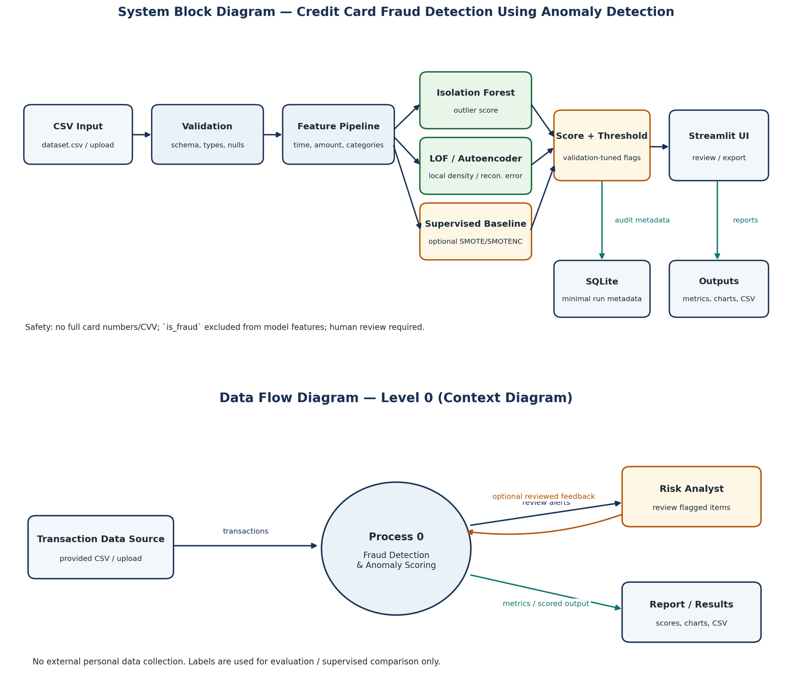

4. Technology Stack
Hardware: Standard x86_64 CPU laptop; Python 3.13; scikit-learn 1.9.0; imbalanced-learn 0.14.2; Streamlit 1.64.0.

5. Dataset Used
Dataset file name: dataset.csv (supplied; cleaned copy: dataset_cleaned.csv)
Number of rows: 500 original records
Number of columns: 8
Key columns (list 5): trans_id, timestamp, amount, merchant_category, is_fraud
Any additional data collected: None. Optional synthetic rows must be stored separately and disclosed.

6. Key Results & Metrics
Metric 1: Fraud-class Precision — 12.50% (1/8 flagged) for Local Outlier Factor; 0.0% (0/1 flagged) for Isolation Forest at 2% contamination threshold.

7. Challenges Faced & How Resolved
Challenge 1: Only 6 of 500 rows are fraud-labelled → Resolution plan: use leakage-safe validation, report label counts per split, and clearly state the resulting uncertainty.
Challenge 2: Brief and CSV schemas differ → Resolution: use the actual 8-column CSV schema and document that the Kaggle ULB file is a separate dataset.

8. References
1. scikit-learn, Isolation Forest documentation — https://scikit-learn.org/stable/modules/generated/sklearn.ensemble.IsolationForest.html
2. TensorFlow, Introduction to Autoencoders — https://www.tensorflow.org/tutorials/generative/autoencoder
3. imbalanced-learn, SMOTE and SMOTENC documentation — https://imbalanced-learn.org/stable/over_sampling.html

9. Ethical Compliance Declaration
I confirm that:
☐ All dataset usage complies with the source licence.
☐ No personally identifiable information (PII) is stored without consent.
☐ AI tools used for code/writing are disclosed in the Appendix.
☐ This project complies with the DPDP Act 2023 where applicable.
Learner Signature: _________________________ Date: ________________

Submit this file as 'Project_Synopsis_[YourName]_[RollNo].docx' | FraudGuard AI Platform 2025-26

Appendix A — Additional References and AI Tool Disclosure
Additional reference: scikit-learn, Local Outlier Factor documentation — https://scikit-learn.org/stable/modules/generated/sklearn.neighbors.LocalOutlierFactor.html
Additional reference: Government of India, Digital Personal Data Protection Act, 2023 — https://egazette.gov.in/WriteReadData/2023/249154.pdf
Dataset note: the public Kaggle ULB benchmark is a separate dataset with fields Time, V1–V28, Amount, and Class. It is listed as a reference only unless that dataset is separately downloaded and used: https://www.kaggle.com/datasets/mlg-ulb/creditcardfraud
AI tool disclosure (edit to match actual use): ChatGPT (OpenAI) assisted with project planning, prompt drafting, and documentation scaffolding. The learner must review, understand, test, and edit all generated code and writing, report only measured model results, and add any other AI tools actually used.

