Output after executing Testing1.java :-
101 Swapnil 100
102 Anushka 99
103 Manas 98
104 Tuhinish 99
105 Arthi 92
106 Gudgudi 95

MySQL Workbench
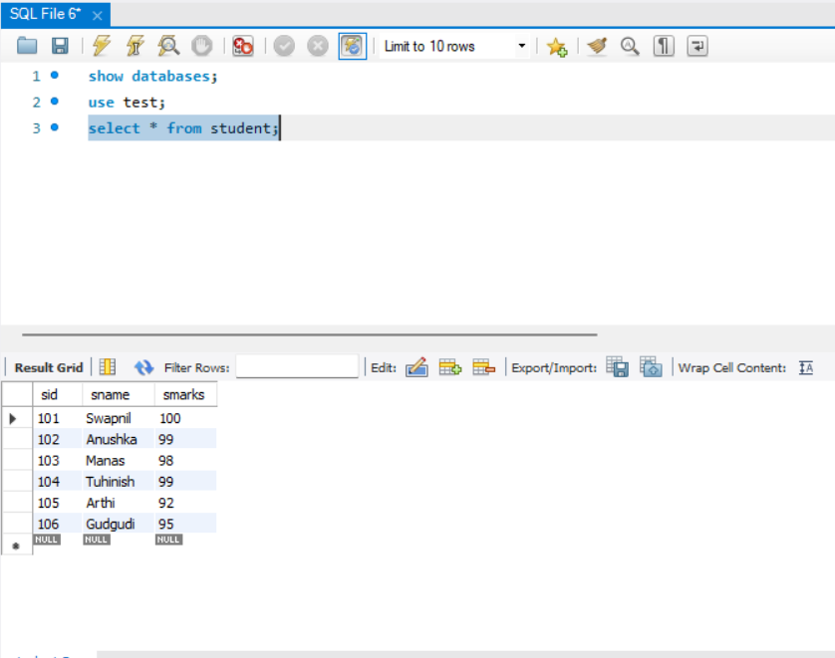
Testing1.java
