16th June 2026

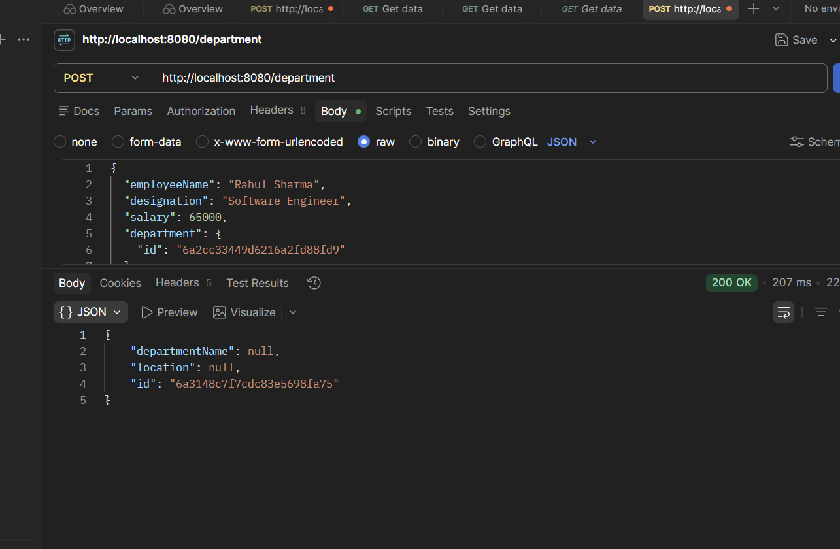
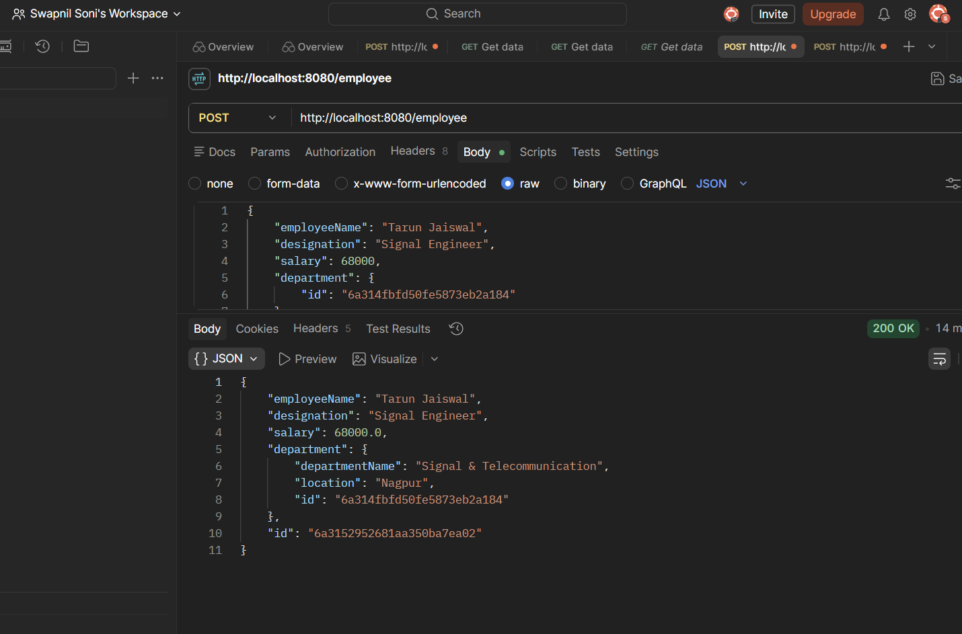
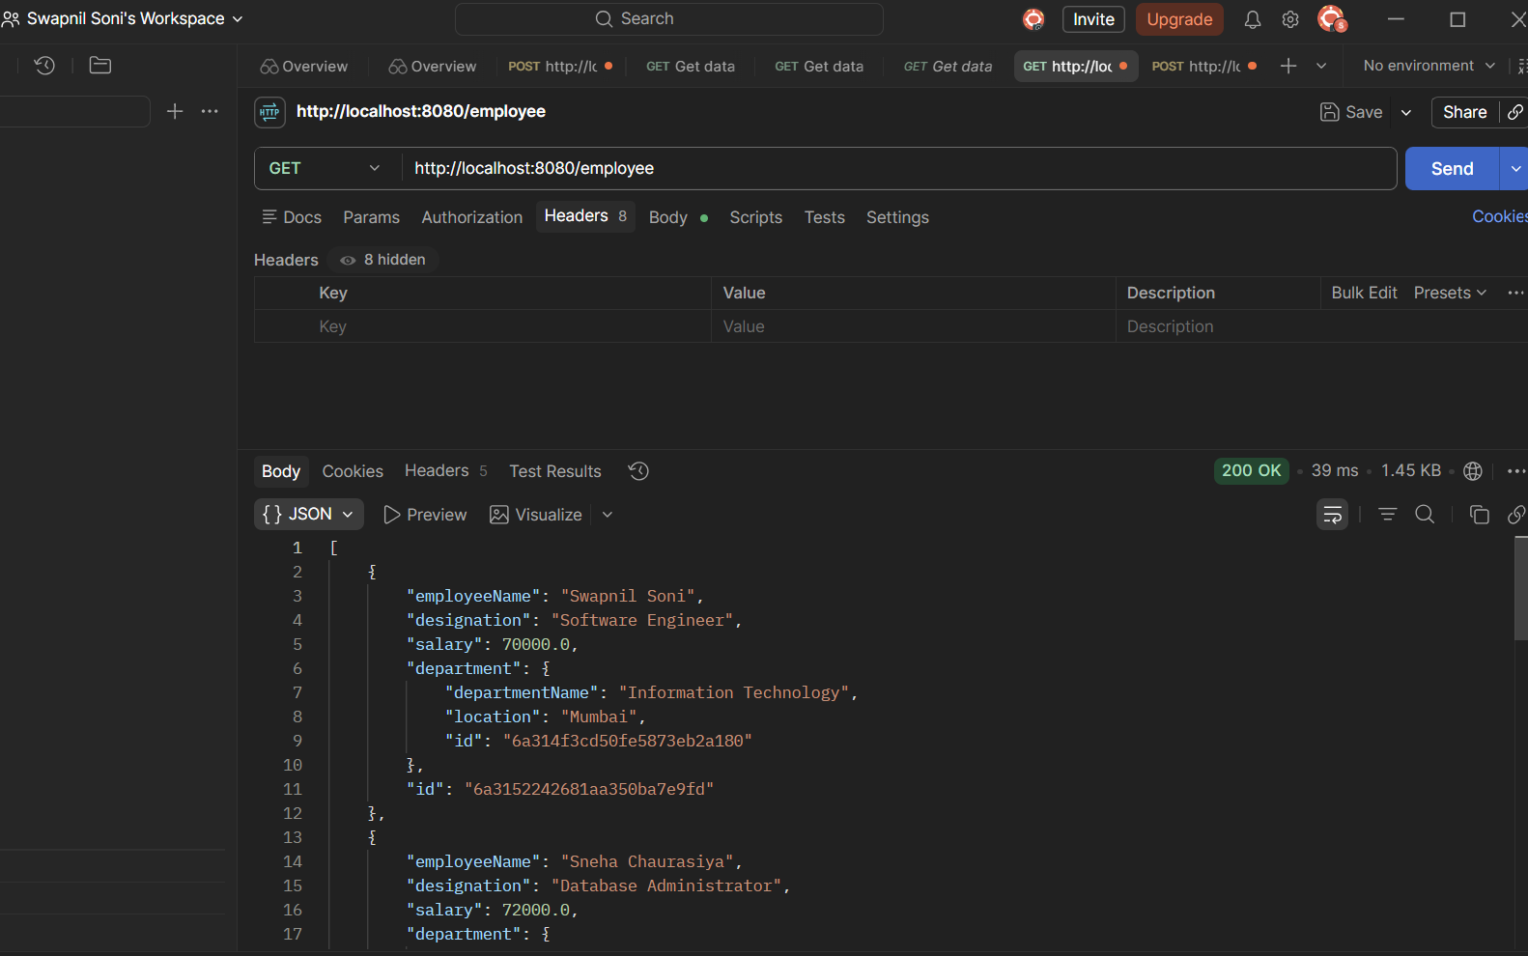
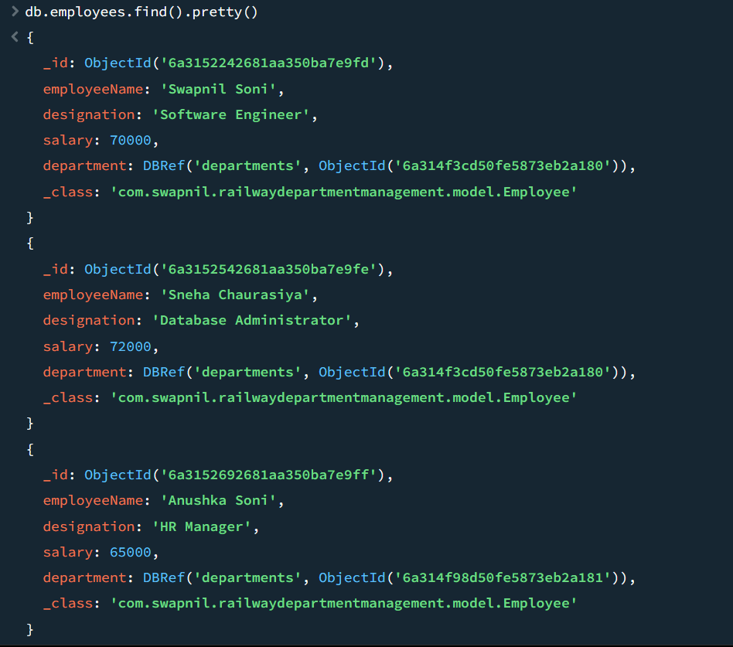
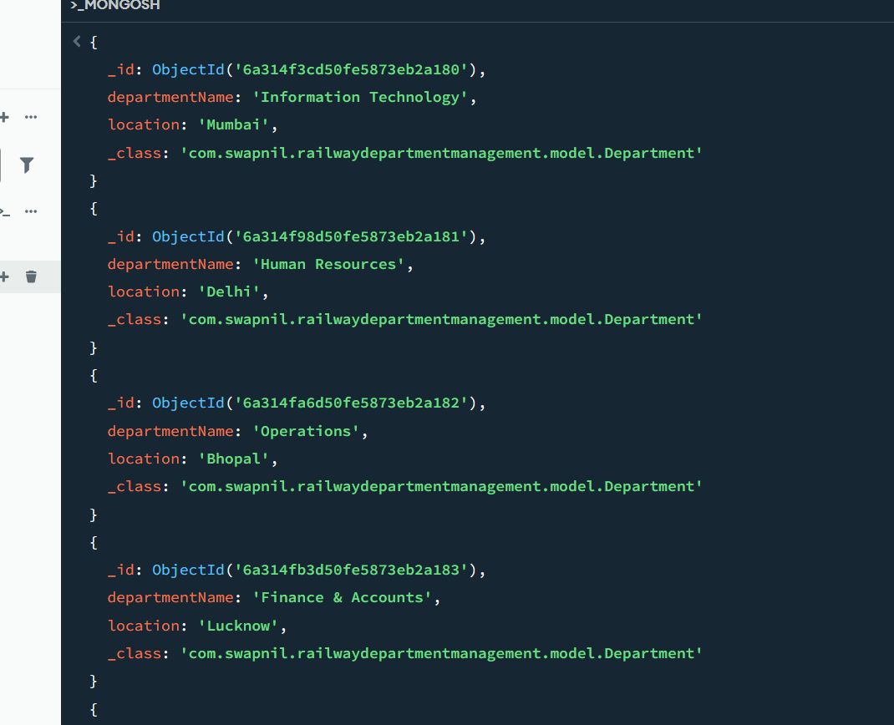

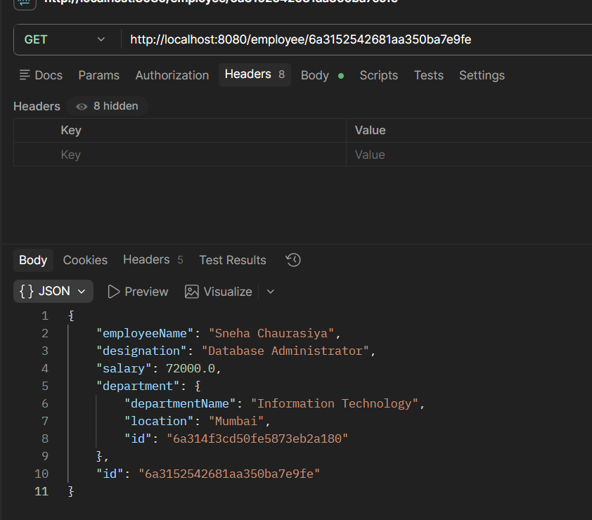
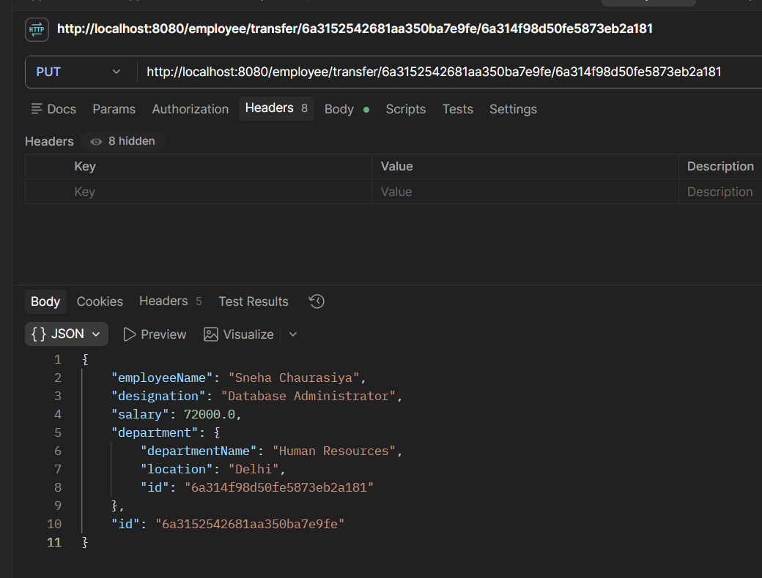

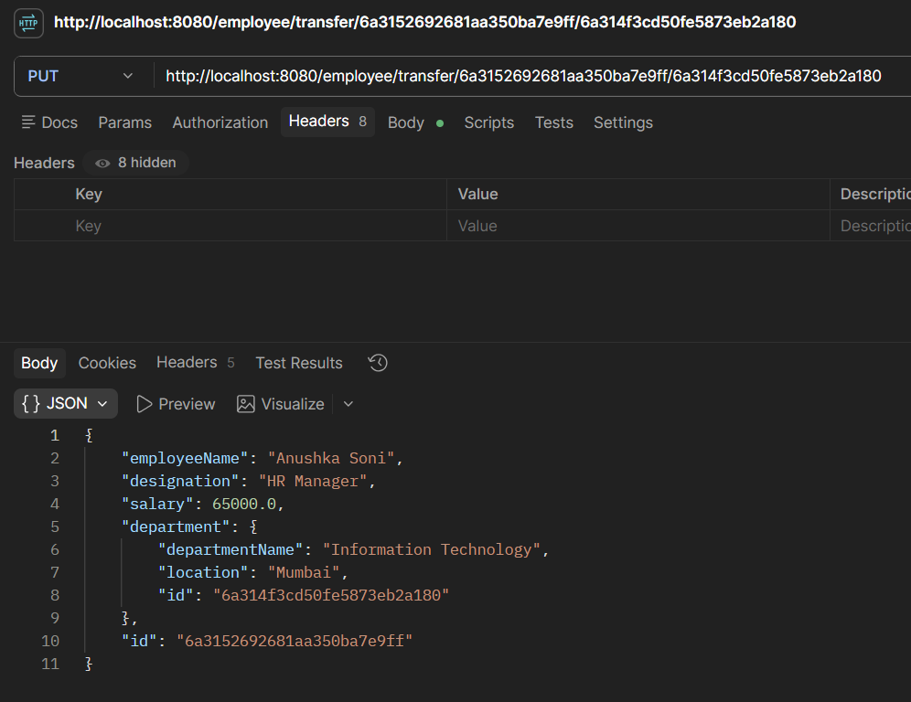
db.employees.find().pretty()
{
_id: ObjectId('6a3152242681aa350ba7e9fd'),
employeeName: 'Swapnil Soni',
designation: 'Software Engineer',
salary: 70000,
department: DBRef('departments', ObjectId('6a314f3cd50fe5873eb2a180')),
_class: 'com.swapnil.railwaydepartmentmanagement.model.Employee'
}
{
_id: ObjectId('6a3152542681aa350ba7e9fe'),
employeeName: 'Sneha Chaurasiya',
designation: 'Database Administrator',
salary: 72000,
department: DBRef('departments', ObjectId('6a314f98d50fe5873eb2a181')),
_class: 'com.swapnil.railwaydepartmentmanagement.model.Employee'
}
{
_id: ObjectId('6a3152692681aa350ba7e9ff'),
employeeName: 'Anushka Soni',
designation: 'HR Manager',
salary: 65000,
department: DBRef('departments', ObjectId('6a314f3cd50fe5873eb2a180')),
_class: 'com.swapnil.railwaydepartmentmanagement.model.Employee'
}
{
_id: ObjectId('6a3152792681aa350ba7ea00'),
employeeName: 'Shriya Patel',
designation: 'Project Manager',
salary: 85000,
department: DBRef('departments', ObjectId('6a314fa6d50fe5873eb2a182')),
_class: 'com.swapnil.railwaydepartmentmanagement.model.Employee'
}
{
_id: ObjectId('6a3152852681aa350ba7ea01'),
employeeName: 'Manas Saraf',
designation: 'Finance Officer',
salary: 75000,
department: DBRef('departments', ObjectId('6a314fb3d50fe5873eb2a183')),
_class: 'com.swapnil.railwaydepartmentmanagement.model.Employee'
}
{
_id: ObjectId('6a3152952681aa350ba7ea02'),
employeeName: 'Tarun Jaiswal',
designation: 'Signal Engineer',
salary: 68000,
department: DBRef('departments', ObjectId('6a314fbfd50fe5873eb2a184')),
_class: 'com.swapnil.railwaydepartmentmanagement.model.Employee'
}
test

TWO EMPLOYEES ARE TRANSFERED

