Week 2 Mini Project
Disc Brake and Caliper Model in SOLIDWORKS
Software: SOLIDWORKS Premium 2024 SP1.0 | Units: MMGS | Part file: DISC BREAK

Project Overview
For this week’s mini project I modelled a disc brake, the kind you would find on the front wheel of a car or a bike. It is made of a drilled rotor (the disc), a central hub with five bolt holes, and a red brake caliper that sits over the edge of the disc. The part file is called DISC BREAK and holds three solid bodies in a single part, so the rotor, hub area and caliper can be seen together in one view.
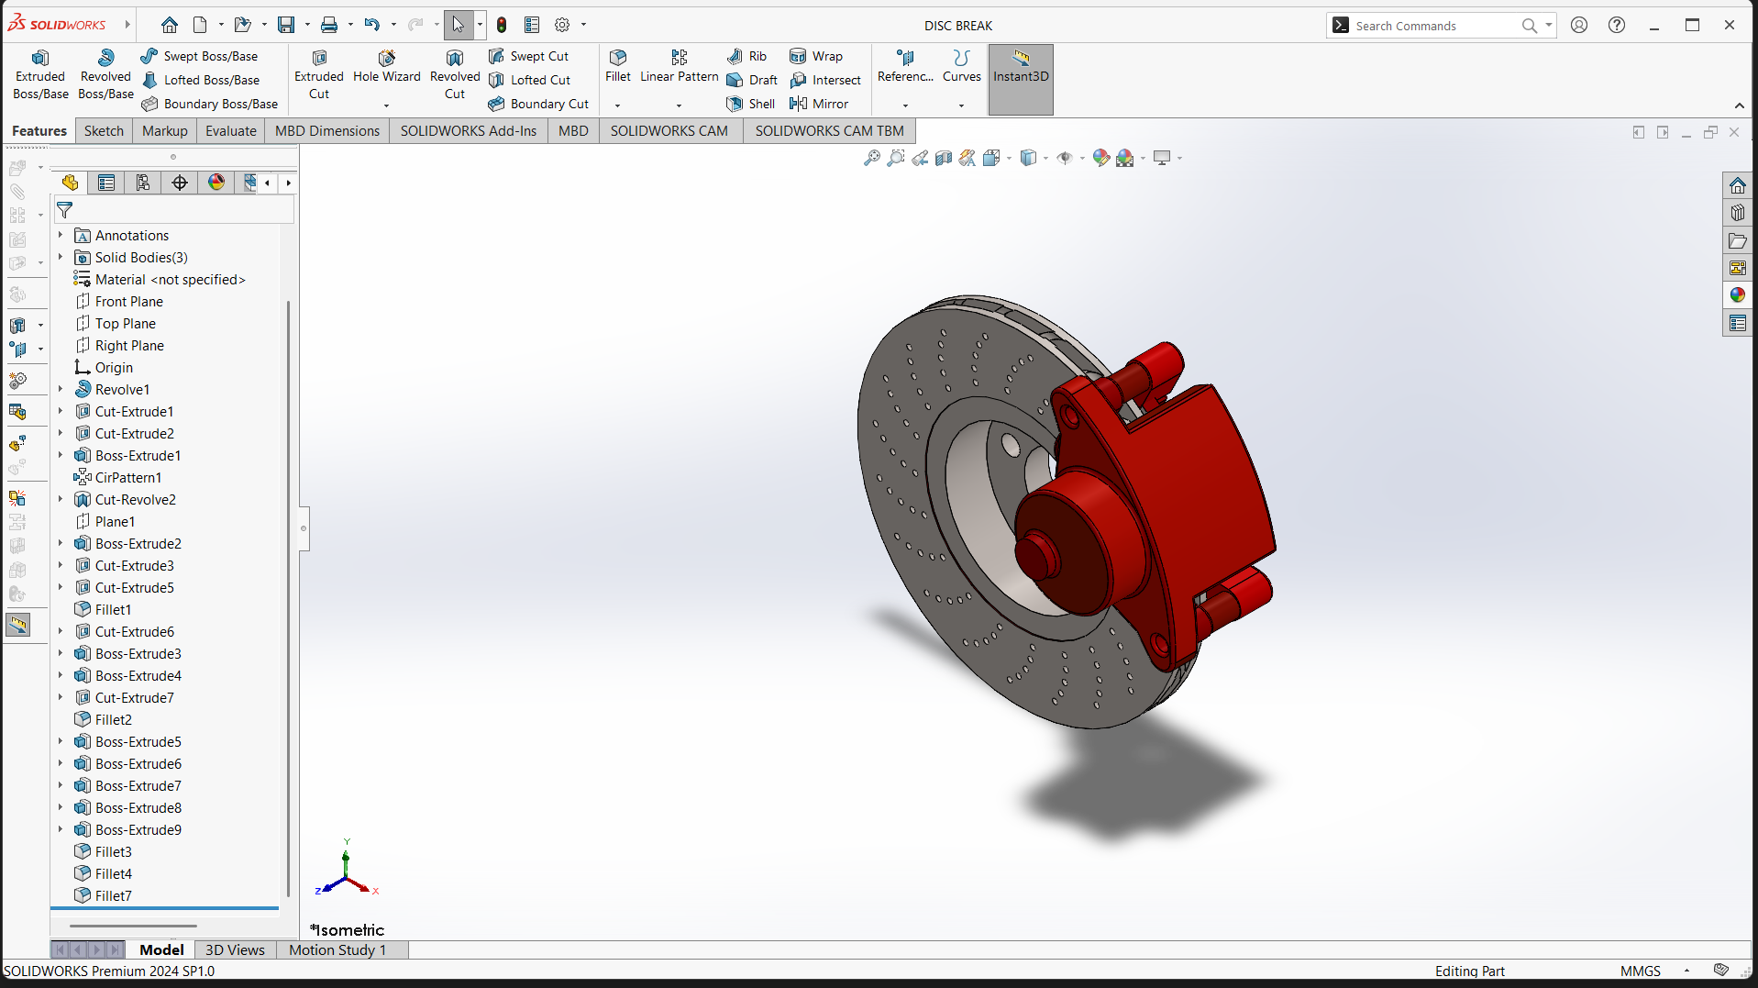
Figure 1: Isometric view of the finished disc brake model

Objective
My goal was simple: take what I learned in the basics of SOLIDWORKS and use it to build something real, not just a practice block. Through this project I wanted to:
- Get comfortable turning a 2D sketch into a 3D part using Revolve, Extrude and Cut features.
- Practise patterns, so that repeated details like the bolt holes and the cooling holes are made once and repeated neatly.
- Learn to add fillets and reference planes to make a part look and behave like a real component.
- Understand how a long feature tree is organised, and why the order of features matters.

How I Built It
The feature tree shows the order I followed. I started with Revolve1, which gives the round body of the disc and hub. After that came a series of Cut-Extrudes to open the centre bore and the five bolt holes, with a circular pattern (CirPattern1) to place the holes evenly around the hub. A Cut-Revolve helped shape the recessed step between the hub and the braking surface.
Then I created Plane1 to build the caliper on a separate plane and used a number of Boss-Extrude features to give it its body, mounting ears and piston housing. Finally I added fillets (Fillet1 to Fillet7) to soften sharp edges, which makes the model look much closer to a manufactured part.
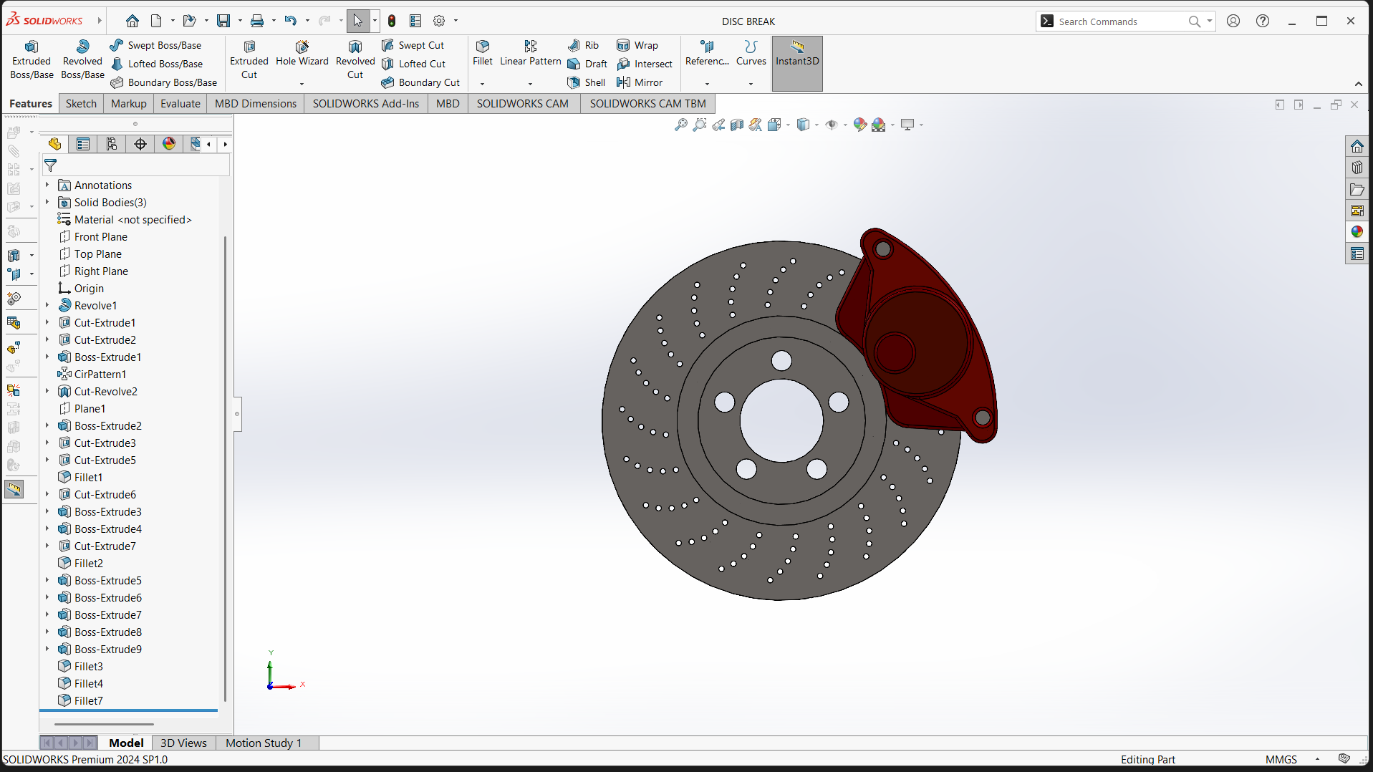
Figure 2: Front view showing the bolt holes, the swirl of cooling holes and the caliper
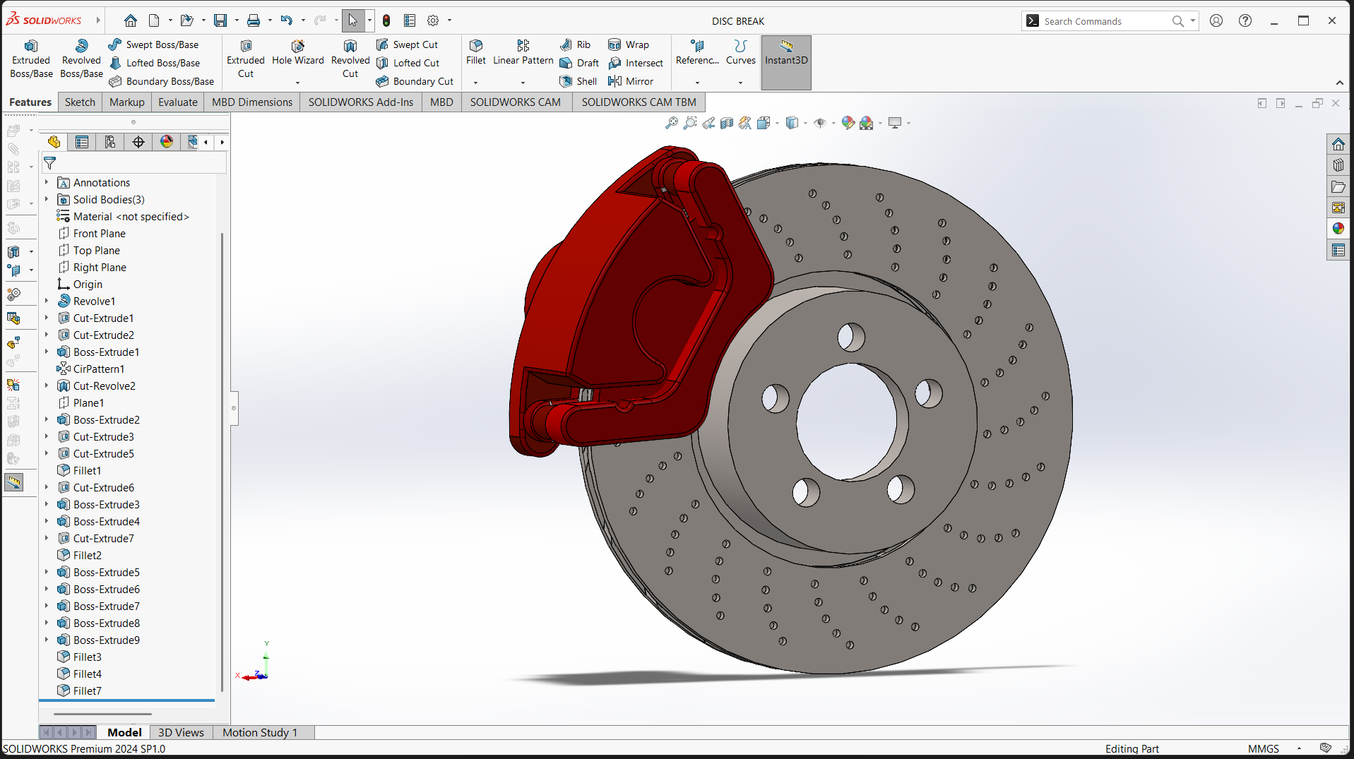
Figure 3: Rear view showing the caliper wrapped over the disc

Application and Use Case
A disc brake is one of the most important safety parts in any vehicle. When the driver presses the pedal, the caliper squeezes brake pads against the spinning disc. Friction slows the wheel down and turns the motion into heat. This model represents exactly that setup, so it can be used in a few practical ways:
- Automotive design: as a starting model for a car or two-wheeler brake system, where engineers check how the disc, hub and caliper fit together.
- Heat and cooling studies: the drilled holes help release heat and water. The model can later be used for thermal analysis in SOLIDWORKS Simulation to see how hot the disc gets during hard braking.
- Stress and wear analysis: once a material such as cast iron is assigned, the part can be tested for stress, deformation and fatigue.
- Assembly and manufacturing: the same geometry can be turned into drawings for machining or used in a motion study to show how the brake works.
- Learning and presentations: it is a clear, easy-to-explain example for students and for portfolio work.

What I Learned
This project taught me that a good model is mostly about planning. If I get the first sketch and the order of features right, the rest falls into place. I also saw how much time patterns save, and how fillets change the look of a part. One thing I noticed is that the material is still shown as “not specified”, so adding a real material is the natural next step before running any analysis.

Conclusion
The disc brake mini project helped me connect the tools I learned in Week 1 into one complete design. It gave me confidence with revolves, cuts, patterns and fillets, and it showed me how a simple CAD model can become the base for real engineering work like simulation and manufacturing. Next, I would like to add a material, a wheel hub assembly and a basic thermal study.

