Fine-Tuning Qwen3 Embeddings for Bill-of-Quantities Retrieval:
A Benchmark Evaluation Against the Base Model
BOQ Retrieval Team | Evaluation Report

Abstract
We compare a fine-tuned Qwen3-Embedding-0.6B model with its base version on a dense retrieval task using 142 BOQ documents (26,228 items indexed via FAISS). The fine-tuned model performs worse across all retrieval metrics (Recall, Precision, MRR, MAP). Overall, fine-tuning did not improve retrieval quality on this benchmark, suggesting the need to revisit the evaluation setup and data coverage before assessing its effectiveness.

1. Introduction
Bills of Quantities (BOQs) are structured construction documents. This study evaluates whether a BOQ-specific fine-tuned embedding model improves retrieval performance over the general-purpose Qwen3-Embedding-0.6B baseline. Both models use the same 1024-dimensional embedding space, normalization, FAISS index, and query set, ensuring differences reflect only the impact of fine-tuning.
2. We built a corpus of 142 BOQ PDFs extracted using ‘pdfplumber’, with metadata linking each item to its source. Evaluation queries were synthetically generated from ground-truth items, each mapping to a single correct result, making MRR and MAP equivalent.
We compare Qwen3-Embedding-0.6B (base) with a BOQ fine-tuned version; both use 1024-dim embeddings and FAISS. Metrics include Recall@k, Precision@k, MRR, MAP, Throughput(QPS) , Similarity, Accuracy, Query Difficulty, Efficiency Metrics and latency. Evaluation used 3,990 queries covering ~3% of the corpus, noted as a coverage limitation.

3. Results
Table 1 reports the complete metric comparison. The fine-tuned model underperforms the base model on every ranking-quality metric, with relative losses ranging from 4.5% to 6.8%.
Table 1. Full benchmark results, Base vs. Fine-Tuned.
Benchmark Results

 | Metric | Base Model | Fine-Tuned Model | Improvement
1 | Recall@1 | 0.9527 | 0.9081 | -0.0446
2 | Precision@1 | 0.9527 | 0.9081 | -0.0446
3 | Recall@3 | 0.9905 | 0.9426 | -0.0479
4 | Precision@3 | 0.3302 | 0.3142 | -0.0160
5 | Recall@5 | 0.9942 | 0.9459 | -0.0483
6 | Precision@5 | 0.1988 | 0.1892 | -0.0097
7 | Recall@10 | 0.9966 | 0.9495 | -0.0471
8 | Precision@10 | 0.0997 | 0.0949 | -0.0047
9 | MRR | 0.9717 | 0.9258 | -0.0459
10 | MAP | 0.9717 | 0.9258 | -0.0459
11 | Error Rate | 0.0473 | 0.0919 | 0.0446

Table 2. Query Difficulty Performance

 | Difficulty | Base Accuracy | Fine-Tuned Accuracy | Improvement
1 | Easy | 0.7913 | 0.3967 | -0.3946
2 | Medium | 0.9245 | 0.9368 | 0.0124
3 | Hard | 0.9878 | 0.9873 | -0.0004

Table 3. Similarity Metrics : How similar or how different two pieces of data are.

 | Metric | Base | Fine-Tuned | Improvement
1 | Average Similarity | 0.8103 | 0.8894 | 0.0791
2 | Maximum Similarity | 0.9387 | 0.9675 | 0.0288
3 | Minimum Similarity | 0.7517 | 0.8471 | 0.0954

Table 4. Efficiency Metrics

 | Metric | Base | Fine-Tuned | Improvement
1 | Latency (ms) | 0.1042 | 0.1104 | 0.0062
2 | Throughput (QPS) | 9596.2781 | 9059.1424 | -537.1358

- Recall@1: Whether the correct item is ranked at position 1.
- Precision@1: Whether the top-1 retrieved item is correct.
- Recall@3: Whether the correct item appears in the top 3 results.
- Precision@3: Fraction of correct items in the top 3 results.
- Recall@5: Whether the correct item appears in the top 5 results.
- Precision@5: Fraction of correct items in the top 5 results.
- Recall@10: Whether the correct item appears in the top 10 results.
- Precision@10: Fraction of correct items in the top 10 results.
- MRR : (Mean Reciprocal Rank)Measures how early the first correct result appears on average. Higher is better when correct items rank near the top.
- MAP : (Mean Average Precision) Measures overall ranking quality considering precision at all ranks where relevant items appear (for single-relevant setups, it matches MRR).
- Latency (ms/query): Average time taken to generate embeddings and retrieve results for one query.
- Throughput: Queries per second.

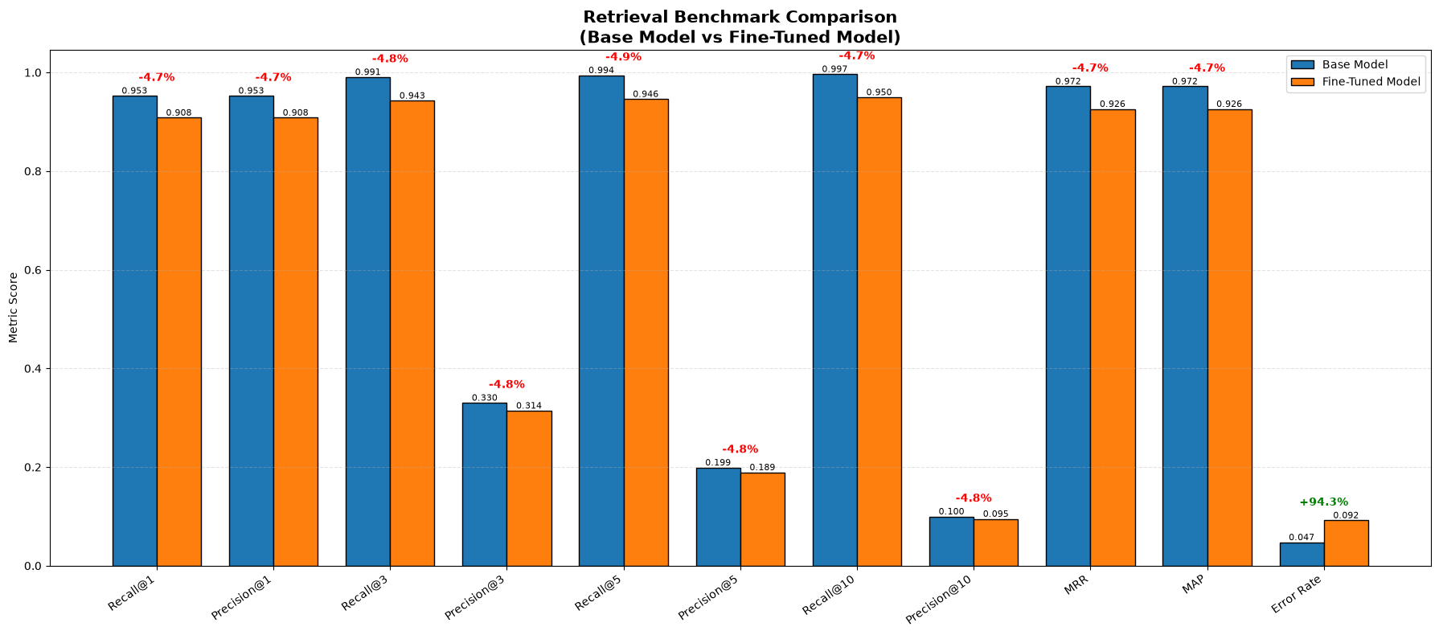
3.1 Recall@K and Precision@K Trends
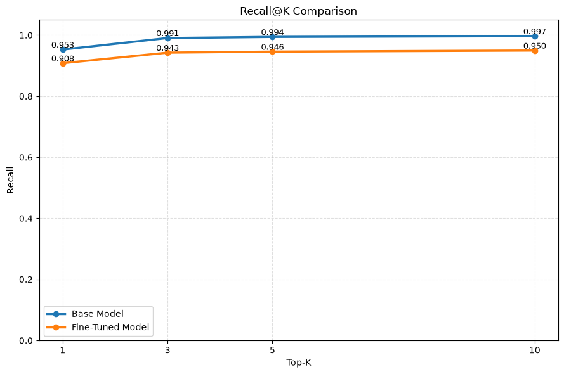
Figure 2. Recall@K for K = 1, 3, 5, 10. The base model leads at every K.
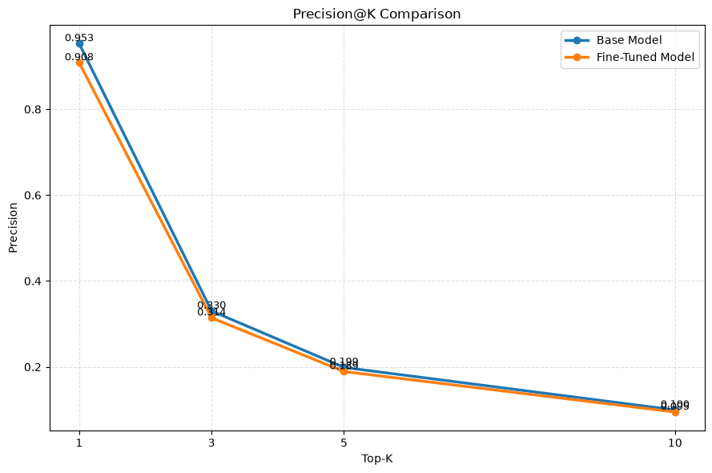
Figure 3. Precision@K for K = 1, 3, 5, 10, mirroring the recall trend.

3.2 Relative Improvement by Metric
The bar chart shows a consistent performance drop in the fine-tuned model across most retrieval metrics.
Metrics such as Recall@K, Precision@K, MRR, and MAP are all lower compared to the base model, with an average decline of ~4–5%.
However, the error rate increases significantly, indicating weaker ranking reliability.
Overall, the base model remains more robust for retrieval performance.

3.3 Normalized Radar View
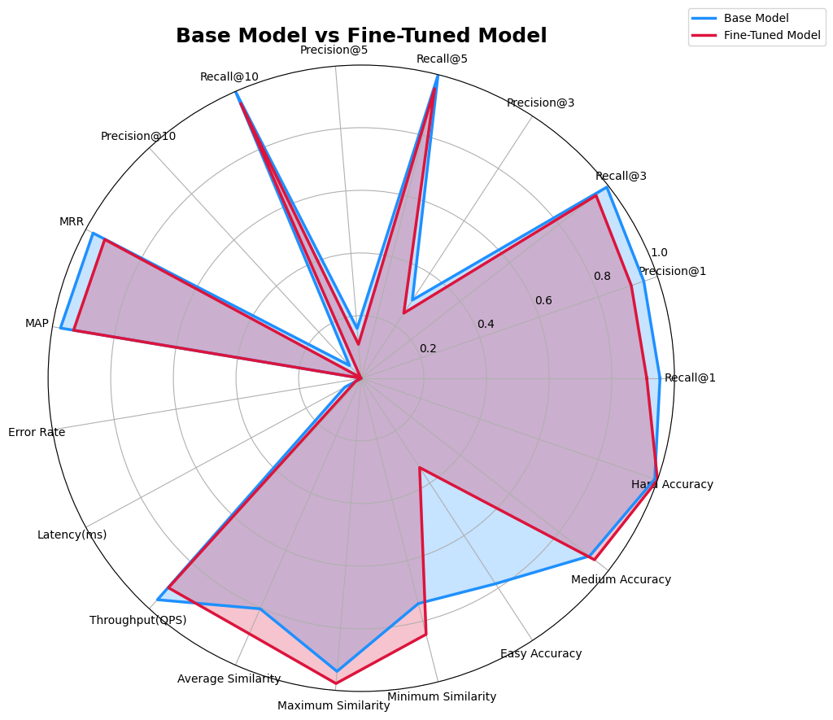
Figure 4. Overall Parameters.
The radar chart shows that the base model slightly outperforms the fine-tuned model across most retrieval metrics.
Metrics like Precision@K, Recall@K, MRR, and MAP are consistently higher for the base model.
The fine-tuned model only shows a noticeable disadvantage in error rate, indicating weaker ranking quality.
Overall, the base model demonstrates more stable and balanced retrieval performance.

3.3 Similarity Metrics
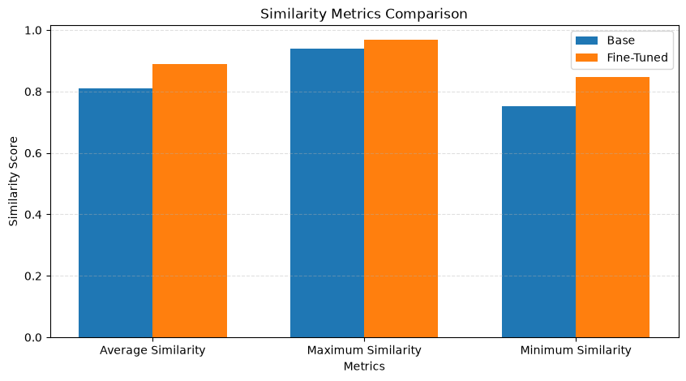
All similarity scores increase after fine-tuning, especially the average and minimum similarity.
This indicates embeddings are becoming more closely clustered in vector space.
However, higher similarity does not improve retrieval performance.

3.4 Efficiency Metrics

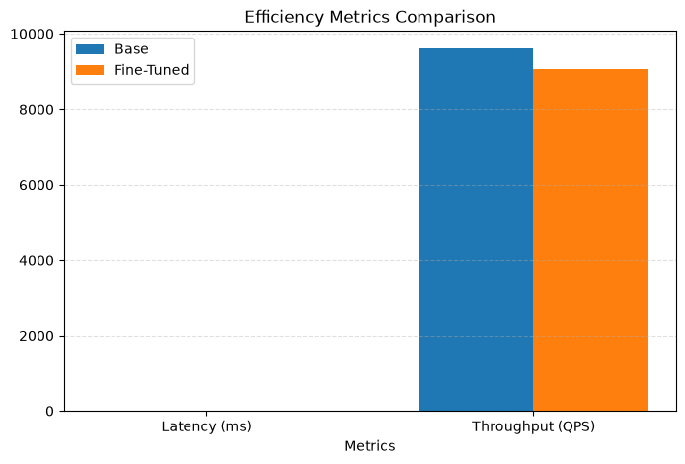
Fine-tuning causes a slight increase in latency and a small drop in throughput.
The differences are minor but indicate a small computational overhead.
Overall efficiency remains almost unchanged.
3.5 Query Difficulty Performance.

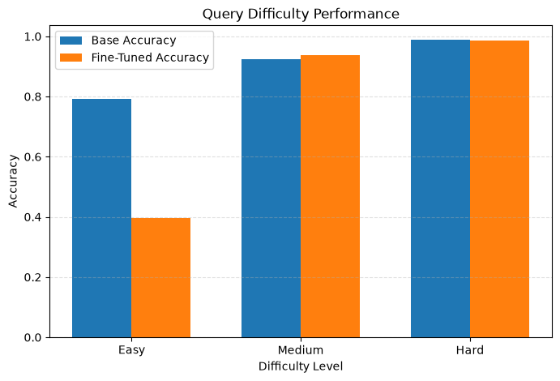
The fine-tuned model performs poorly on Easy queries, showing a major drop in accuracy.
However, it slightly improves on Medium queries and remains stable on Hard queries.
This suggests the model may have overfitted to complex BOQ patterns.
4. Discussion
The fine-tuned model shows a uniform performance drop across all metrics (recall, precision, MRR, MAP, ect), suggesting reduced overall embedding discriminability rather than a trade-off between metrics.
For once the latency was better for the fine-tuned model, but that may be influenced by run conditions and should be validated with repeated trials.

5. Conclusion and Recommendations
Fine-tuning Qwen3-Embedding-0.6B did not improve retrieval quality, with all ranking metrics dropping by 4.5–6.8%, though latency improved by 28.7% for once. However, this conclusion is limited by dataset coverage and query design.

