A Project report on

**Student Web Portal**

Submitted in Particular fulfilment for the Award of

“**BACHELOR OF TECHNOLOGY”**

IN

**“COMPUTER ENGINEERING**”

By

PATEL SWAPNIL NATVARBHAI

(PRN:2020095900009773)

ZALA MITRAJSINH MANJITSINH

(PRN:2020095900009757)

PATEL KRISH RAKESHKUMAR

(PRN:2020095900009943)

Under the Supervision of

Rupal R. Chaudhari

(Assistance Professor)



**FACULTY OF ENGINEERING & TECHNOLOGY**

**SANKALCHAND PATEL COLLEGE OF ENGINEERING**

Ambaji-Gandhinagar State Highway

Visnagar-384315

Dist:Mehsana , Gujarat

August,2022

**CONTENTS**

|  |  |  |
| --- | --- | --- |
| **SR.NO** | **CHAPTER NAME** | **PAGE NO.** |
| 01 | INTRODUCTION | 03 |
| 02 | DEVELOPMENT TOOLS | 03 |
| 03 | SYSTEM REQUIREMENTS | 03-04 |
| 04 | FEATURE | 04 |
| 05 | SYSTEM FLOW | 05 |
| 06 | SNAPSHOT | 06-07 |
| 07 | SOURCE CODE | 08 |
| 08 | FUTURE SCOPE | 08 |
| 09 | REFRENCE | 08 |

2.

**INTRODUCTION**

The main objective of this project is to design an dynamic,responsive Website. This whole project can be related in student which has multiple function

Included in the project. A student can learn through a task Tutorial Page.

There are other pages related to students which are mention below.

**DEVELOPMENT TOOLS:**

1. We Make our Module with PHP,MySQL
2. Language:HTML , CSS , JS , PHP , SQL
3. We used Visual Studio Code as our editor.
4. We use Apache server
5. Web-Browser:Mozila firefox/Google Chrome/Opera Mini/Microsoft Edge.
6. Framework and Libraries:Bootstrap And JQuery.

**SYSTEM REQUIREMENTS:**

**On client side:**

* Operating System
* Web Browser(Google Chrome,Mozila Firefox,Opera,Safari)

**On server side:**

* Web server(Apache)
* PHP
* MySQL

3.

**Hardware Requriment:**

At Server Side:

* Processor 5 or Above
* 2 GB ram
* 120 GB HDD/SDD
* Internet

**FEATURES:**

* Secure Login Page
* User Friendly
* Fully Information
* Home Page
* Material Page
* Syllabus Page

**SYSTEM DESIGN:**

* **TABLE DESIGN**

To maintain Login Information

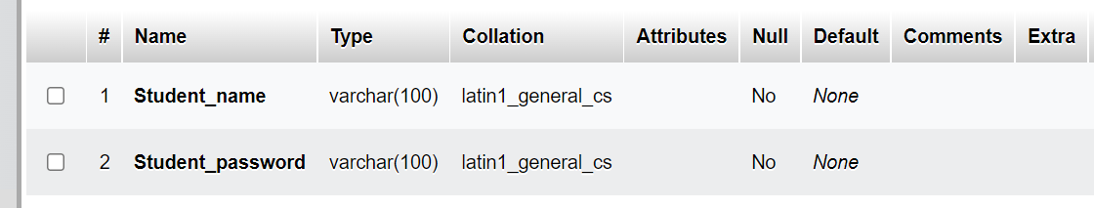

4.

**DATA FLOW DIAGRAM:**

* DATA FLOW DIAGRAM FOR STUDENT LOGIN

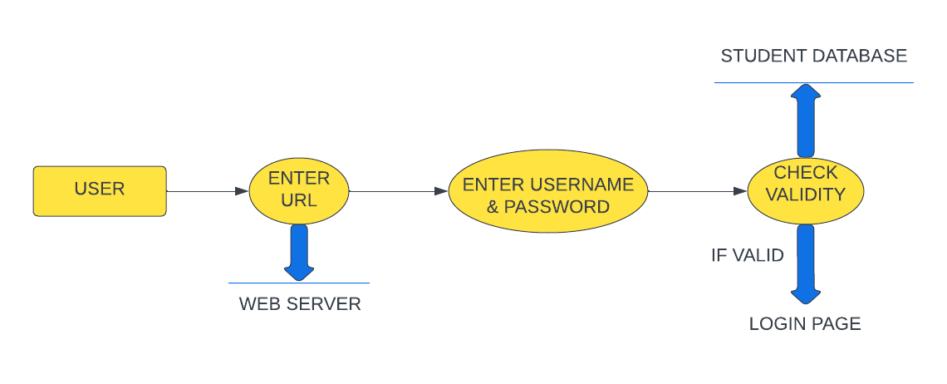

After entering to the home page of the website,and student can access all page.

**STUDENT DATAFLOW DIAGRAM:**

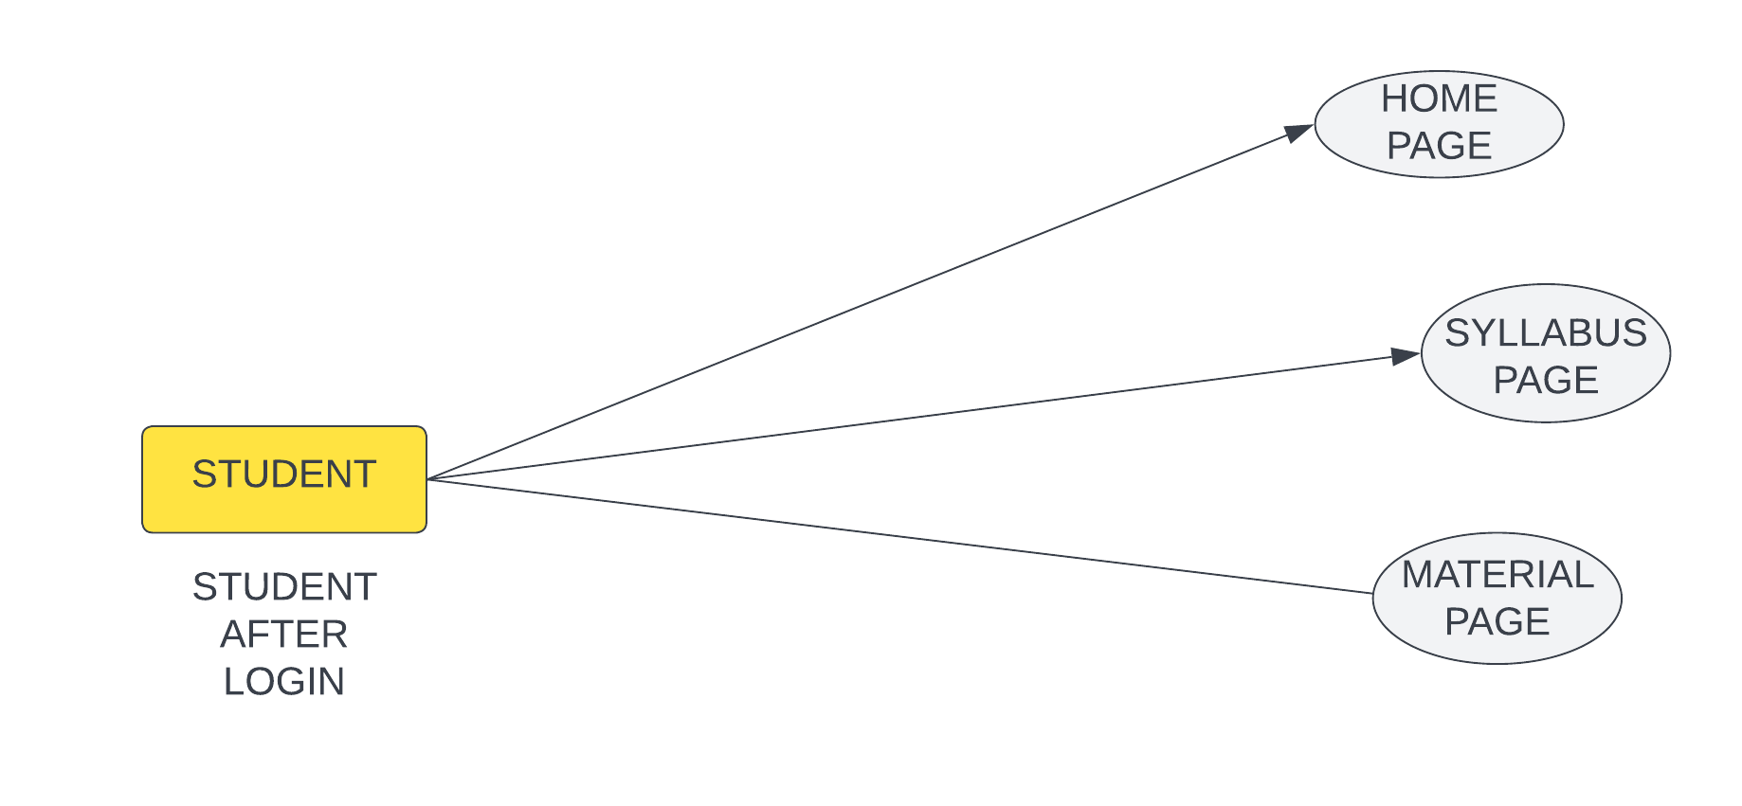

5.

**SCREENSHOT:**

* SCREEN SHOT FOR LOGIN PAGE

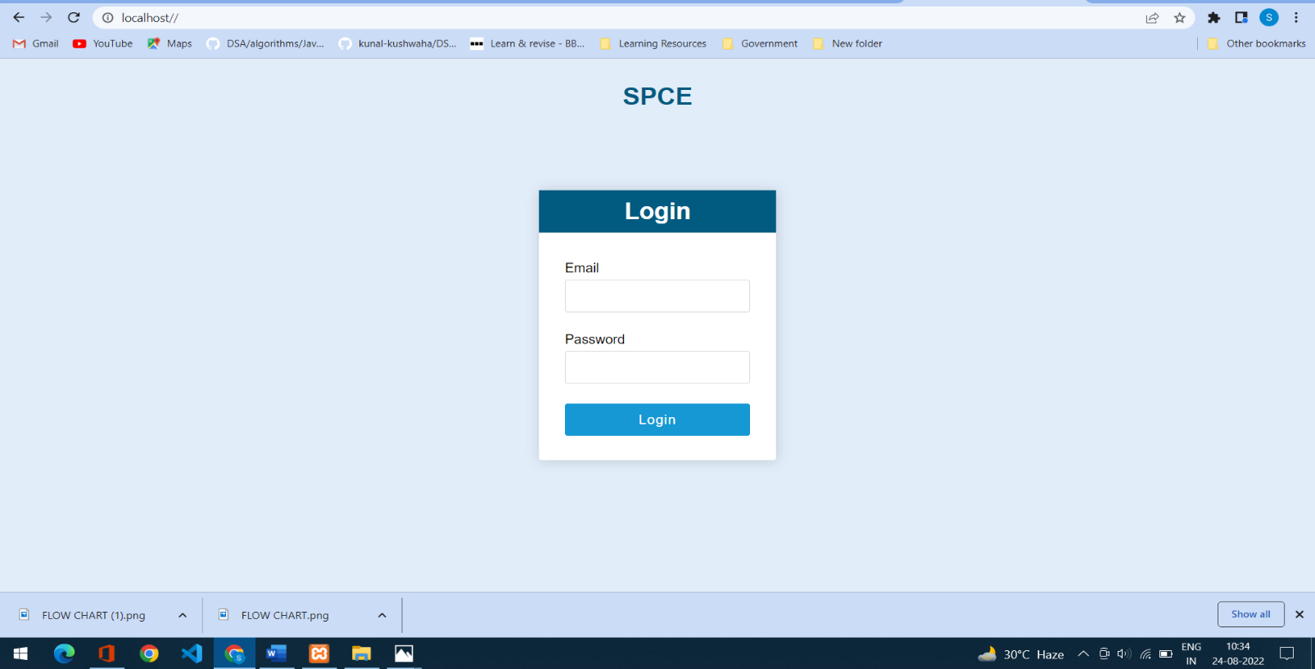

* SCREENSHOT FOR HOME PAGE

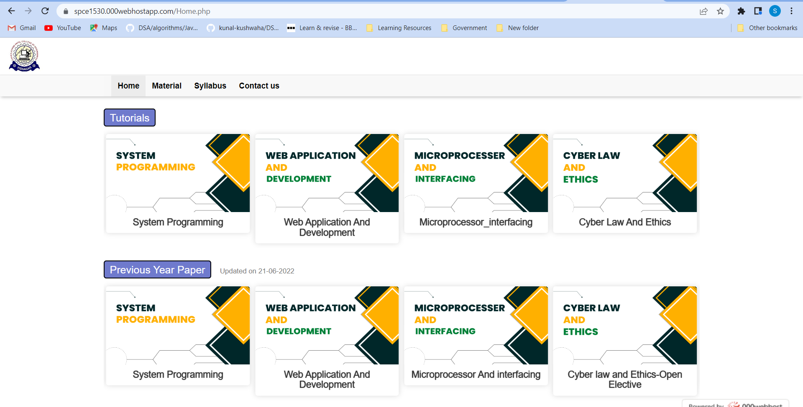

6.

* SCREENSHOT FOR MATERIAL PAGE

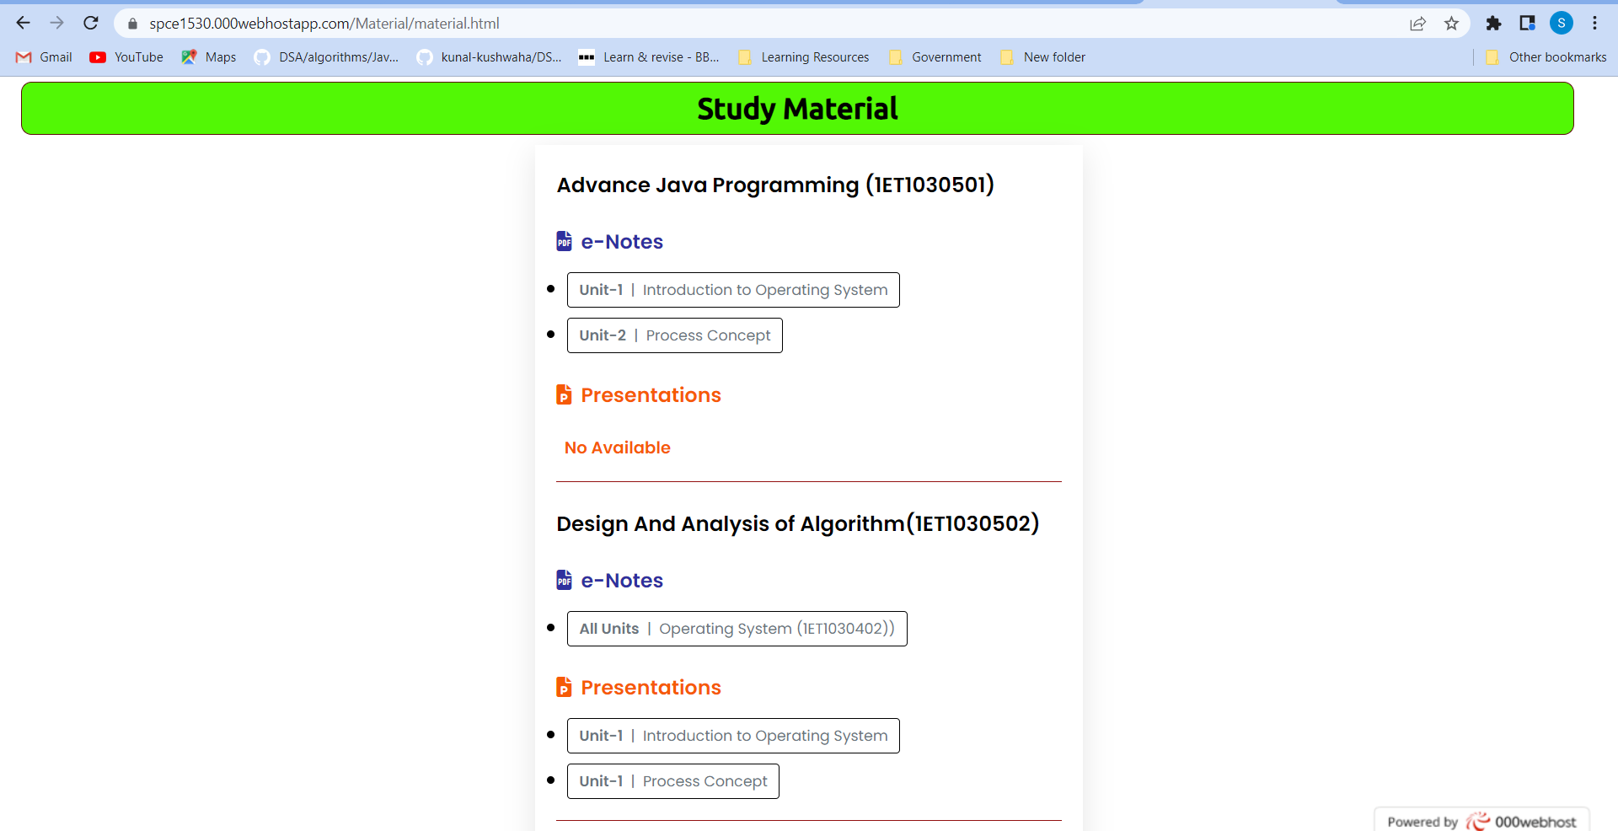

* SCREENSHOT FOR SYLLABUS PAGE

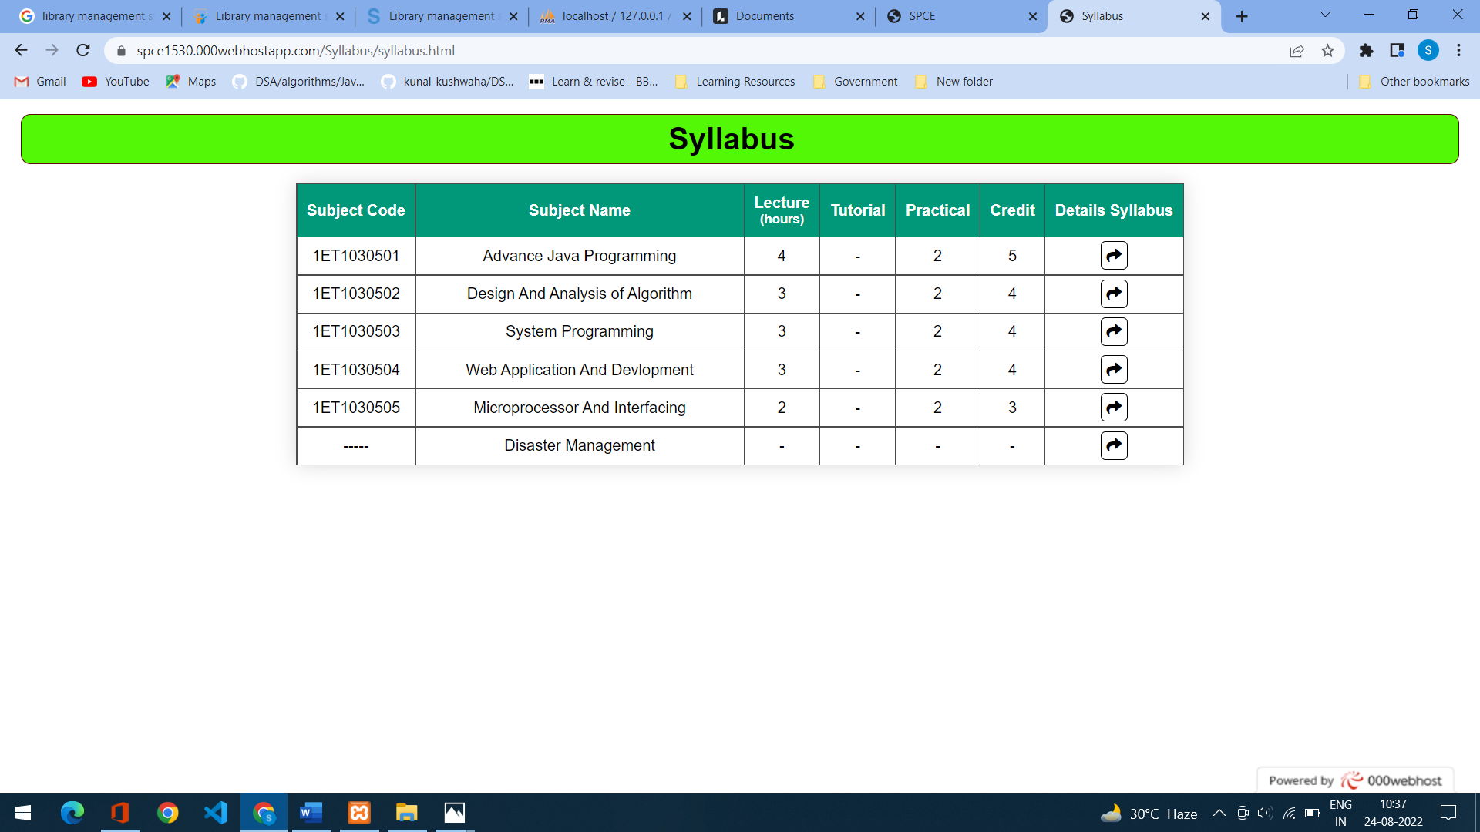

7.

**SOURCE CODE**

* SOURCE CODE AVILABLE IN GITHUB PAGE
* GITHUB LINK: https://github.com/Swapnil1530/Mini_Project_1.git

**WEBSITE PREVIEW**

* LINK: http://spce1530.000webhostapp.com/

**FUTURE SCOPE**

* ADD MORE PAGES
* STUDENT PROFILE PAGE
* STUDENT FEE DETAILS TRACK
* STUDENT ATTENDANCE
* RESULT
* ETC…

**REFRENCE**

<https://www.w3schools.com/html/default.asp>

<https://www.youtube.com/>

8.