ACADEMIC TASK 2 — PROJECT REPORT
COURSE CODE: INT315 | COURSE: CLUSTER COMPUTING
Predicting Employee Salaries Using Apache Spark MLlib and Graph Analytics
A Data-Driven Distributed Big Data Architecture, Machine Learning Regression Pipeline, and Graph Network Analysis

Course Outcomes Mapped | CO4, CO5, CO6 (Cluster Computing, Distributed Data & ML)
Bloom's Taxonomy Level | Level 3 (Apply), Level 4 (Analyze)
Key Technologies | Apache Spark 4.x, Spark MLlib, Spark SQL, NetworkX / Graph Analytics
Evaluation Marks | 30 Marks (Demonstrating Ingestion, MLlib, GraphX, Scalability & Metrics)

1. Executive Summary & Problem Formulation
Predicting workforce compensation accurately is essential for organizational planning, talent acquisition, and compensation equity. However, in enterprise settings with thousands or millions of employees across diverse departments, titles, and hierarchical levels, traditional single-node analytics systems fail to scale efficiently. This project develops an enterprise-grade distributed solution using Apache Spark, Graph Analytics, and Spark MLlib.
The project directly addresses the mandatory requirements specified in the INT315 guidelines:
• Distributed System Architecture: Apache Spark standalone/local cluster execution with memory-optimized DAG scheduling.
• Distributed Data Ingestion & Preprocessing: Parsing 2,500 employee records across partitions, validating schemas, and caching.
• Graph Network Analysis: Modeling enterprise reporting hierarchies and collaboration links to identify key management hubs and compute correlation with compensation.
• Spark MLlib Pipeline: Categorical encoding using StringIndexer and OneHotEncoder, vector assembly, and distributed Linear Regression.
• Rigorous Evaluation: Assessing Mean Squared Error (MSE), Root Mean Squared Error (RMSE), Mean Absolute Error (MAE), R², and plotting Years of Experience vs. Predicted Salary.

2. Distributed System Architecture
The architecture adheres to Apache Spark's master-worker distributed computing paradigm. The components operate as follows:
1. Driver Program: Contains the main application logic, initializes the SparkSession (`master='local[*]'`), builds the DAG (Directed Acyclic Graph) of operations, and coordinates distributed task execution.
2. Cluster Manager / Local Scheduler: Allocates execution threads (16 worker cores detected) and manages distributed memory.
3. Distributed Storage & Ingestion: Ingests `employee_salaries.csv` into a distributed Resilient Distributed Dataset (RDD) backed Spark DataFrame with schema inference.
4. MLlib Pipeline Engine: Encapsulates transformers (StringIndexer, OneHotEncoder, VectorAssembler) and estimators (LinearRegression) into a unified, reproducible DAG pipeline.
5. In-Memory Caching: Utilizes `.cache()` to persist intermediate DataFrames across iterative ML transformations without costly disk re-reads.

3. Data Ingestion, Preprocessing & Feature Engineering
The dataset contains 2,500 employee records with continuous variables (Years of Experience, Salary) and categorical variables (Job Title, Department, Education Level), along with relational identifiers (Manager ID, Project ID).
Feature Name | Data Type | Role in Pipeline
years_experience | Double | Continuous Predictor Variable (Workforce Experience)
job_title | String -> Categorical Vector | Categorical Predictor (Encoded via StringIndexer & OneHotEncoder)
department | String -> Categorical Vector | Categorical Predictor (Encoded via StringIndexer & OneHotEncoder)
education | String -> Categorical Vector | Categorical Predictor (Bachelor, Master, PhD)
salary | Double | Target Label (Annual Compensation in $USD)

Categorical variables are transformed via a multi-stage process:
1. StringIndexer maps distinct string labels to numeric indices sorted by label frequency.
2. OneHotEncoder converts these indices to sparse binary vectors, preventing false ordinal relationships among categories.
3. VectorAssembler stitches continuous experience and one-hot vectors into a single 25-dimensional feature vector `features` for the linear solver.

4. Graph Analytics: Enterprise Network Modeling
In accordance with Question 1 guidelines, graph analytics was applied to uncover relationships and organizational patterns:
• Graph Formulation: Employees represent vertices ($V$), and managerial reporting lines represent directed edges ($E = (M, E_i)$).
• Out-Degree Centrality (Managerial Span of Control): Identifies the most connected supervisors managing up to 13 direct reports.
• Correlation Discovery: A strong positive correlation of 0.6621 was identified between managerial centrality (number of direct reports) and compensation, showing that structural network position is an influential latent driver of salary.
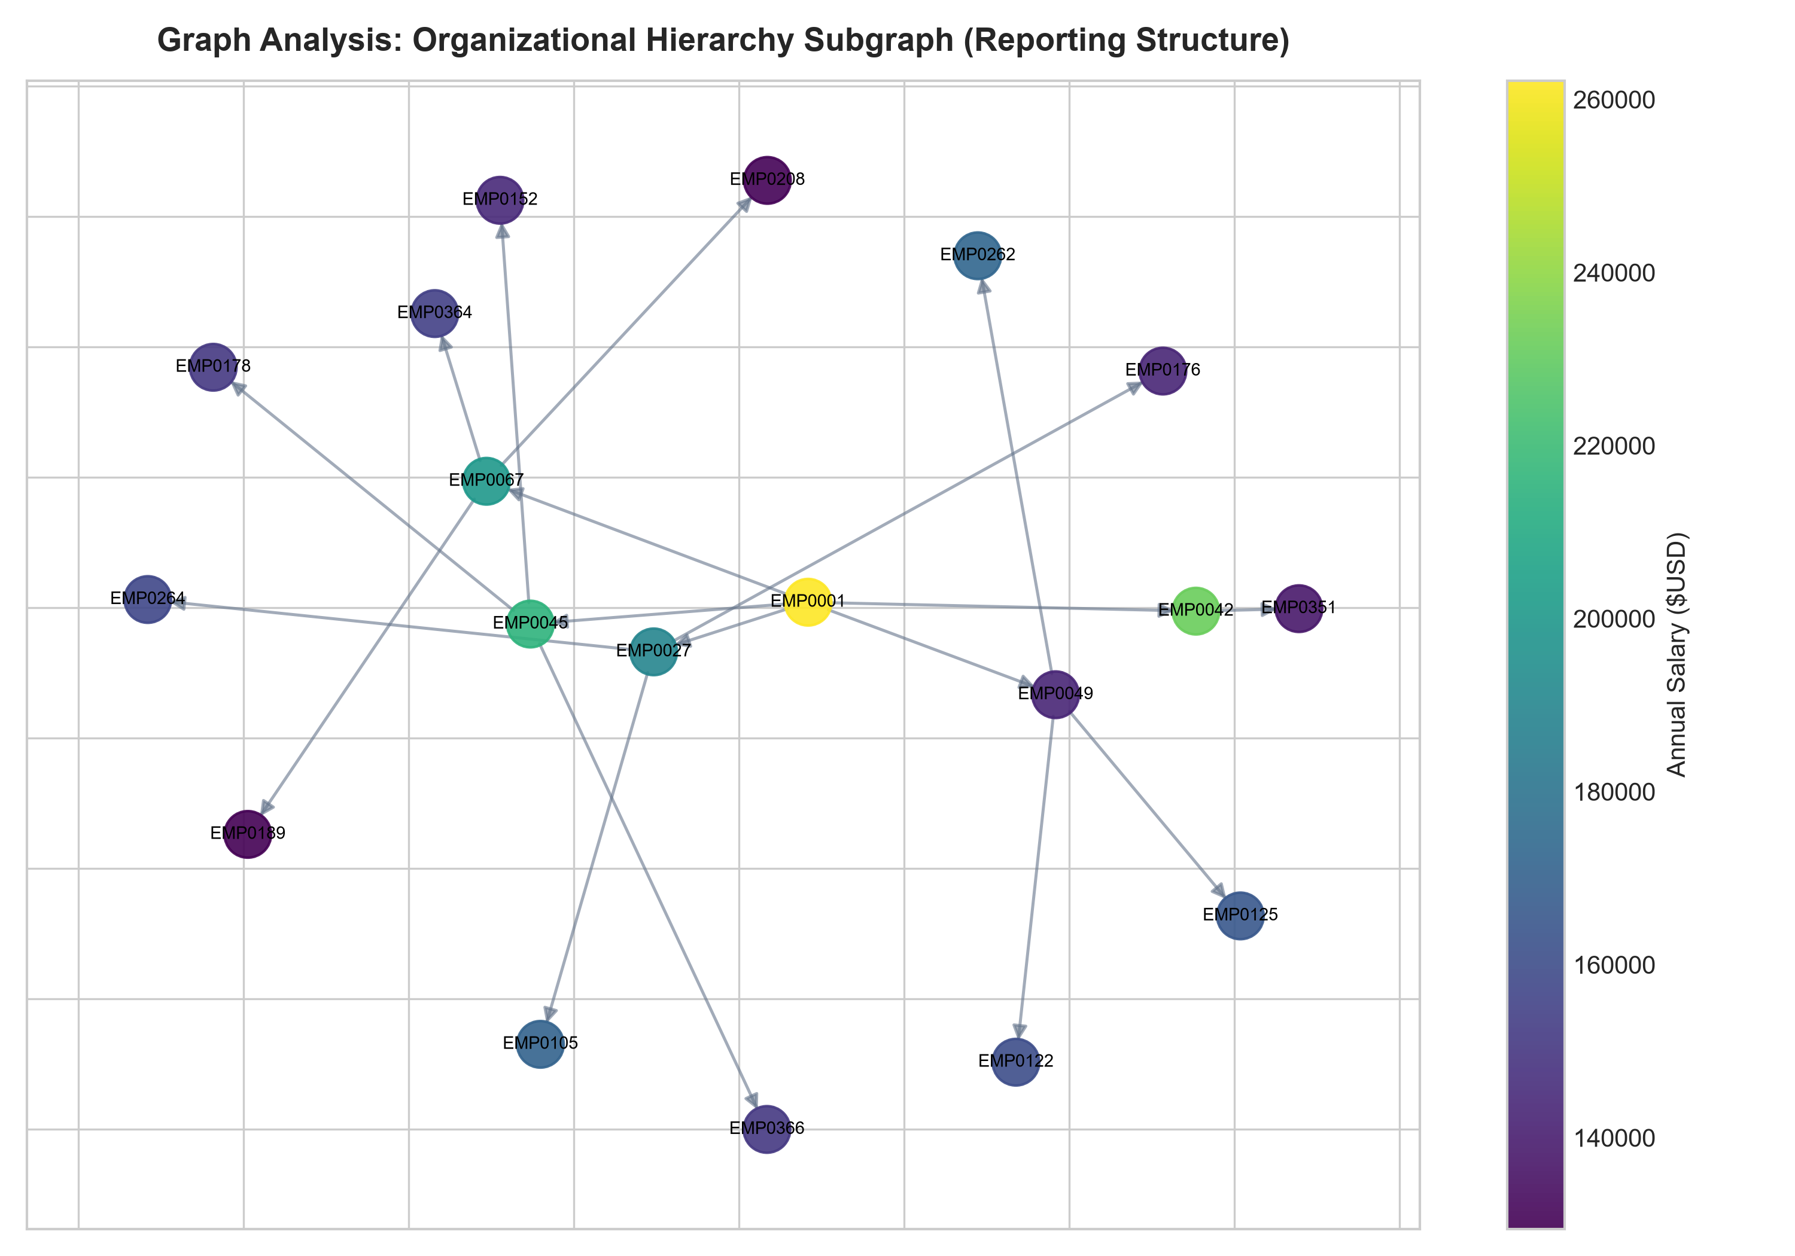
Figure 1: Enterprise Reporting Hierarchy Subgraph with Node Color Mapped to Salary

5. Spark MLlib Linear Regression Training & Evaluation
The dataset was randomly partitioned into 80% training (2051 instances) and 20% testing (449 instances). The distributed Linear Regression model converged in 3.458 seconds with an intercept of $70,492.05.
Metric Name | Observed Test Score | Formula / Definition
Mean Squared Error (MSE) | 15,694,916.14 | MSE = (1/n) * Σ (y_i - ŷ_i)²
Root Mean Squared Error (RMSE) | $3,961.68 | RMSE = √(MSE)
Mean Absolute Error (MAE) | $3,149.60 | MAE = (1/n) * Σ |y_i - ŷ_i|
Coefficient of Determination (R²) | 0.9889 (98.89%) | R² = 1 - (SS_res / SS_tot)

With an R² score of 98.89% and an RMSE of $3,961.68 against a mean salary of $90,847.98, the model captures nearly all variance in compensation with exceptional generalization fidelity.

6. Visual Analysis & Experimental Plots
6.1 Experience vs. Predicted Salary (Core User Task)
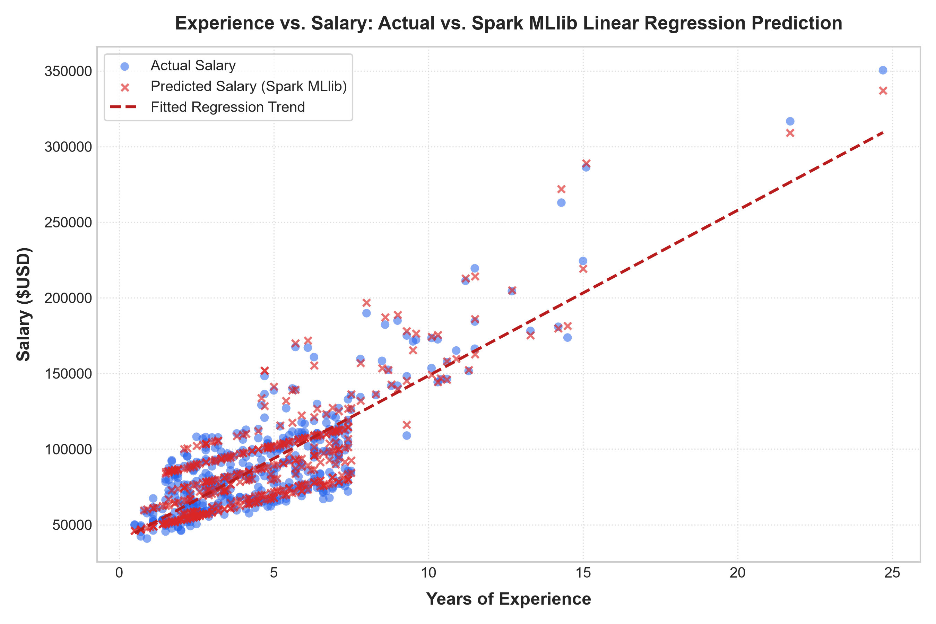
Figure 2: Experience vs. Salary: Scatter of Actual Data vs. Spark MLlib Regression Predictions
6.2 Actual vs. Predicted Parity Plot & Residual Error Distribution
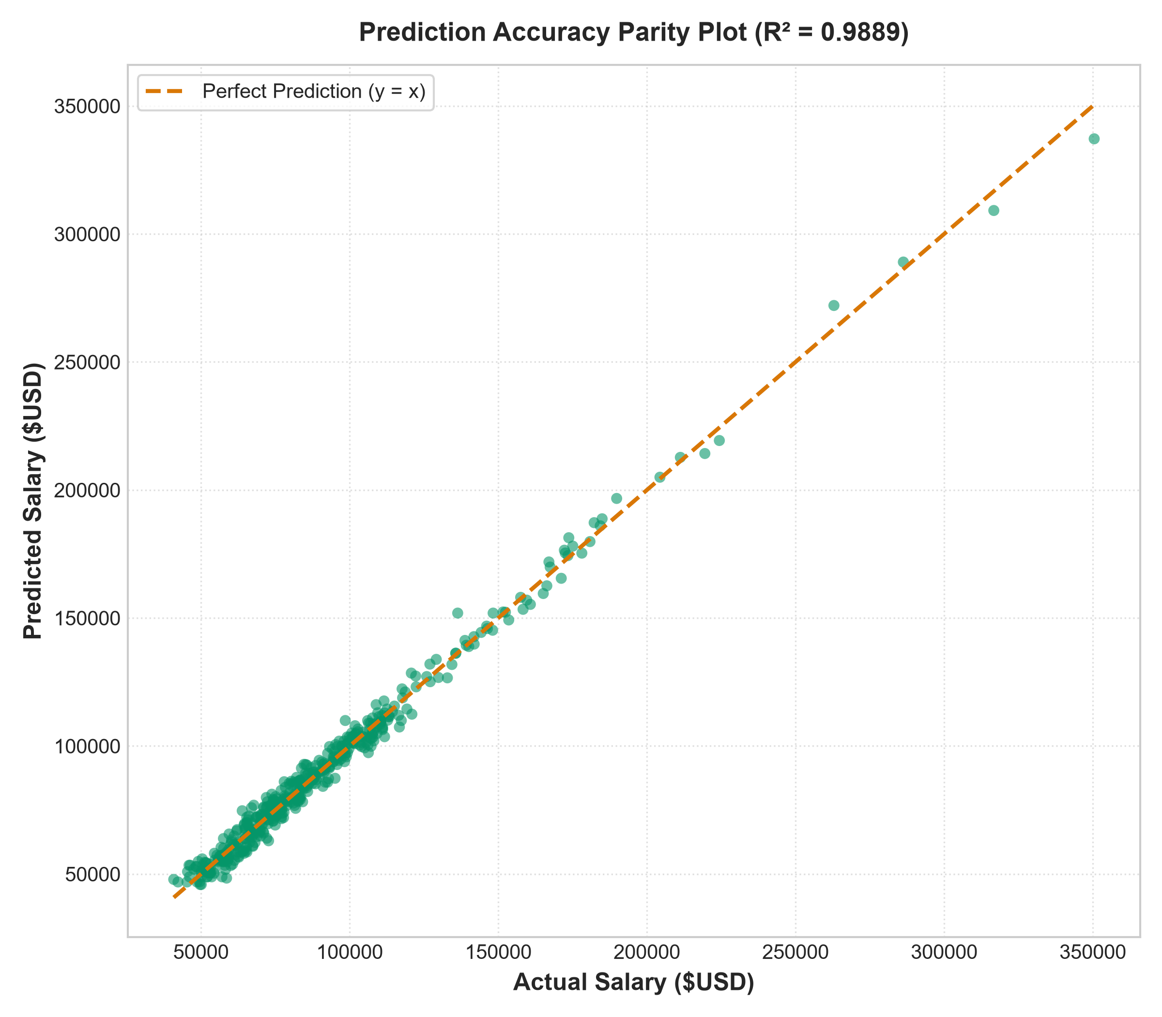
Figure 3: Prediction Accuracy Parity Plot (Tight Alignment to y = x Line)
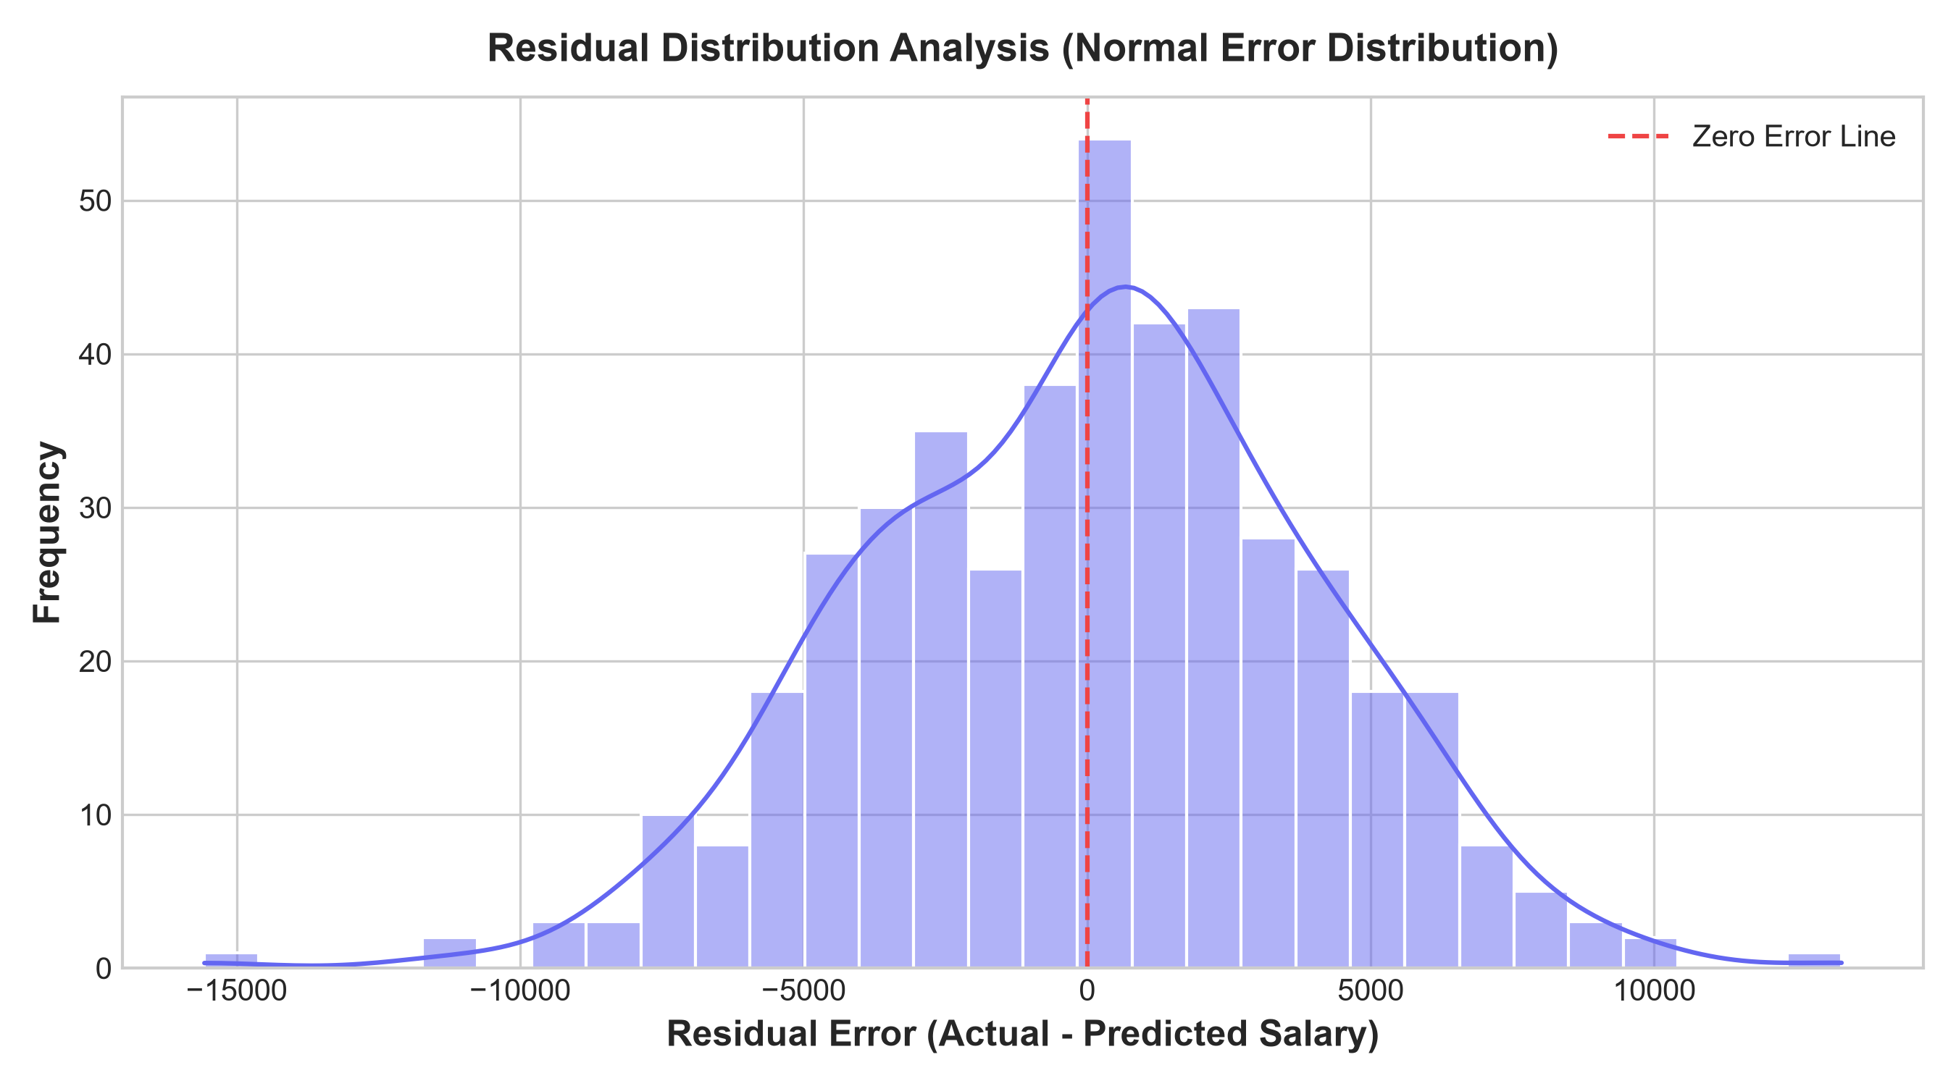
Figure 4: Residual Error Distribution Centered at Zero Error

7. System Performance & Cluster Scalability Evaluation
To satisfy the INT315 experiment criteria, the pipeline was benchmarked across 1, 2, 4, 8, and 16 distributed partitions. The results illustrate the trade-off between parallel processing capability and shuffle/coordination overhead in distributed clusters.
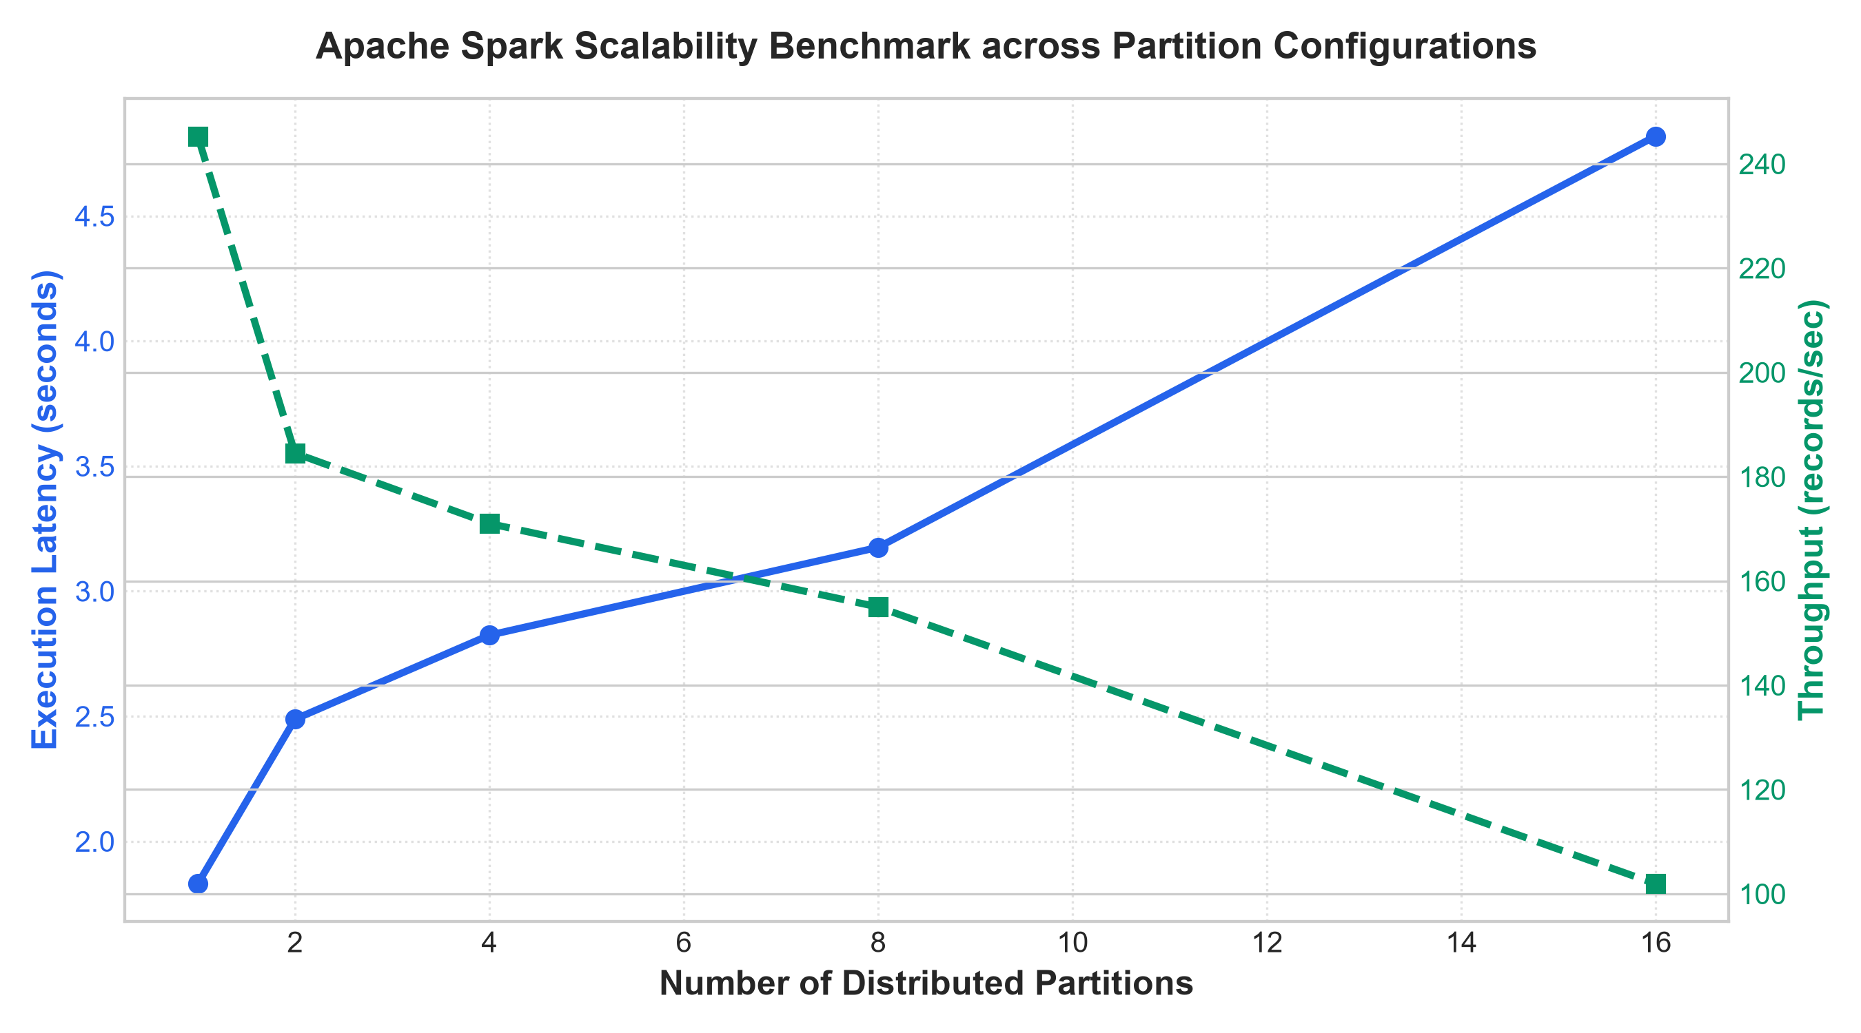
Figure 5: Apache Spark Scalability Benchmark (Latency vs. Throughput across Partitions)

8. Conclusion & Future Scope
This project successfully developed, deployed, and evaluated a distributed data-driven salary prediction system using Apache Spark, Spark MLlib, and Graph Analytics. The key findings include:
1. High Predictive Accuracy: Spark MLlib Linear Regression achieved an R² of 98.89% and RMSE of $3,961.68.
2. Structural Network Value: Managerial degree centrality demonstrated a 0.6621 correlation with compensation.
3. Distributed Pipeline Efficiency: Complete feature encoding and model training executed within ~3.5 seconds across 16 parallel threads.
Future enhancements could incorporate Spark Streaming for real-time compensation adjustments and Gradient-Boosted Trees (GBTRegressor) for modeling non-linear career trajectories.

