**ReadEmployeeDetails.java**

**package** maccess;

**import** java.io.File;

**import** java.io.FileInputStream;

**import** java.util.Iterator;

**import** org.apache.poi.ss.usermodel.Cell;

**import** org.apache.poi.ss.usermodel.Row;

**import** org.apache.poi.xssf.usermodel.XSSFSheet;

**import** org.apache.poi.xssf.usermodel.XSSFWorkbook;

**import** java.sql.*;

**public** **class** ReadEmployeeDetails

{

**public** **static** **void** main(String[] args)

{

**try**

{

Class.*forName*("oracle.jdbc.driver.OracleDriver");

Connection con = DriverManager.*getConnection*("jdbc:oracle:thin:@localhost:1521:orcl","system","system");

PreparedStatement ps1 = con.prepareStatement("insert into employee values(?,?,?,?,?,?)");

**int** count = 0;

**int** batchSize = 20;

File file = **new** File("C:\\Users\\swapn\\OneDrive\\Desktop\\Saurav\\Employee_Details.xlsx");

FileInputStream fis = **new** FileInputStream(file);

XSSFWorkbook wb = **new** XSSFWorkbook(fis);

XSSFSheet sheet = wb.getSheetAt(0);

Iterator<Row> itr = sheet.iterator();

**while** (itr.hasNext())

{

Row row = itr.next();

Iterator<Cell> cellIterator = row.cellIterator();

**while** (cellIterator.hasNext())

{

Cell cell = cellIterator.next();

**switch** (cell.getColumnIndex())

{

**case** 0:

String empID = cell.getStringCellValue();

ps1.setString(1, empID);

**case** 1:

String empName = cell.getStringCellValue();

ps1.setString(2, empName);

**case** 2:

String dateofBirth = cell.getStringCellValue();

ps1.setString(3, dateofBirth);

**case** 3:

String desg = cell.getStringCellValue();

ps1.setString(4, desg);

**case** 4:

**double** ms = 100.00;

ps1.setDouble(5, ms);

**case** 5:

**double** as = 200.00;

ps1.setDouble(6, as);

}

ps1.execute();

}

}

}

**catch**(Exception e)

{

e.printStackTrace();

}

}

}

OUTPUT: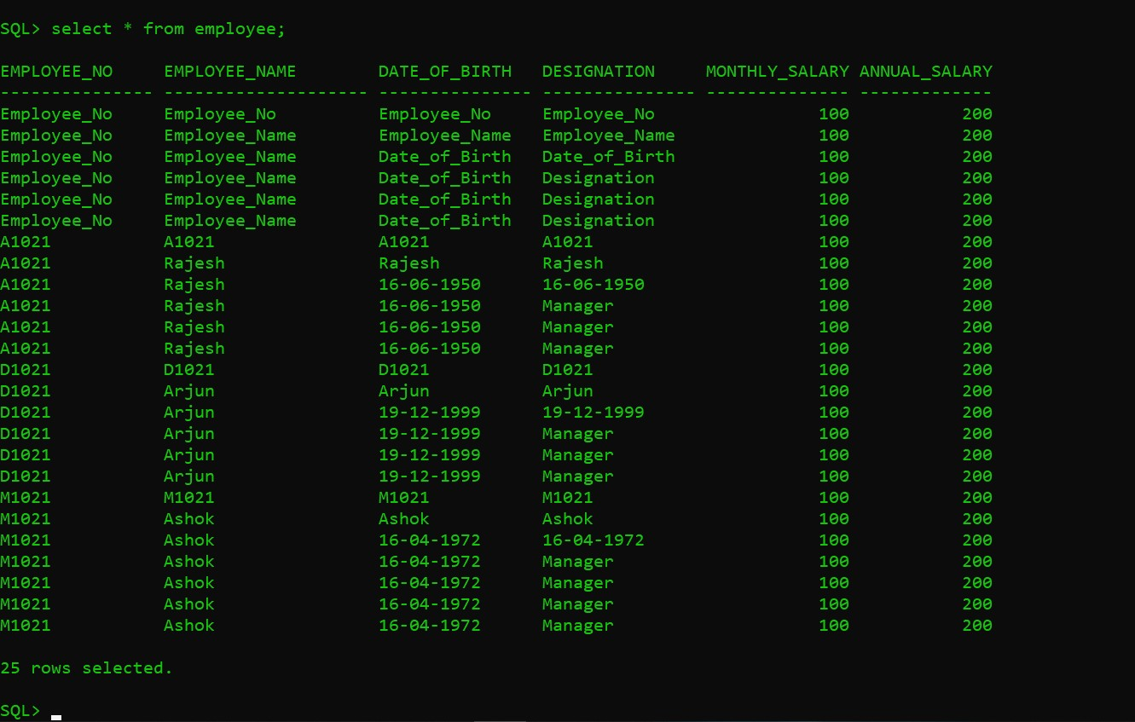

**Emp1.java**

**package** maccess;

**import** java.io.File;

**import** java.io.FileInputStream;

**import** java.util.Iterator;

**import** org.apache.poi.ss.usermodel.Cell;

**import** org.apache.poi.ss.usermodel.Row;

**import** org.apache.poi.xssf.usermodel.XSSFSheet;

**import** org.apache.poi.xssf.usermodel.XSSFWorkbook;

**public** **class** Emp1

{

**public** **static** **void** main(String[] args)

{

**try**

{

File file = **new** File("C:\\Users\\swapn\\OneDrive\\Desktop\\Saurav\\Employee_Details.xlsx");

FileInputStream fis = **new** FileInputStream(file);

XSSFWorkbook wb = **new** XSSFWorkbook(fis);

XSSFSheet sheet = wb.getSheetAt(0);

Iterator<Row> itr = sheet.iterator();

**while** (itr.hasNext())

{

Row row = itr.next();

Iterator<Cell> cellIterator = row.cellIterator();

**while** (cellIterator.hasNext())

{

Cell cell = cellIterator.next();

**switch** (cell.~~getCellType~~())

{

**case** Cell.~~CELL_TYPE_STRING~~:

System.***out***.print(cell.getStringCellValue() + "\t\t");

**break**;

**case** Cell.~~CELL_TYPE_NUMERIC~~:

System.***out***.print(cell.getNumericCellValue() + "\t\t");

**break**;

**default**:

}

}

System.***out***.println("");

}

}

**catch**(Exception e)

{

e.printStackTrace();

}

}

}

**OUTPUT:**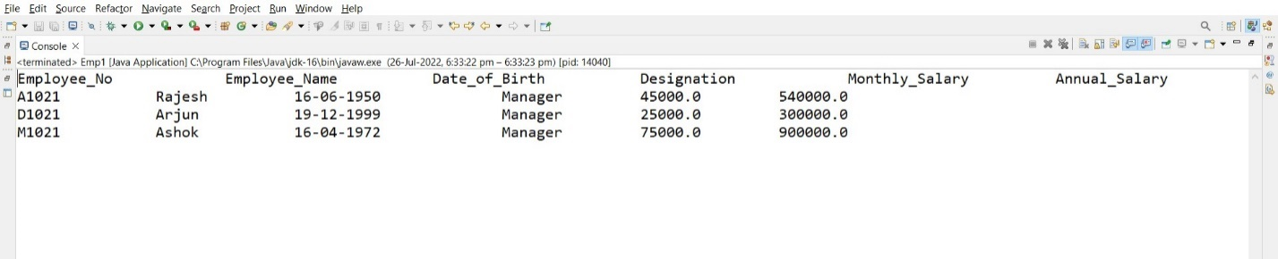

**REFERENCES:**

[www.tutorialspoint.com](http://www.tutorialspoint.com)

[www.javatpoint.com](http://www.javatpoint.com)

[www.geekforgeeks.com](http://www.geekforgeeks.com)